

**SCHOOL OF** INFOCOMM TECHNOLOGY

**Cloud Architecture and Technologies (CAT)**

**Assignment - April 2023 Semester**

**35% of CAT Module – (Team: 70%, Individual 30%)**

**3 July – 6 Aug 2023 (Weeks 12 - 16)**

**Deadline for submission:**

**SOFTCOPY:** Submit in Brightspace by 06 Aug 2023, 23:59

|  |  |  |  |
| --- | --- | --- | --- |
| **Tutorial Group:** | P05 | **Team Number:** | 1 |
| **Members** | **Student No.** | **Student Name** | **Grade** |
| S10243168 | Bernice Tan Xuan Rong |  |
| S10242811 | Liew Yun Yi Phoedora |  |
| S10242471 | Wong Jia Yi |  |
| S10242025 | Lim Jie Hong Jonathan |  |
| S10241971 | Huang Wen |  |

Contents

1. Introduction - 5 -

2. Requirement 1 - 5 -

2.1 Network Diagram - 5 -

2.1.1 Scale In: - 5 -

2.1.2 Scale Out: - 6 -

2.2 Description of Network Diagram - 6 -

2.2.1 Virtual Private Cloud (VPC) - 6 -

2.2.2 Availability Zones - 6 -

2.2.3 Internet Gateway - 7 -

2.2.4 Public Subnet & ACL - 7 -

2.2.5 Private Subnet & ACL - 7 -

2.2.6 EC2 & Auto Scaling Group - 7 -

2.2.7 Security Groups - 8 -

2.2.8 Elastic Load Balancing (ELB): - 8 -

2.2.9 Relational Database Service (RDS) - 9 -

2.2.10 CloudWatch - 9 -

2.2.12 CloudTrail - 10 -

3. Requirement 2 - 11 -

3.1 Network Diagram - 11 -

3.2 Description of Network Diagram (Our Cloud Solution) - 11 -

3.2.1 S3 (Simple Storage Service) - 11 -

3.2.2 Lambda - 14 -

3.2.3 API Gateway - 16 -

3.2.3 DynamoDB - 18 -

3.2.5 SNS (Simple Notification Service) - 18 -

4. Explanation of the Implementation and Meeting of the Requirements - 19 -

4.1. Description of Cloud Solution (Requirement 1) - 19 -

4.1.1. Virtual Private Cloud (VPC) - 20 -

4.1.2. Subnets - 21 -

4.1.2.1. Internet Gateway - 22 -

4.1.2.2. Public Subnets - 22 -

4.1.2.3. Private Subnets - 23 -

4.1.3. Availability Zones - 25 -

4.1.4. EC2 - 25 -

4.1.5. Relational Database Service (RDS) - 29 -

4.1.6. Elastic Load Balancing (ELB) - 33 -

4.1.7. Auto Scaling Group - 37 -

4.1.7.1. Amazon Machine Image (AMI) - 37 -

4.1.7.2. New Security Group - 37 -

4.1.7.3. Launch Template - 38 -

4.1.7.4. Auto Scaling Group - 40 -

4.1.7.5. Monitoring - 43 -

4.1.8. Implementation and AWS Well-Architected Principles - 45 -

4.1.9. Cloud Monitoring Plan and Techniques - 46 -

4.2 Description of cloud solution (Requirement 2) - 64 -

4.2.1 NoSQL Database for Customer Data - 64 -

4.2.2 HTML Forms Page and API Gateway Integration - 65 -

4.2.3 Lambda Functions for Data Processing: - 67 -

4.2.4 Retrieving and Displaying Customer Data: - 67 -

4.2.5 Notification System Requirements - 68 -

4.3 Optional requirement - 68 -

5. Lambda Functions Code - 69 -

5.1 Post Customer Data To DynamoDB Function - 69 -

5.2 Get Customer Data From DynamoDB Function - 70 -

5.3 Notify New DynamoDB Record Function - 70 -

5.4 Notify S3 File Upload Function - 71 -

5.5 Thumbnail Lamba Function - 71 -

6. Testing methods - 72 -

6.1 Requirement 1 - 72 -

6.2 Requirement 2 - 82 -

6.2.1 Testing steps: - 82 -

7. Our Cloud Solution Design Principles: - 86 -

7.1 Security: - 86 -

8.1.1 Enable traceability - 86 -

8.1.2 Apply security at all layers - 86 -

8.1.3 Automate security best practices - 86 -

8.1.4 Protect data in transit and at rest (storage) - 87 -

8.1.5 Keep people away from data - 87 -

8.1.6 Prepare for security events - 87 -

8.2 Reliability - 88 -

8.2.2 Automatically recover from failure - 88 -

8.2.3 Test recovery procedures - 89 -

8.2.4 Scale horizontally to increase aggregate workload availability - 89 -

8.2.5 Stop guessing capacity - 89 -

8.2.6 Manage change in automation - 89 -

8.3 Performance Efficiency - 89 -

8.3.2 Democratize advanced technologies - 90 -

8.3.3 User serverless architectures - 90 -

8.3.4 Consider mechanical sympathy - 90 -

8.4 Cost Optimization - 90 -

9 Cloud Monitoring Plan for Web Application and AWS Resources/Services - 91 -

Techniques Used: - 91 -

Principles Used: - 91 -

6. Problems and Resolutions - 91 -

7. References - 92 -

# Introduction

The objective of the report is to show that our cloud infrastructure implemented for KVM Pte Ltd is resilient and secure.

In this report, we will explain our network diagram, the problems, and resolution we faced when creating the cloud infrastructure and lastly, the features and functions we used and the reasons behind it. Both the requirement 1 and 2 architecture are implemented Huang Wen’s account.

# Requirement 1

## 2.1 Network Diagram

### 2.1.1 Scale In:

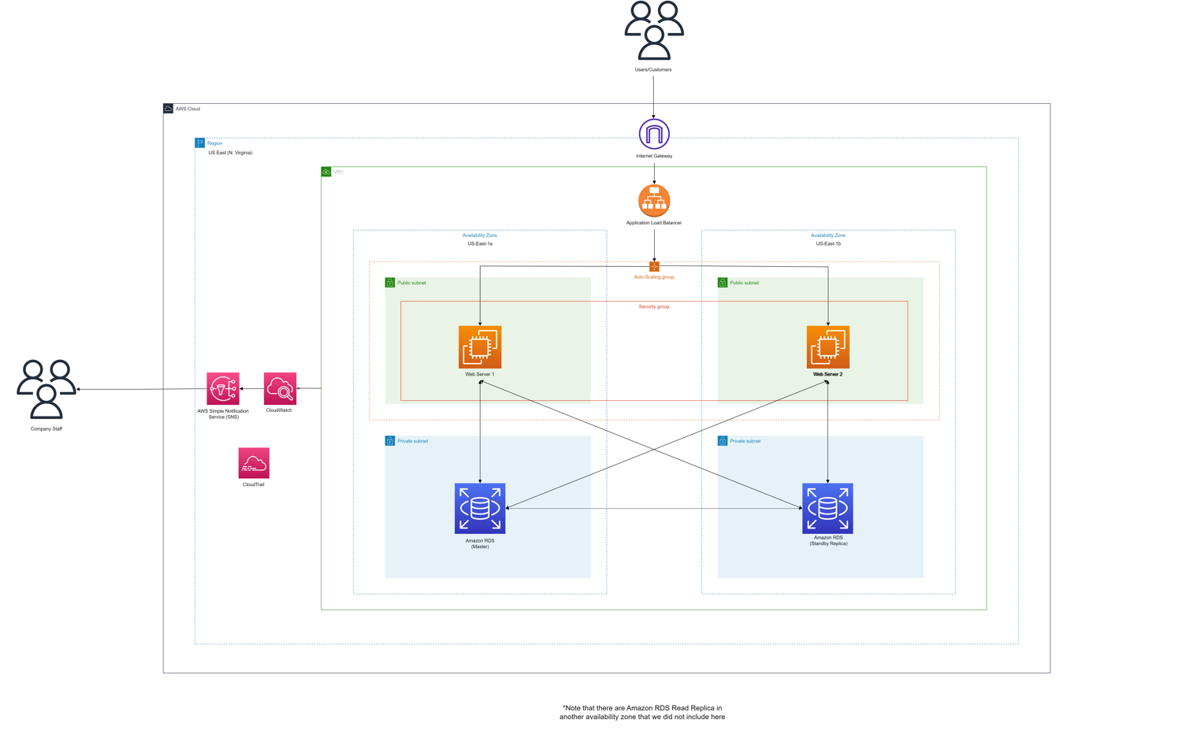

### 2.1.2 Scale Out:

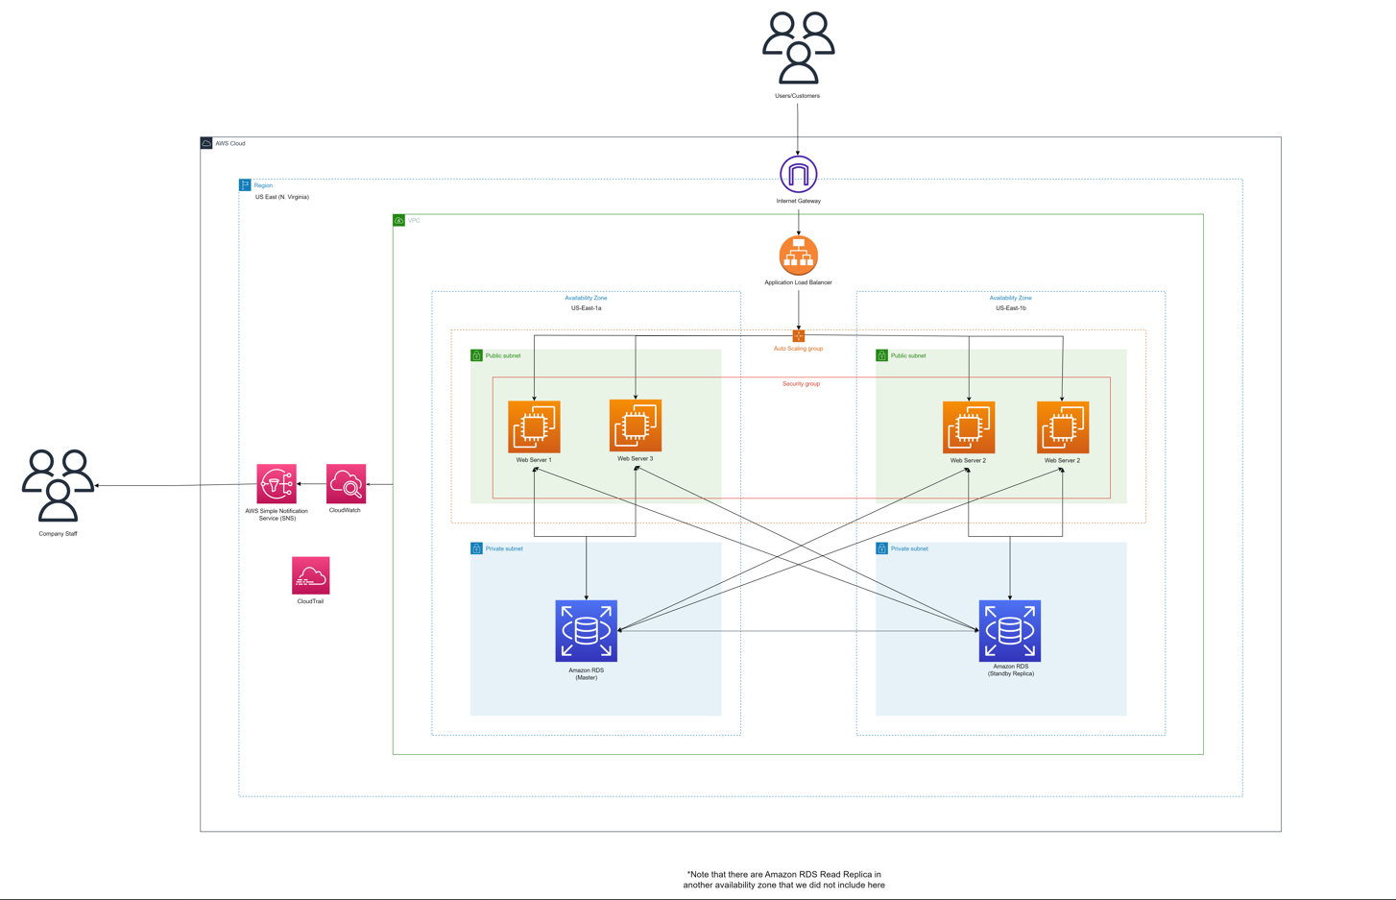

## 2.2 Description of Network Diagram

### 2.2.1 Virtual Private Cloud (VPC)

In our AWS Cloud Infrastructure, resources like EC2 web servers, and relational database service (RDS) will be deployed in a Virtual Private Cloud (VPC) in the N. Virginia region.

A VPC is an isolated virtual network that is scalable, unlike a physical and traditional data center where we can add subnets in it (AWS, 2023). For the public to access the EC2 web servers in the VPC, an internet gateway is needed.

### 2.2.2 Availability Zones

We have **2 Availability Zones** in place in our VPC: **us-east-1a and us-east-1b**

The reason for implementing 2 availability zones and not more is to ensure cost optimization as well as reliability. Another reason is to ensure resiliency, especially during natural disasters. In the event of a natural disaster, when one availability zone is down, resources in another availability zone within the same region will still be able to operate, serve traffic and handle requests, which thus minimizes the downtime and always ensure the availability of the services.

### 2.2.3 Internet Gateway

In our cloud infrastructure, it would require users to interact with the AWS Cloud’s EC2 web server instances. Hence, we have implemented an Internet Gateway, which acts as a bridge between the Internet and the VPC, enabling bidirectional connection for resources within the VPC such as web servers, allowing them to receive and respond to external requests.

For the first requirement, we are doing Web Application Hosting. For hosting the web application in AWS and making it accessible from the internet, we would use an Internet Gateway. An Internet Gateway enables communication between your VPC and the public internet. Internet Gateway is used for web application hosting and providing internet access to our VPC.

### 2.2.4 Public Subnet & ACL

A public subnet is where the public can use the internet gateway to enter the subnet. The public subnet of our network diagram is where the EC2 servers are. Users from the internet are allowed access to the EC2 as it is places in a public subnet through the associated internet gateway linked to the VPC (N, 2023).

With the public subnet, there is a network access control list (ACL) that is stateless. This means that the public subnet has no memory at all and every time an inbound or outbound traffic at a subnet level will be checked against its ACL rules (AWS, 2023).

### 2.2.5 Private Subnet & ACL

A private subnet a part of the VPC where the public does not have access to. In our network diagram, it contains the RDS that stores customers’ data that needs to be kept confidential. The private subnet is also associated to a route table that does not route to an internet gateway (N, 2023). Hence, the public are not able to gain access to the resources in the private subnet.

A private subnet also has an ACL attached to it. Similar to the public subnet ACL, the ACL is stateless. However, for a private subnet, the ACL rules would be much stricter with more set rules (AWS, 2023).

### 2.2.6 EC2 & Auto Scaling Group

The web servers are placed in a public subnet, inside the VPC, allowing them to receive and respond to requests from the Internet. The auto-scaling demonstrates scalability and elasticity where it will dynamically adjust the changing demand. We have set the configurations to:

* Minimum Capacity: 2
* Desired Capacity: 2
* Maximum Capacity: 4

With the above configurations, it will adjust the number of instances from a minimum of 2 instances on low traffic demand to a maximum of 4 when there is a high traffic demand. After a period of high traffic demand, and there is a low traffic demand to access the web server, the auto-scaling will scale down the number of instances to 2 only.

### 2.2.7 Security Groups

Security groups are similar to network ACLs but of an instance level. Security groups check is stateful and check for inbound traffic only. This means that security groups have some memory that remembers packets from that instance. If a packet from that instance returns, it would automatically allow access to the instance. All outbound traffic is not checked in a security group.

### 2.2.8 Elastic Load Balancing (ELB):

A ELB automatically distributes incoming application traffic across multiple Amazon EC2 instances and scales resources to handle varying traffic demands. ELB detects unhealthy instances and automatically reroutes traffic to healthy instances until the unhealthy instances have been restored, enhancing reliability. Additionally, servers can be transparently added or reduced based on the size of the incoming requests, reducing over/under capacity, providing greater agility. AWS provides 3 different types of load balancer.

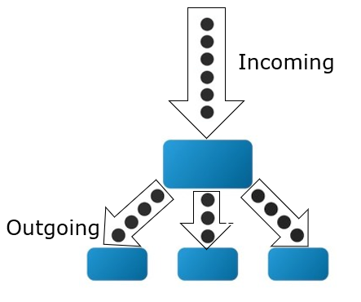

For this assignment, we will be utilizing the application load balancer for this assignment. The application load balancer offers flexible application management and advanced load balancing capabilities for HTTP and HTTPS traffic, operating at the request level (Layer 7). This aligns with the specific requirements of our assignment. We will not be using the network and classic load balancer types as they are better suited for extreme performance scenarios or when working with applications within the EC2-Classic network.

### 2.2.9 Relational Database Service (RDS)

Amazon RDS stands for "Relational Database Service", and we mostly use it for structured and relational data (SQL). RDS is the name of the service rather than the database engine itself. So, we can choose from six database engines, including Amazon Aurora, MySQL, and MariaDB.

RDS supports reliability and resiliency as whenever an RDS database is created, it would be available in 3 separate availability zones with the master database, standby replica and read replica as well as snapshots of the database. RDS also ensures that its databases are encrypted with keypairs managed by Amazon Key Management Service (KMS). This would also ensure that the data in the database are secure and that attackers who get their hands on the database are unable to read the data as only with the key then the data can be unencrypted.

To support security of the data, the RDS in our network infrastructure is linked to our EC2 web server instances where data of the users will be stored in the RDS database. The RDS database are stored in a private subnet where internet users are unable to access it since it contains confidential data.

RDS is also a fully managed service, which means that it would automate management within the infrastructure. It monitors running workload and has self-healing storage and automated scaling (AWS, 2023). This would heavily benefit the company staffs as they would then have more time to spend on other application developments than to manage the database (AWS, 2023).

### 2.2.10 CloudWatch

CloudWatch is a platform for monitoring and managing all AWS cloud applications, infrastructure, network, and services. CloudWatch provides live statistics and metrics about AWS resources in a graphical format that users can view. Users can create an alarm for when resources exceed a certain metric. Tasks can be performed automatically when alarms are triggered, such as sending notifications or activating a lambda function to perform a task.

Benefits of CloudWatch include Ease of troubleshooting and debugging as historical data could be analyzed for trends and patterns. CloudWatch also allows for auto scaling and resource optimization by integrating with AWS auto scaling to add or remove resources based on utilization metrics.

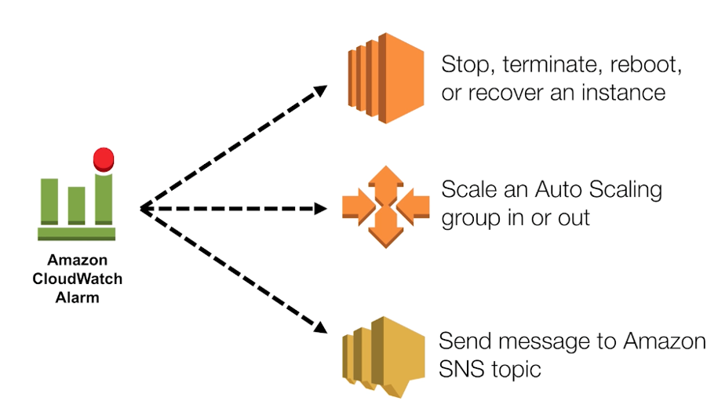

*From Wk04 CAT Database and Load Balancing.pptx

### 2.2.12 CloudTrail

Amazon CloudTrail is a service that provides operational and risk auditing (AWS, 2023). AWS CloudTrail is enabled by default when you create an AWS account. When there are any activities that are made in the network infrastructure, it is being recorded down and can be easily seen and accessed in the CloudTrail console (AWS, 2023).

To implements security in out network diagram, it is important that we audit anything that happens in our network diagram. By implementing CloudTrail service in our network infrastructure, it would help us audit and actions made by a user, role or to a service (AWS, 2023).

# Requirement 2

## 3.1 Network Diagram

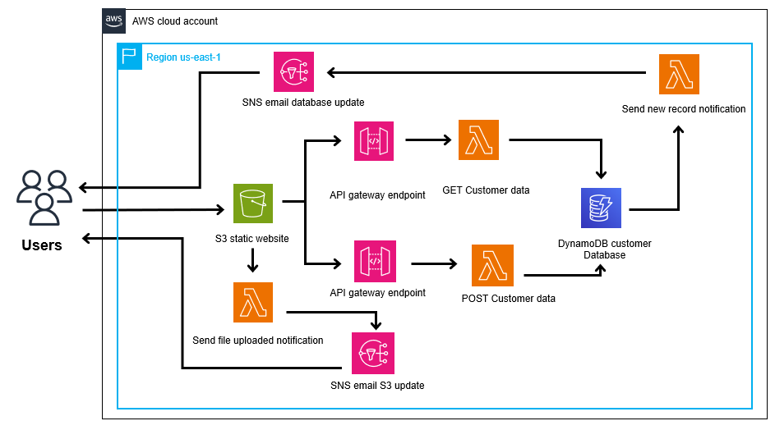

Figure 3.1.1 – serverless architecture diagram

## 3.2 Description of Network Diagram (Our Cloud Solution)

### 3.2.1 S3 (Simple Storage Service)

AWS S3 is used in this application. S3 (Simple Storage Service), is a storage service that stores data in the form of objects which can be any form of data such as documents, images, videos, backups and others. S3 is serverless and able to store virtually unlimited amounts of data. It is also highly durable and cost-efficient. S3 has different storage types based on the frequency of data retrieval. We will be using S3 standard tier for this application, which is the most expensive but provides the fastest retrieval time.

An S3 bucket will be used in this application for static website hosting to host the HTML forms customer data page. The bucket will contain the website hosting file. We have implemented an S3 bucket named **“asg2-static-web-host-bucket”** which is made public and can be accessed on the internet, which means any files uploaded can be accessed by anyone with the URL link:

<http://asg2-static-web-host-bucket.s3-website-us-east-1.amazonaws.com>.

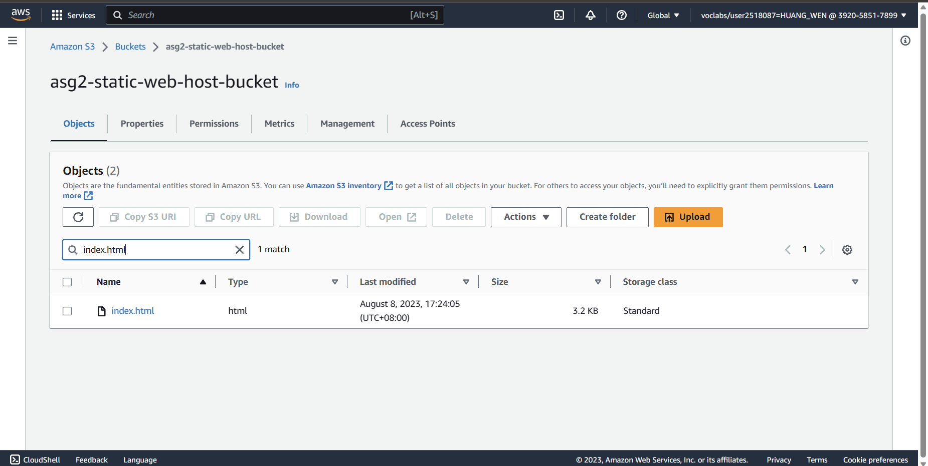

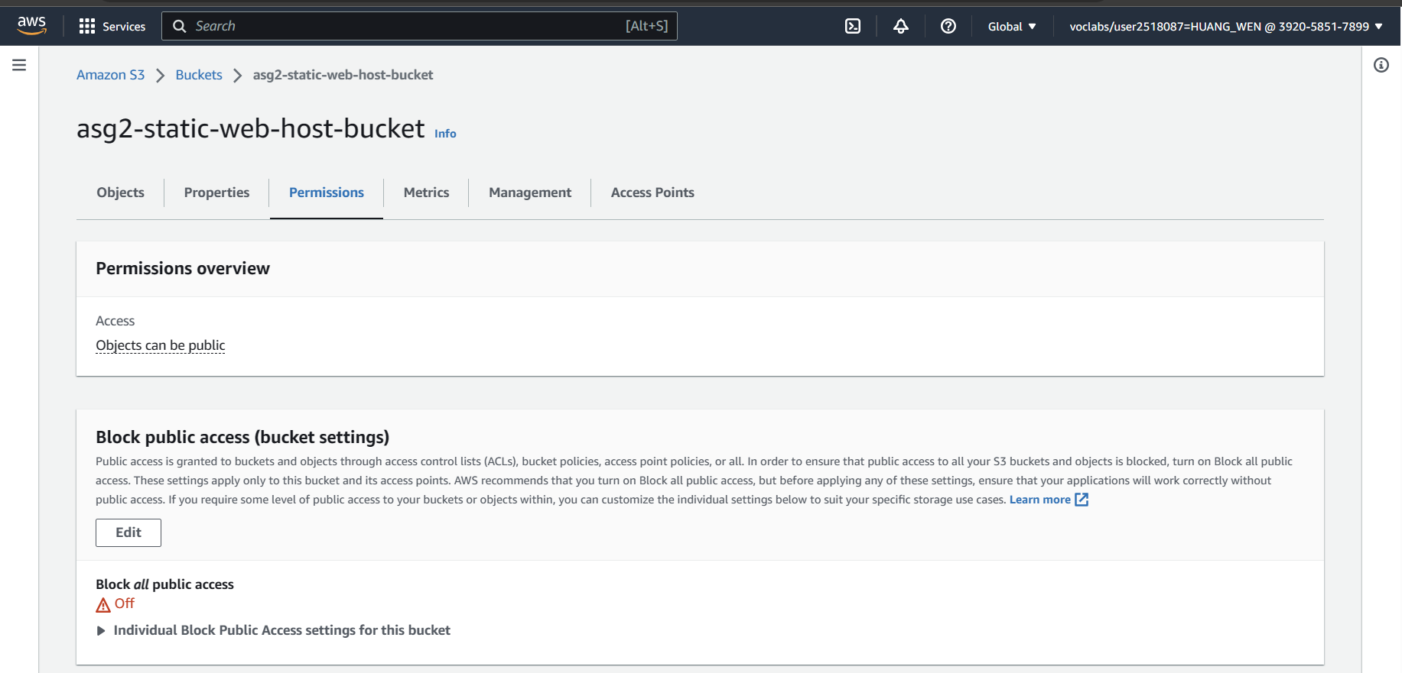

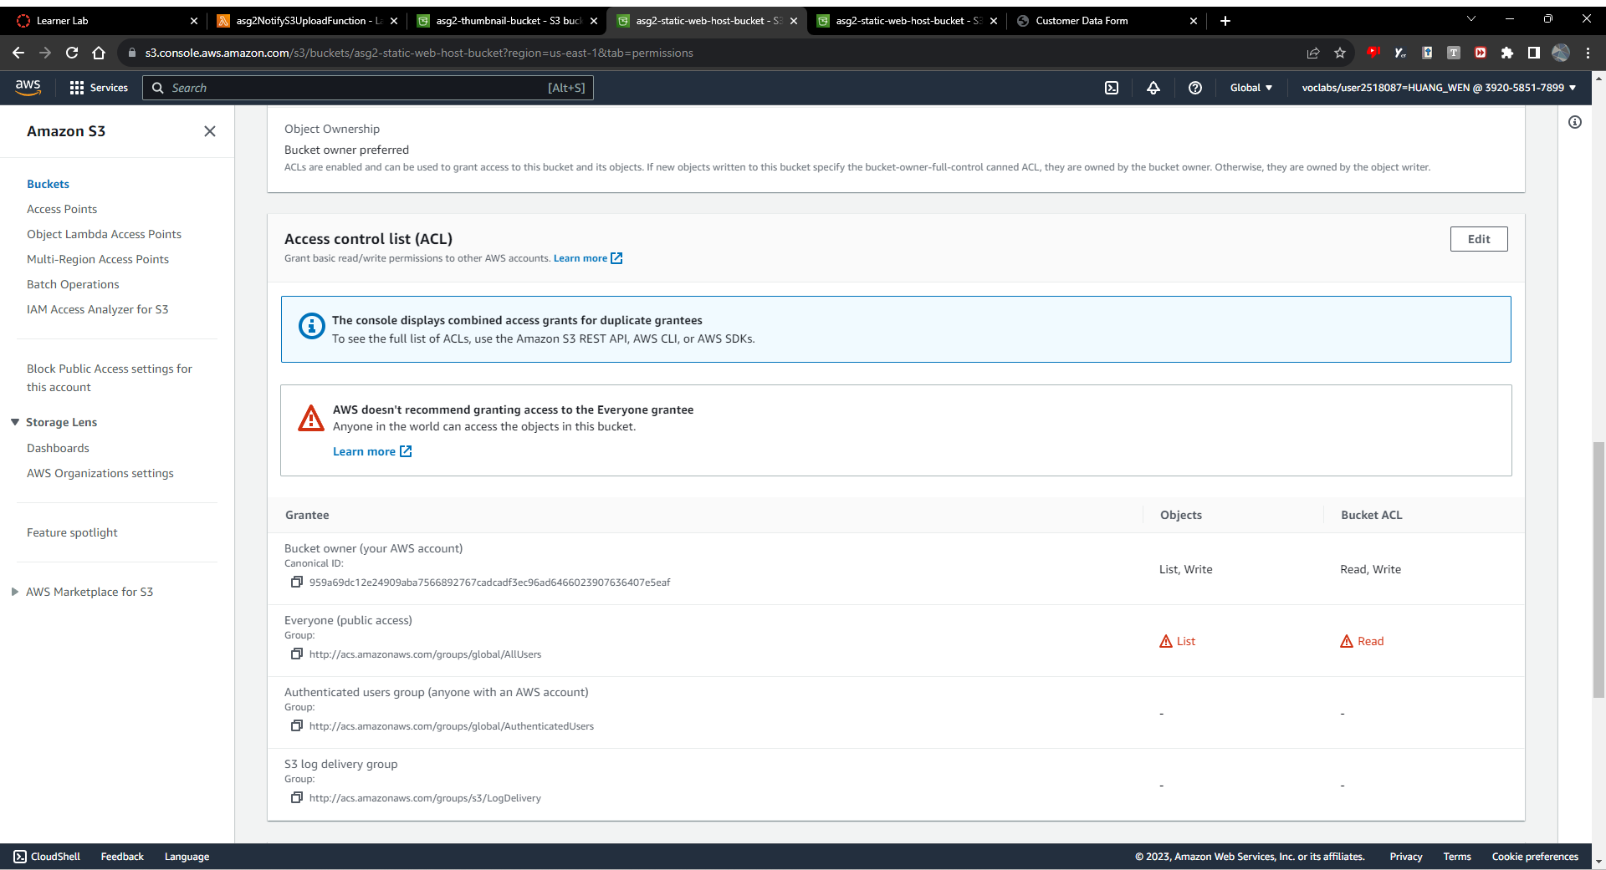

Figure 3.2.1.1 - Images of “asg2-static-web-host-bucket”

The website hosting file will be named **“index.html”** and contain the HTML code for the web page. The **“index.html”** file is also granted read access permissions to the everyone group so that everyone can access the website.

The website will be accessed by the “index.html” file link: <https://asg2-static-web-host-bucket.s3.amazonaws.com/index.html>

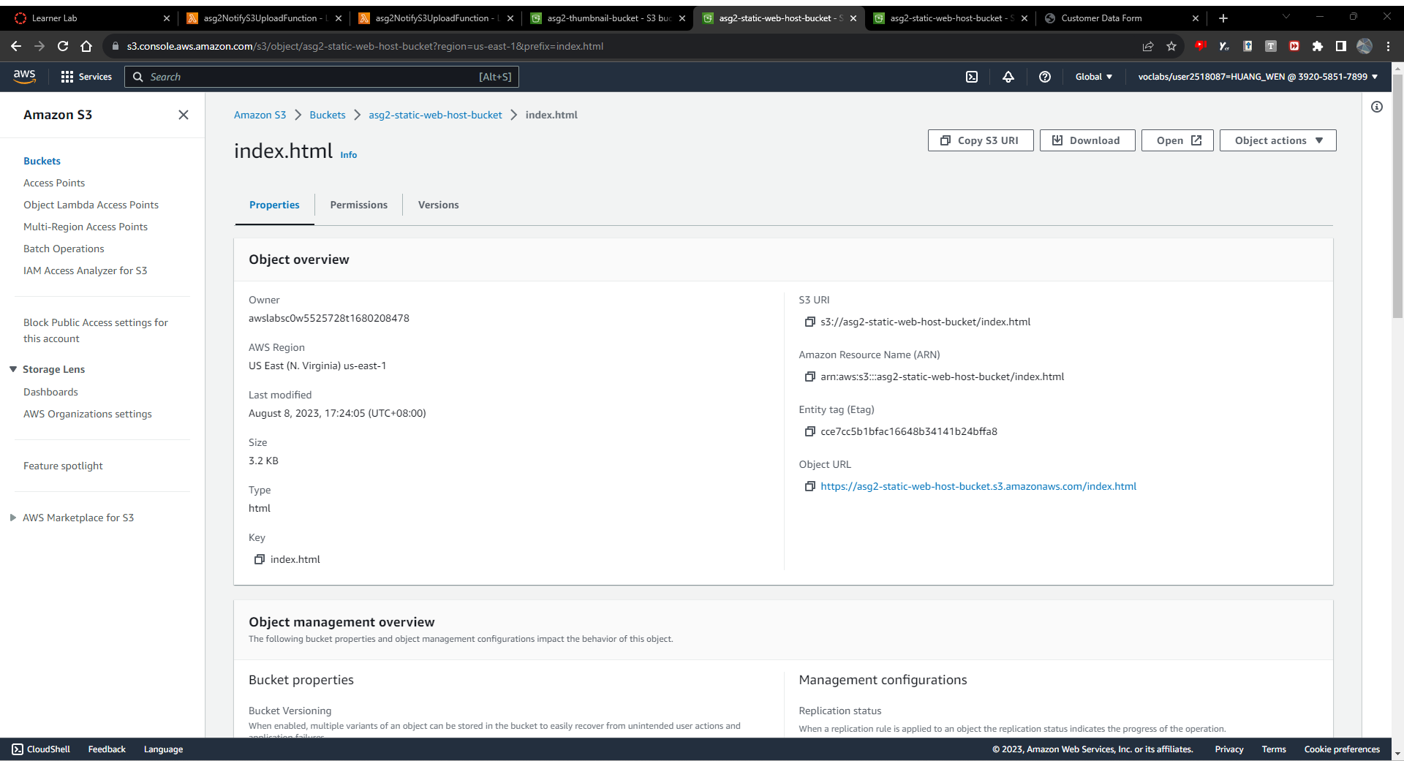

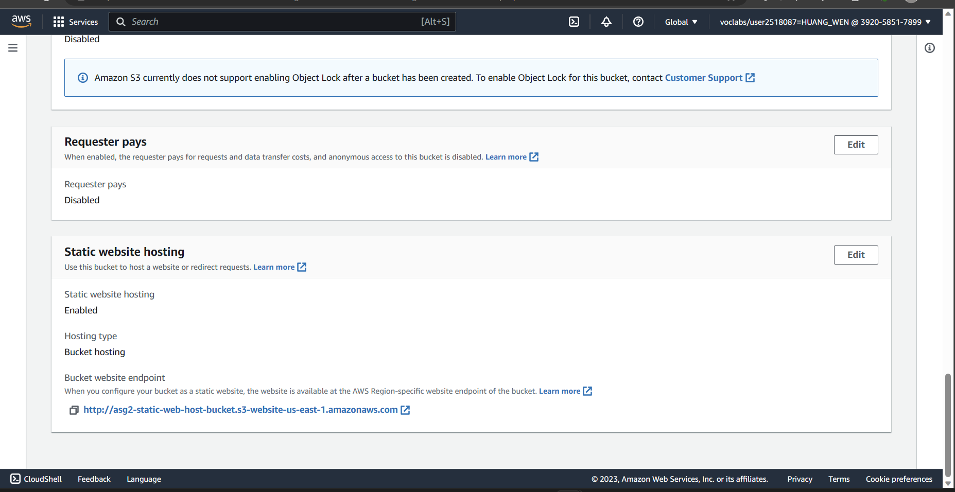

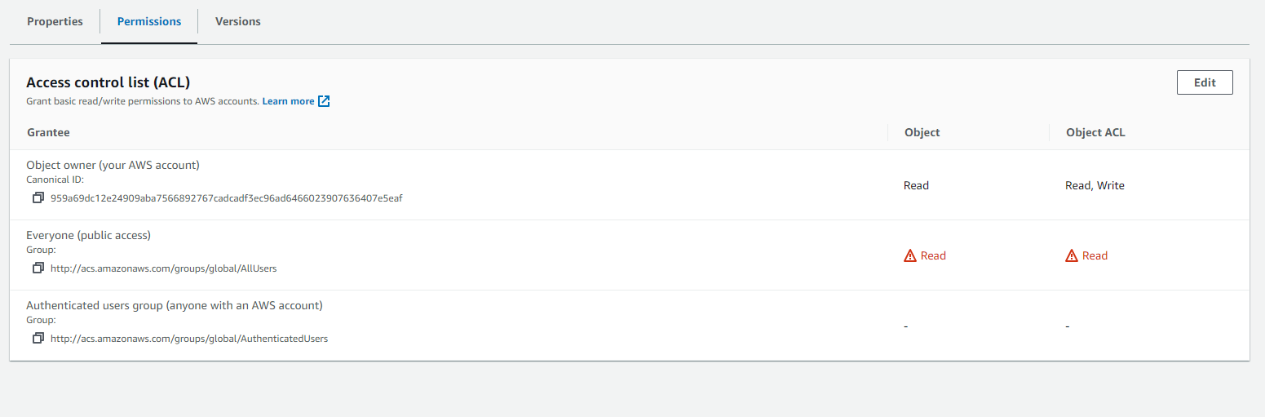

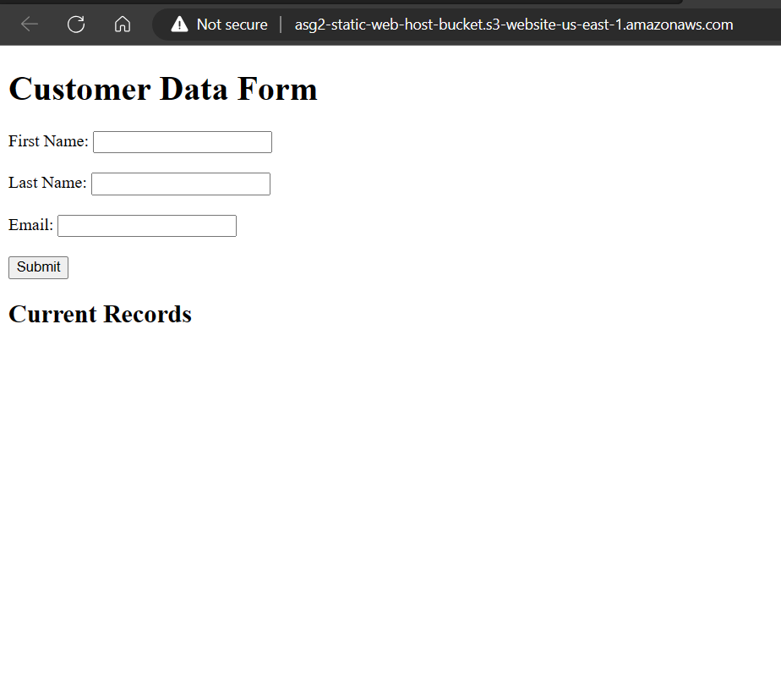[http://asg2-static-web-host-bucket.s3-website-us-east-1.amazonaws.com/](http://asg2-static-web-host-bucket.s3-website-us-east-1.amazonaws.com)

Figure 3.2.1.2 - Images for “index.html” webpage and file

### 3.2.2 Lambda

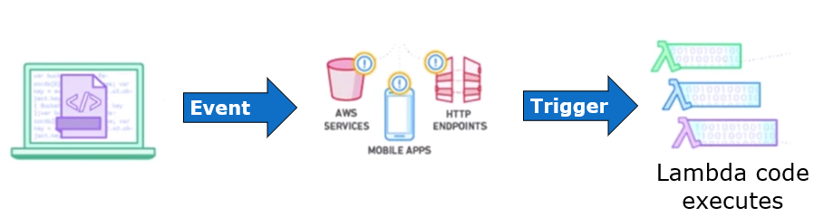

Figure 3.2.2.1 – Lambda diagram from Wk03 CAT Computer and Storage.pptx

Amazon Lambda is a fully managed serverless compute service that runs your code in response to events. With support for various programming languages and automatic scaling, users only pay for the compute time they use, giving developers flexibility in their language choice and making it cost-efficient. It is able to run code virtually for any application or backend service with zero administration. Lambda enables automatic triggering of code execution from other AWS services or call it directly from any web or mobile app. AWS Lambda simplifies development, handles administration, and offers high availability, making it an ideal choice for a wide range of applications.

In Requirement 2’s architecture, there are 4 lambda functions being used. All 4 lambda functions are written in python. **“asg2GetDataFromDBFunction”** is used for **retrieving** the customer **data from** the **DynamoDB** table. **“asg2PostDataToDBFunction”** is to **send** customer **data to** the **DynamoDB** table. When a *new record* is created in the DynamoDB table, **“asg2NotifyNewDataDBFunction”** **sends an email and SMS** to the administrator. The **“asg2NotifyS3NewUploadFunction**” will **send an email** and SMS to the administrator whenever a *file is uploaded* to the S3 bucket.

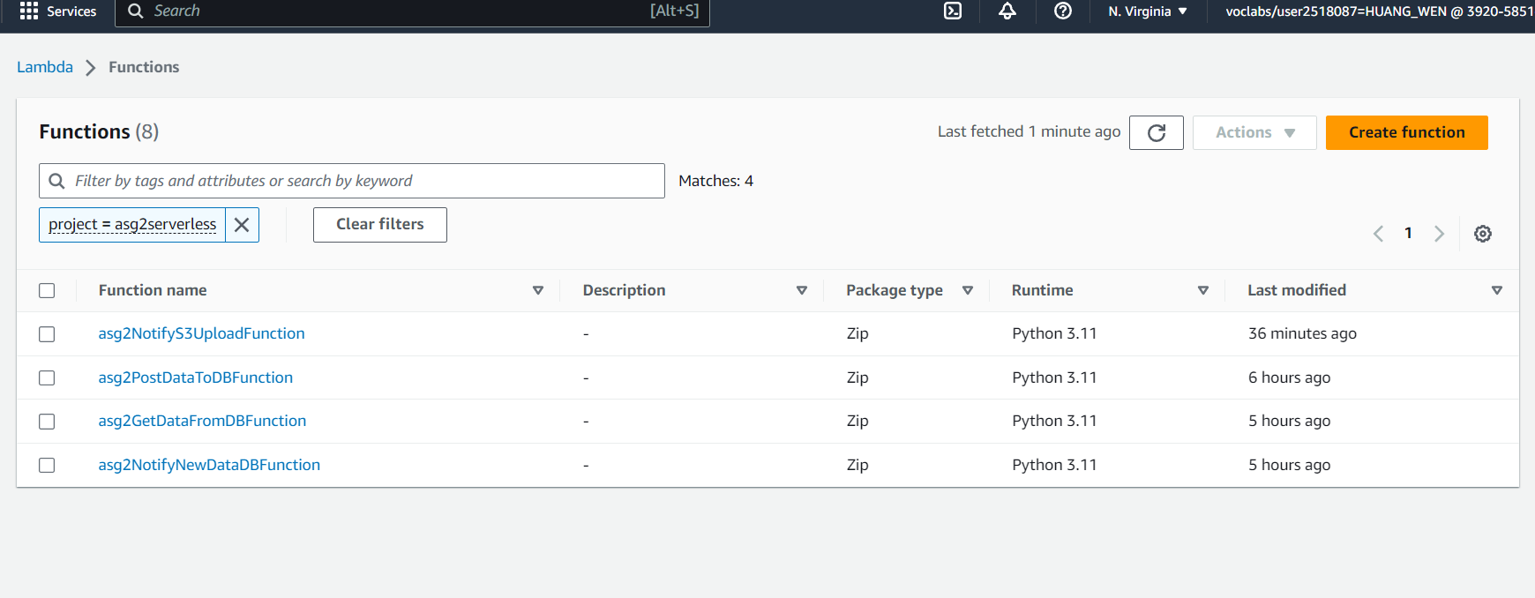

Figure 3.2.2.2 – list of lambda functions

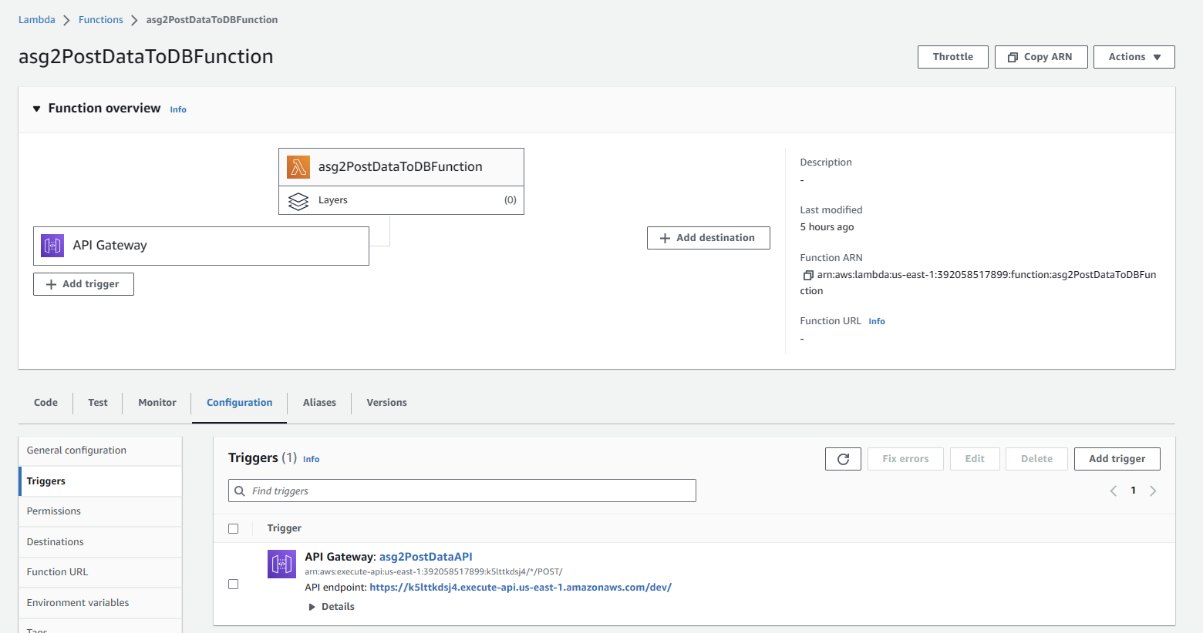

Figure 3.2.2.3 – “asg2PostdataToDBFunction”

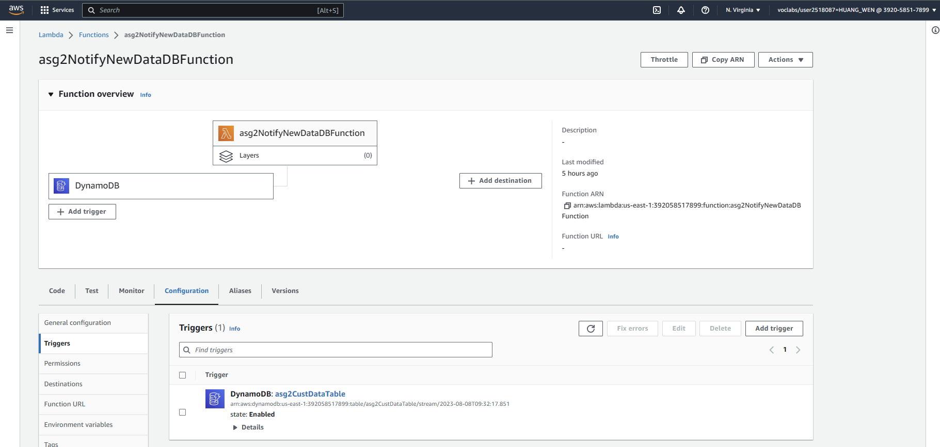

Figure 3.2.2.4 – “asg2NotifyNewDataDBFunction”

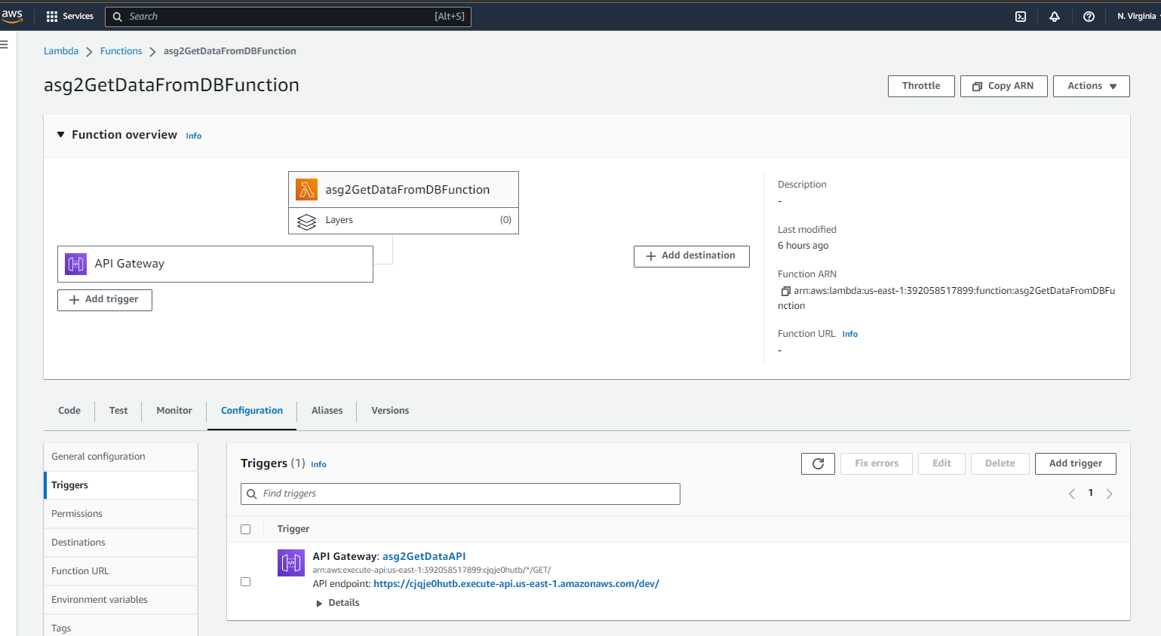

Figure 3.2.2.5 – “asg2GetDataFromDBFunction”

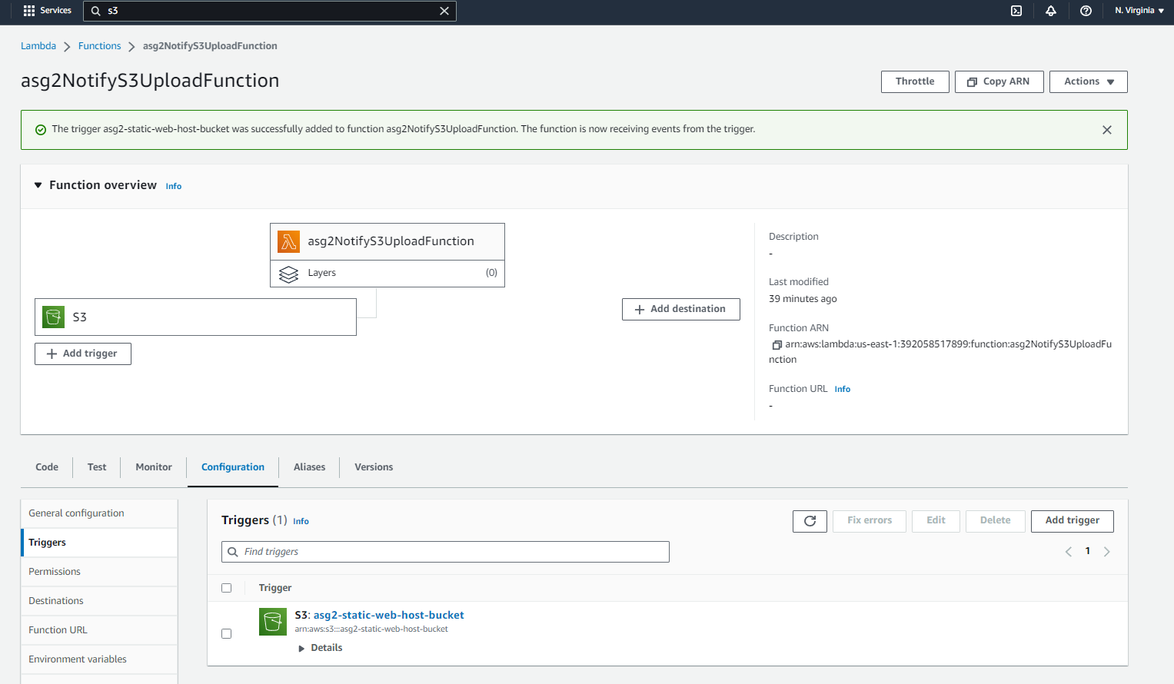

Figure 3.2.2.6 – “asg2NotifyS3UploadFunction”

### 3.2.3 API Gateway

The forms page in this application architecture needs a way to **post and get** data **to and from** the DynamoDB database using **HTTP**. Thus, we decided to use API Gateway. API Gateway is an AWS service that **acts as the "front door"** for our serverless application. It handles HTTP requests from the HTML form and routes them to the Lambda functions, enabling two-way, real-time communication between applications to access data from backend services. The API Gateway manages and processes API calls including traffic management and authorization and control. API Gateway serves as the entry point for HTTP requests and integrating with Lambda functions.

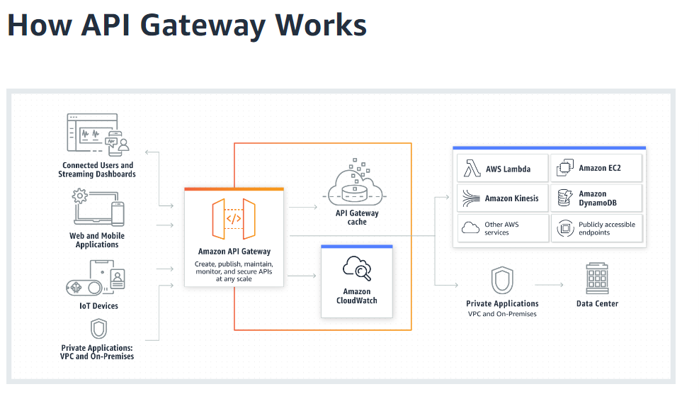

Figure 3.2.2.3 – API Gateway diagram

As the website that is hosted does not involve any chats or need for immediate real-time bidirectional communication, it is not efficient and effective to opt for the WebSocket API. Instead, it would be better to opt for building an HTTP API as it is low latency, meaning that there will be lesser delays and it is a more cost-effective REST API.

For this application architecture, we have implemented two APIs named **“asg2PostDataAPI”** and **“Asg2GetDataAPI”** using API Gateway. **“Asg2PostDataAPI”** will handle HTTP POST requests from the HTML form page. It will connect to and activate the Lambda function **“asg2PostDataToDBFunction”** which will send data to the database. For **“Asg2GetDataAPI”**, it will manage HTTP GET requests and activate the lambda function “**asg2GetDataFromDBFunction”** and retrieve data from the database.

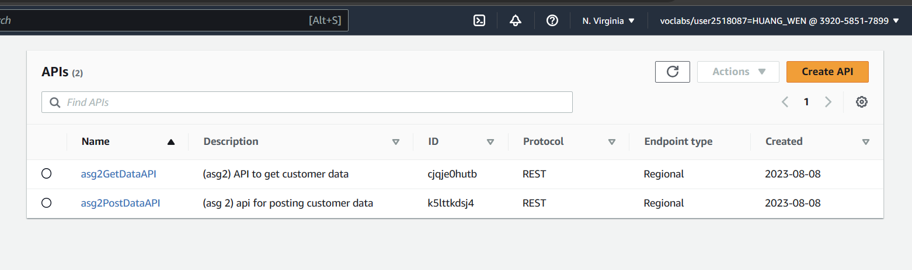

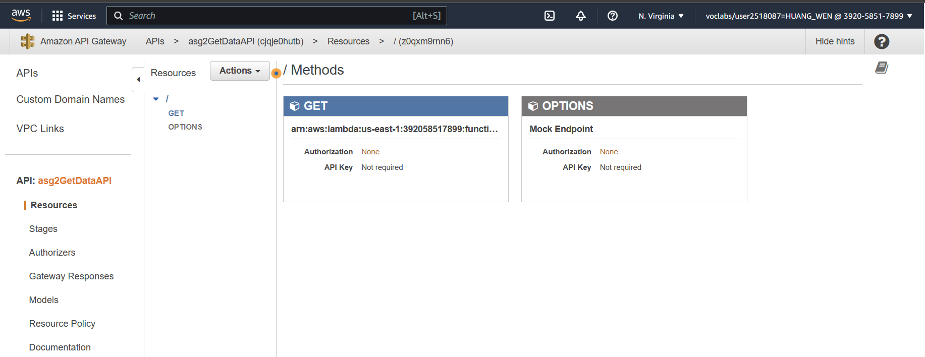

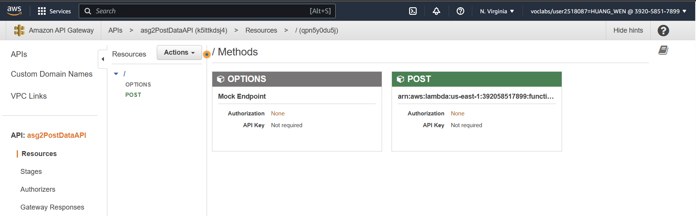

Figure 3.2.2.3 – APIs for posting and getting data

### 3.2.3 DynamoDB

DynamoDB is a fully managed, serverless, key-value NoSQL database. NoSQL is means that there is no fixed schema, allowing it to be flexible to store structured and unstructured data.

In this application architecture, we have implemented one DynamoDB table called **“asg2CustDataTable”.** The table contains the attributes emailAddress, firstName, and lastName where emailAddress is the Partition Key.

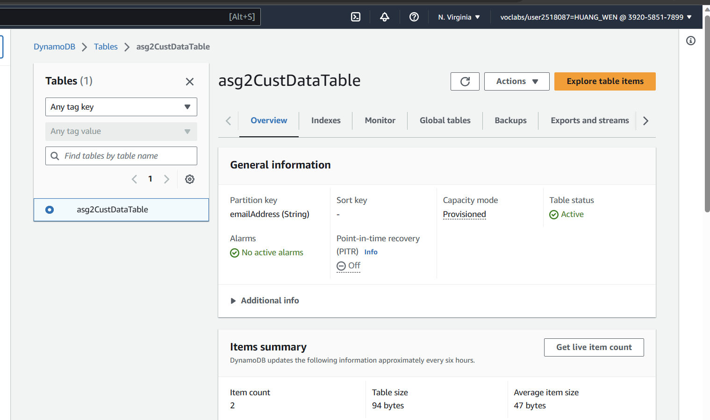

Figure 3.2.2.3 – DynamoDB table “asg2CustDataTable”

### 3.2.5 SNS (Simple Notification Service)

AWS SNS is a simple, fully managed cloud messaging service. It uses a publish-subscribe model. In this model, subscribers subscribe to a topic, and messages are sent to the specific topic, which the subscribers will receive.

This application utilizes SNS to send notifications to the administrator when a new customer record is created in the NoSQL database, and when a file is uploaded to the S3 bucket. The names of the SNS topics are **“ASG2newDBrecordTopic”** and **“ASG2newS3fileTopic”.** They are triggered by the Lambda functions, “ASG2NotifyDynamoDBFunction” and “ASG2NotfiyS3Function” whenever a new DynamoDB record is created or when a new S3 file is uploaded.

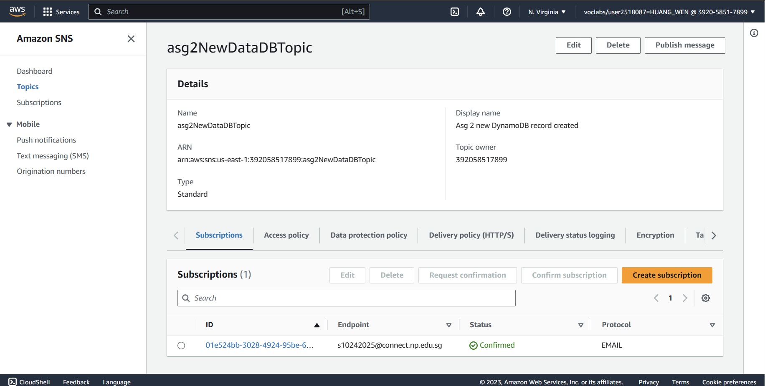

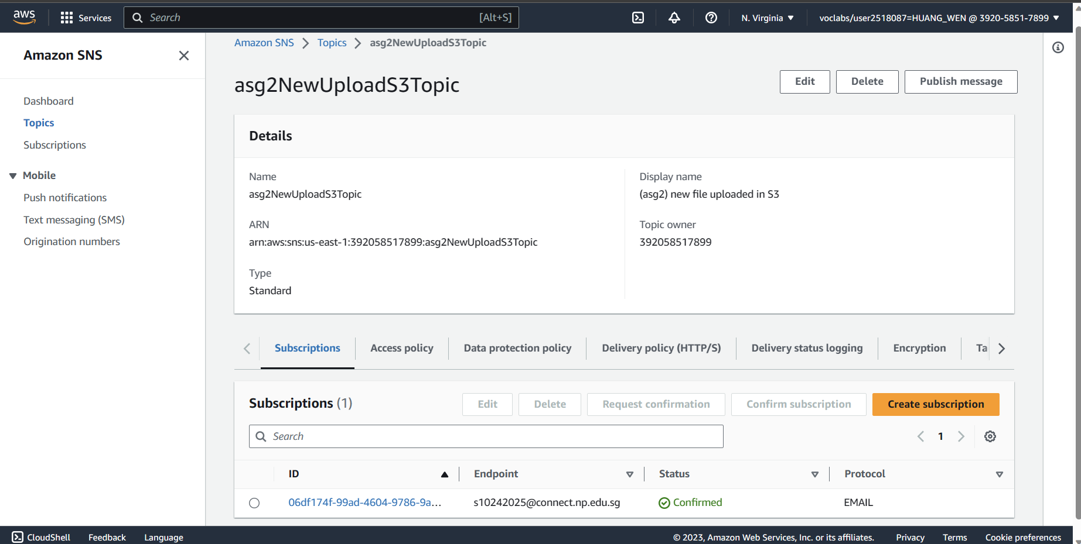

Figure 3.2.2.3 – Topics for DynamoDB and S3

# Explanation of the Implementation and Meeting of the Requirements

# Description of Cloud Solution (Requirement 1)

To meet KVM Pte Ltd.’s requirements, we have implemented a *secure, resilient, highly available* and accessible web application in KVM’s private cloud. This solution also incorporates the AWS well-architected design principles of Operational Excellence, Security, Reliability, Performance Efficiency and Cost Optimization.

The solution consists of KVM’s virtual private cloud encompassing multiple availability zones to ensure high availability and resilience. Additionally, the web servers (EC2 instances) are configured with an Auto Scaling Group, to ensure the scalability of the web application during varied traffic and demands. The traffic is managed by the load balancer which ensures traffic is evenly distributed between the web servers.

To address security concerns, network ACLs and Security Groups are utilized to restrict access to subnets and web servers respectively. Data is also secured through encryption and backup.

KVM admins will also be notified of changes to traffic management, scaling of web servers and breaches in predefined thresholds through Simple Notification Service (AWS SNS). Furthermore, real time performance metrics of applications can be monitored through customized dashboards on CloudWatch.

# Virtual Private Cloud (VPC)

We started out by creating a VPC for KVM named “VPC-Team1” hosted in the North Virginia Region containing 4 subnets, 2 in each availability zone (us-east-1a and us-east-1b). Within each availability zone, there is a public and private subnet. This ensures that the VPC is resilient and secure.

These are the configurations for the VPC:

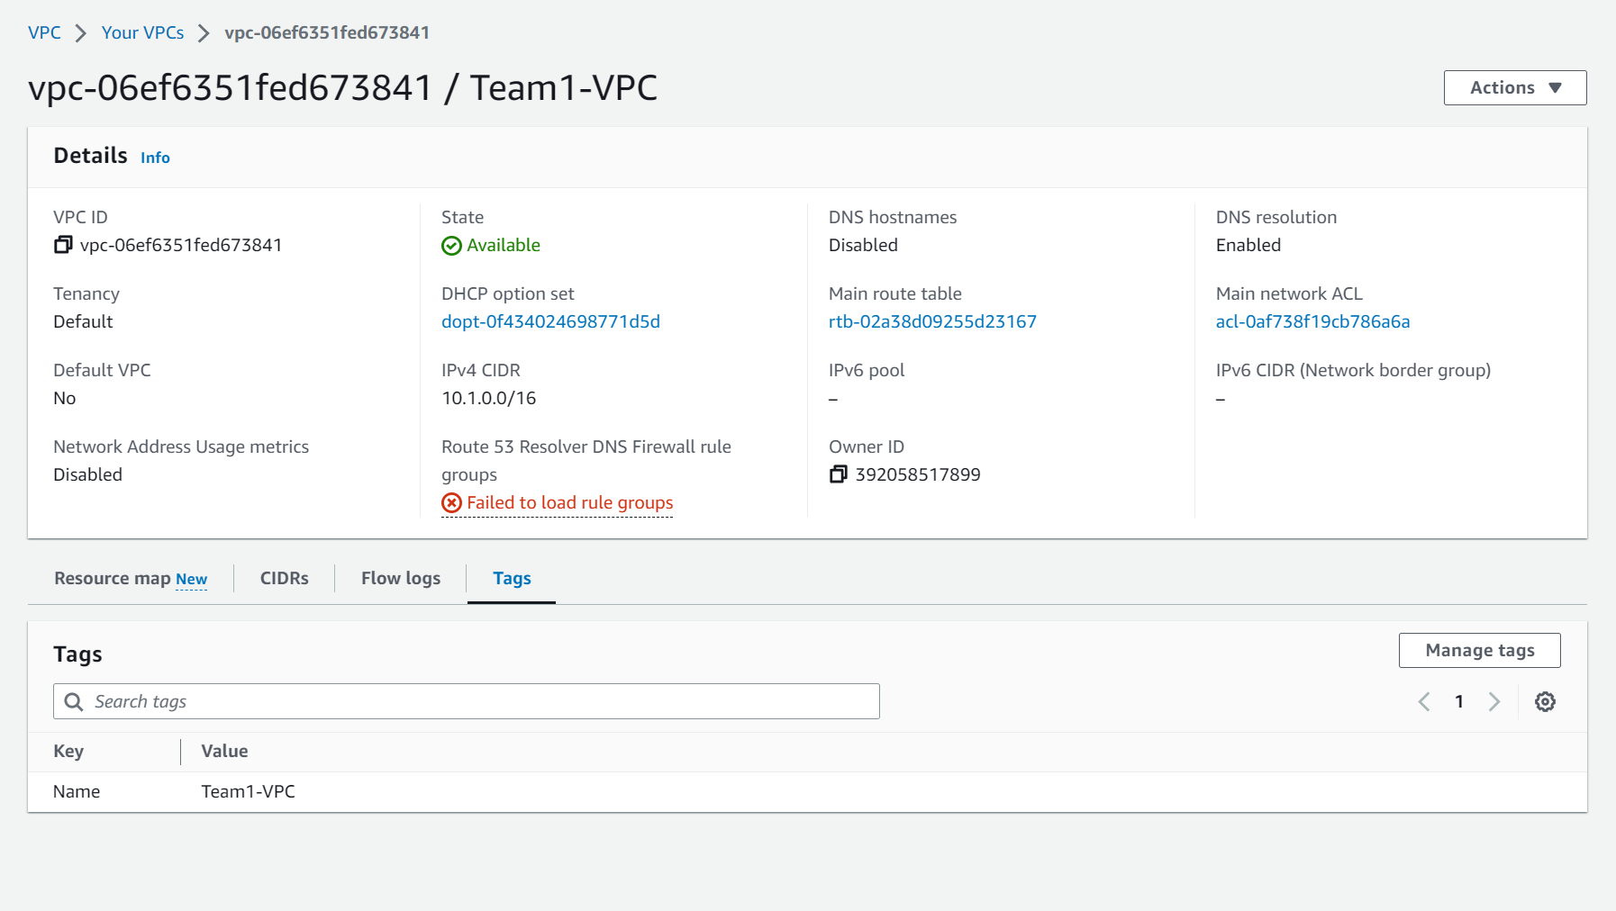

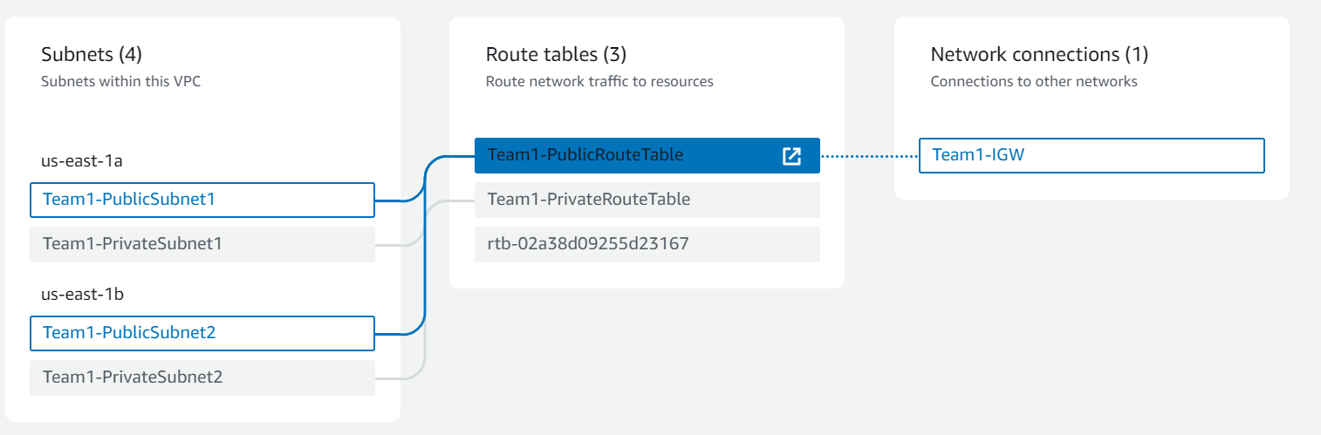

The Public Route Table is linked to the Public Subnets which is connected to an Internet Gateway, enabling traffic from the Internet to access the VPC and vice-versa.

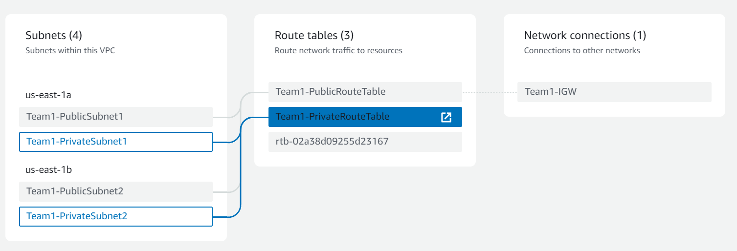

The Private Route Table is linked to the Private Subnets within the VPC and does not accept any traffic from the Internet.

# Subnets

All the subnets have been configured under the VPC we created (VPC – Team1). Subnets provide a layer of security for the web servers as access to the subnet is restricted. Additionally, the CIDR Address we have configured follows format 10.1.0.0 and among the usable private CIDR addresses we have decided on the following to streamline the addresses.

10.1.0.0/24 – Public Subnet 1

10.1.1.0/24 – Public Subnet 2

10.1.2.0/24 - Private Subnet 1

10.1.3.0/24 - Private Subnet 2

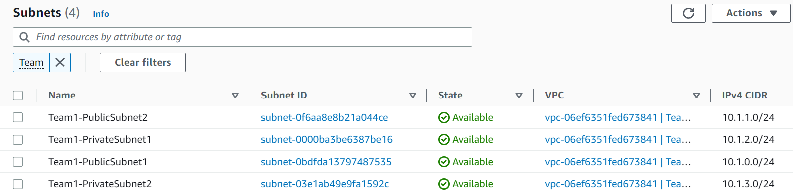

# Internet Gateway

The internet gateway is attached to the VPC, establishing a connection for traffic from the Internet to access the Public Subnet and vice-versa.  
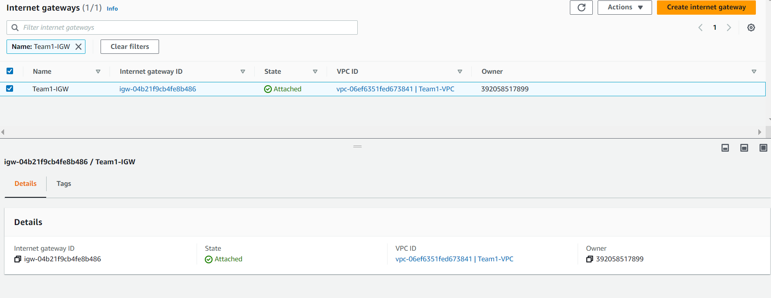

## Public Subnets

Public subnets have access to the Internet as a route (0.0.0.0/0) has been configured in the Public Route table connected to the public subnets, allowing traffic to and from the Internet through the Internet Gateway connection.

PublicSubnet1

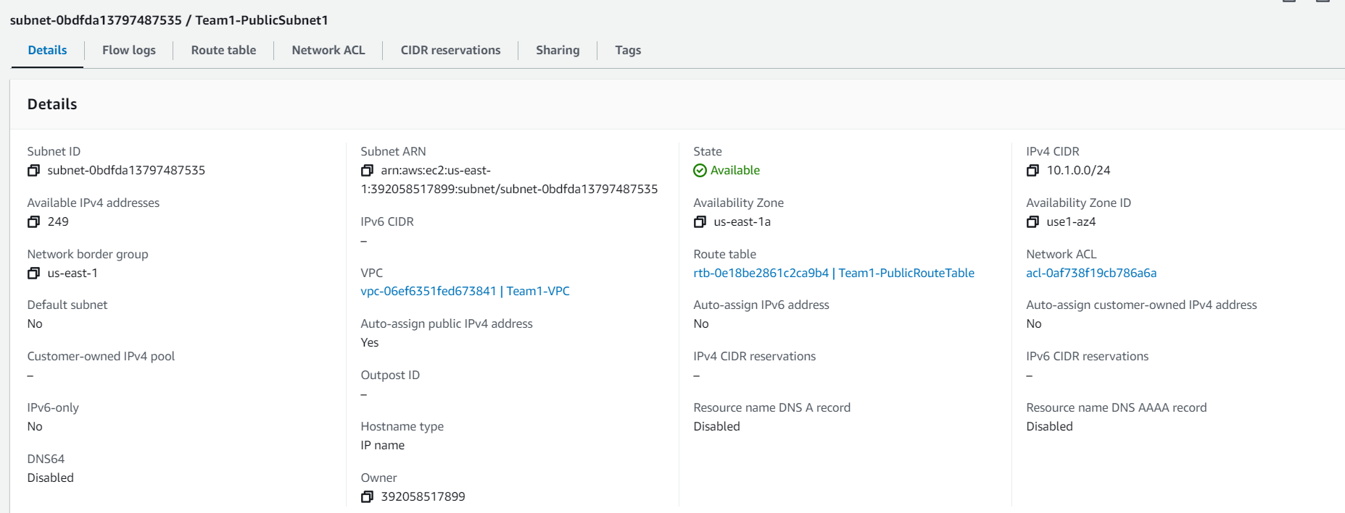 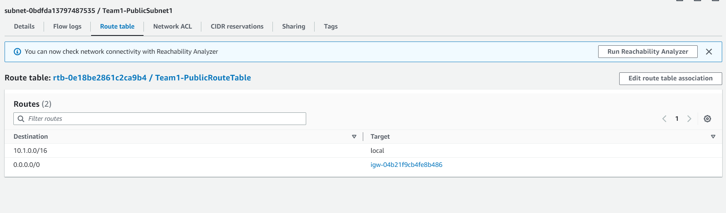

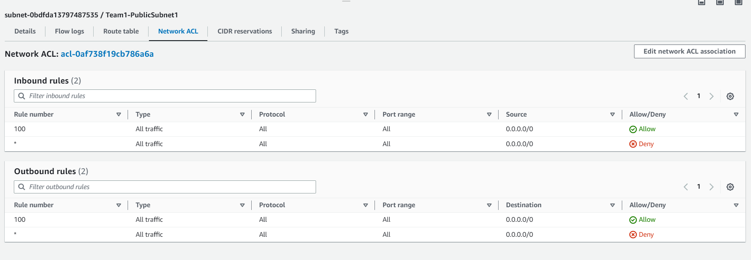

Public Subnet2

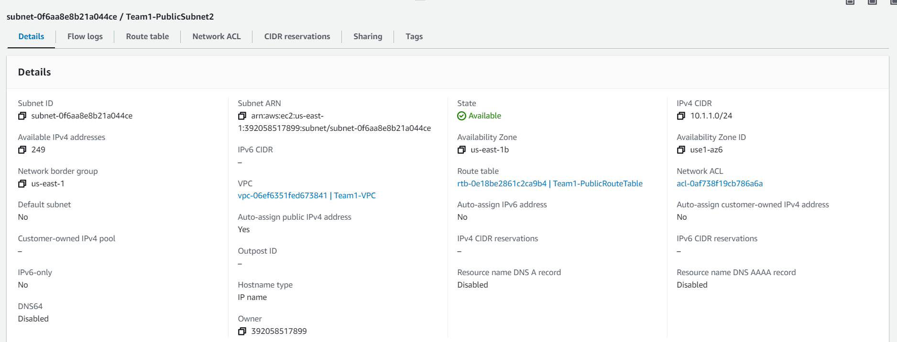

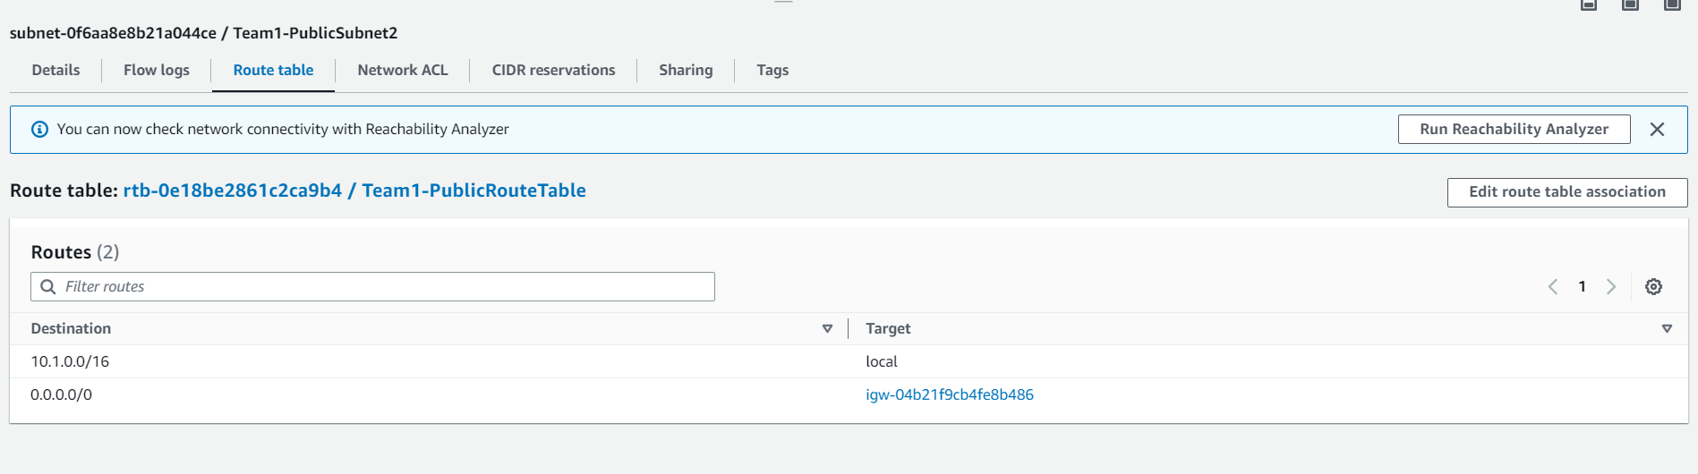

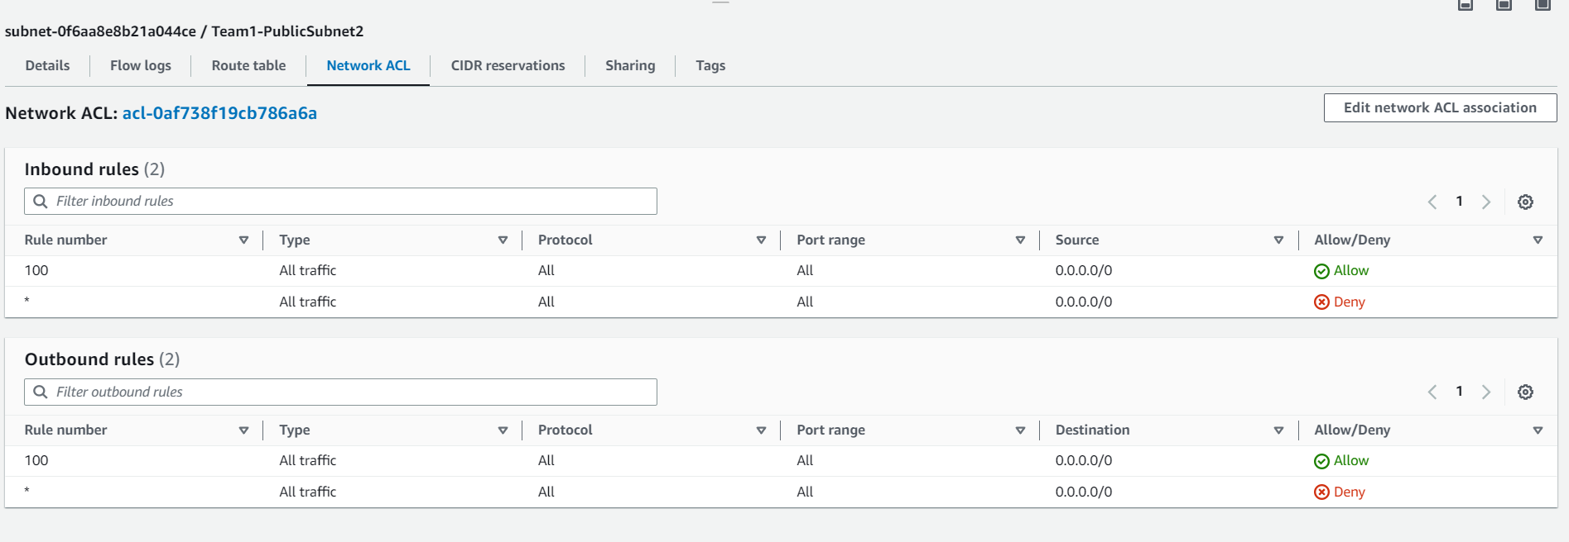

## Private Subnets

PrivateSubnet1

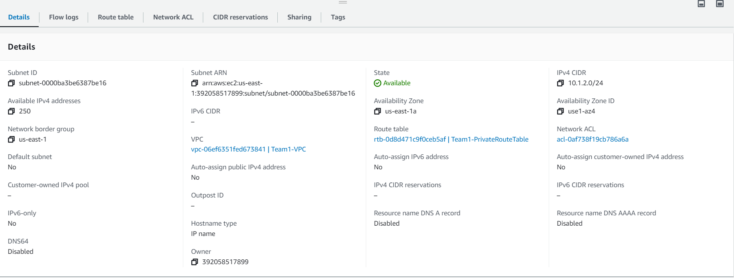

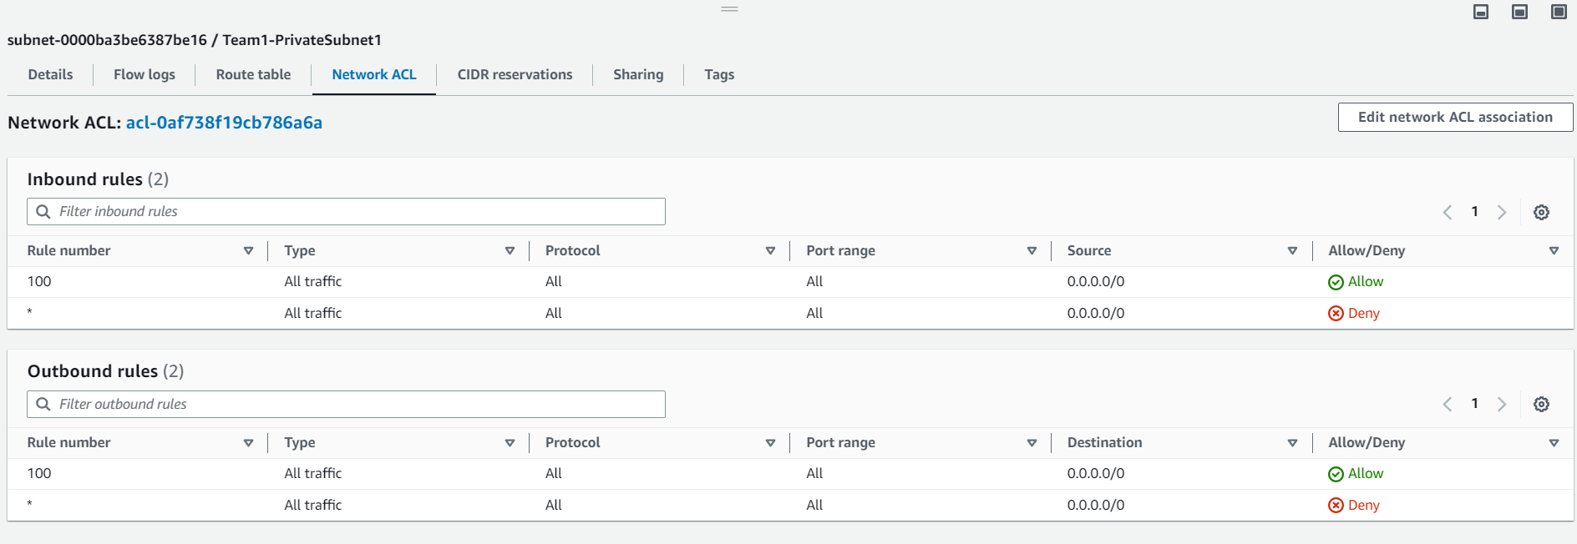

Private Subnet2

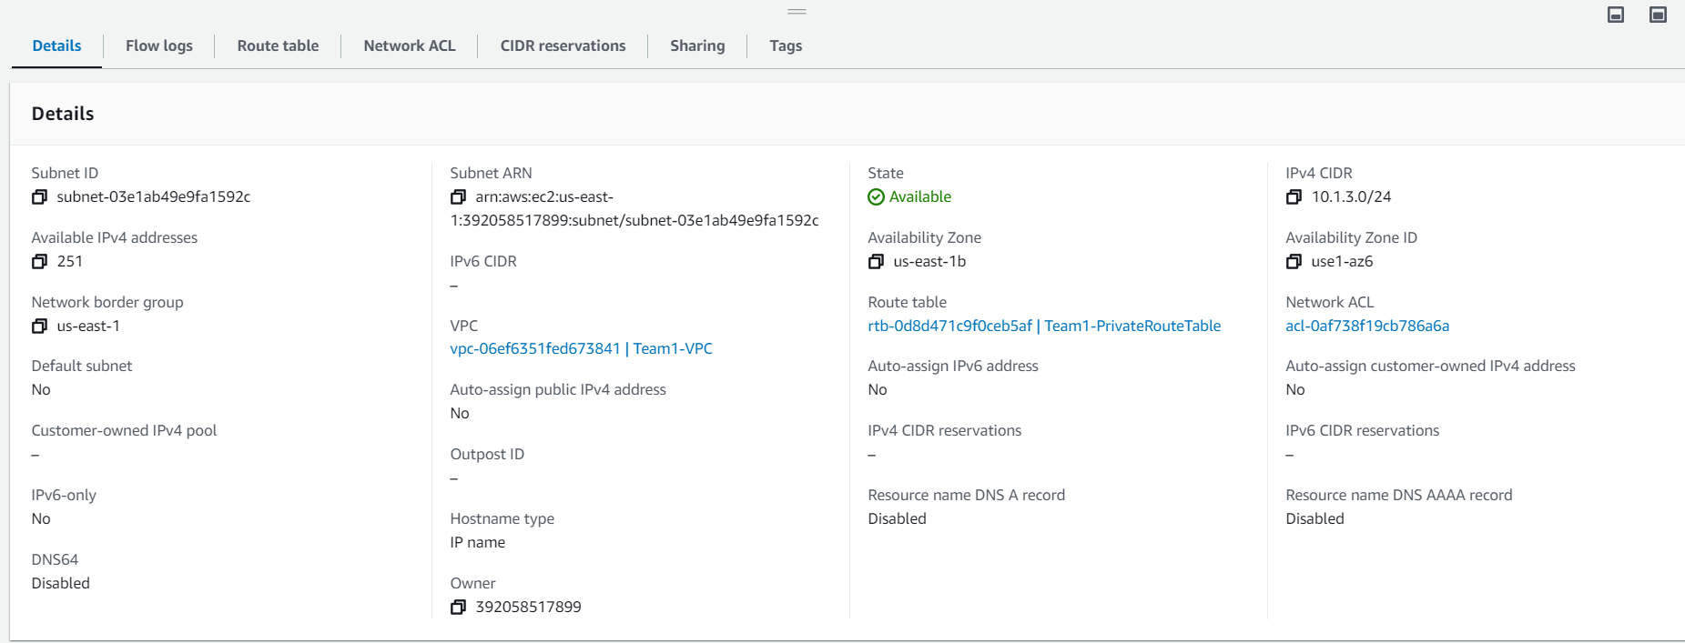

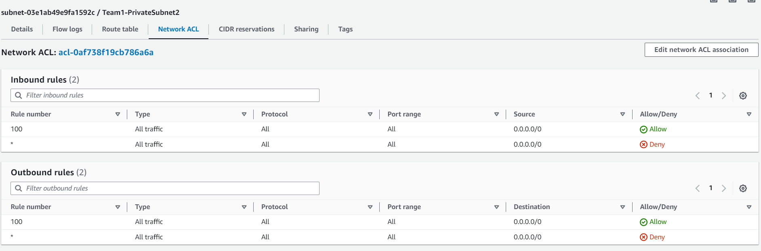

# Availability Zones

At normal capacity, there are 2 web servers (Web Server 1 and Web Server 2) in 2 different availability zones respectively and they are stored under the same virtual private cloud (VPC).

Because the instances are in 2 different availability zones (us-east-1a and us-east-1b), the servers will be resilient to natural disasters. If one of the servers are affected by natural disasters, the other availability zone will still be able to function.

# EC2

Configurations of EC2 Instances:

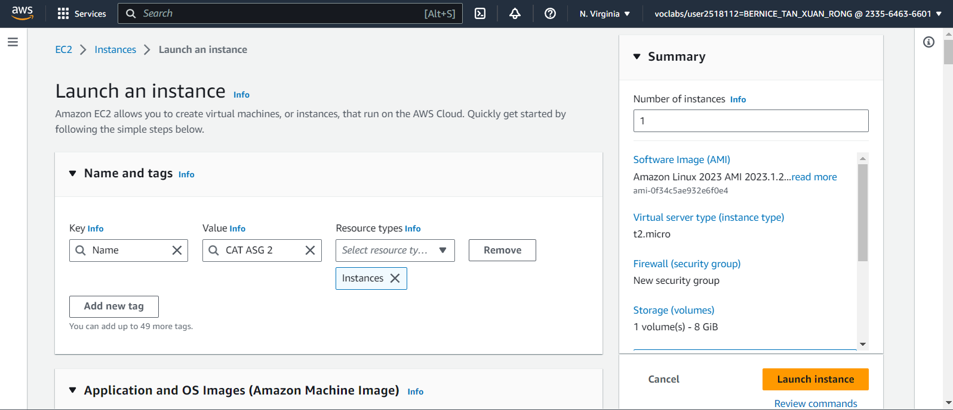

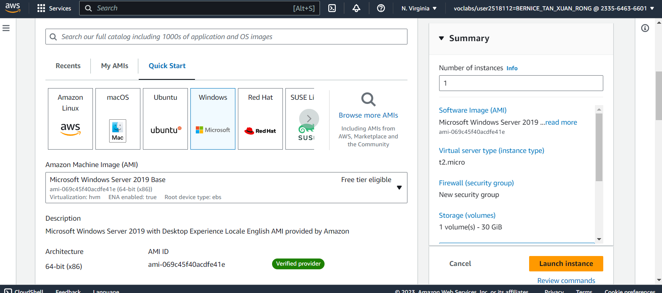

For the OS, we decided to choose Microsoft Windows Server 2019 as it supports hosting Windows .Net Core web application. Costs can also be optimised with the free tier.

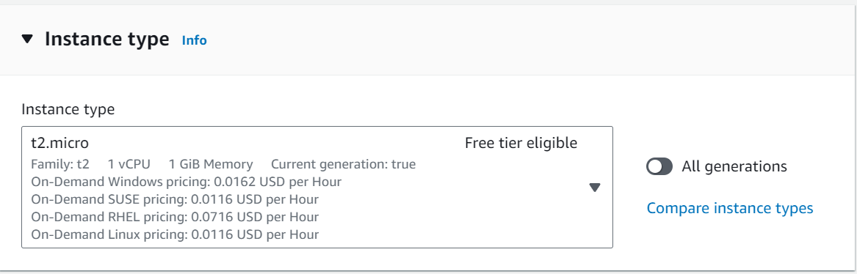

To continue optimising costs, we have decided on using t2.micro instance type as it offers a free tier and supports the operations of KVM.

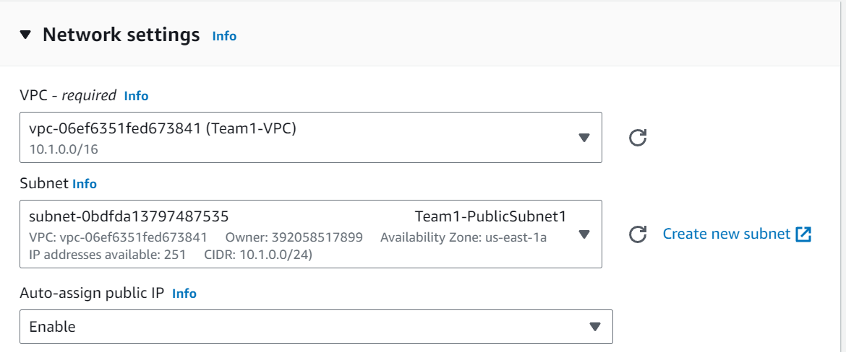

To ensure that the EC2 instances can be accessed in KVM’s private cloud, we selected the VPC created from before. We are also using the Public Subnet for access to the Internet.

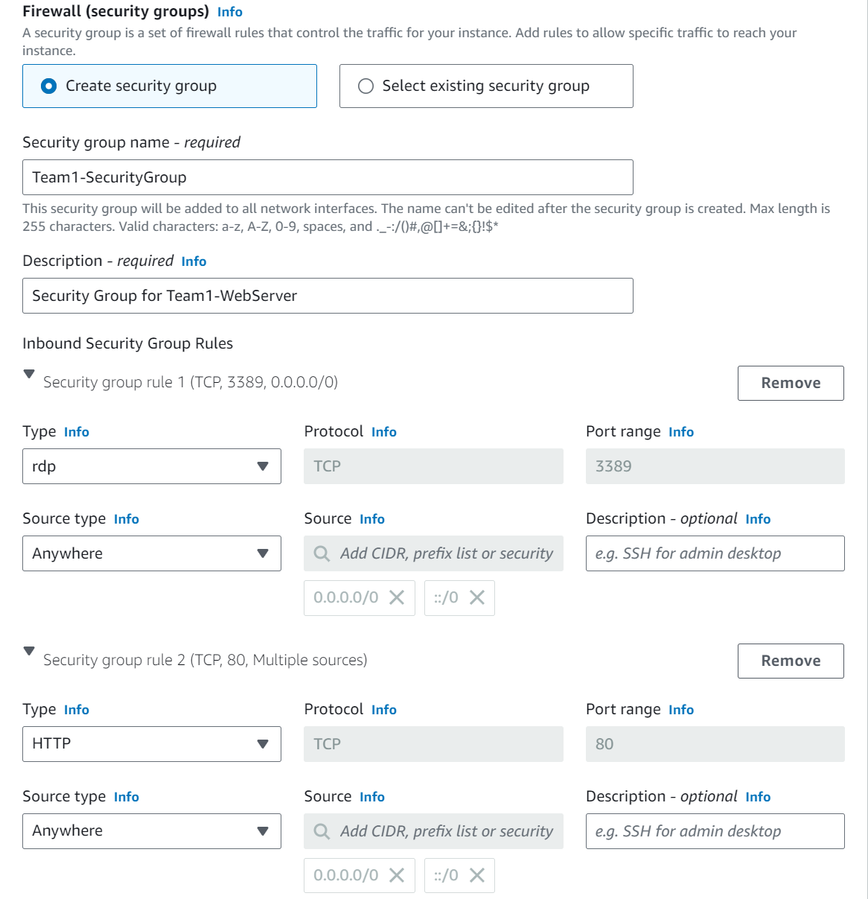

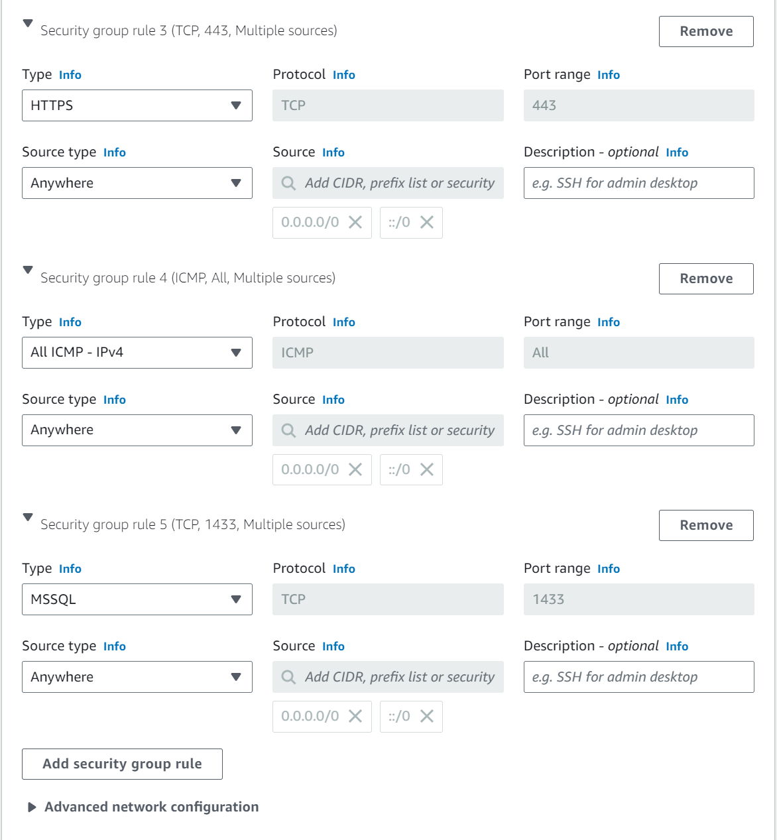

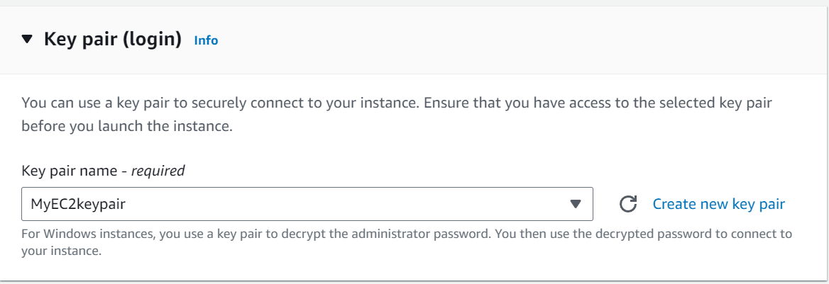

The security group allows only certain traffic into the Web Servers such as HTTP, HTTPS, All ICMP-IPv4, MSSQL, rdp and ssh. This ensures security for the web servers as only specified traffic in the security groups have access.

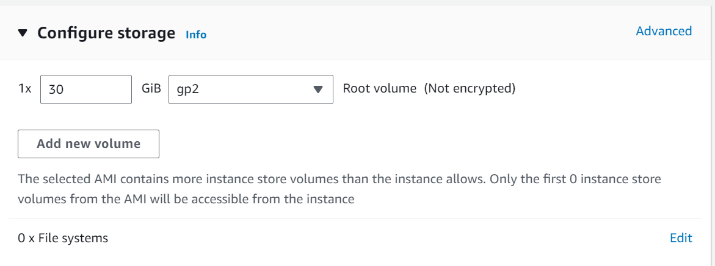

**Windows Password**

We have also set up the remote connection from the EC2 instances to the SQL server so that the web application can be launched and receive requests from the RDS.

Using the key pair that we generated, we are able to decrypt the private key to obtain the Windows password for the remote desktop connection.

Username: Administrator

Password: Zur49(4F(pLv&o2mqZZ$4w2m*G$PbMyn

# Relational Database Service (RDS)

To manage the relational database for web application, we have implemented RDS. RDS is a managed service by Amazon and helps with database management tasks, allowing KVM to focus on more crucial tasks such as application development. Because of this, Operational Excellence and Performance Efficiency is achieved.

RDS Configurations:

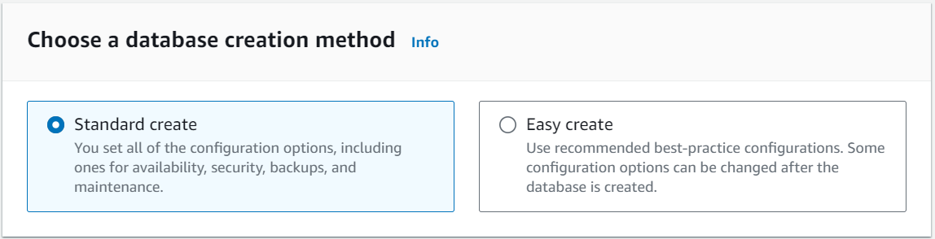

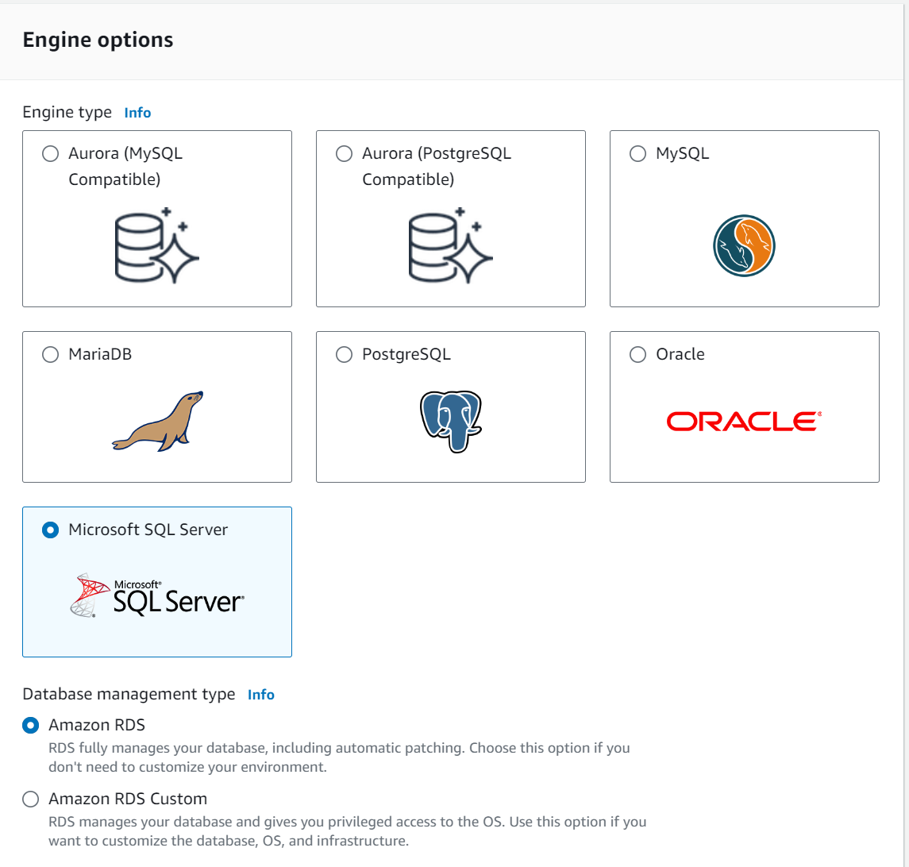

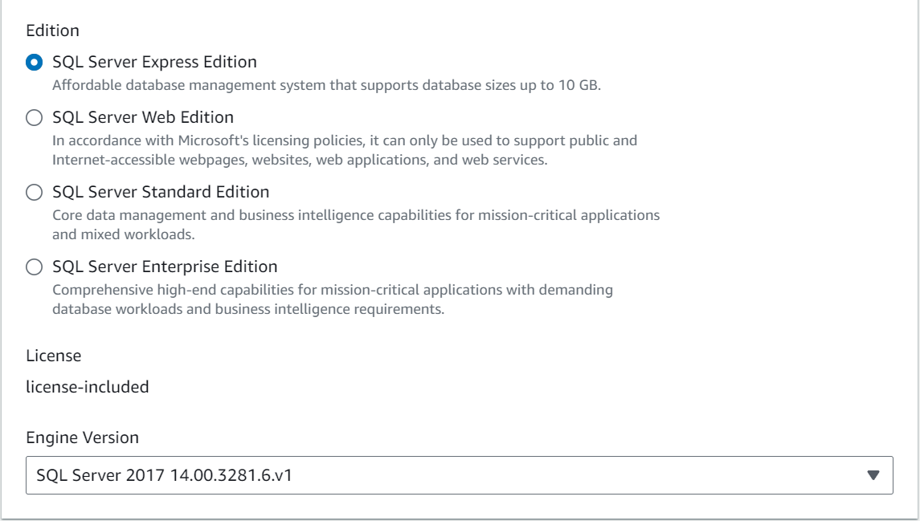  
We have chosen the standard create option to have more control over the RDS configurations and used Microsoft SQL Server as the web application requires SQL server compatibility.

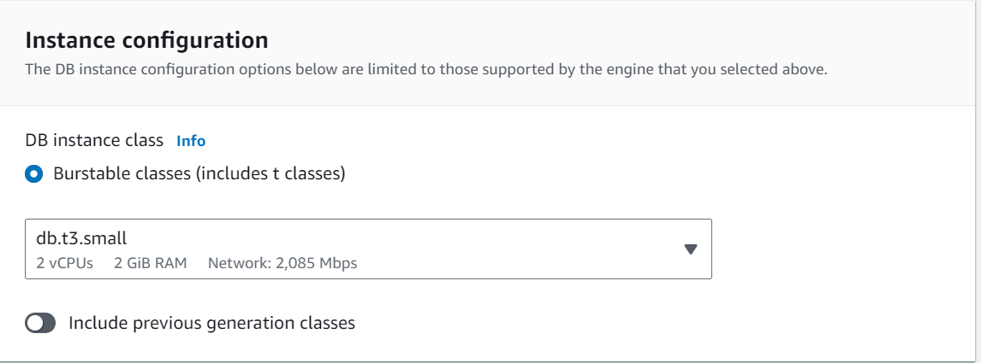

To balance cost and performance, we selected the db.t3.small instance class, suited to support KVM’s web application.

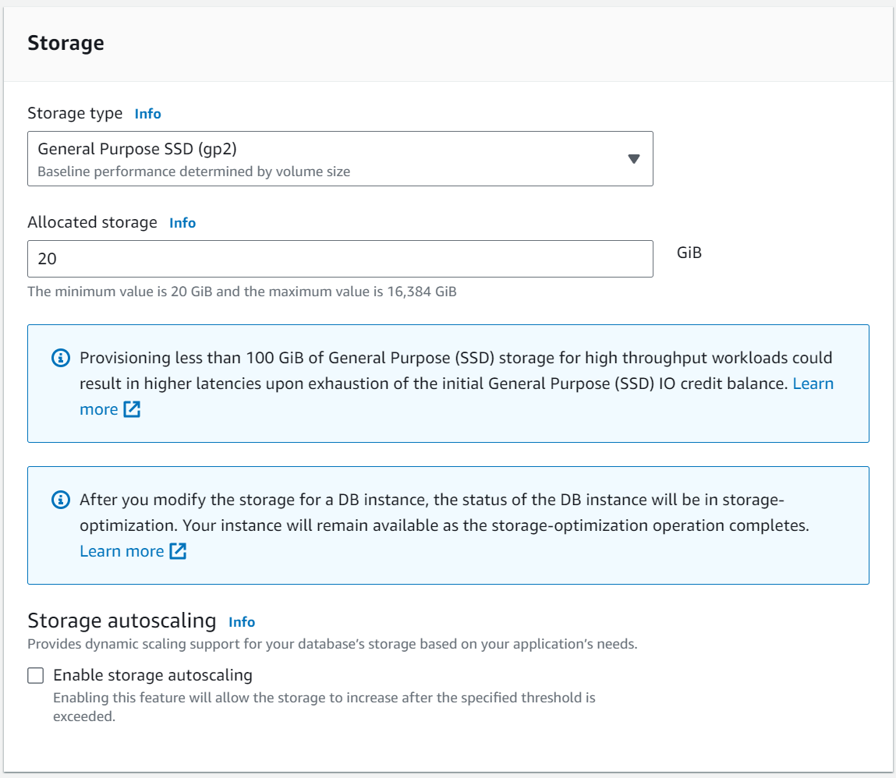

The General Purpose SSD was also selected based on KVM’s requirements and we chose the minimum allocated storage value, 20 , which can support the application but also reduce costs. Additionally, RDS provides storage optimisation.

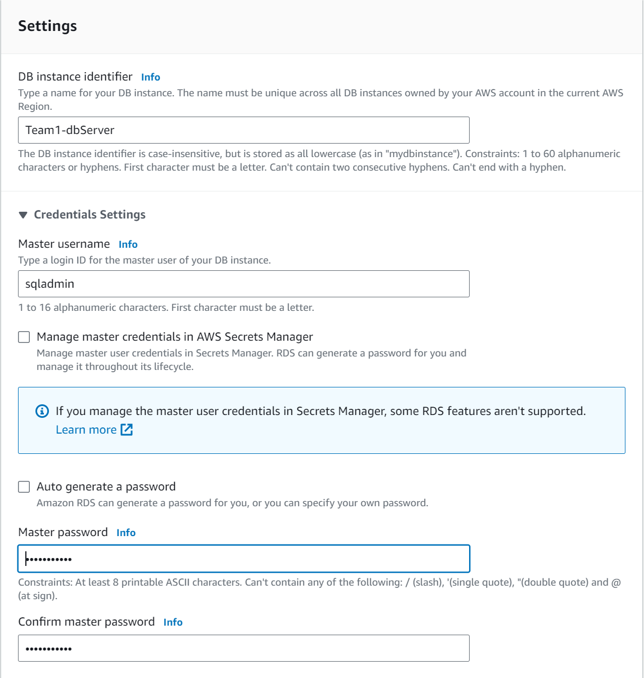

To ensure only authorised users can access the database, we have configured the master username as “sqladmin” and the master password as “Password123”

# Elastic Load Balancing (ELB)

Next, we created a Load Balancer to ease the traffic load on the web servers. The load balancer acts as a single-entry point and forwards traffic to healthy web servers, consisting of listeners, health checks and network mappings to monitor the traffic in the instances and automatically redistribute the traffic when there is change in demand. This helps to ensure the smooth operation of applications and supports the Operational Excellence pillar of the well architected framework.

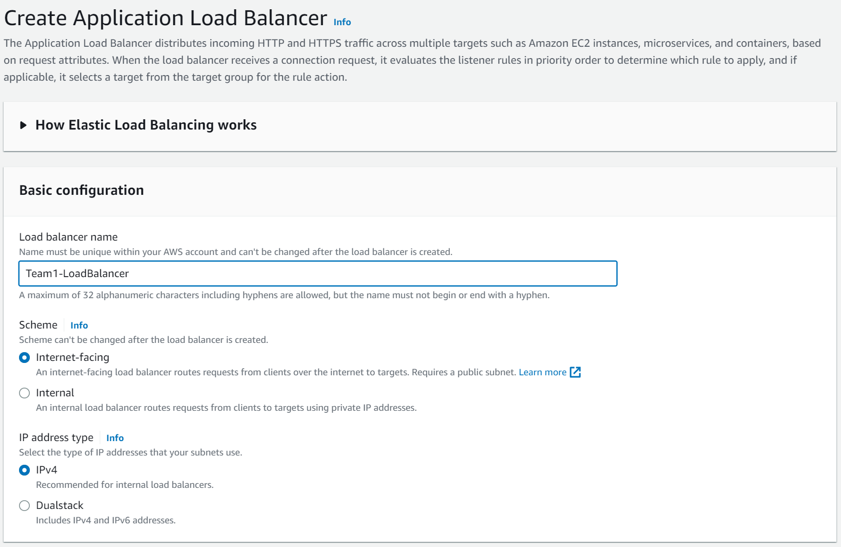

Since KVM requires access to the Internet, we had to use the Internet-facing scheme to allow the ELB to route traffic from the Internet to the web servers.

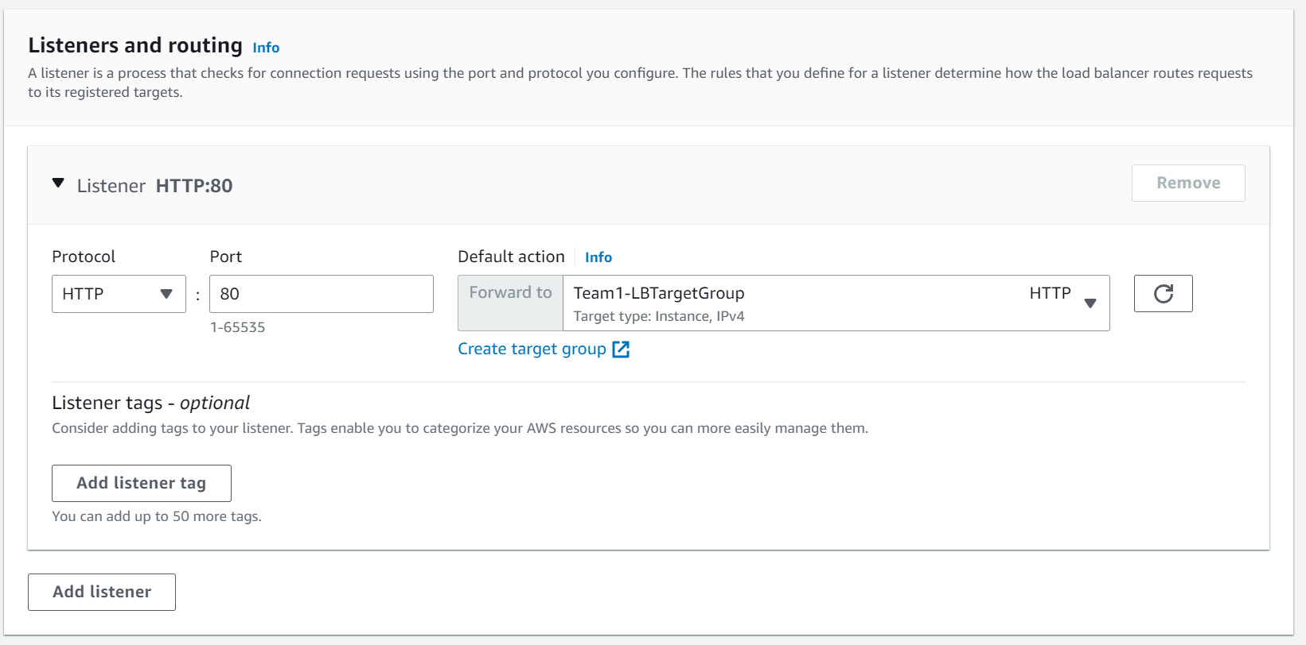 We also configured a listener to monitor and accept HTTP traffic requests, which are forwarded to “Team1-LBSecurityGroup”

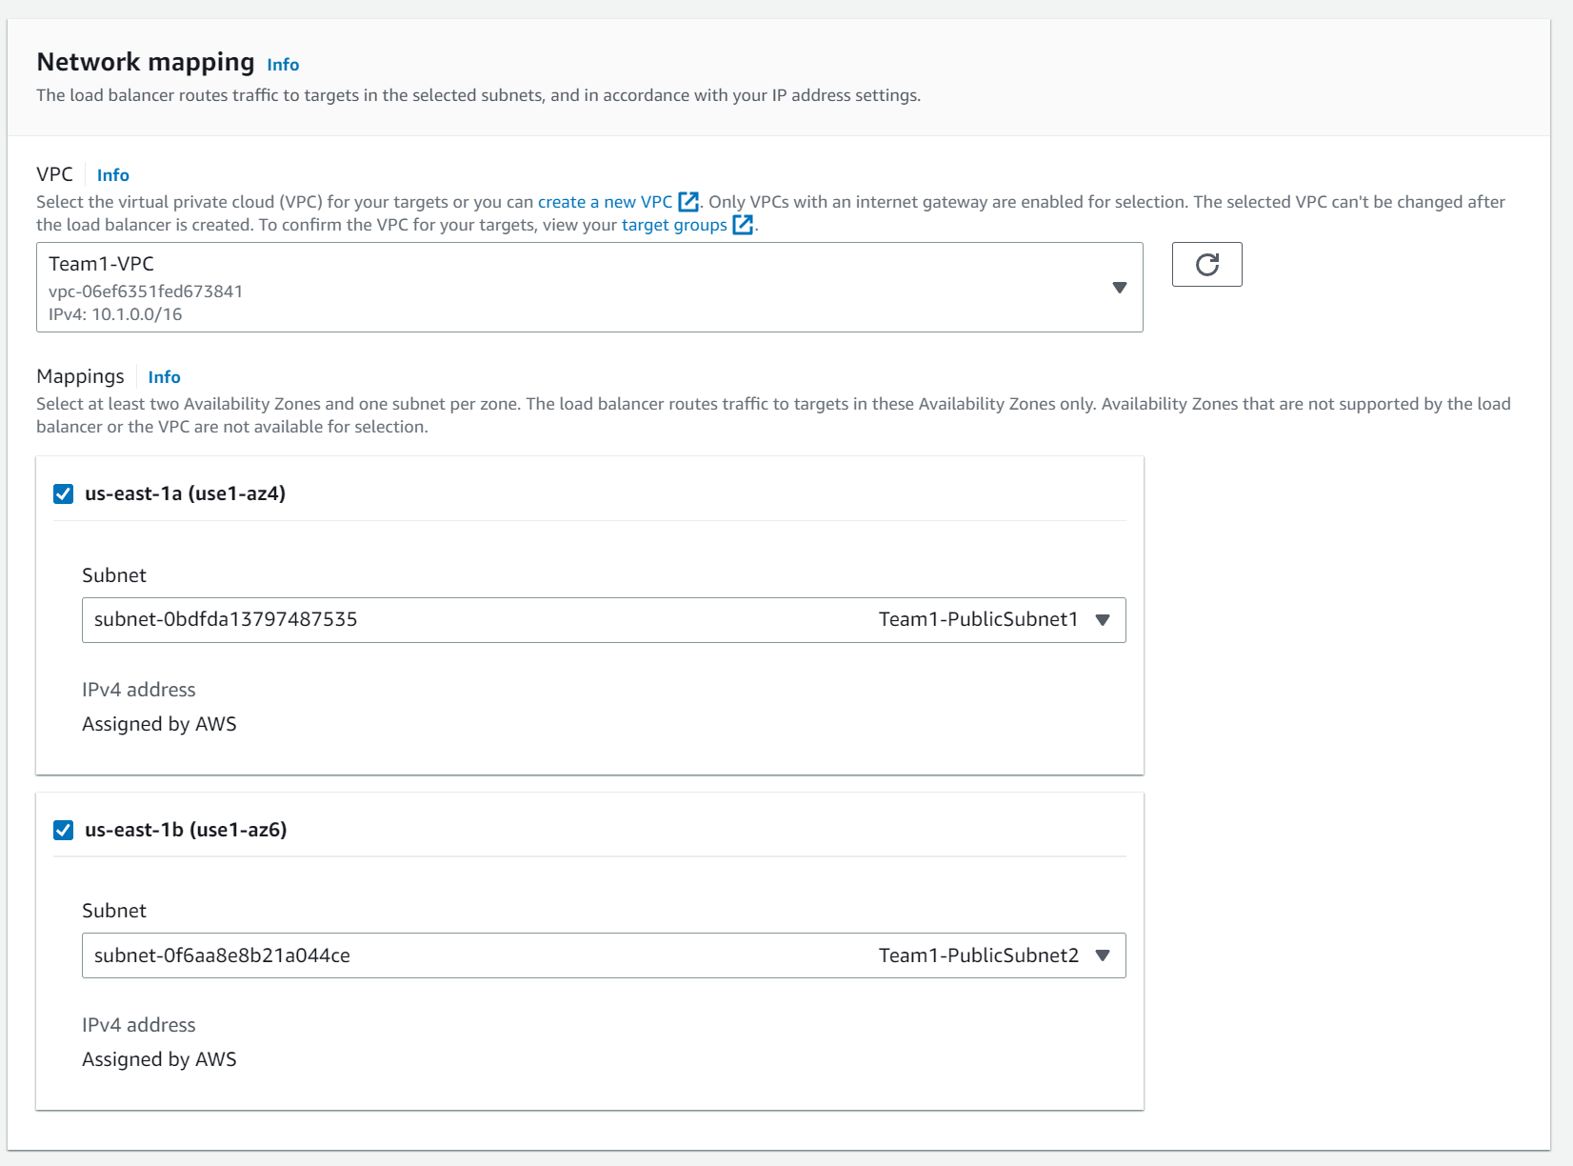

To ensure high availability and fault tolerance, ELB is mapped across the 2 availability zones in the same VPC, connected to the public subnets to allow Internet access.

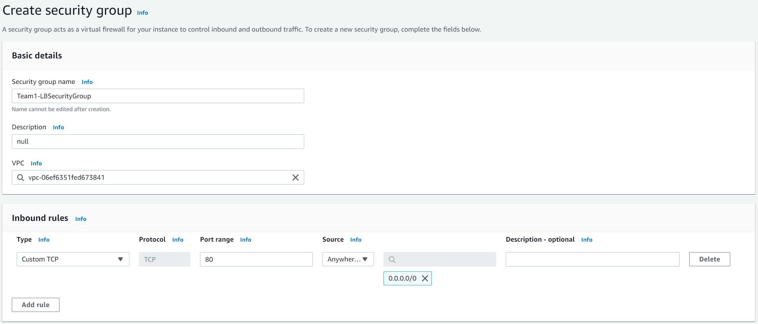

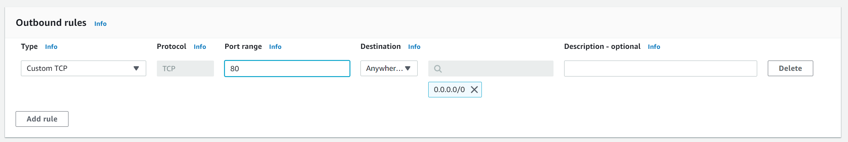

We created the security group “Team1-LBSecurityGroup” allowing inbound and outbound traffic from port 80 form anywhere, enabling communication between the ELB and instances.

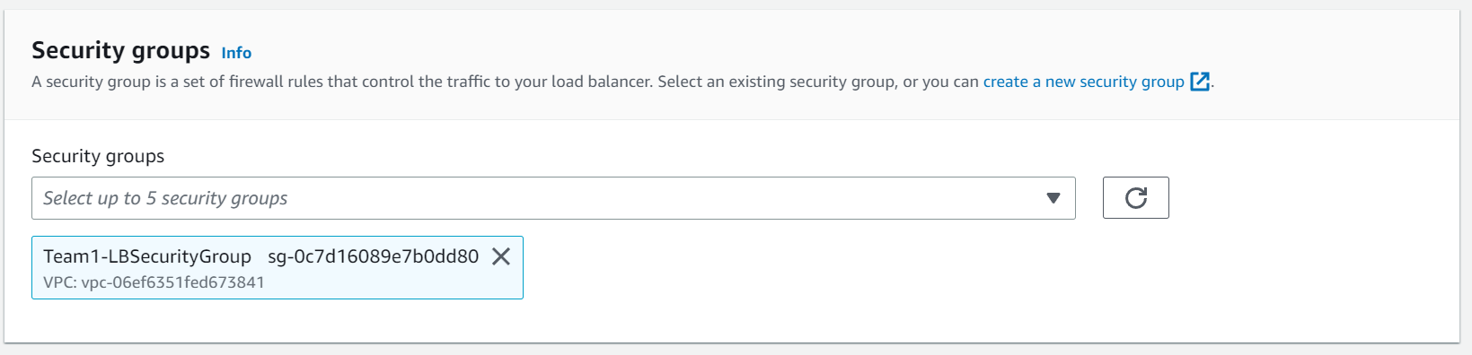

This is the security group previously configured and will be used to control traffic access to the ELB.

#### Target Group

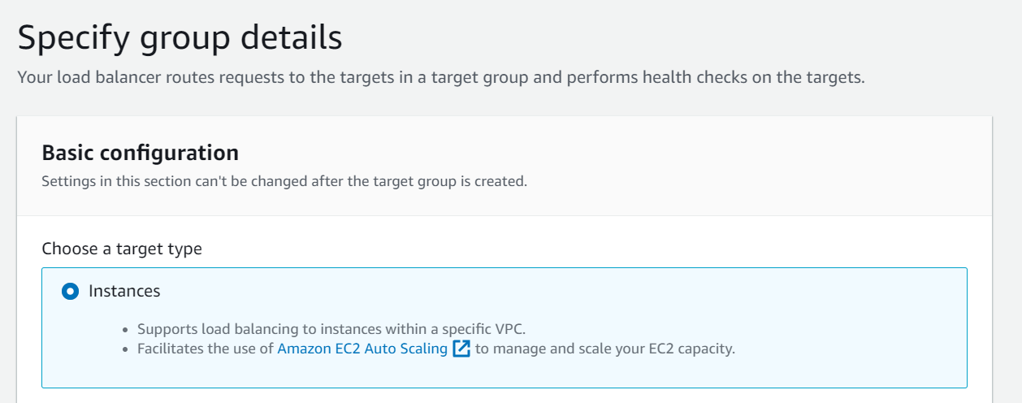

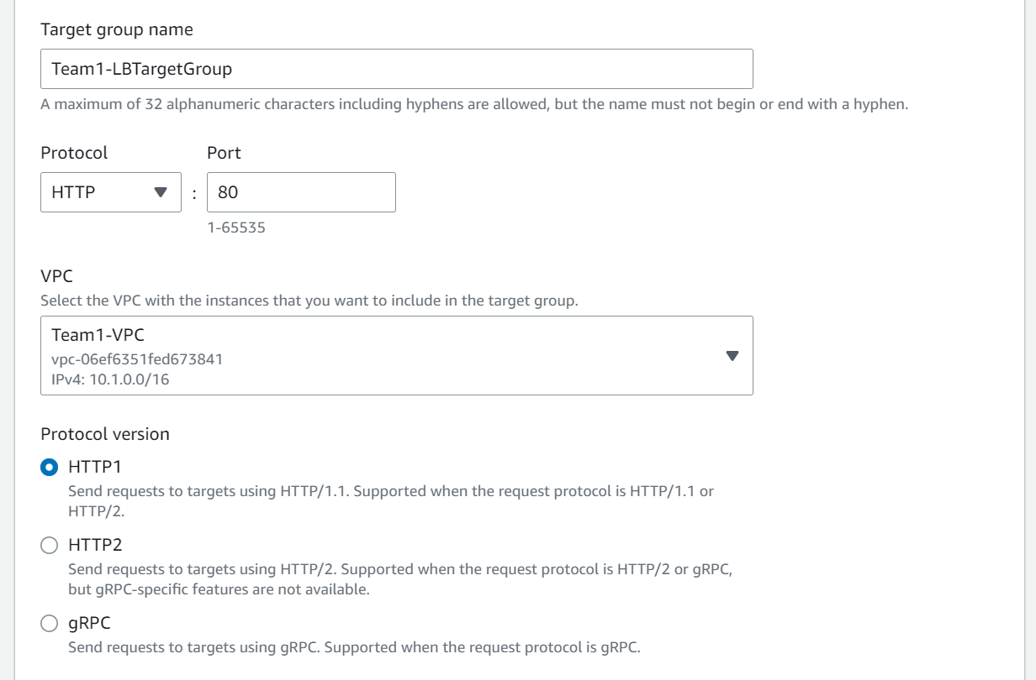

“Team1-LBTargetGroup” is the target group containing the instances where the ELB directs traffic to and is configured to use HTTP protocol for communication.

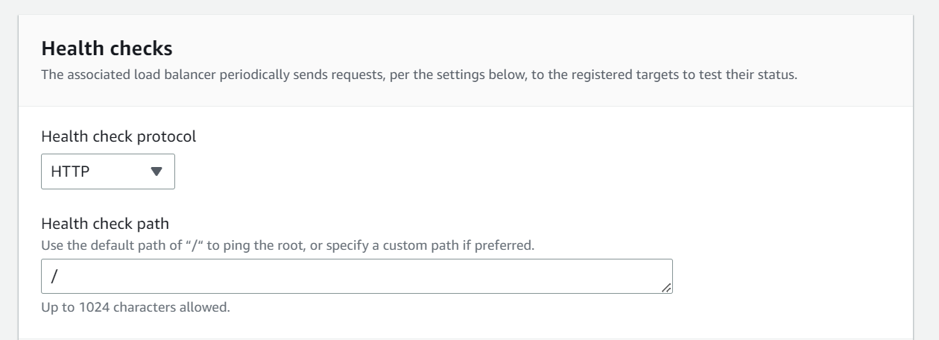

ELB performs health checks using HTTP protocol and removes an instance from the target group if it fails the health check, ensuring that traffic will not be congested.

# Auto Scaling Group

Web servers are configured to meet specific requirements of KVM and scale in and out to meet demands, ensuring the scalability.

## Amazon Machine Image (AMI)

From the instance we launched previously, we created an AMI. The AMI stores a “snapshot” of the instance and will be used in the launch template.

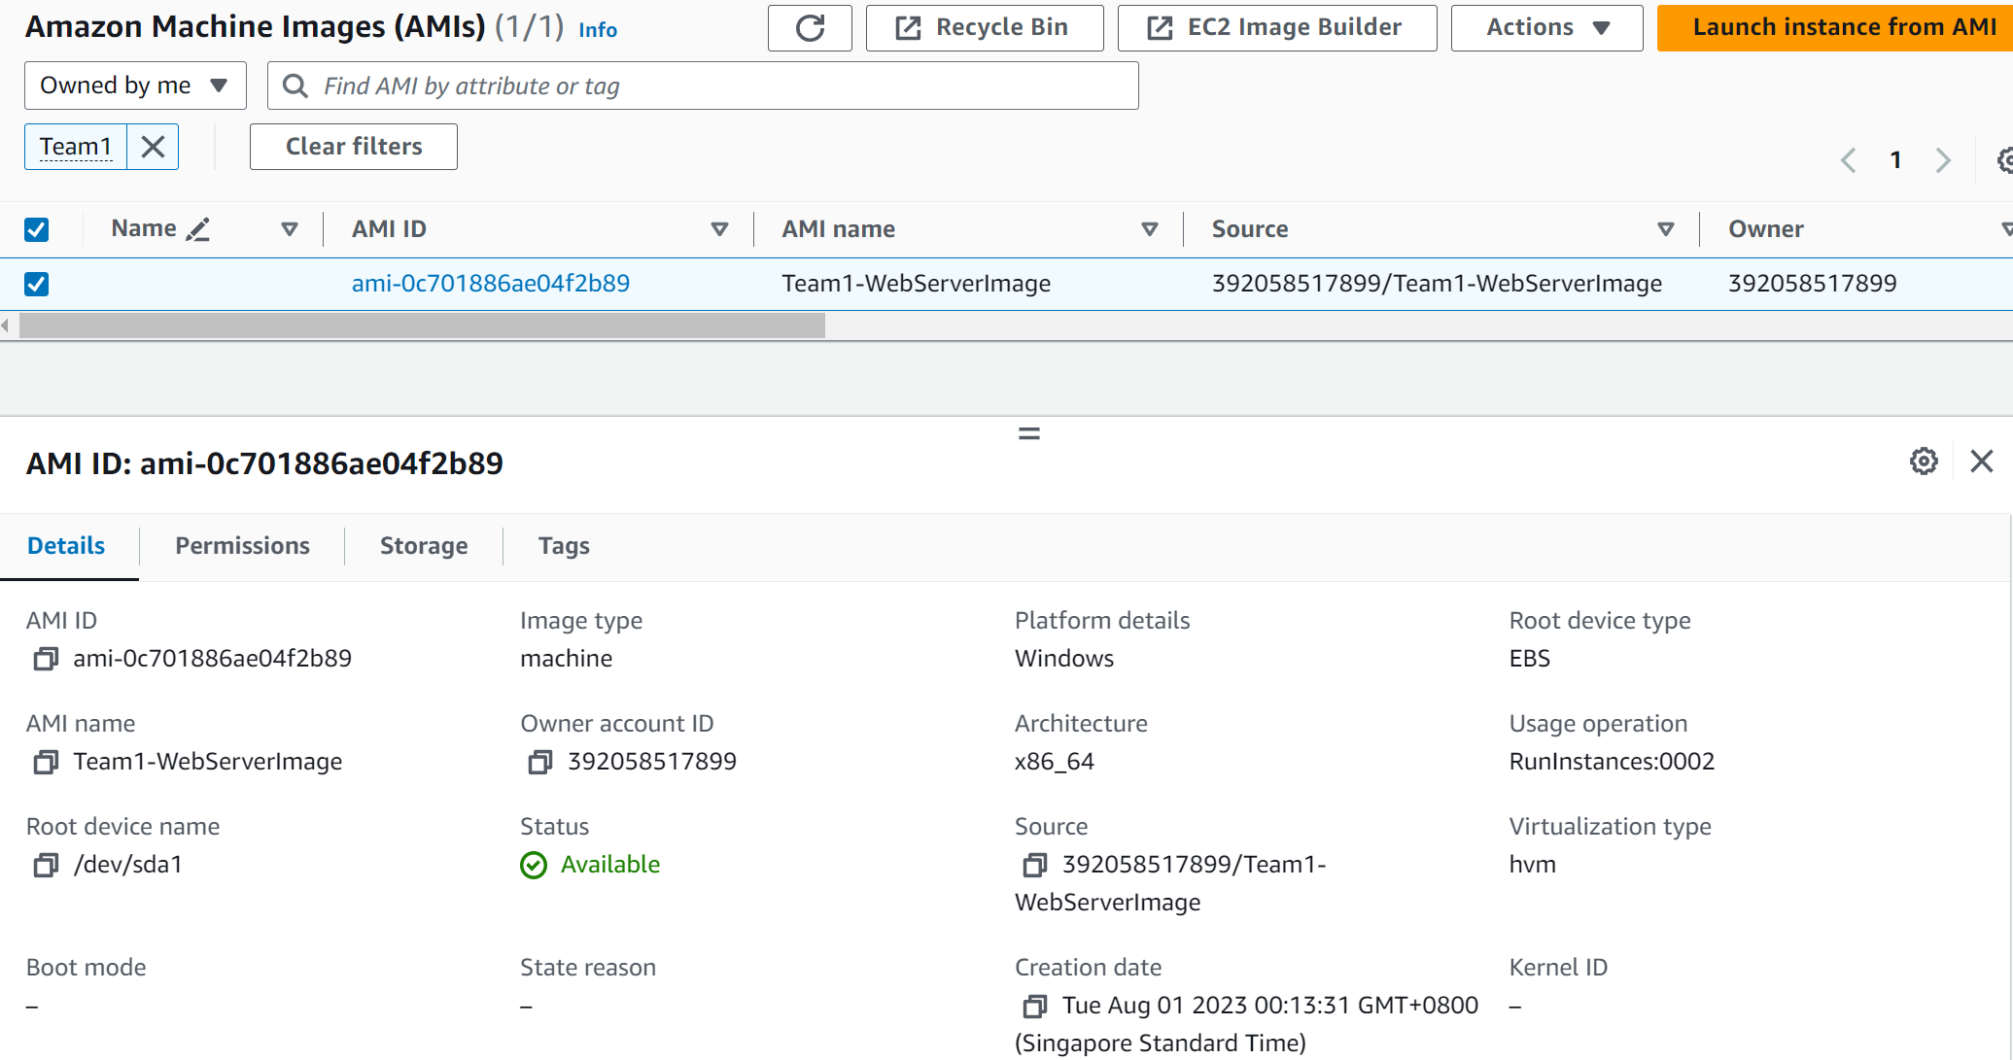

## New Security Group

We also created a new security group for the launch template, RDP, HTTP and HTTPS traffic are allowed in the EC2 instances launched from the launch template.

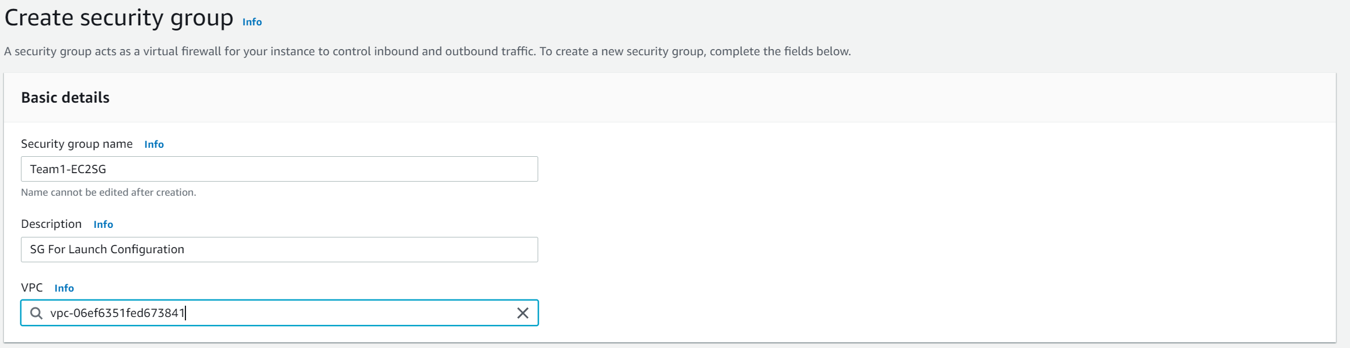

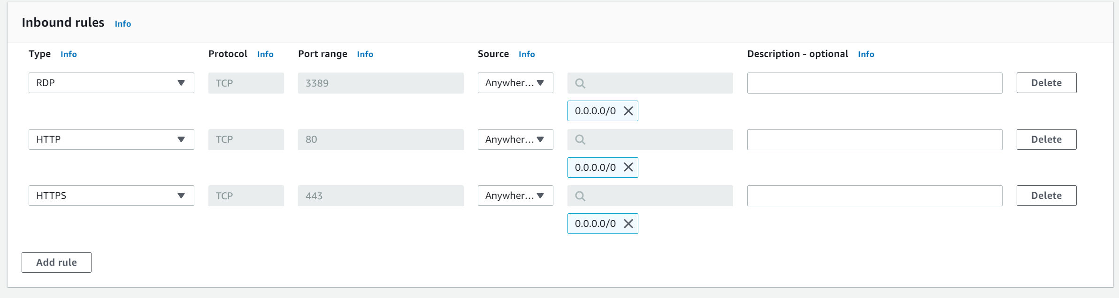

## Launch Template

Before creating an auto scaling group, we had to create a launch template which contains the configurations for launching instances. Having a launch template makes it convenient to instances in an auto scaling group as everything is already configured.

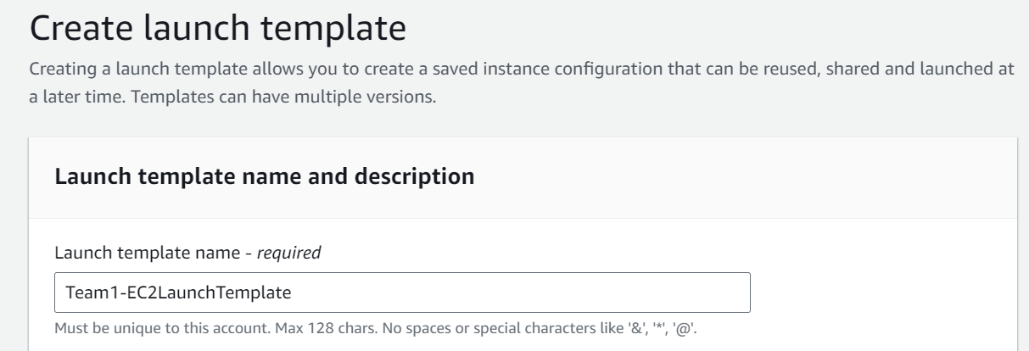

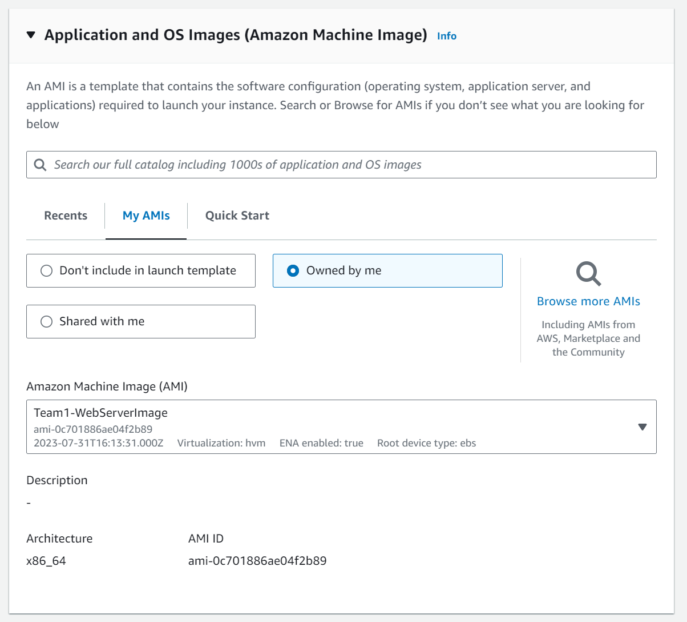

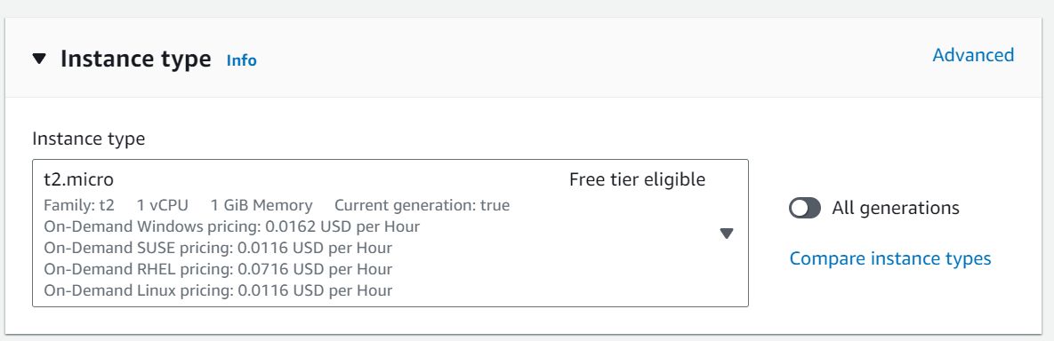

Since t2.micro supports the web application and has a free tier available, we used it to optimise costs.

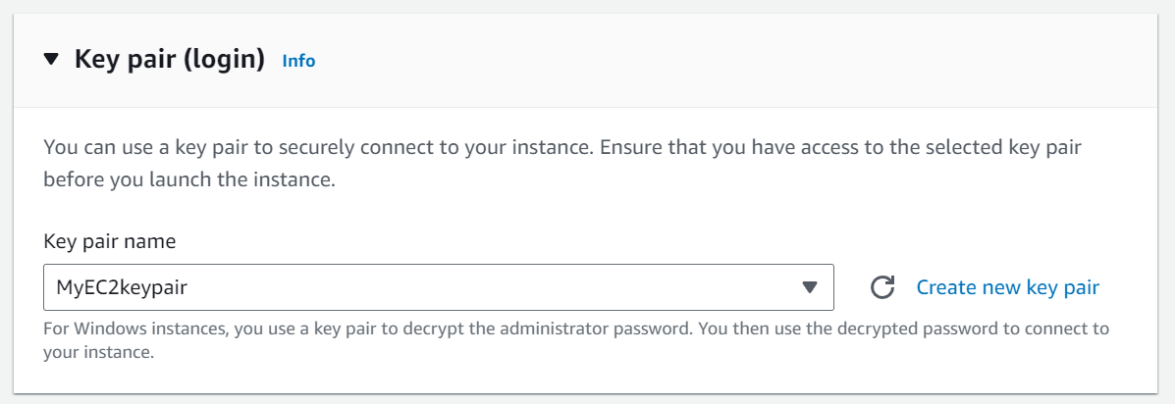

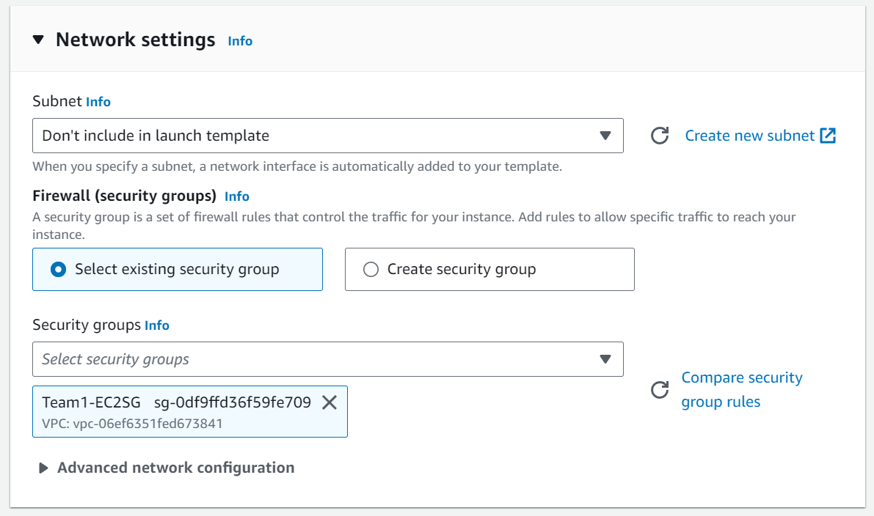

## Auto Scaling Group

To ensure that the web servers are able to handle traffic demands, we have created an auto scaling group to shrink and grow the web servers. This ensures the availability and scalability of the web application. We have also used previously configured components such as the AMI, new security group and launch template to help us easily deploy the auto scaling group.

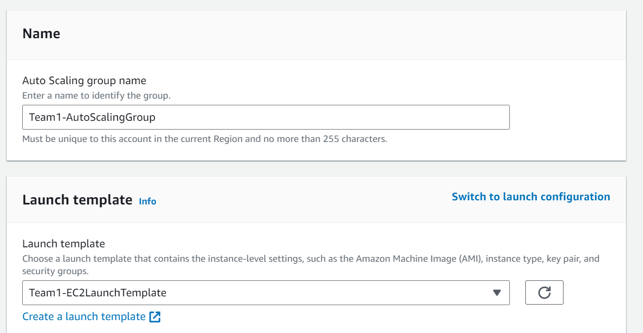

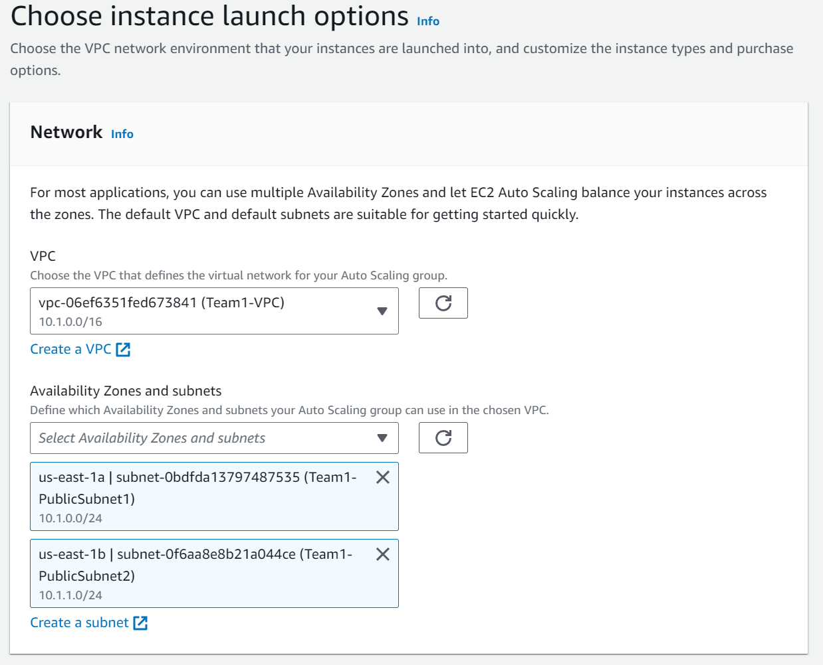

We also made use of the VPC and Availability Zones previously configured to achieve security and reliability.

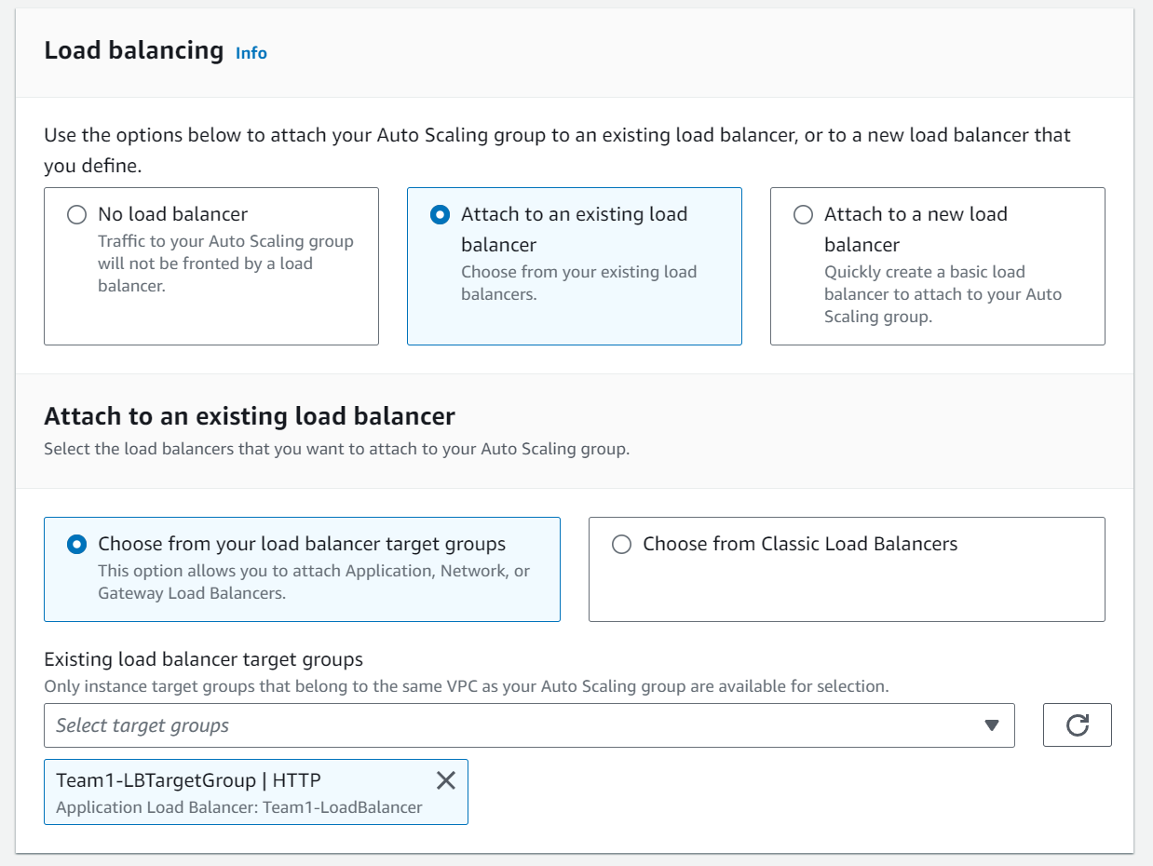

Since we have also configured the load balancer to distribute traffic across the instances, we are also including it by choosing the target group.

## Monitoring

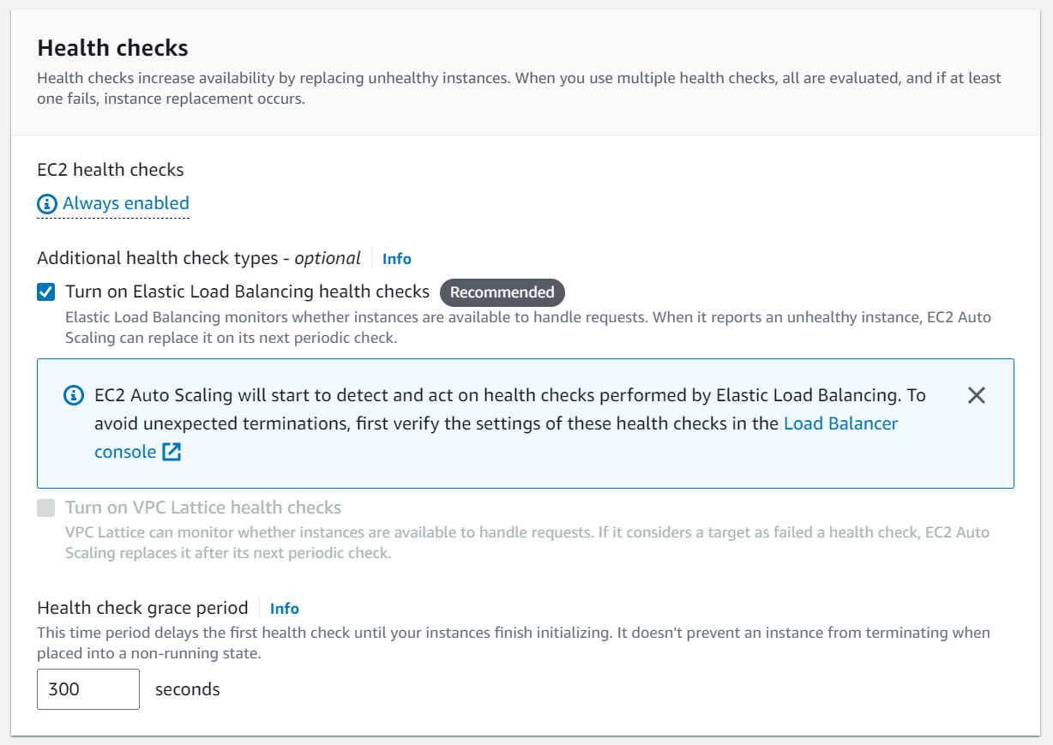

By configuring health checks, we are able to monitor and track if there are unhealthy instances and take action to resolve the issue so that the underlying issues will not hinder KVM’s operations , once again providing Operational Excellence and resiliency.

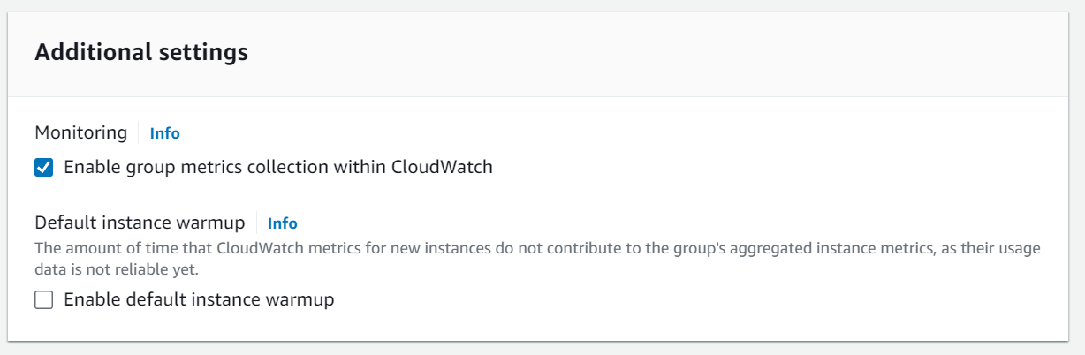

Using CloudWatch group metrics collection, we will be able to view and gain summarised insights from all the instances within the auto scaling group this will enable us to have a better understanding of the overall health and efficiency of the application’s architecture.

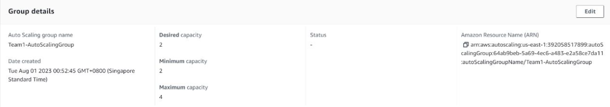

**Supporting Additional Network Load**

* Minimum EC2 web servers: 2
* Maximum EC2 web servers: 4

When the load increases, the servers will auto scale the servers to 4 and each availability zone will be hosting 2 web servers.

**Reduction of Network Load**

When the load on the server decreases, the auto scaling will decrease as 2 instances are not needed anymore.

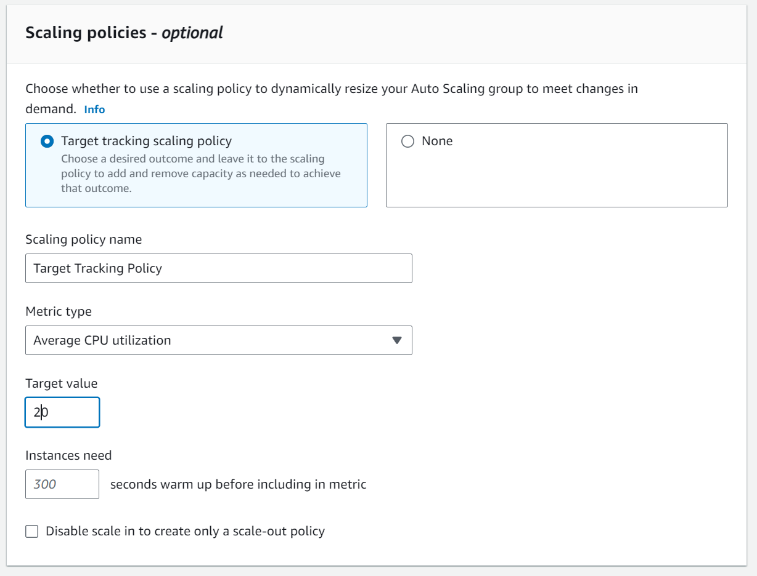

We have also configured the target tracking policy where instances will be removed or added based on the average CPU utilization. Once the CPU utilisation of the application reaches 20%, instances will be added to handle the traffic load and will be removed if it is below 20%.

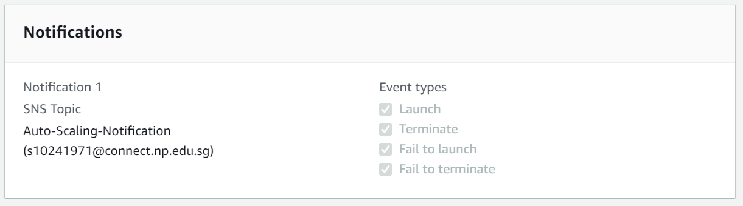

To ensure that KVM admins will be notified through email, we have also configured CloudWatch to send out emails to admins subscribed to the SNS topic when Instances are launched, terminated, fail to launch and fail to terminate.

Business advantages of Auto Scaling:

* Scalability ensures that there the capacity of servers needed is just right to support network load, improving performance efficiency.
* Optimise costs by paying only for the web servers that are running.

# Implementation and AWS Well-Architected Principles

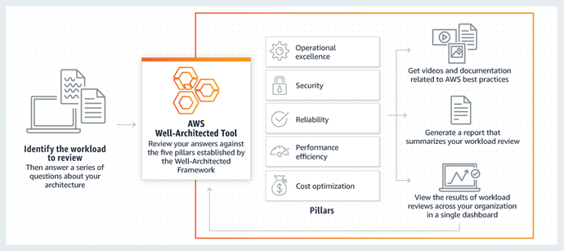

Our cloud solution is meticulously crafted to meet KVM Pte Ltd's requirements. By adopting AWS well-architected principles, we ensure:

Security: Network ACLs, Security Groups, encryption, and regular backups safeguard data and resources.

Reliability: The multi-availability zone setup ensures operational continuity even in the face of disruptions.

Performance Efficiency: Elastic Load Balancing optimizes resource utilization, enhancing application performance.

Cost Optimization: Auto Scaling adjusts server count, minimizing costs during low demand periods.

# Cloud Monitoring Plan and Techniques

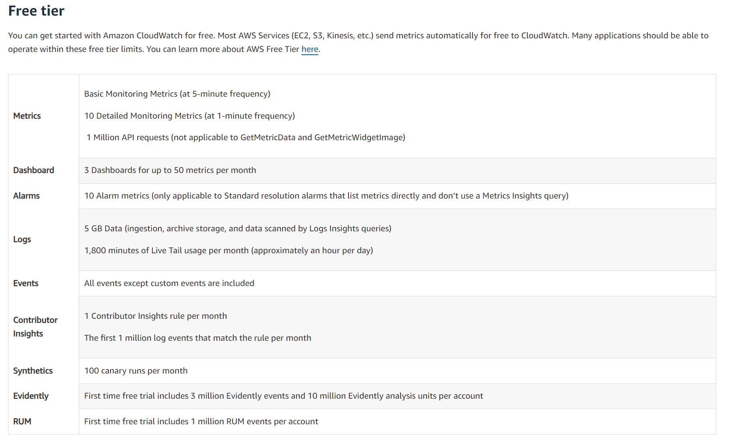

Firstly, there is a free tier section for cloud monitoring(cloud watch) as long as we do not exceed the limit, it will not charge us money, and it is always free without time limit.

Our cloud monitoring plan involves constant tracking of vital metrics through AWS CloudWatch. Techniques employed include:

* Metric Collection: CloudWatch gathers performance data on EC2 instances, RDS databases, and other resources.
* Custom Dashboards: We've designed custom dashboards to visualize essential metrics, allowing quick and informed decisions.

First dashboard is the cost and alarm dashboard.

It shows the estimated cost for each function used in AWS and the alarm that is ok or in alarm state.

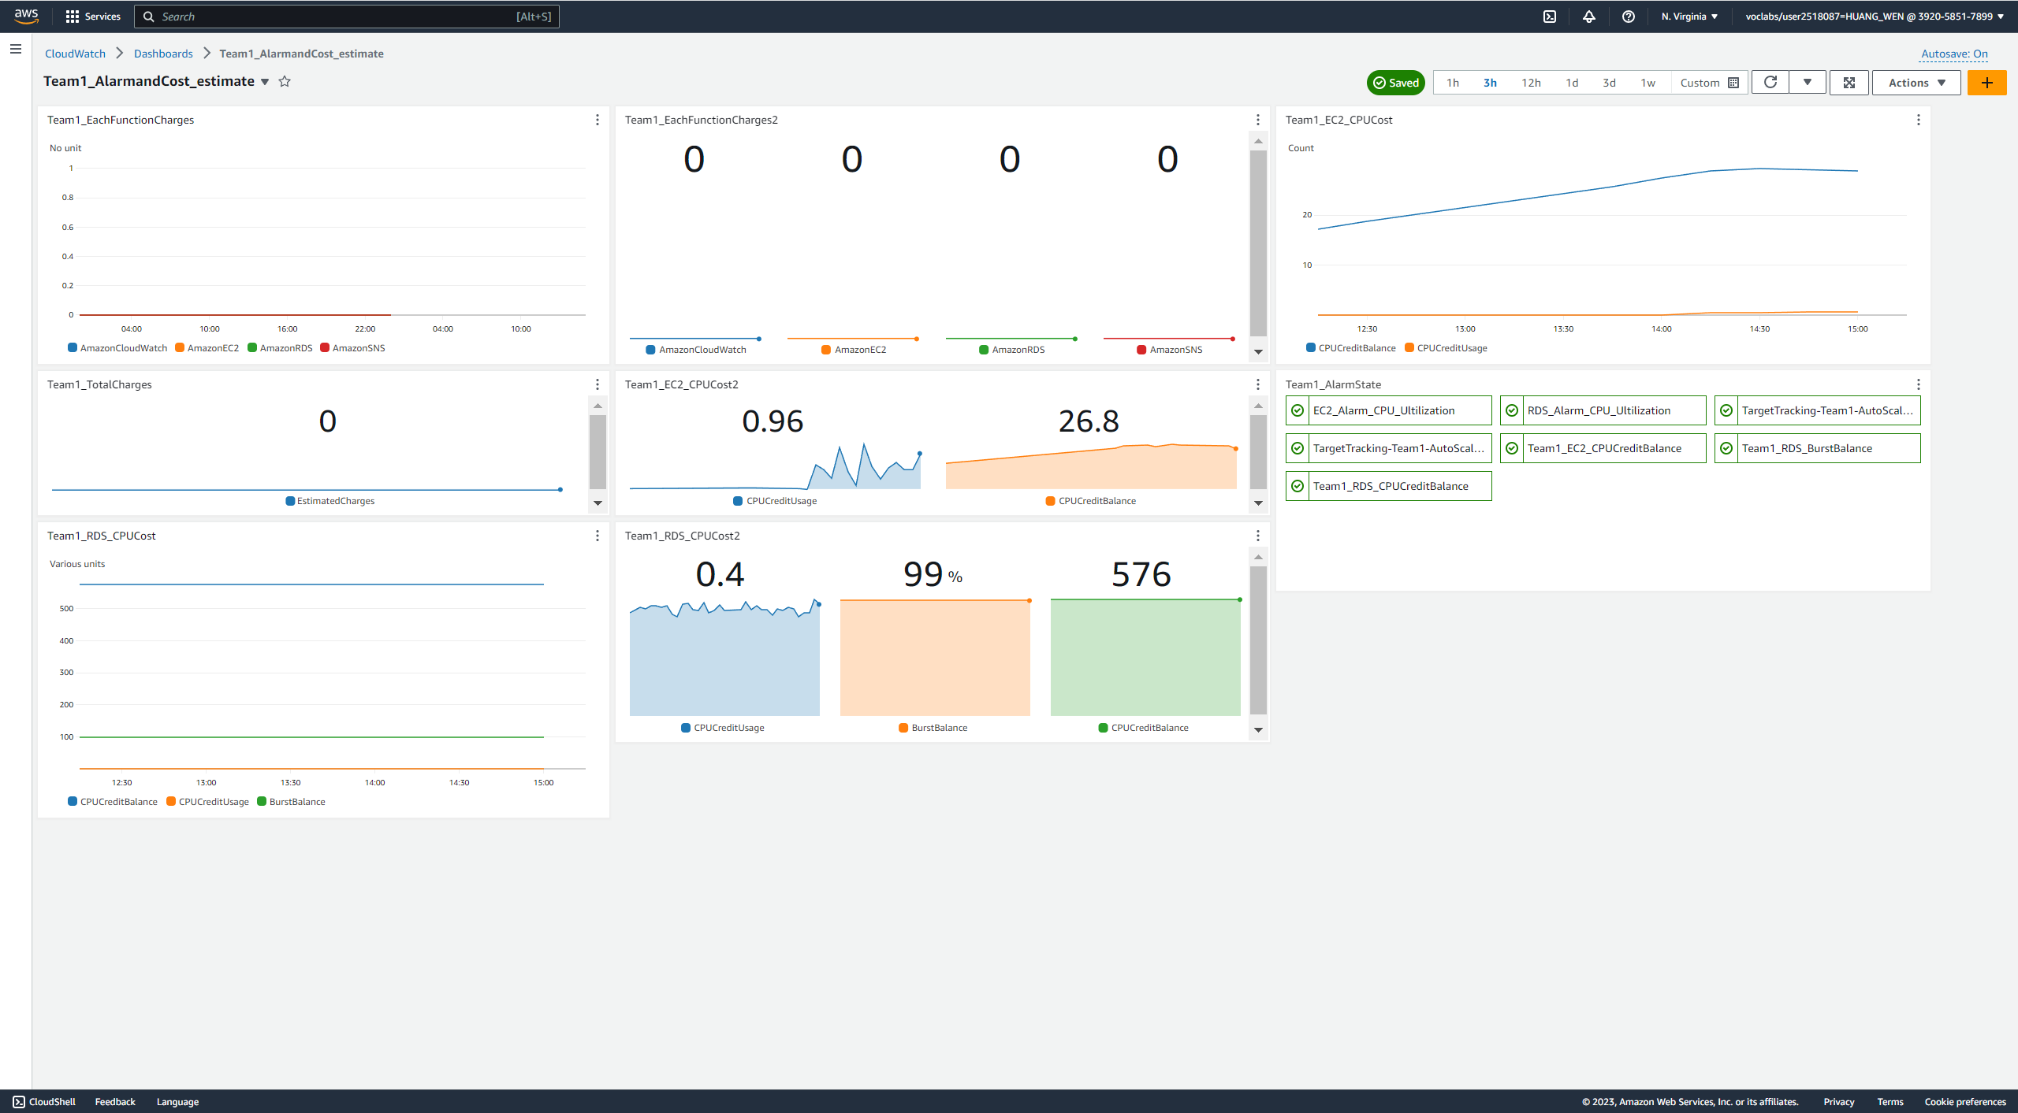

Each Widget

Team1_EachFunctionCharges

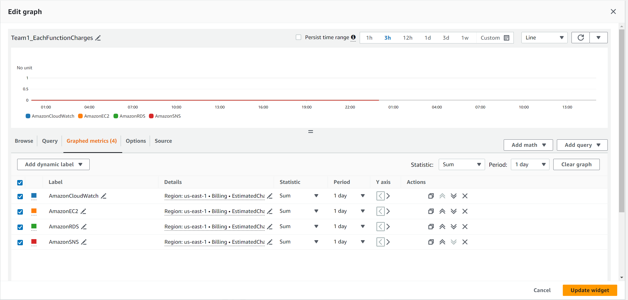

This shows the user the sum of estimated cost for AmazonCloudWatch, AmazonEC2, AmazonRDS and AmazonSNS for each day. This helps user to keep track on their spendings easily.

Team1_EachFunctionCharges2

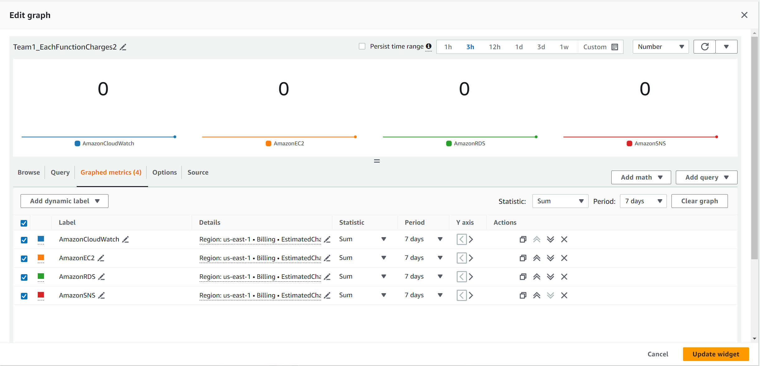

This shows the user the sum of estimated cost for AmazonCloudWatch, AmazonEC2, AmazonRDS and AmazonSNS for each week. This helps user to keep track on their spendings easily.

Team1_TotalCharges

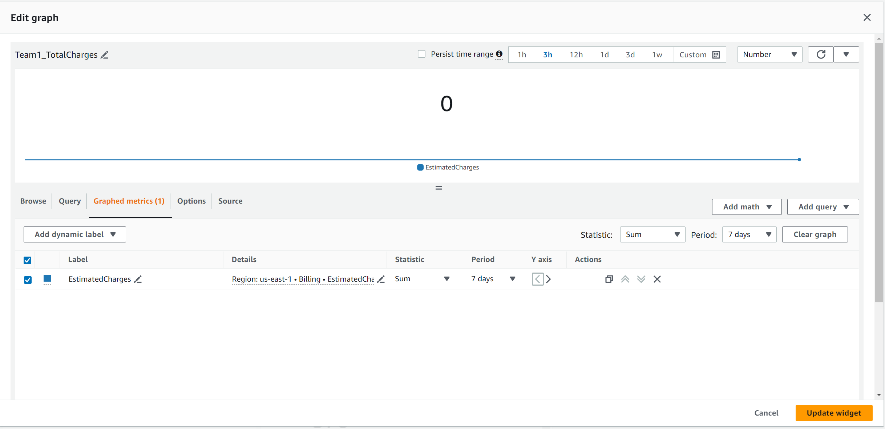

Allow user to view their total spendings on aws each week easily.

Team1_AlarmState

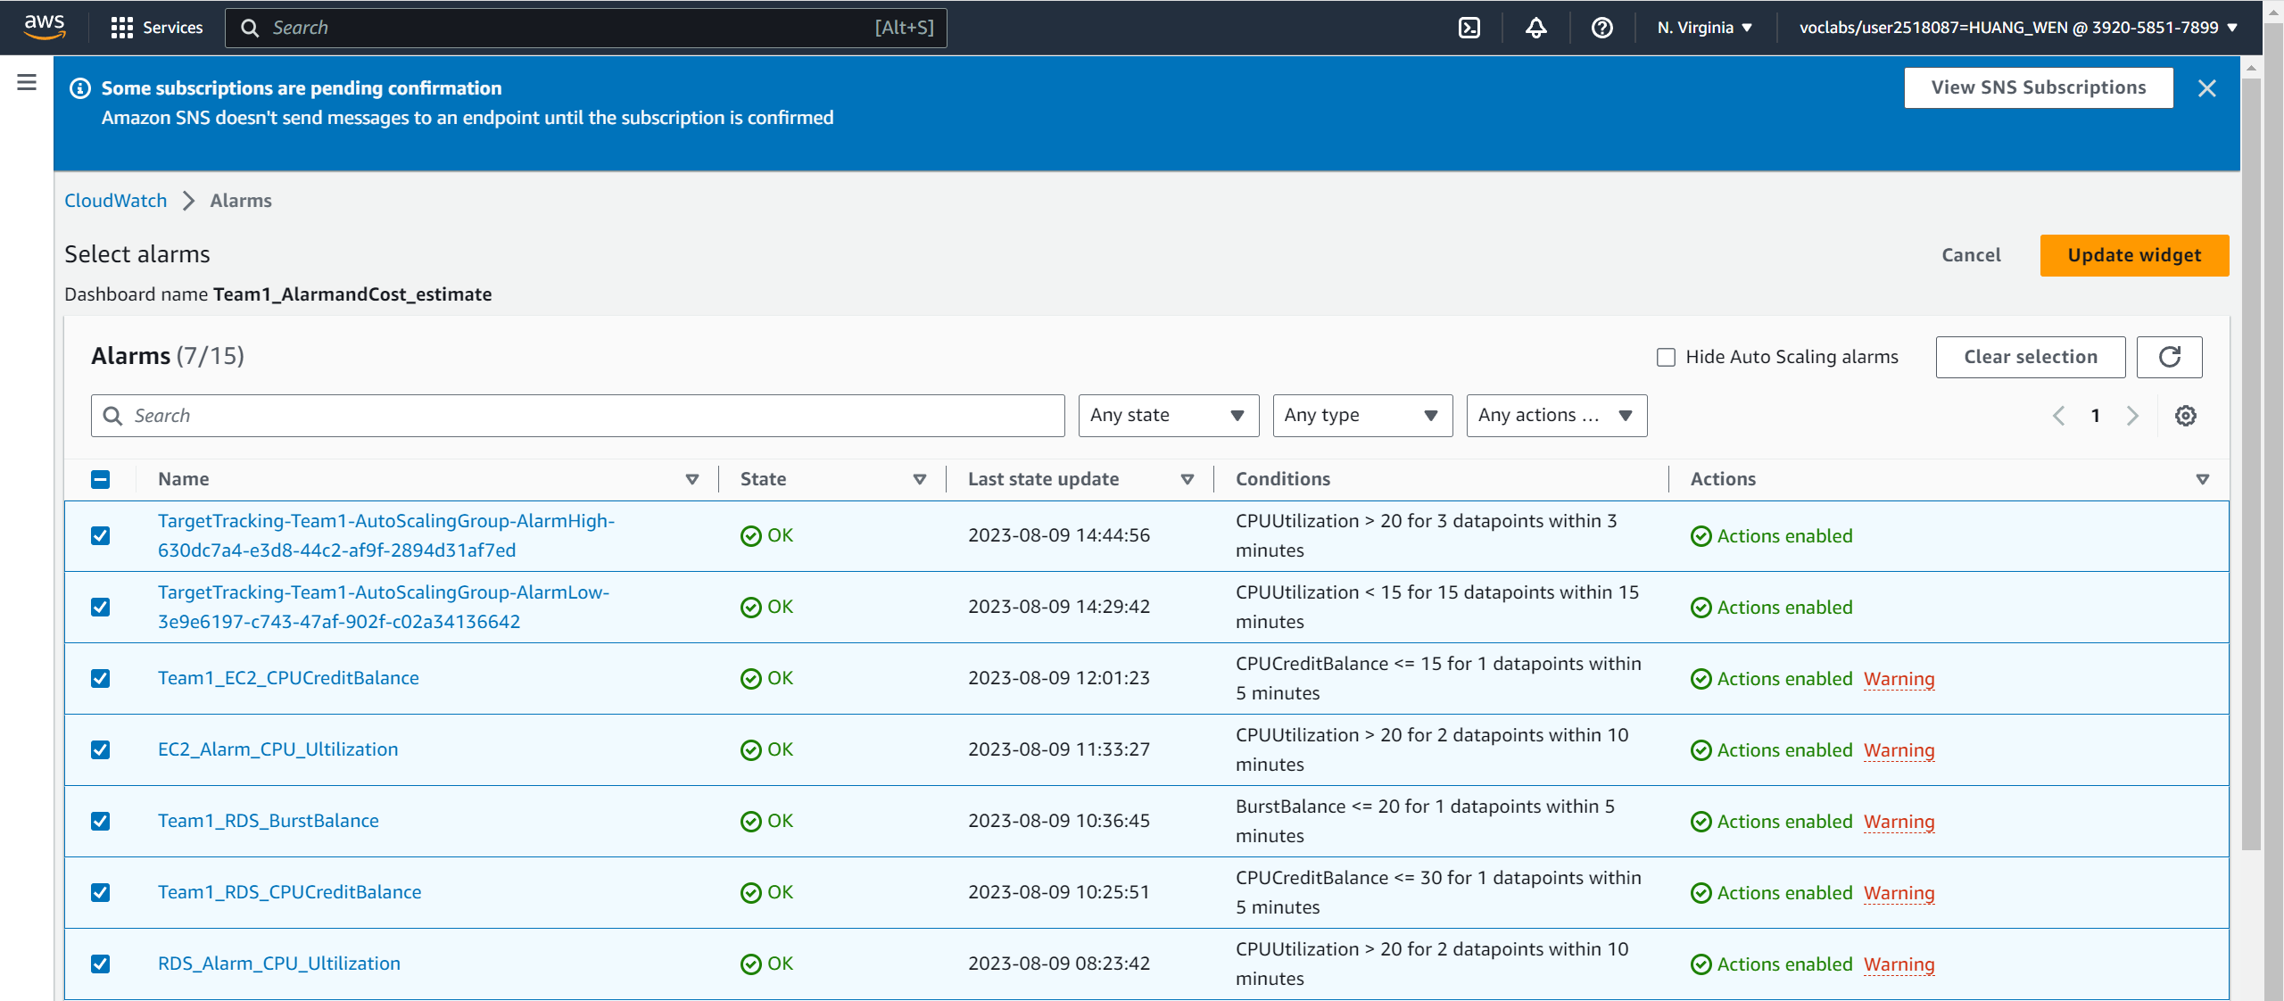

User can see the alarm state easily.

Team1_EC2_CPUCost

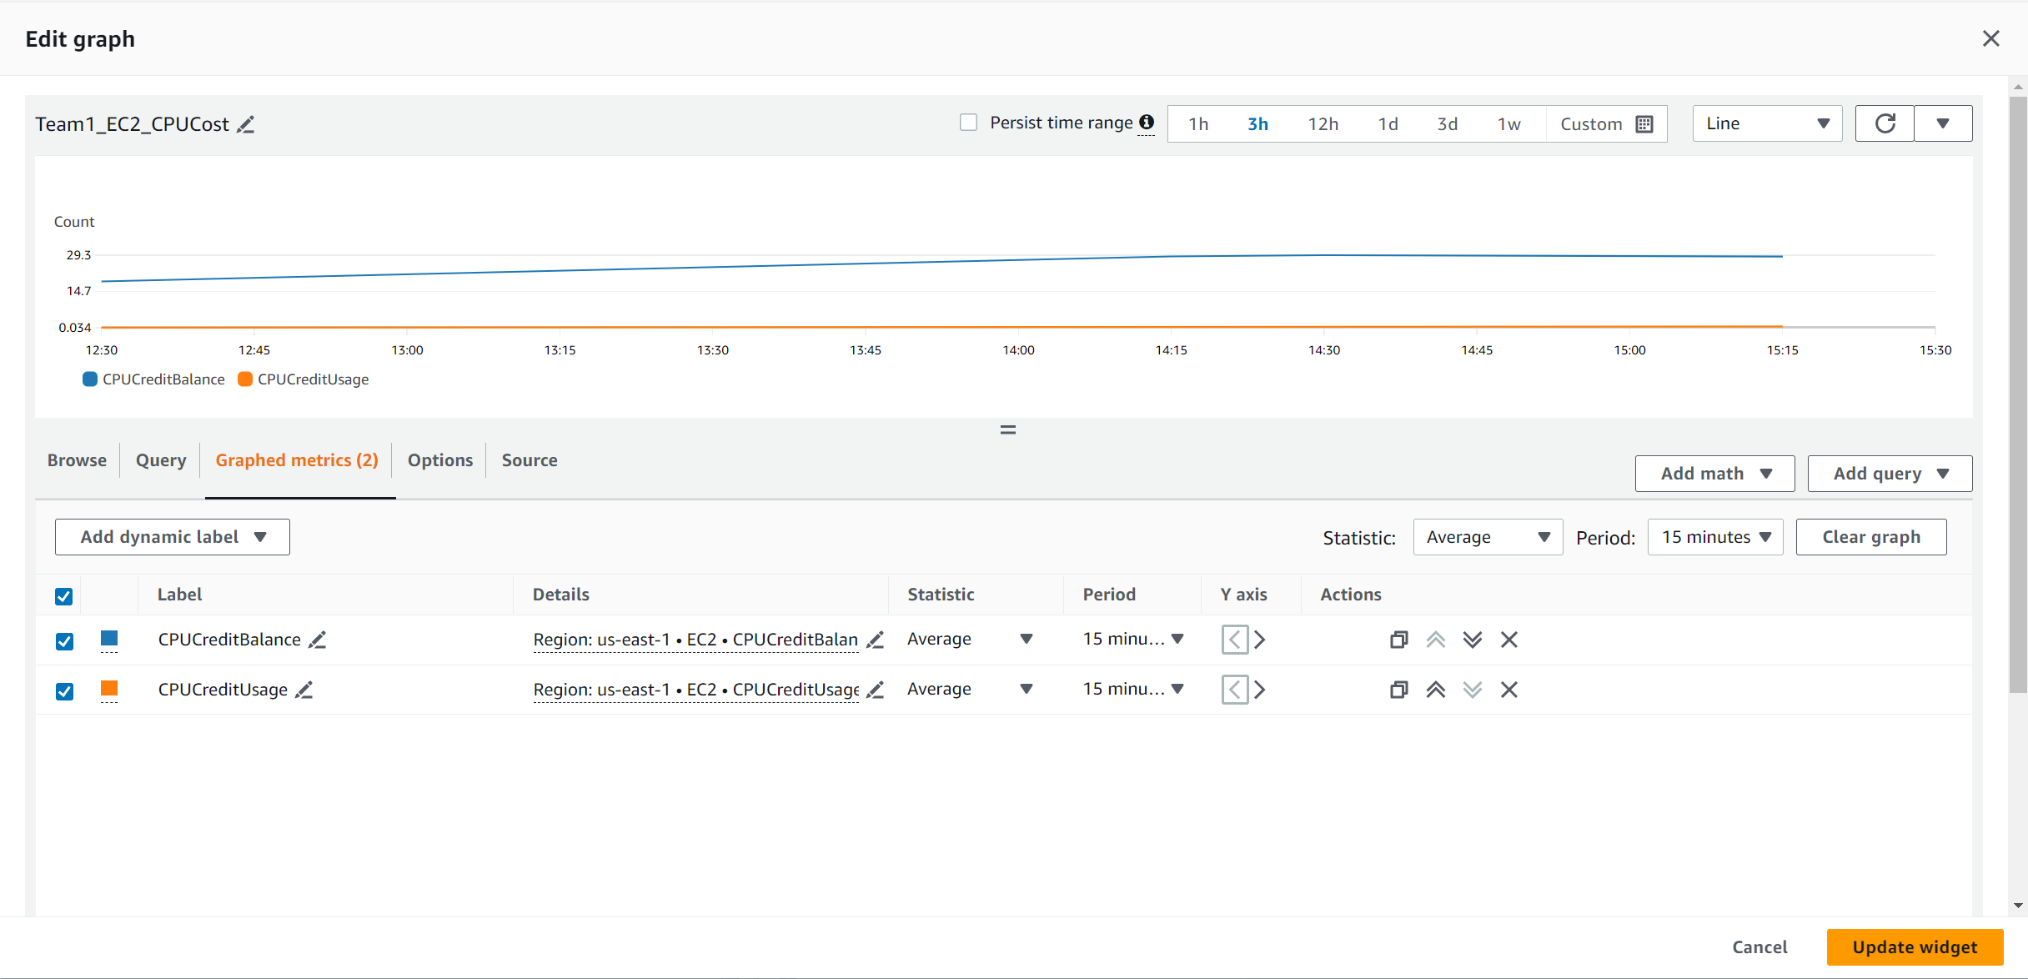

Allows users to view the CPU credit usage for EC2. It is important to keep track of this as if the credit balance reaches zero, the CPU cannot run on burst performance and keep to base line performance, which may negatively affect the experience of user when accessing the web application.

Team1_EC2_CPUCost2

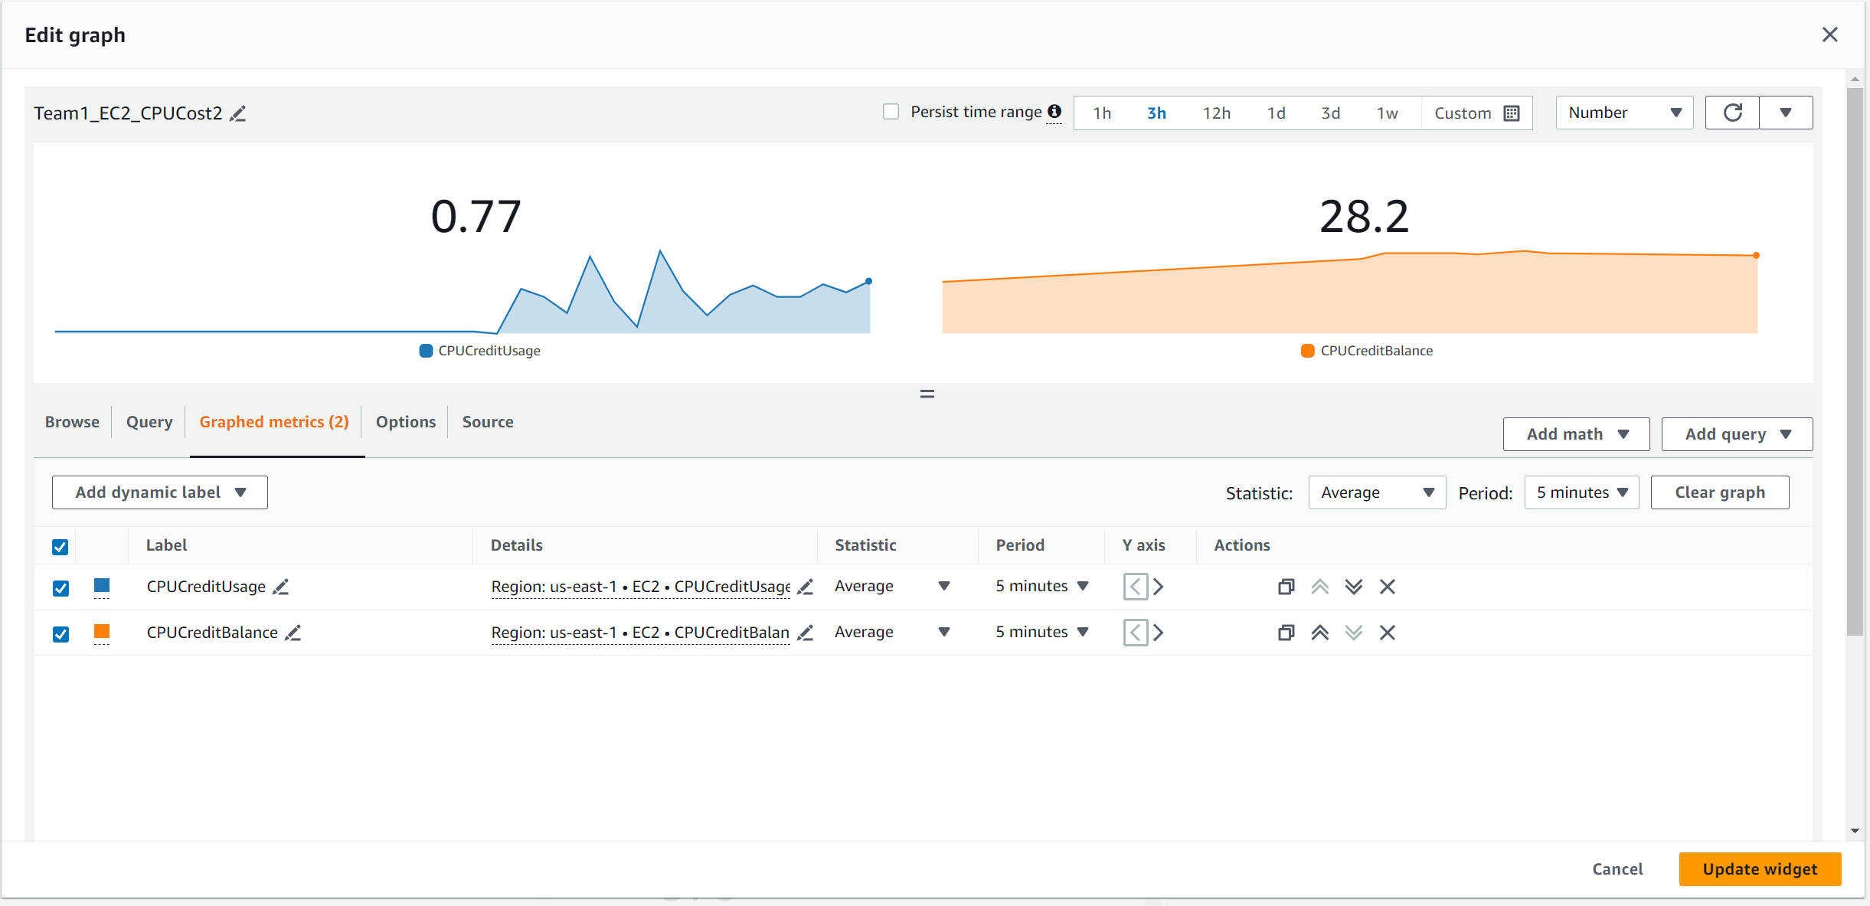

Similar to the line graph, but it uses numbers to represent instead.

Team1_RDS_CPUCost

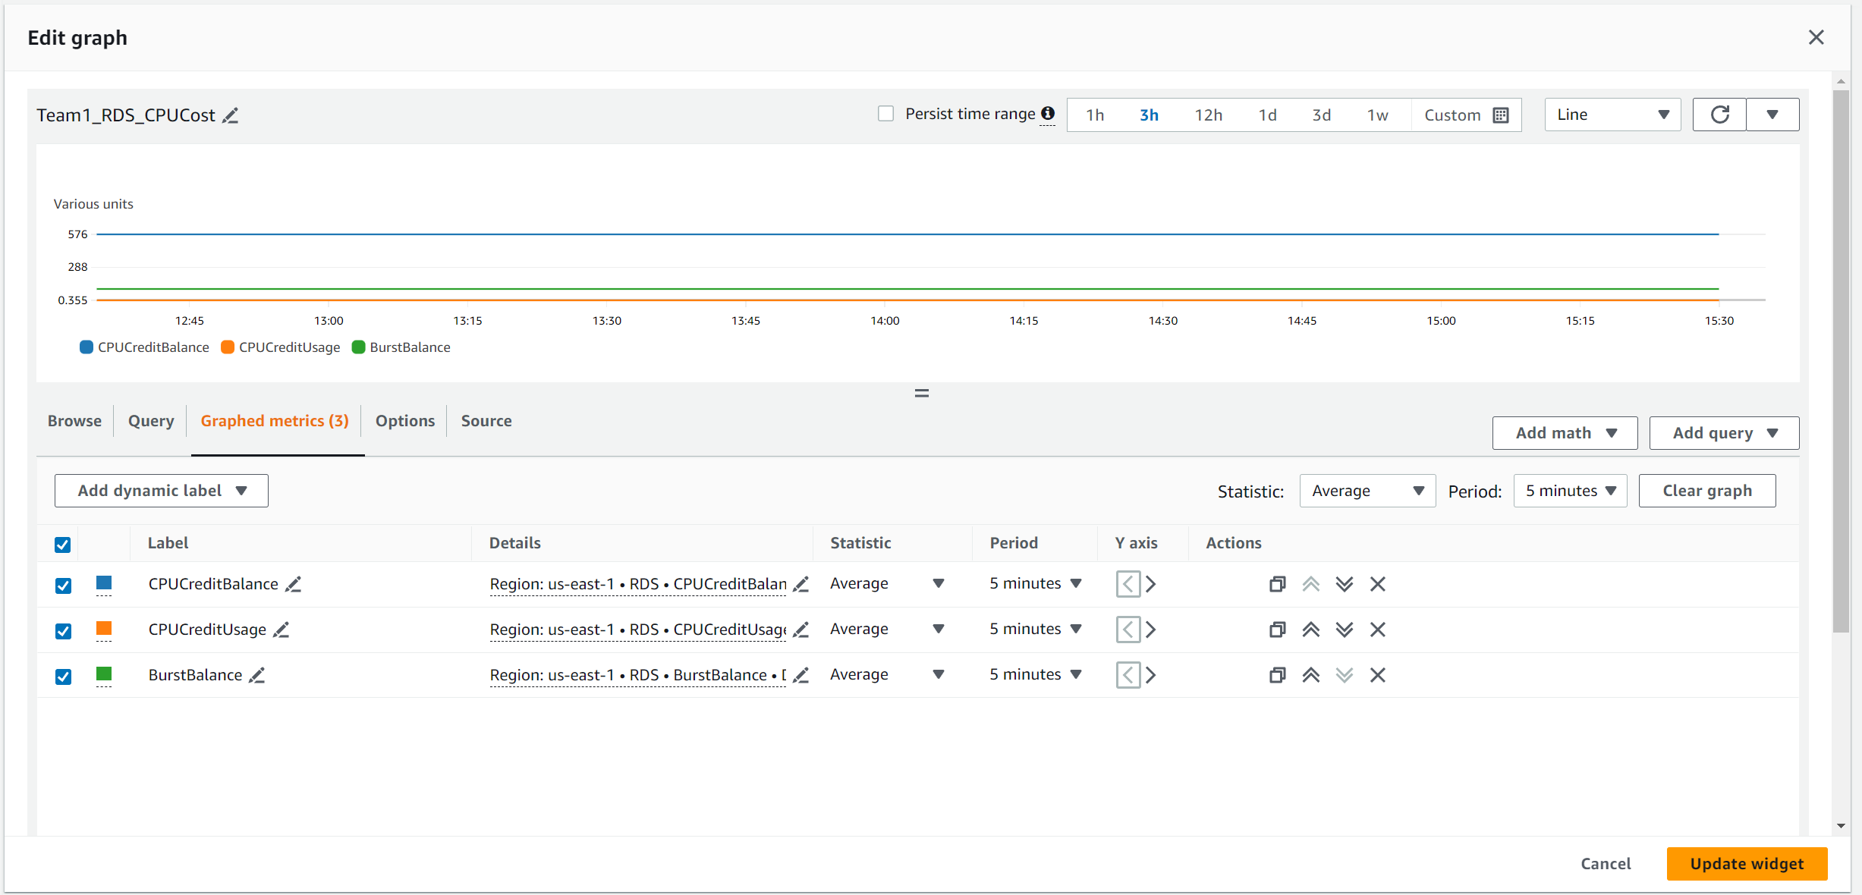

Allows users to view the CPU credit usage and Burst balance for RDS.

Team1_RDS_CPUCost2

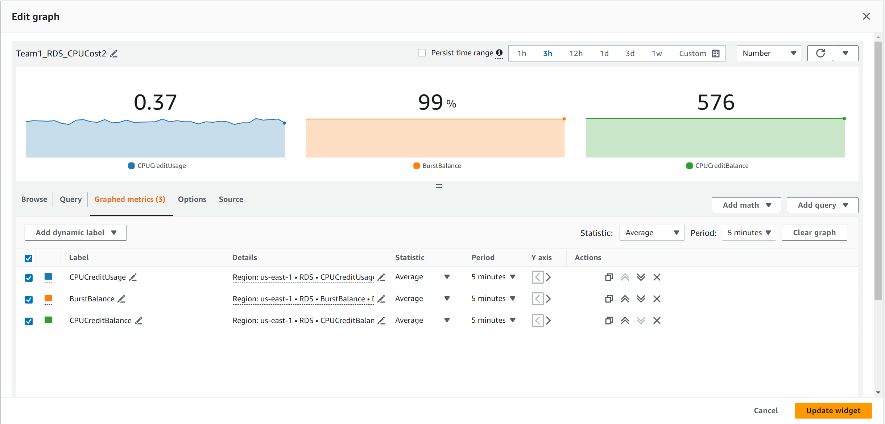

Similar to the line graph, but it uses numbers to represent instead.

The next dashboard is called Team1_EC2Dashboard. This dashboard allows users to know the performance and the usage of the EC2 instances.

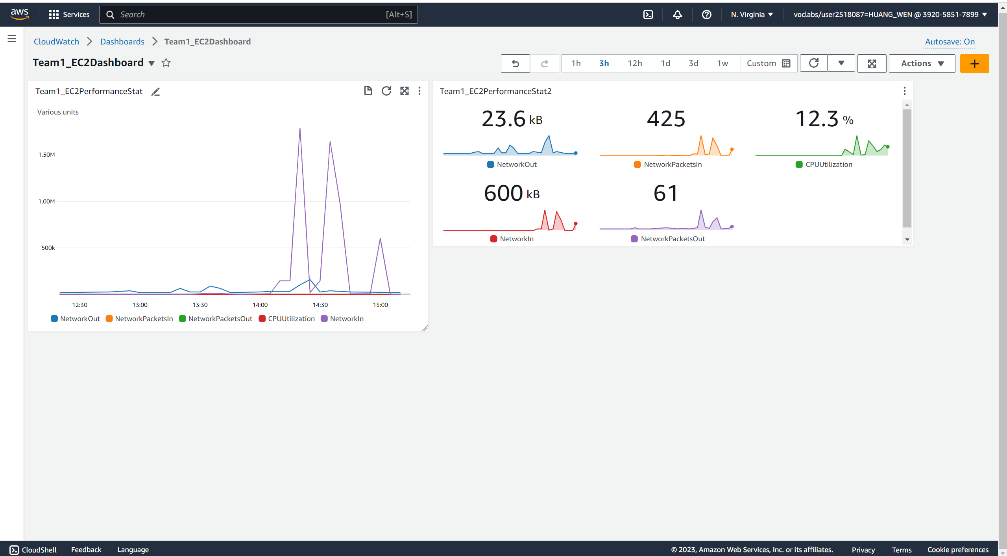

Team1_EC2PerformanceStat

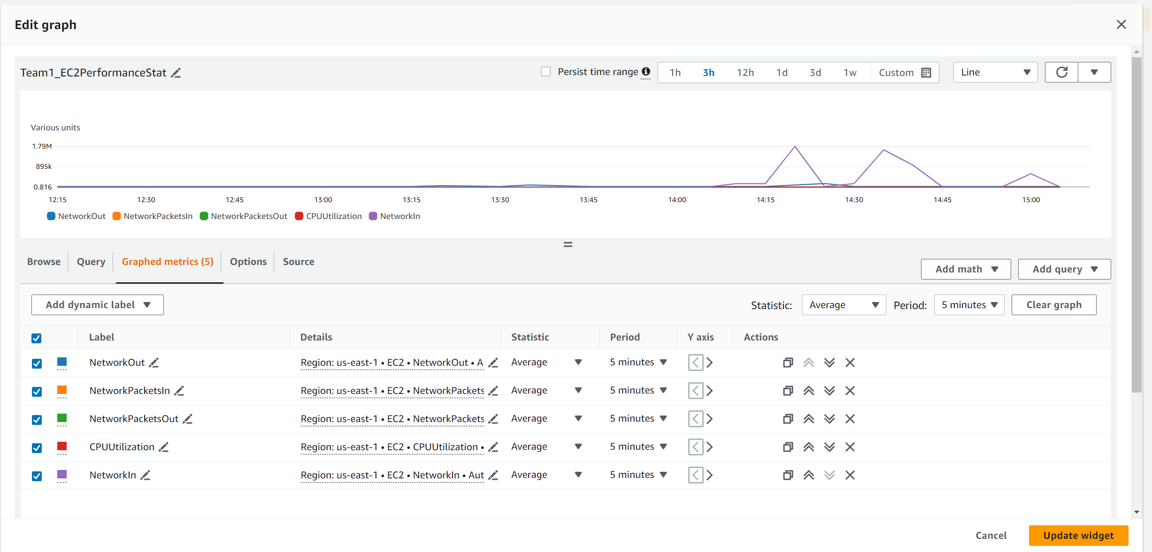Shows the Network In/Out, Network Packet In/Out and CPU Utilization of the EC2, help the user to see the usage of the Web application and identify trends related to the usage of web application such as when user normally used the web application and so on.

Team1_EC2PerformanceStat2

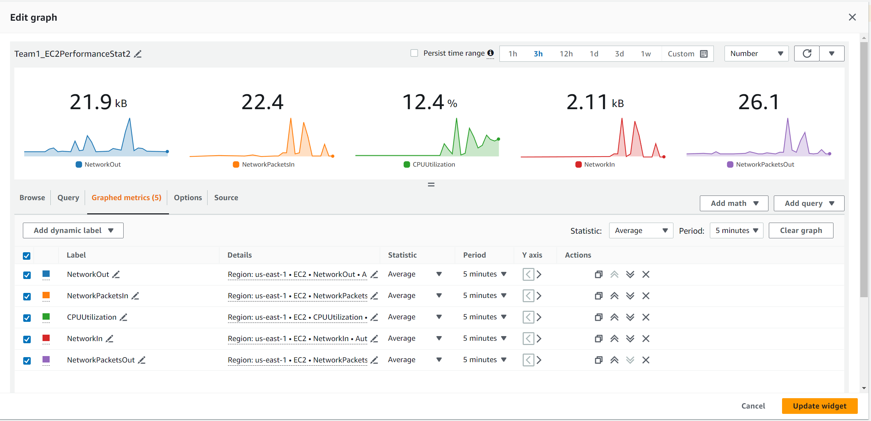

Similar to the line graph instead it uses numbers as representation.

The next dashboard is Team1_RDSDashboard.

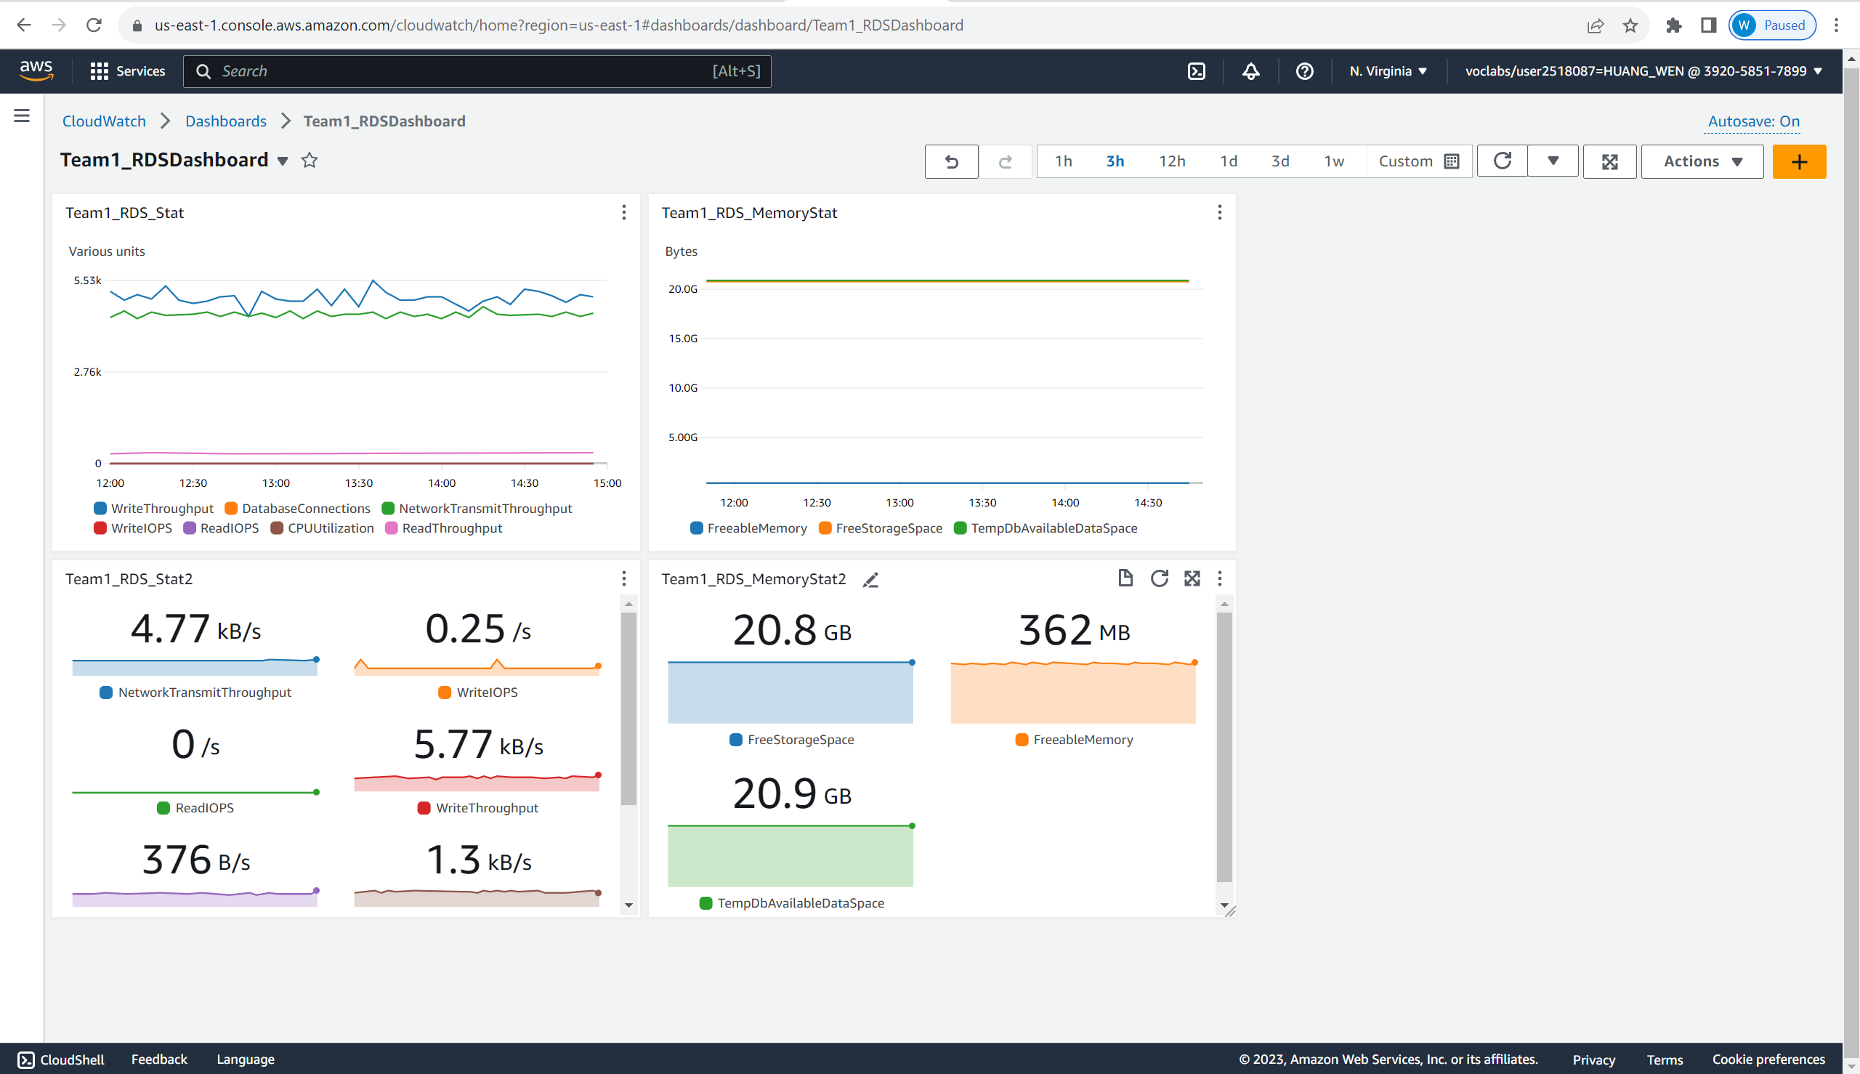

This dashboard shows statistic of the RDS performance for user to view. It is mainly split up as memory statistic and performance statistics.

Performance Statistics:

Team1_RDS_Stat

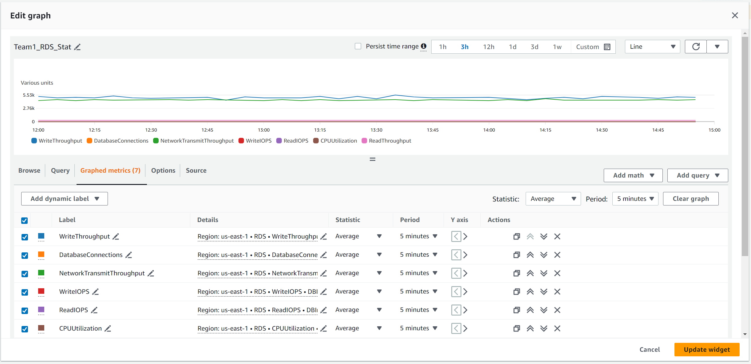

It shows the user the write/read throughput, database connection, write/read IOPS and CPU Utilization of the RDS, allowing the user to know the trend of the RDS performance.

Team1_RDS_Stat2

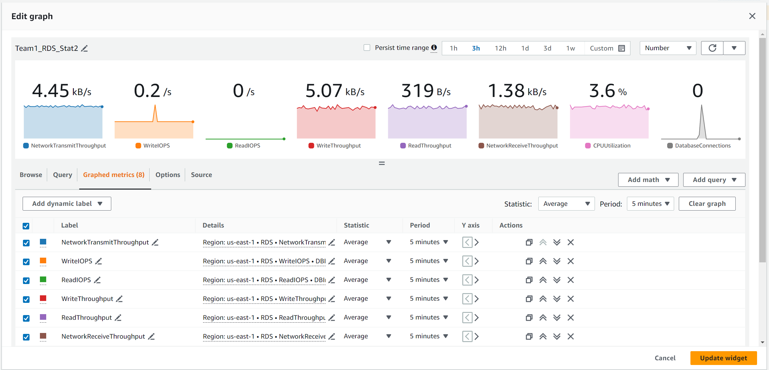

Similar to the line graph instead it uses numbers as representation.

Memory:

Team1_RDS_MemoryStat

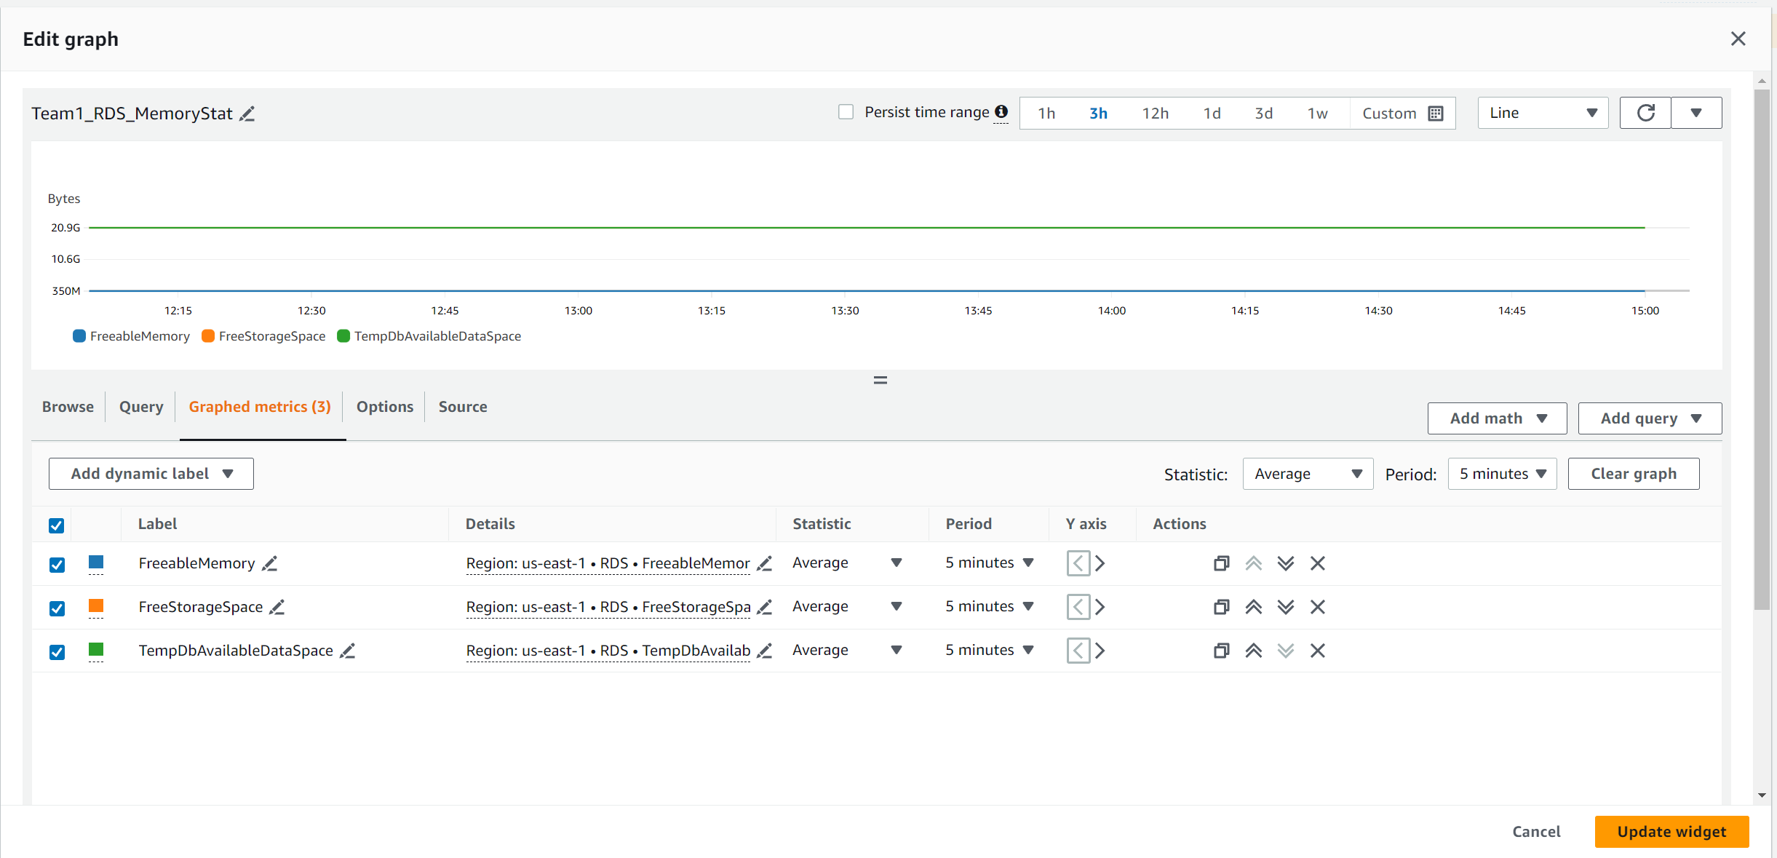

It shows the user the Freeable Memory, Free Storage Space and TempDb Available Data space of the RDS, allowing users to know more about their RDS memory.

Team1_RDS_MemoryStat2

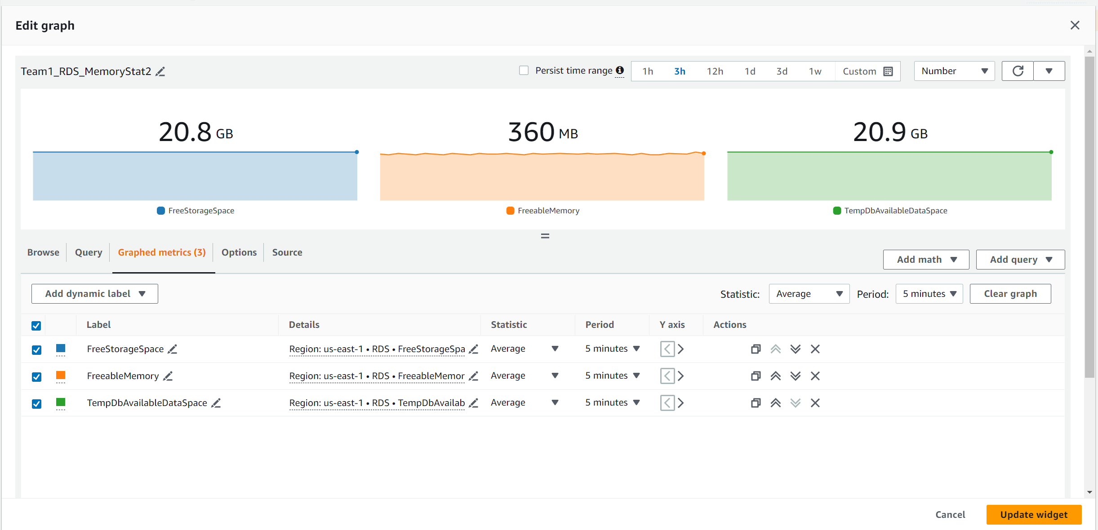

Similar to the line graph instead it uses numbers as representation.

Alarms and Notifications: CloudWatch Alarms are set to trigger AWS SNS notifications when predefined thresholds are breached.

The following is the alarms created:

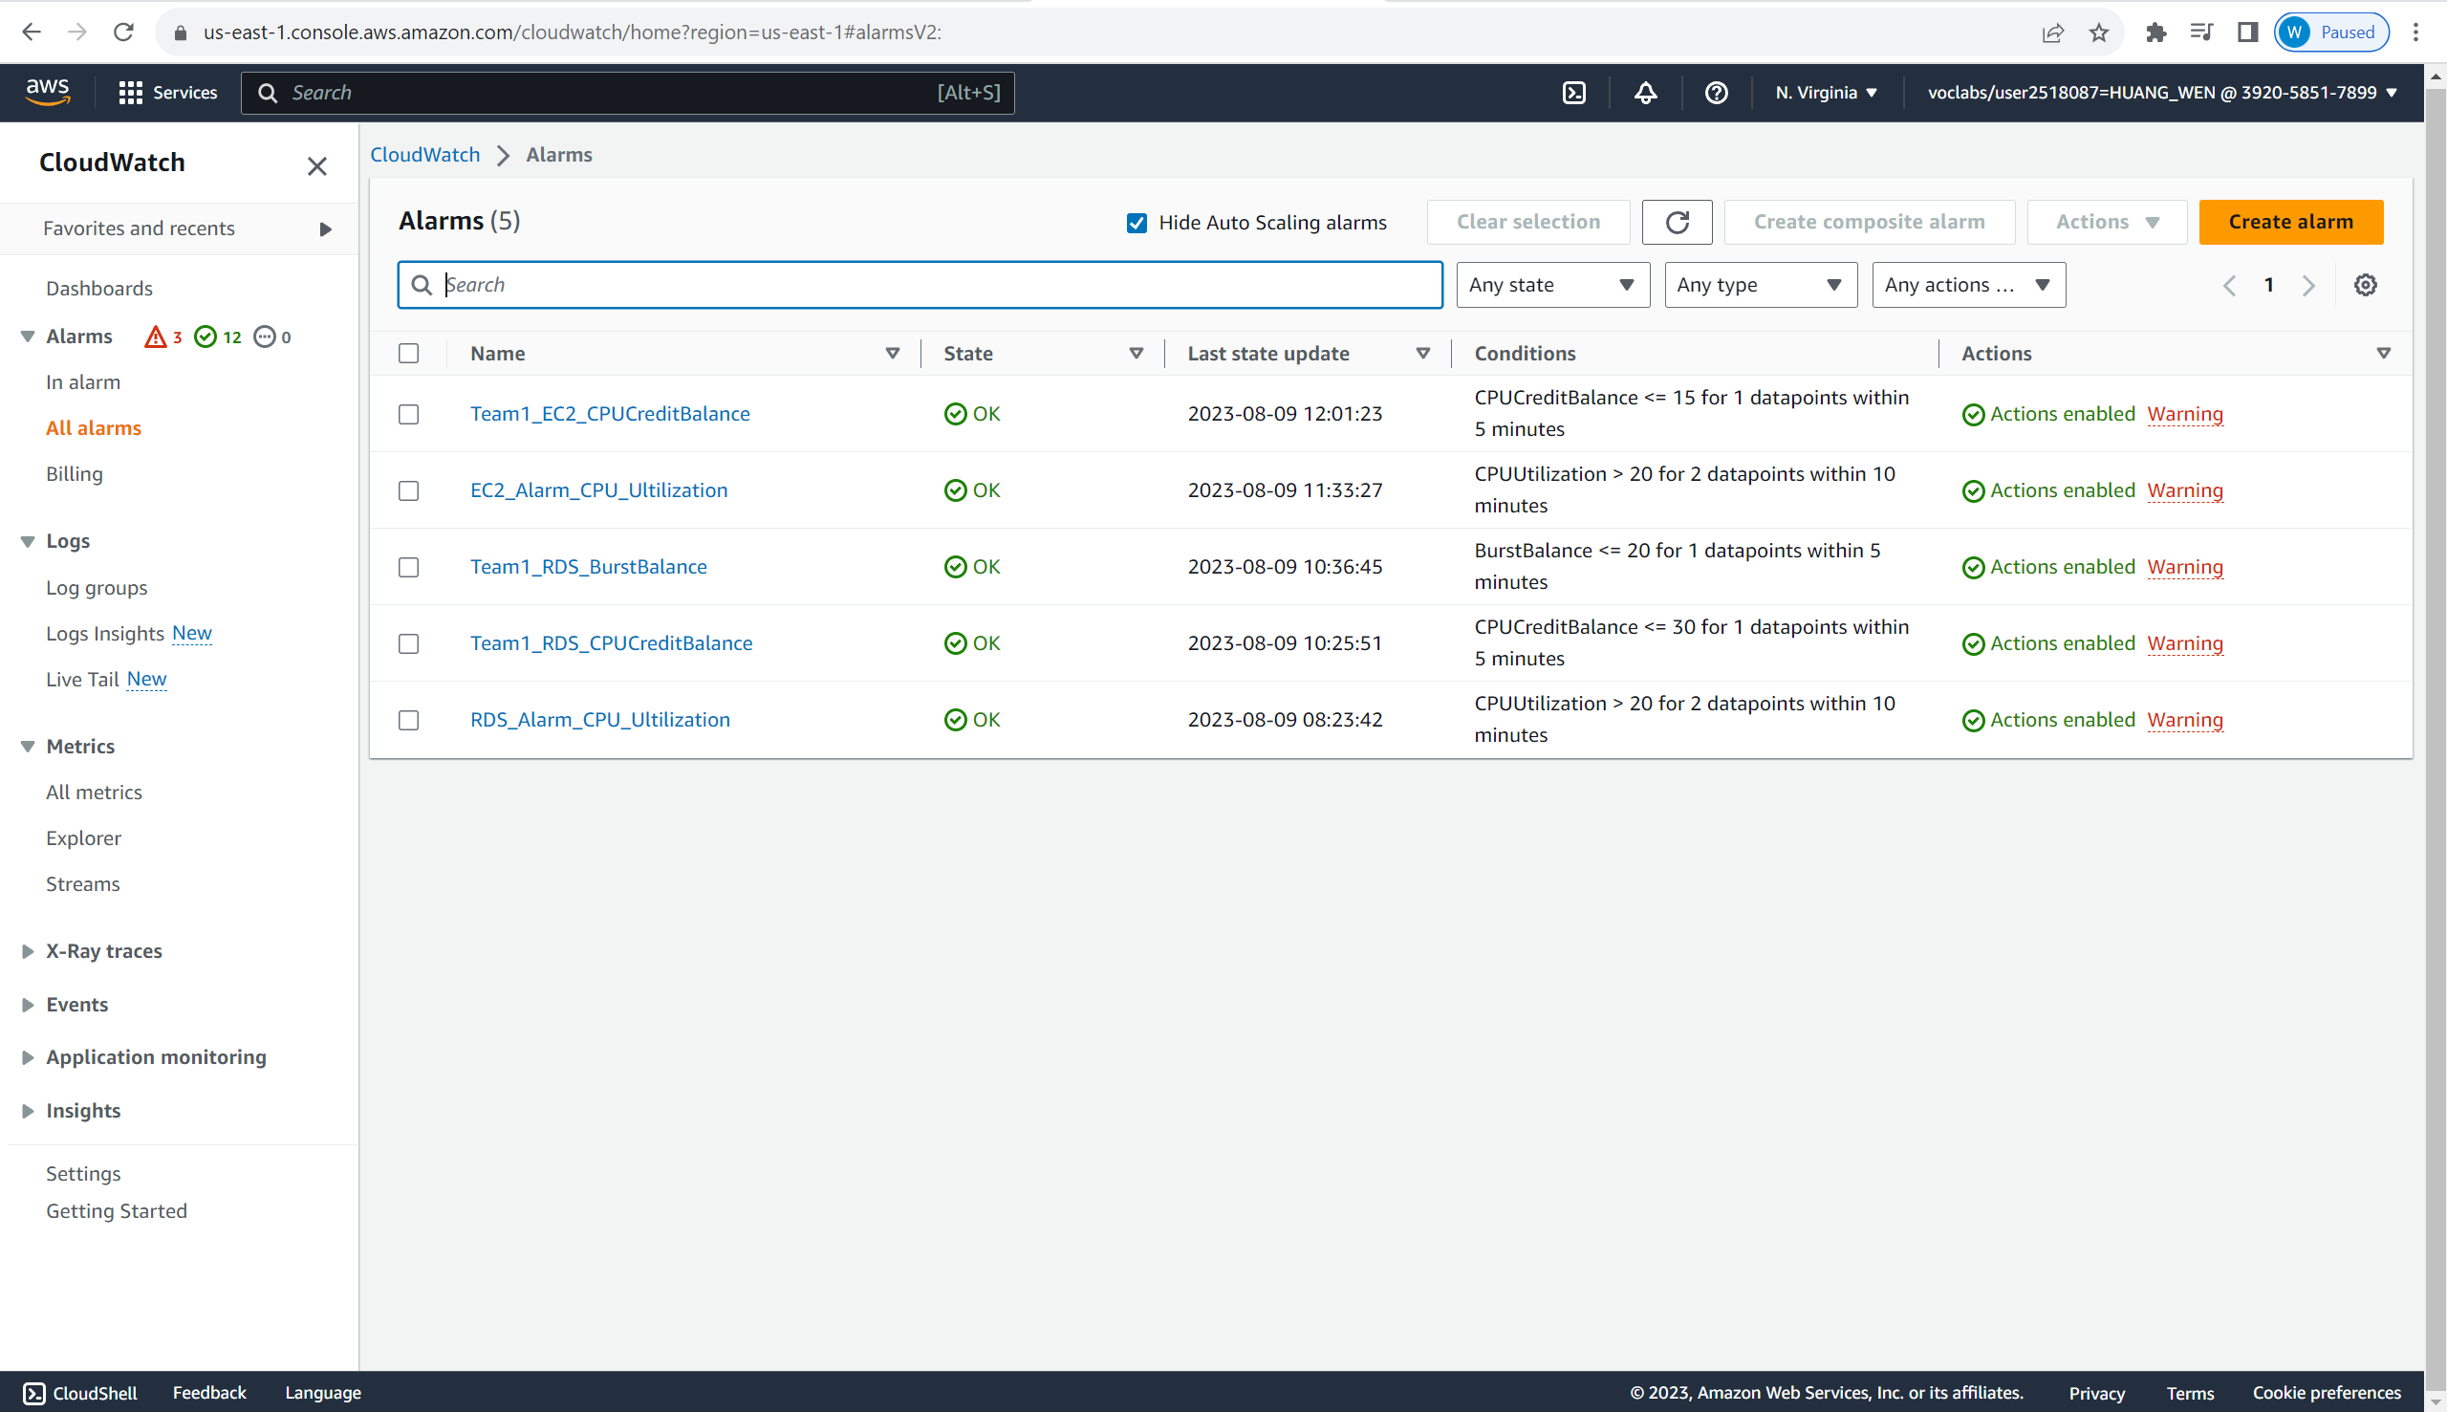

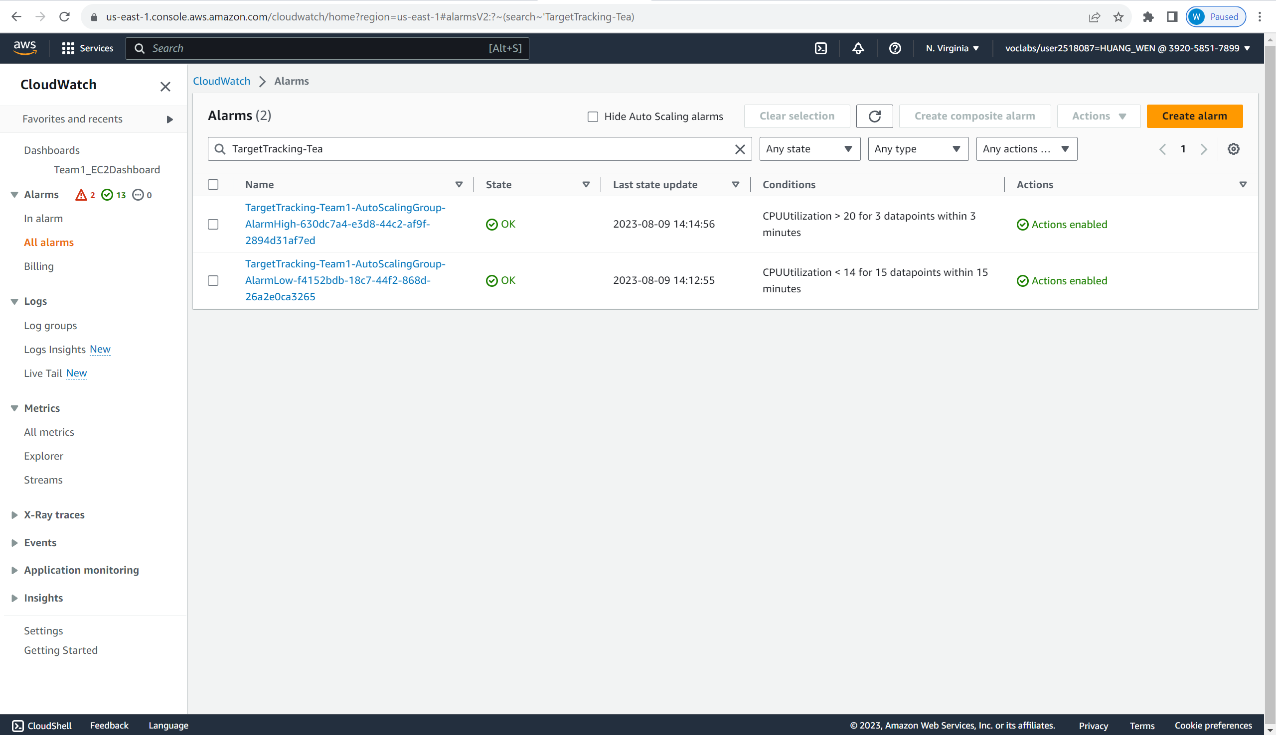

Next, we will explain what each of the alarms does and their settings. The first alarm set is Team1_EC2_CPUCreditBalance.

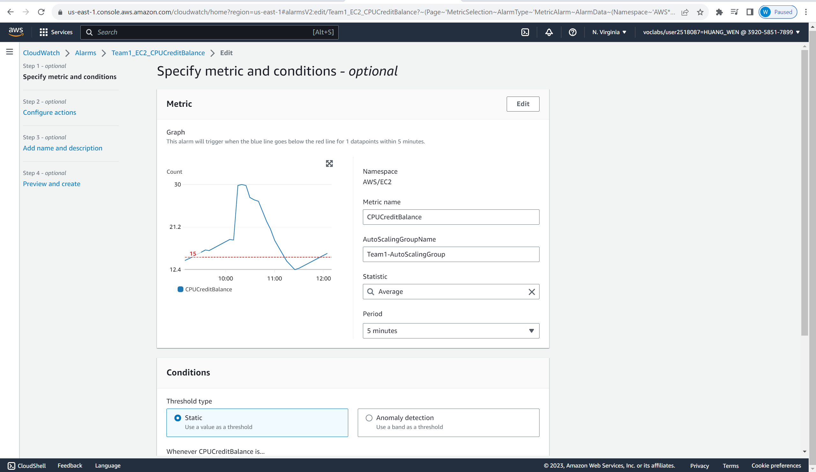

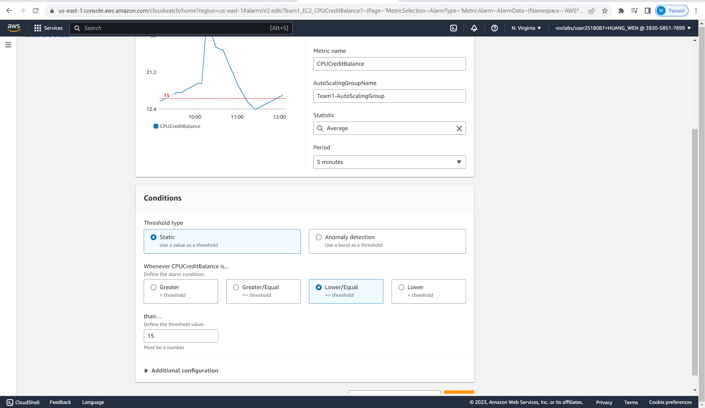

The alarm is set to monitor our EC2 CPU credit balance. The CPU credit balance is the available CPU credit that can be spent for CPU utilisation. One CPU credit equals one vCPU running at 100% utilization for one minute or an equivalent combination of vCPUs, utilization, and time. This is very important as if the balance runs out, the EC2 will only be able to run on baseline performance until is has earned enough credit to perform burstable performance. The alarm will be triggered if the credit balance is lower/equal to 15.

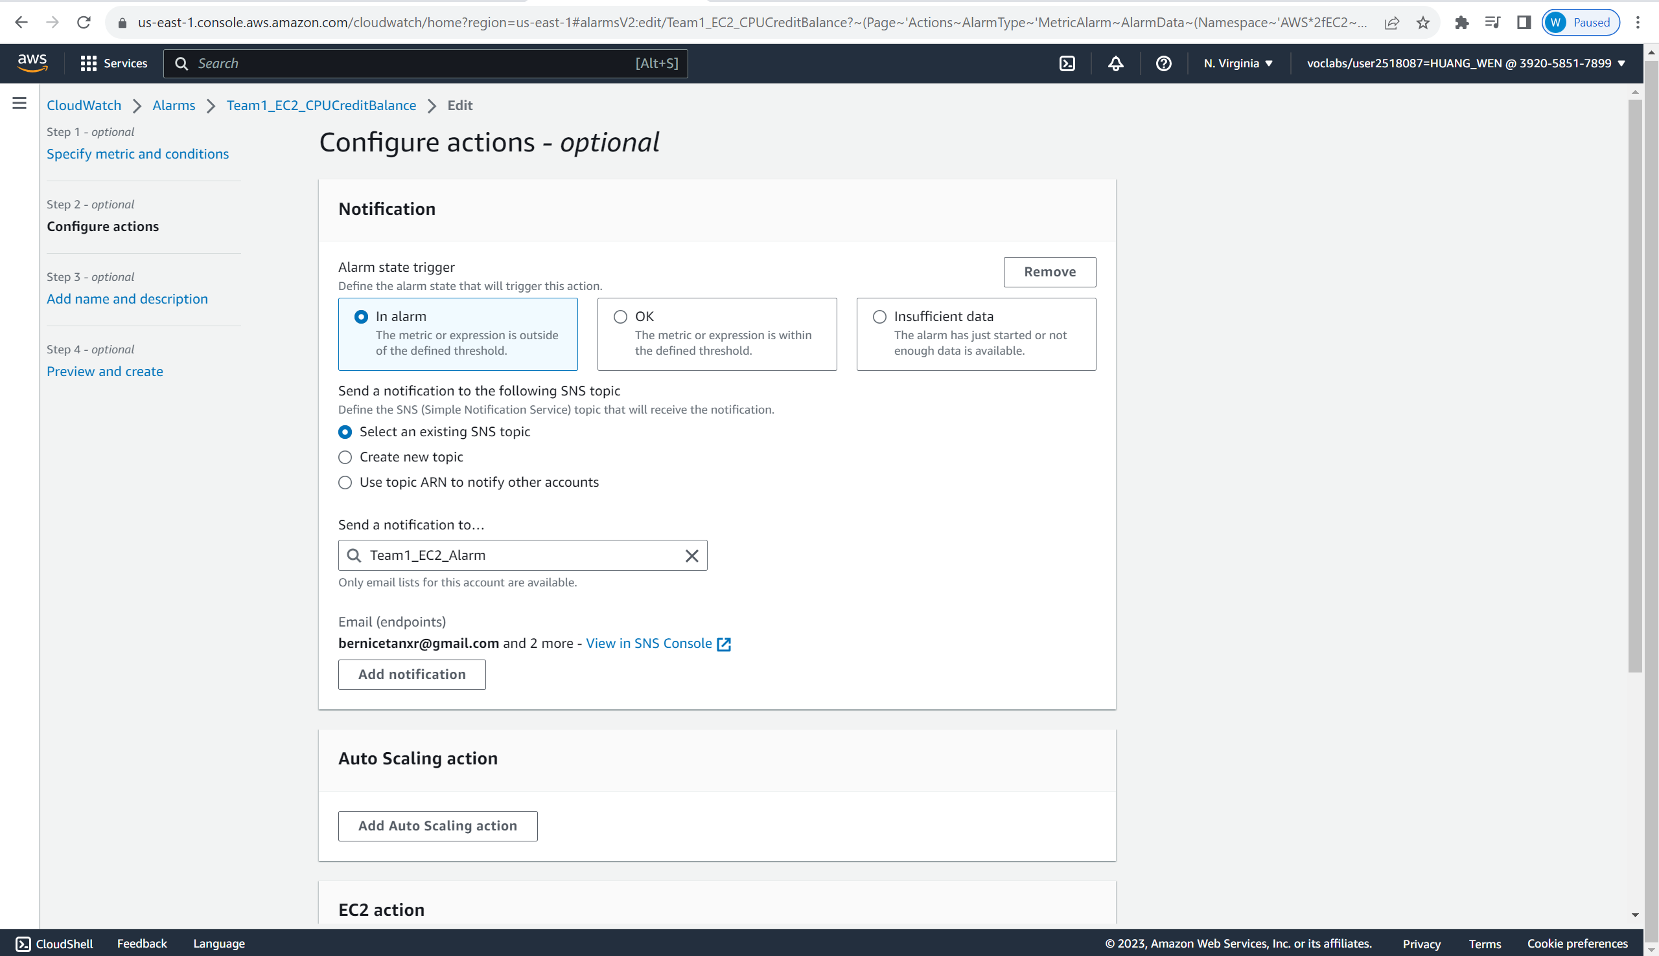

After the Alarm is triggered, it will be sending a notification to a Team1_EC2_Alarm topic, which will email to the administrator of the website, who can decide on the actions needed to solve this credit balance-depleting issue.

Next, we will move on to EC2_Alarm_CPU_Ultilization Alarm.

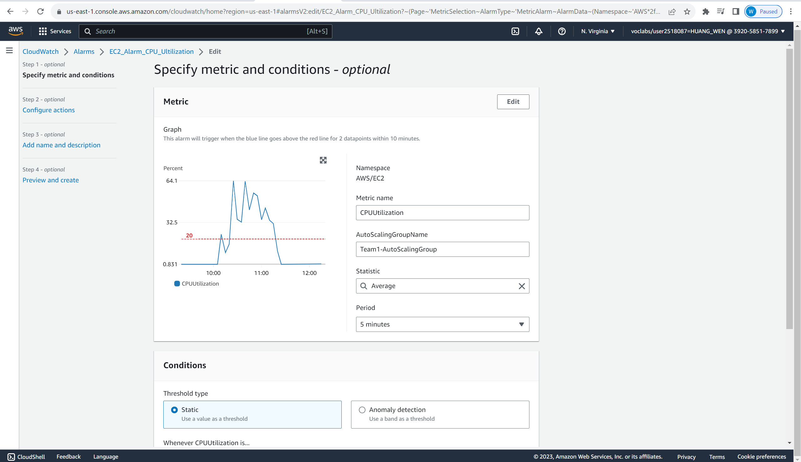

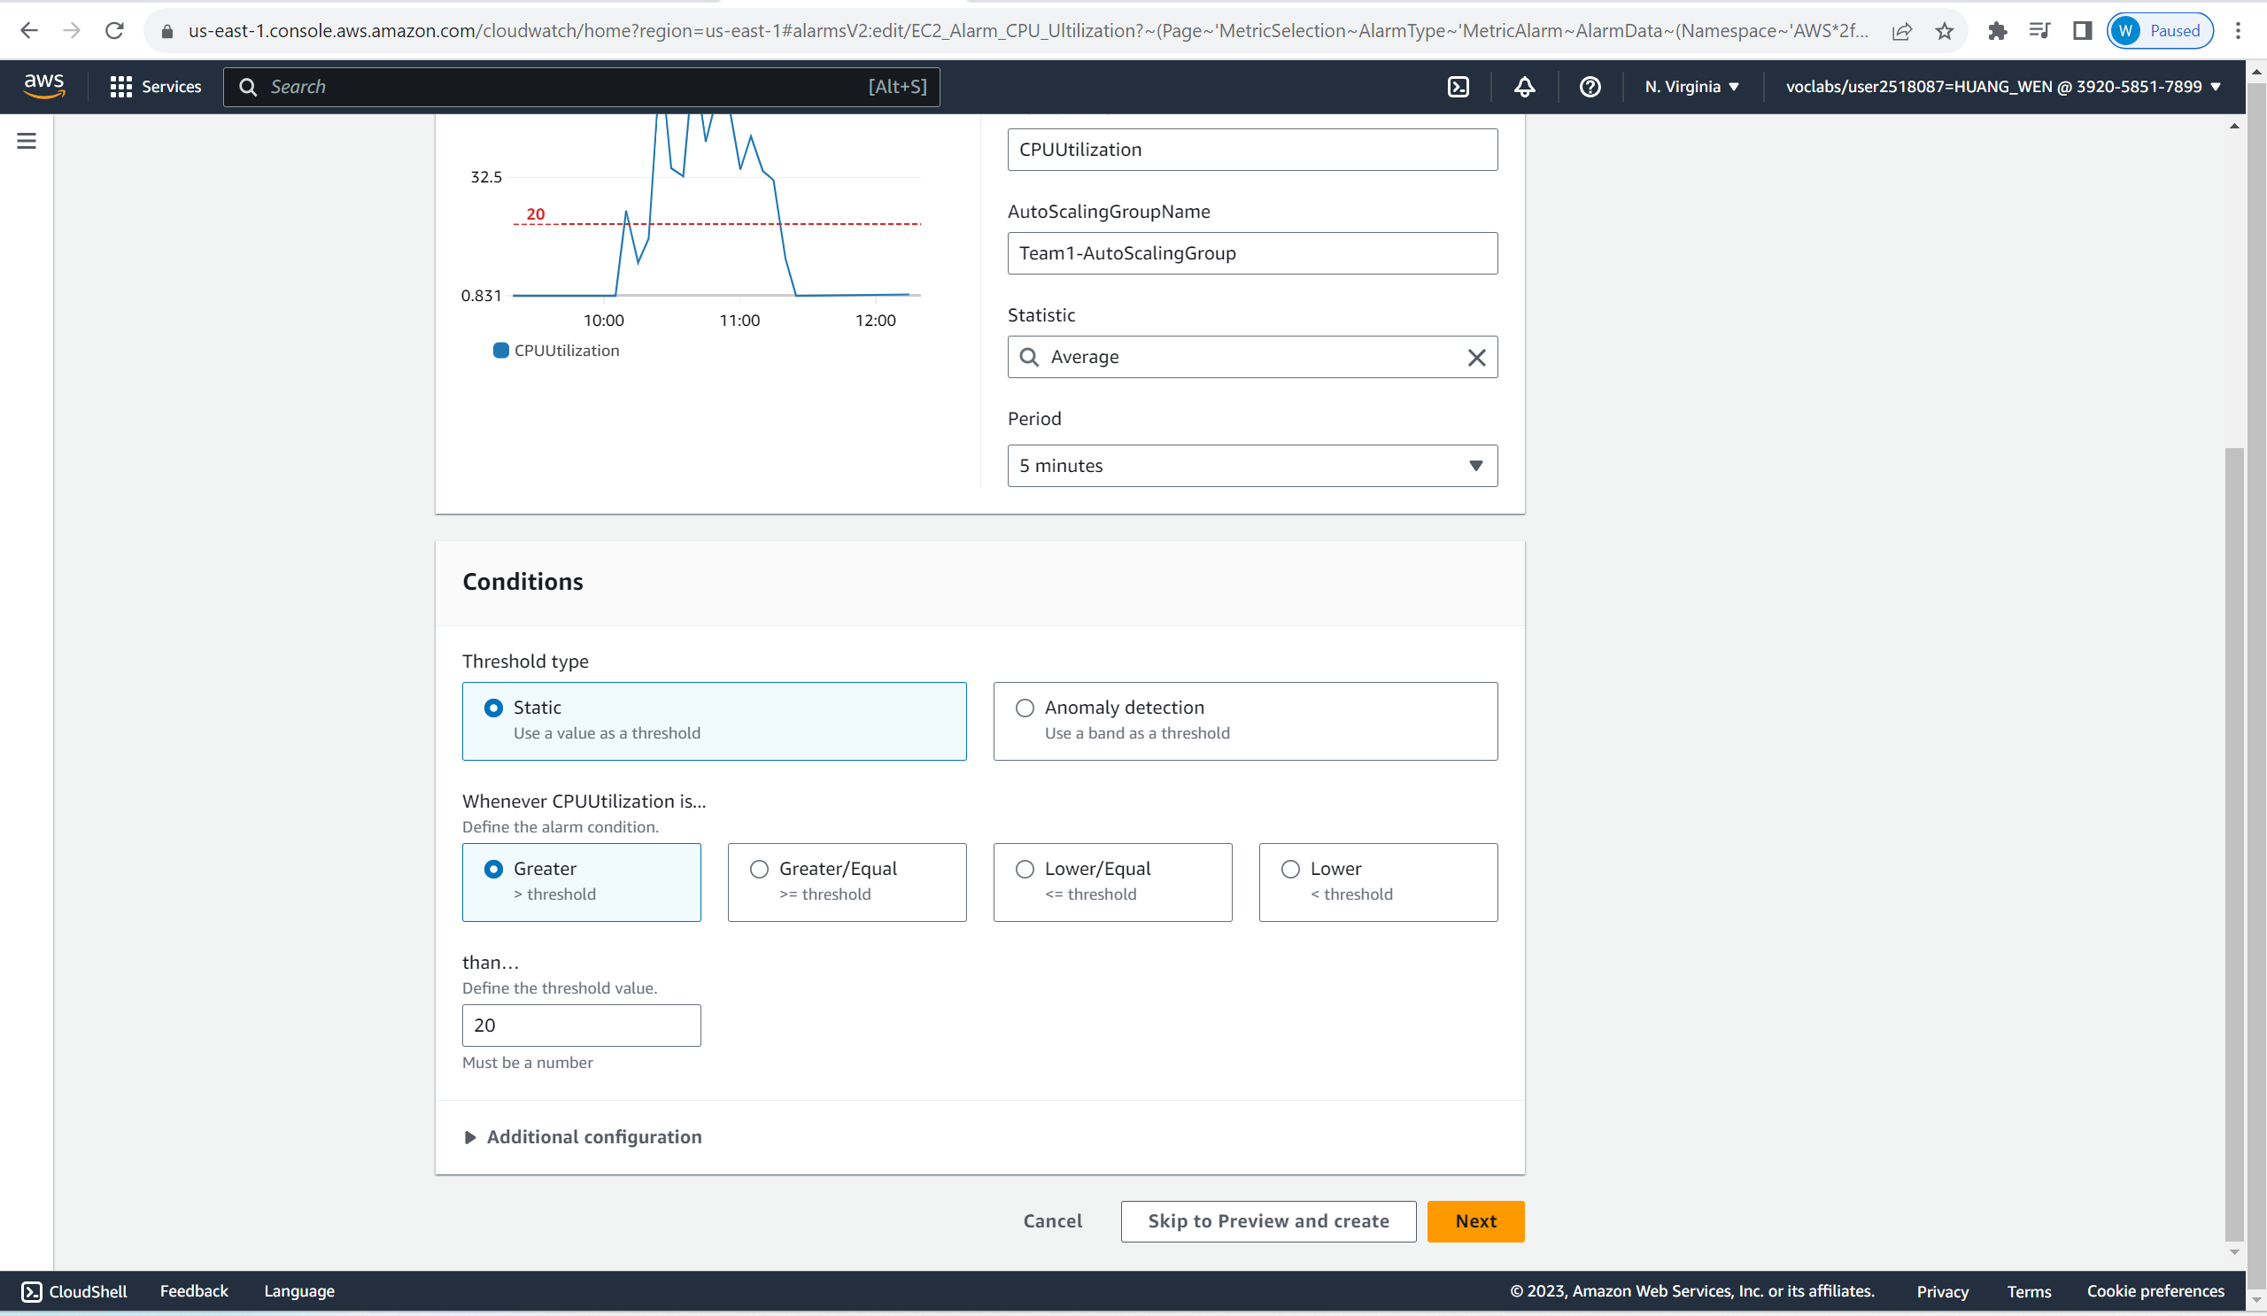

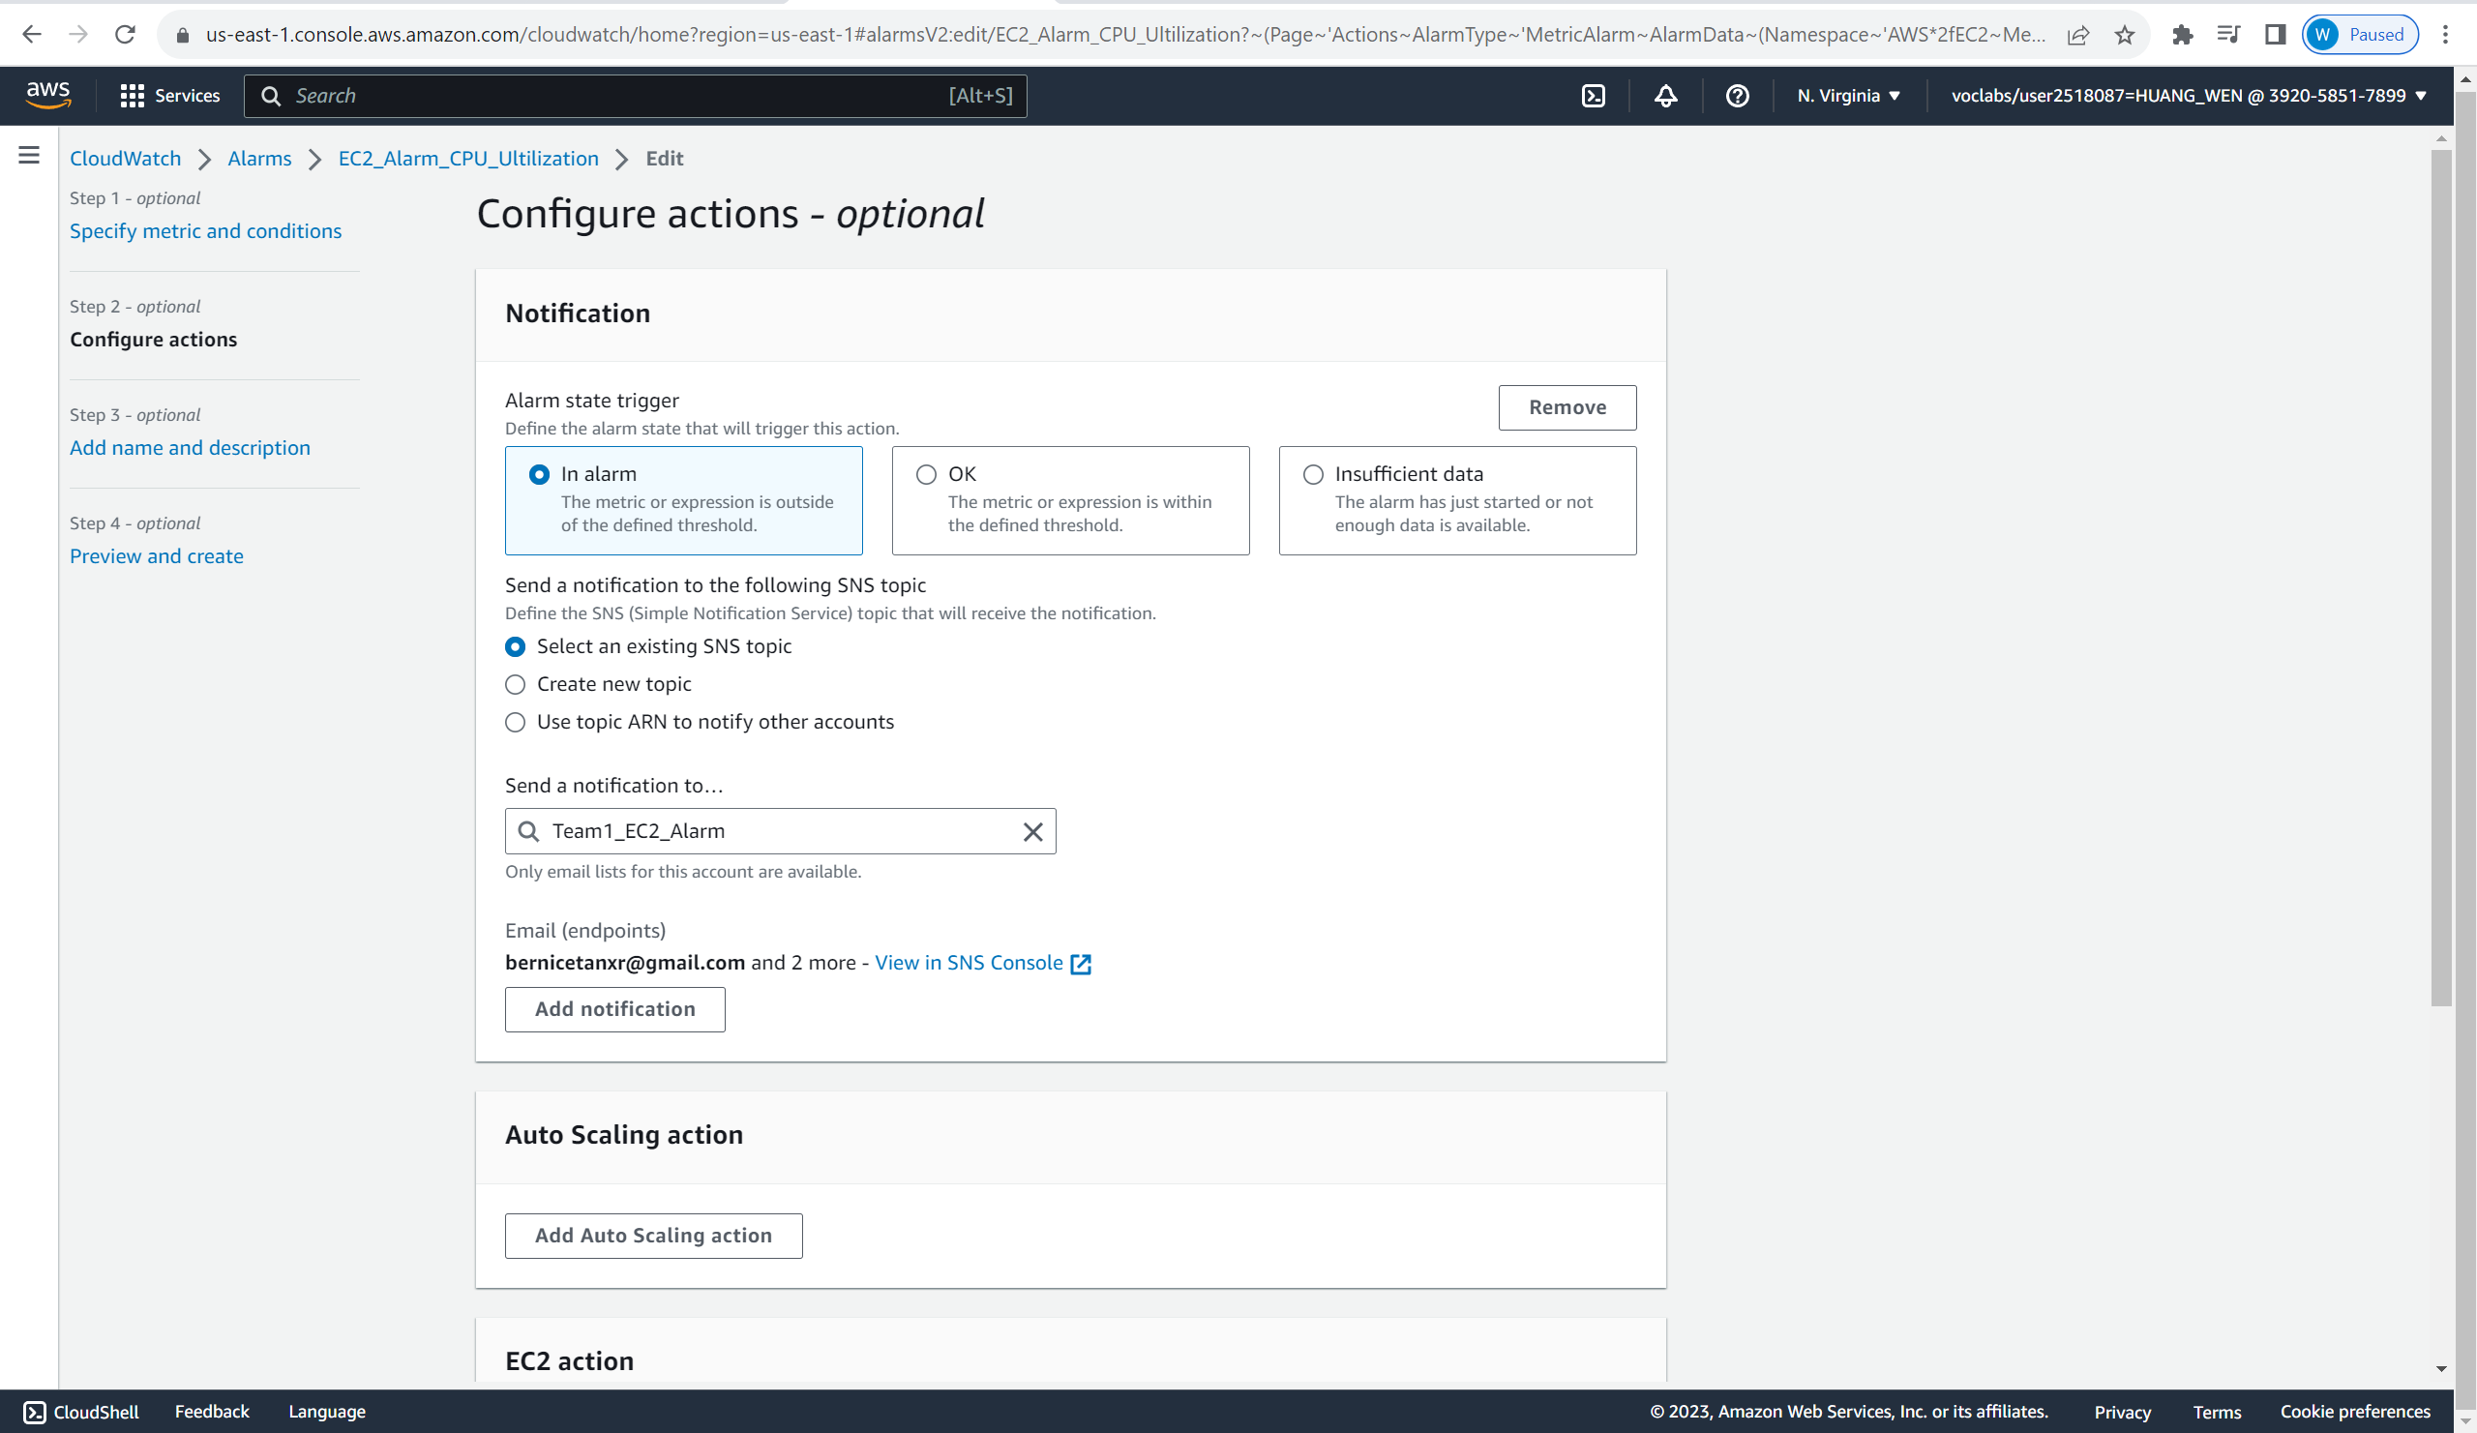

As we can see the alarm is set to monitor the CPU utilization of the EC2. If the CPU utilization exceeds 20%, it will send a notification to the Team1_EC2_Alarm topic.

Next, the alarm will be called Team1_RDS_BurstBalance.

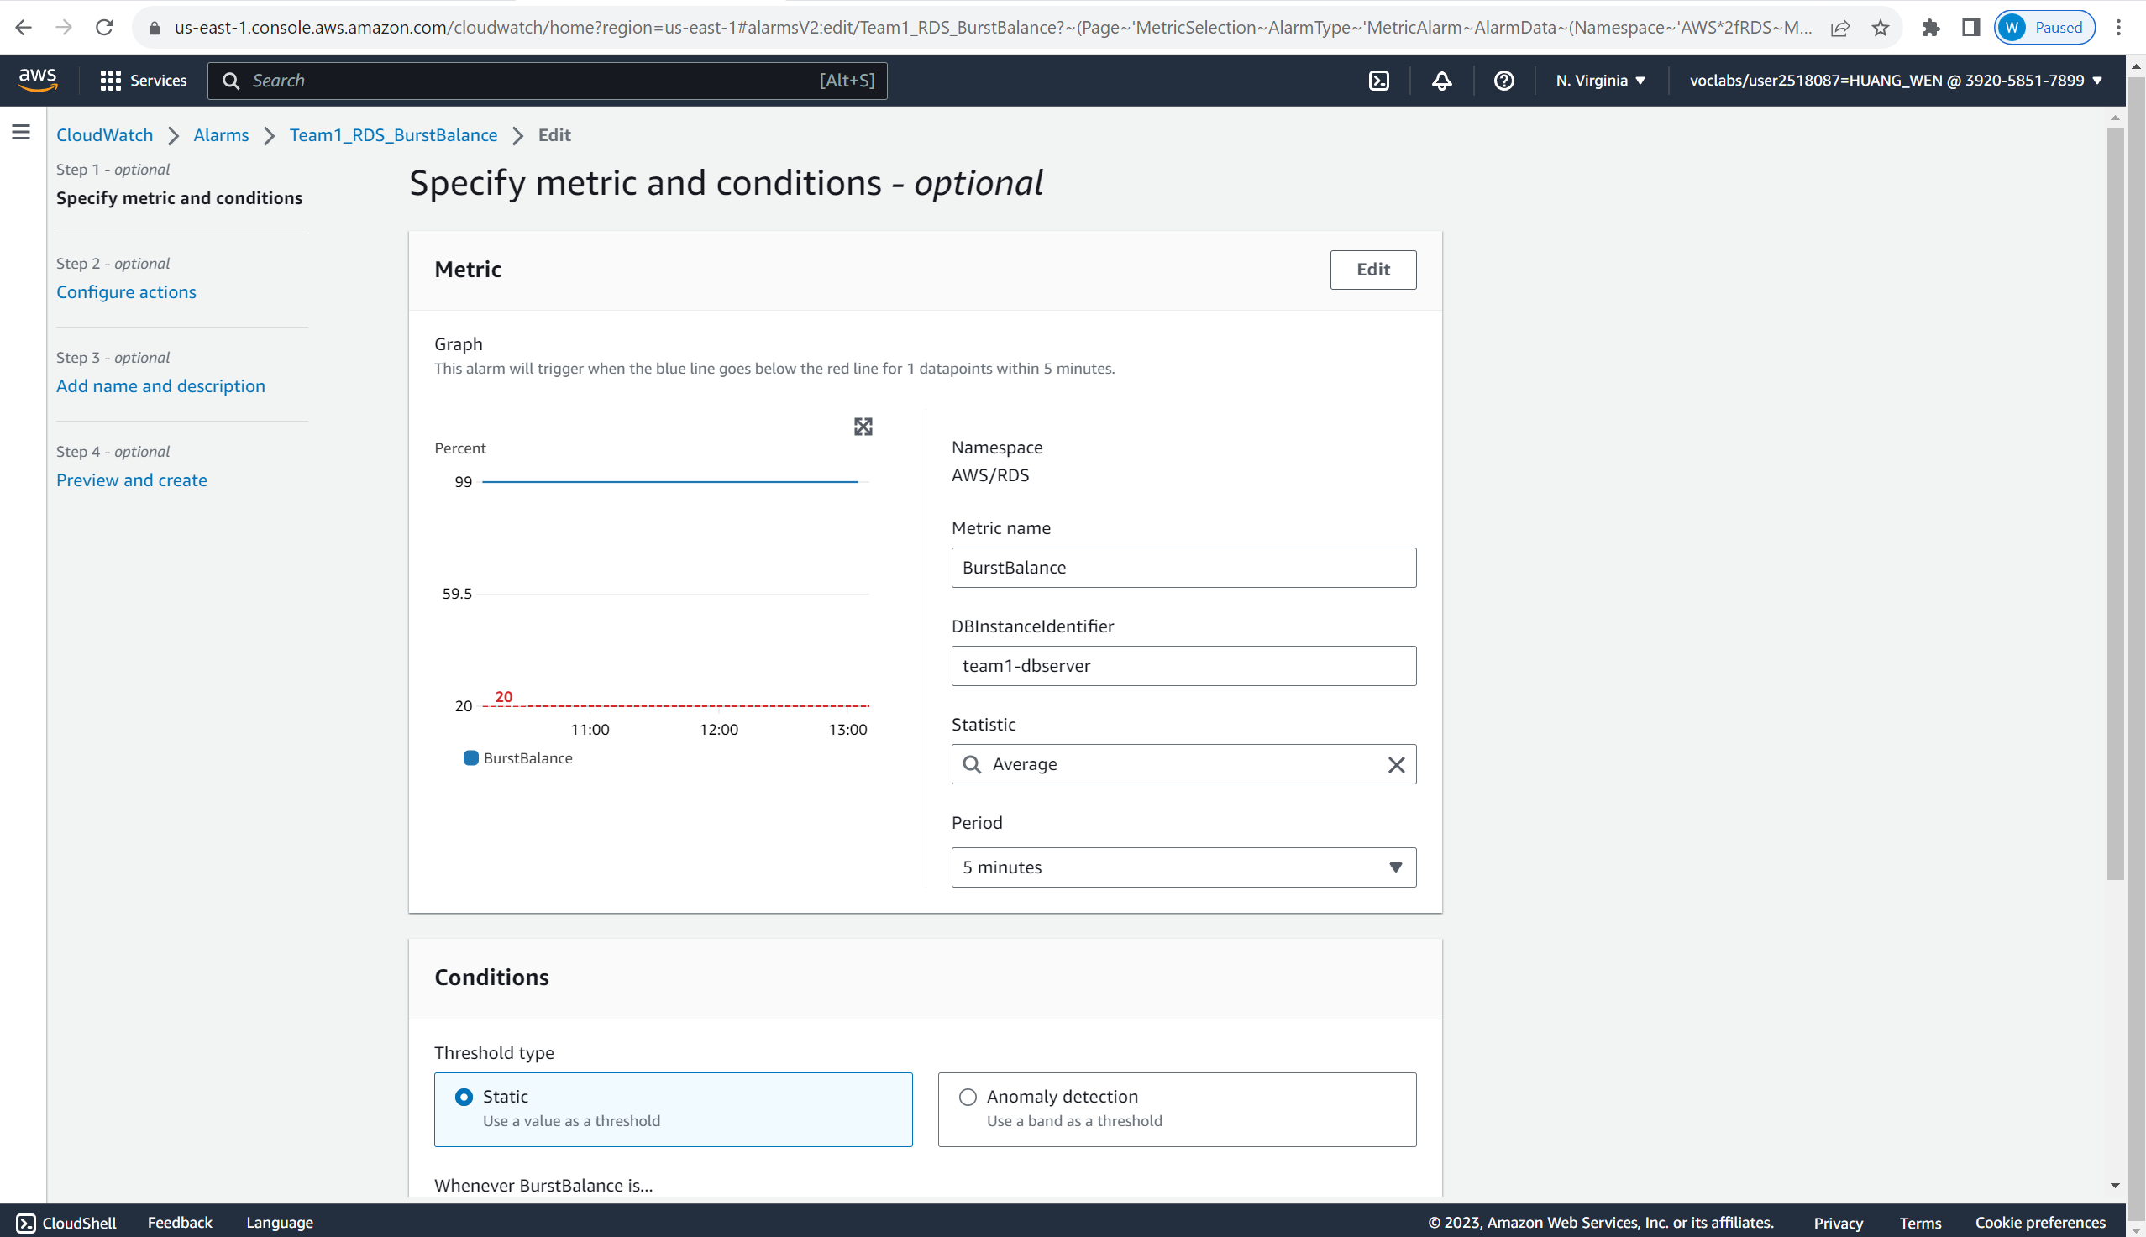

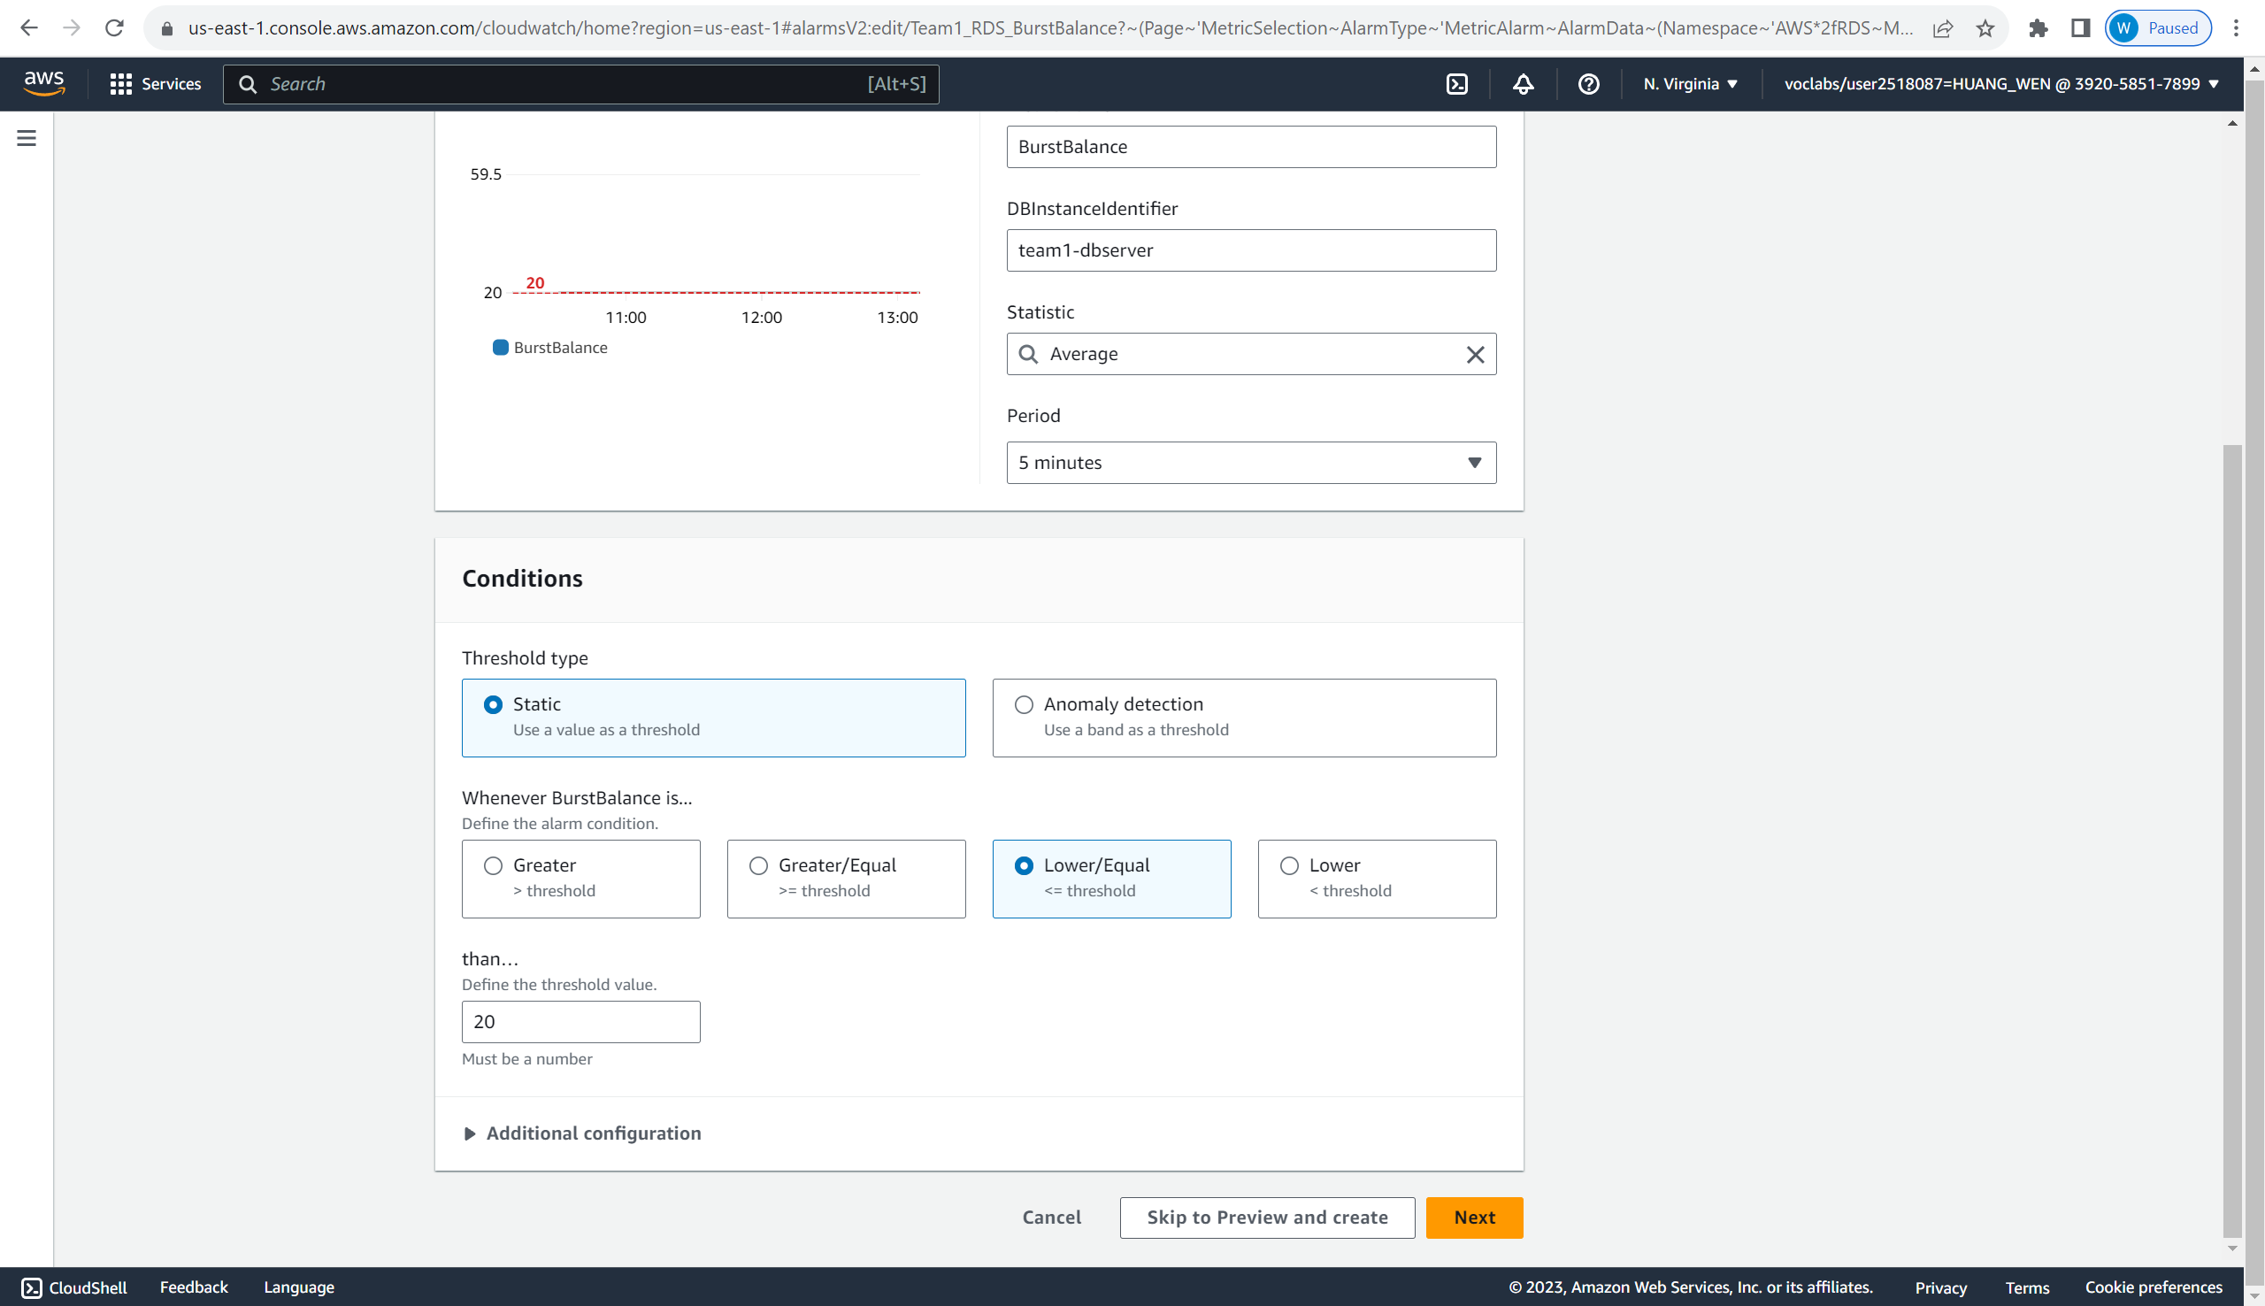

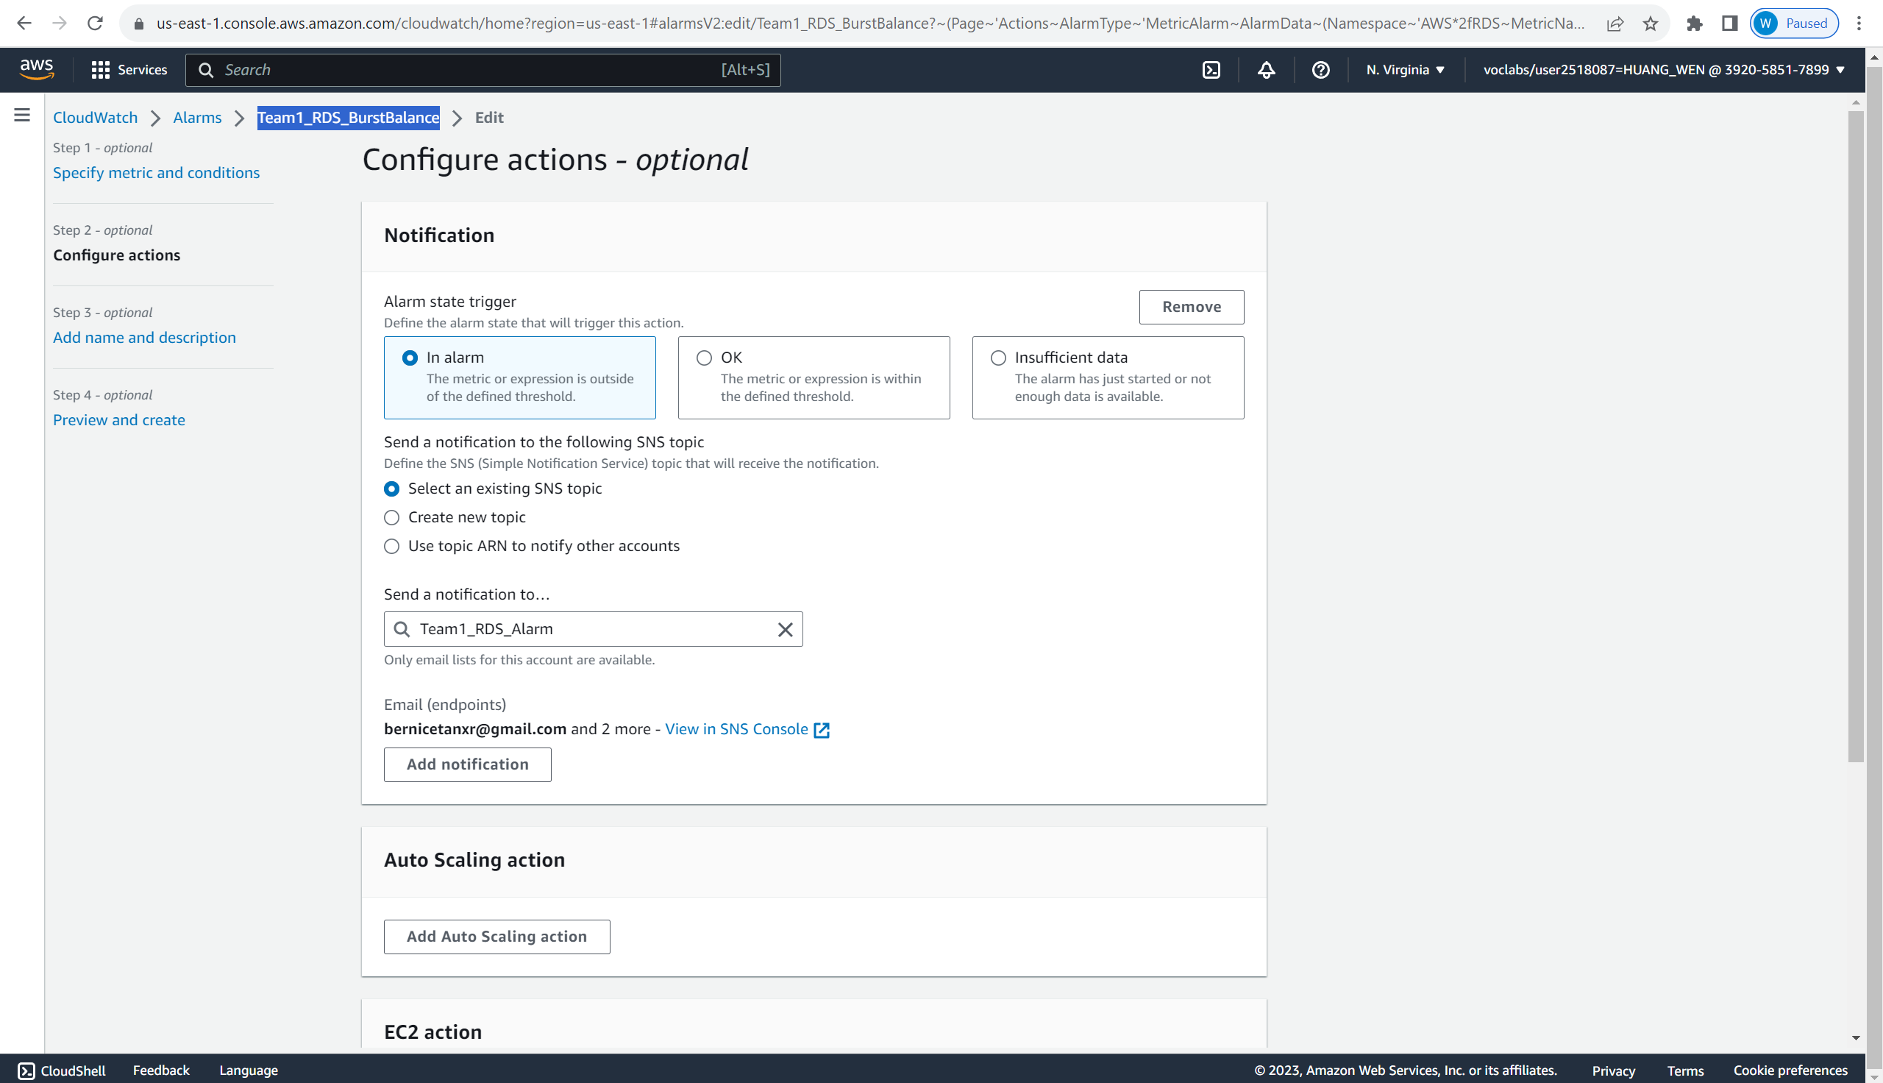

The alarm is set to monitor the Burst Balance for our RDS. Burst Balance is the per cent of General Purpose SSD (gp2) burst-bucket I/O credits available. When the percentage of Burst Balance is lower/equal to 20%, it will send a notification to the Team1_RDS_Alarm topic.

The next alarm is Team1_RDS_CPUCreditBalance.

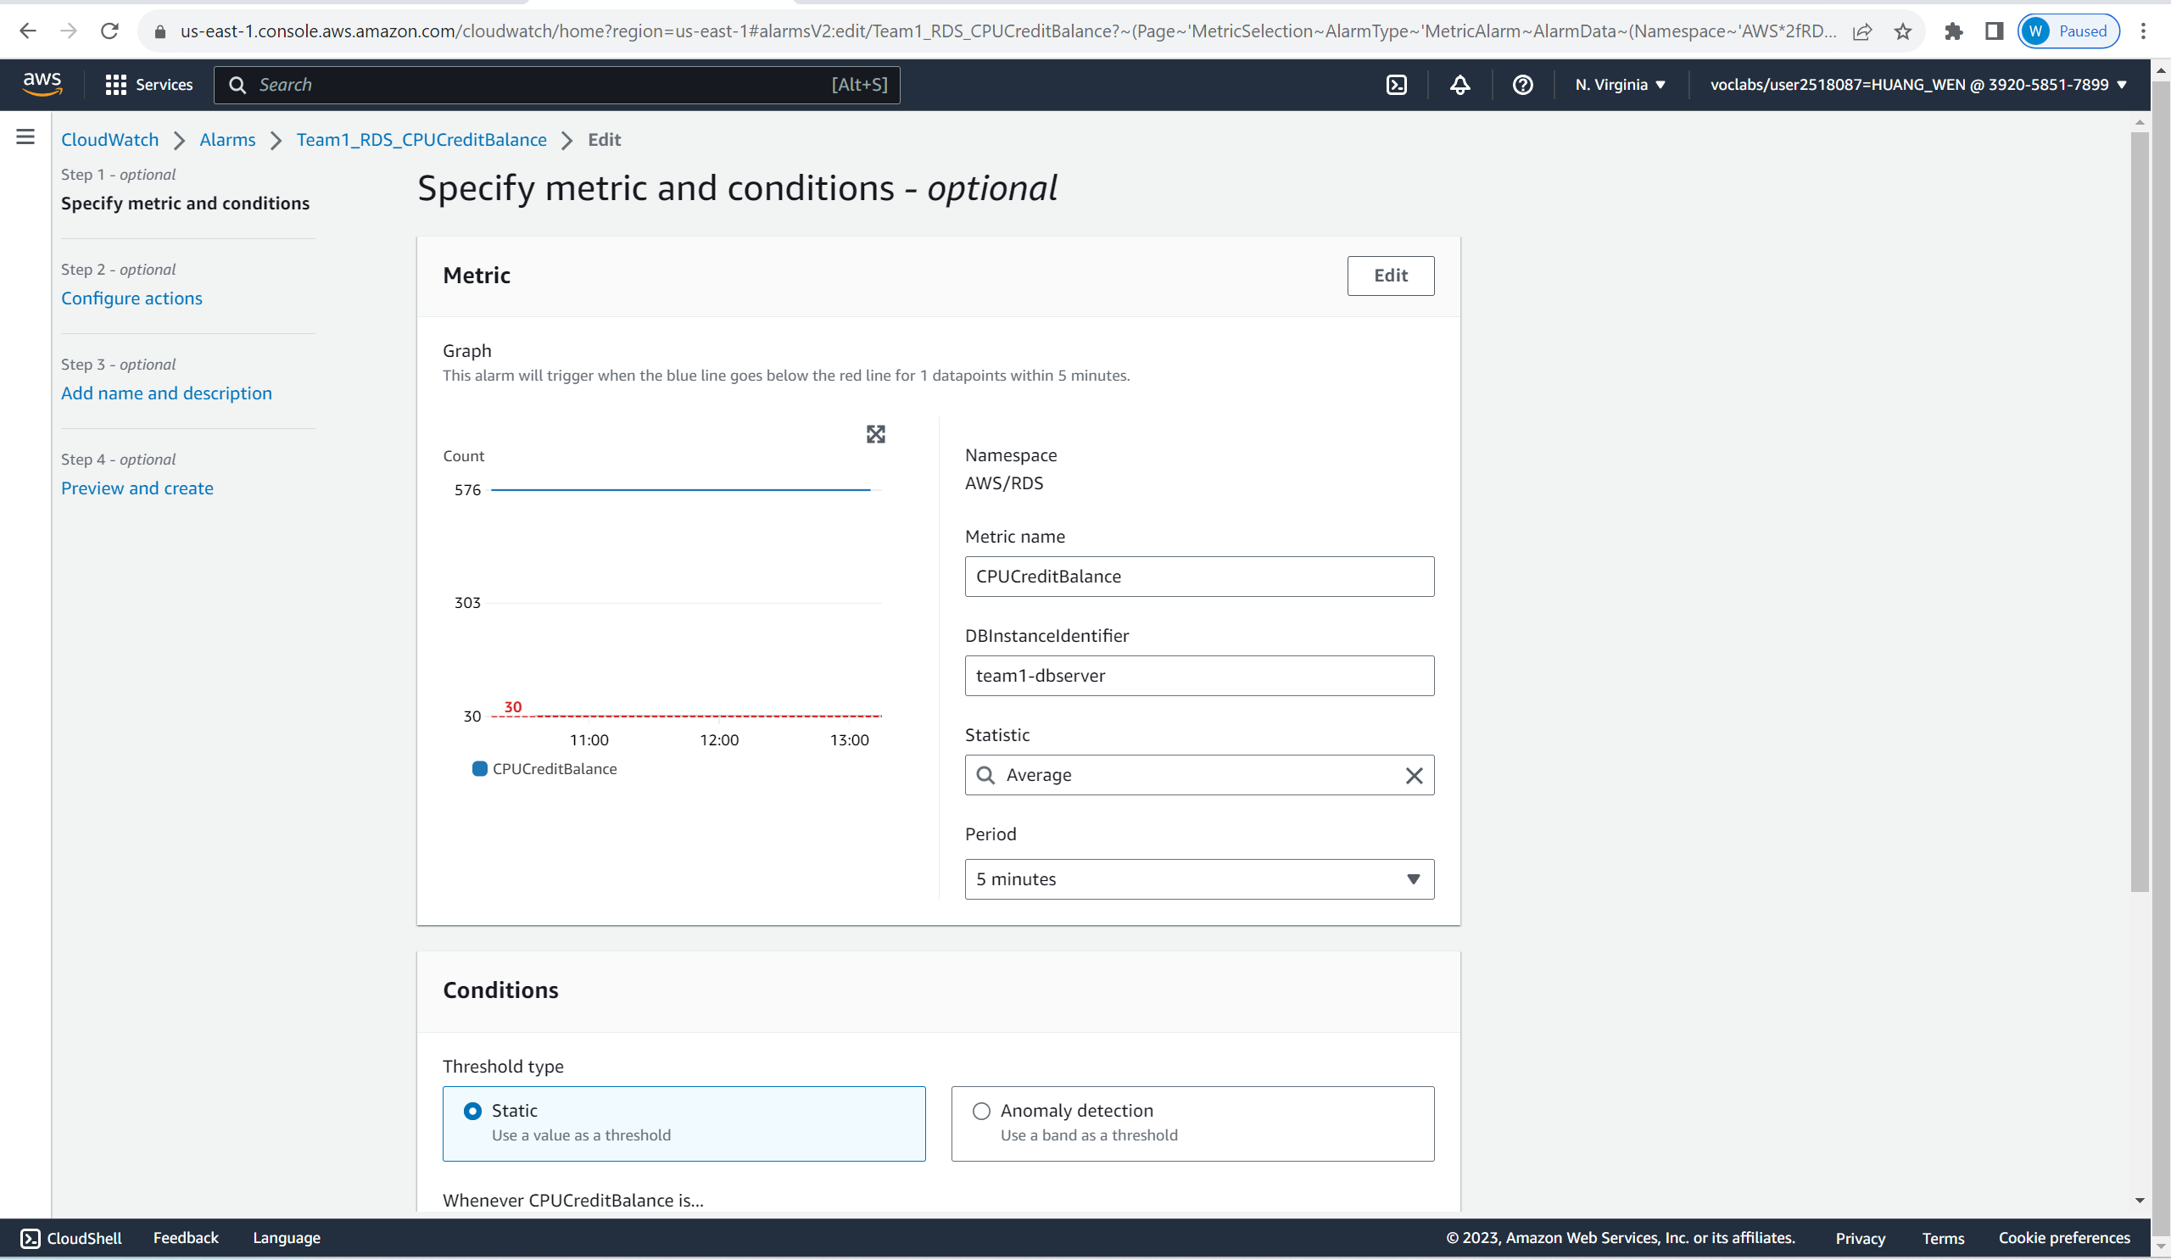

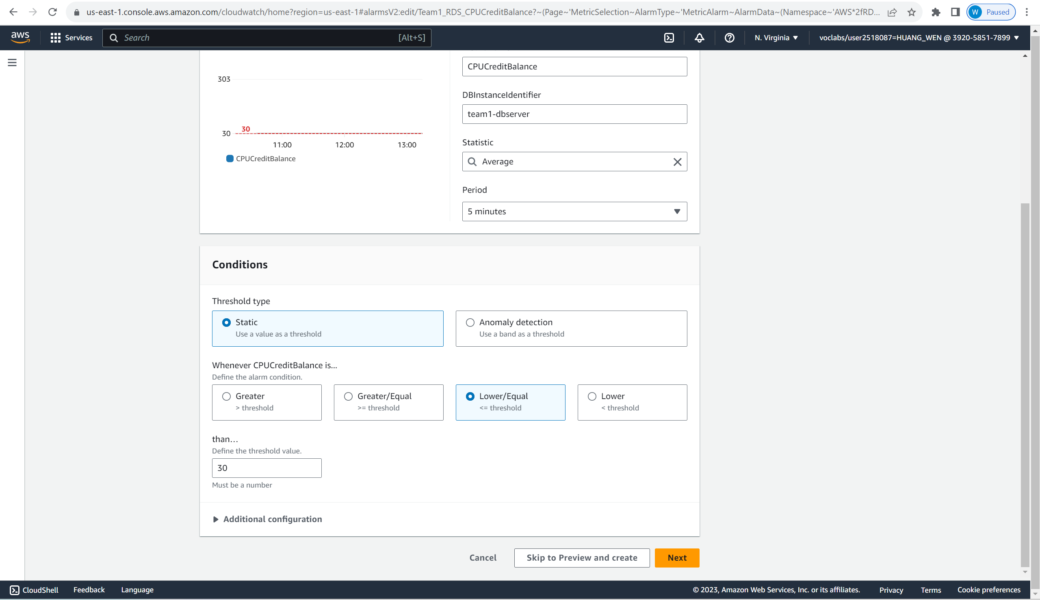

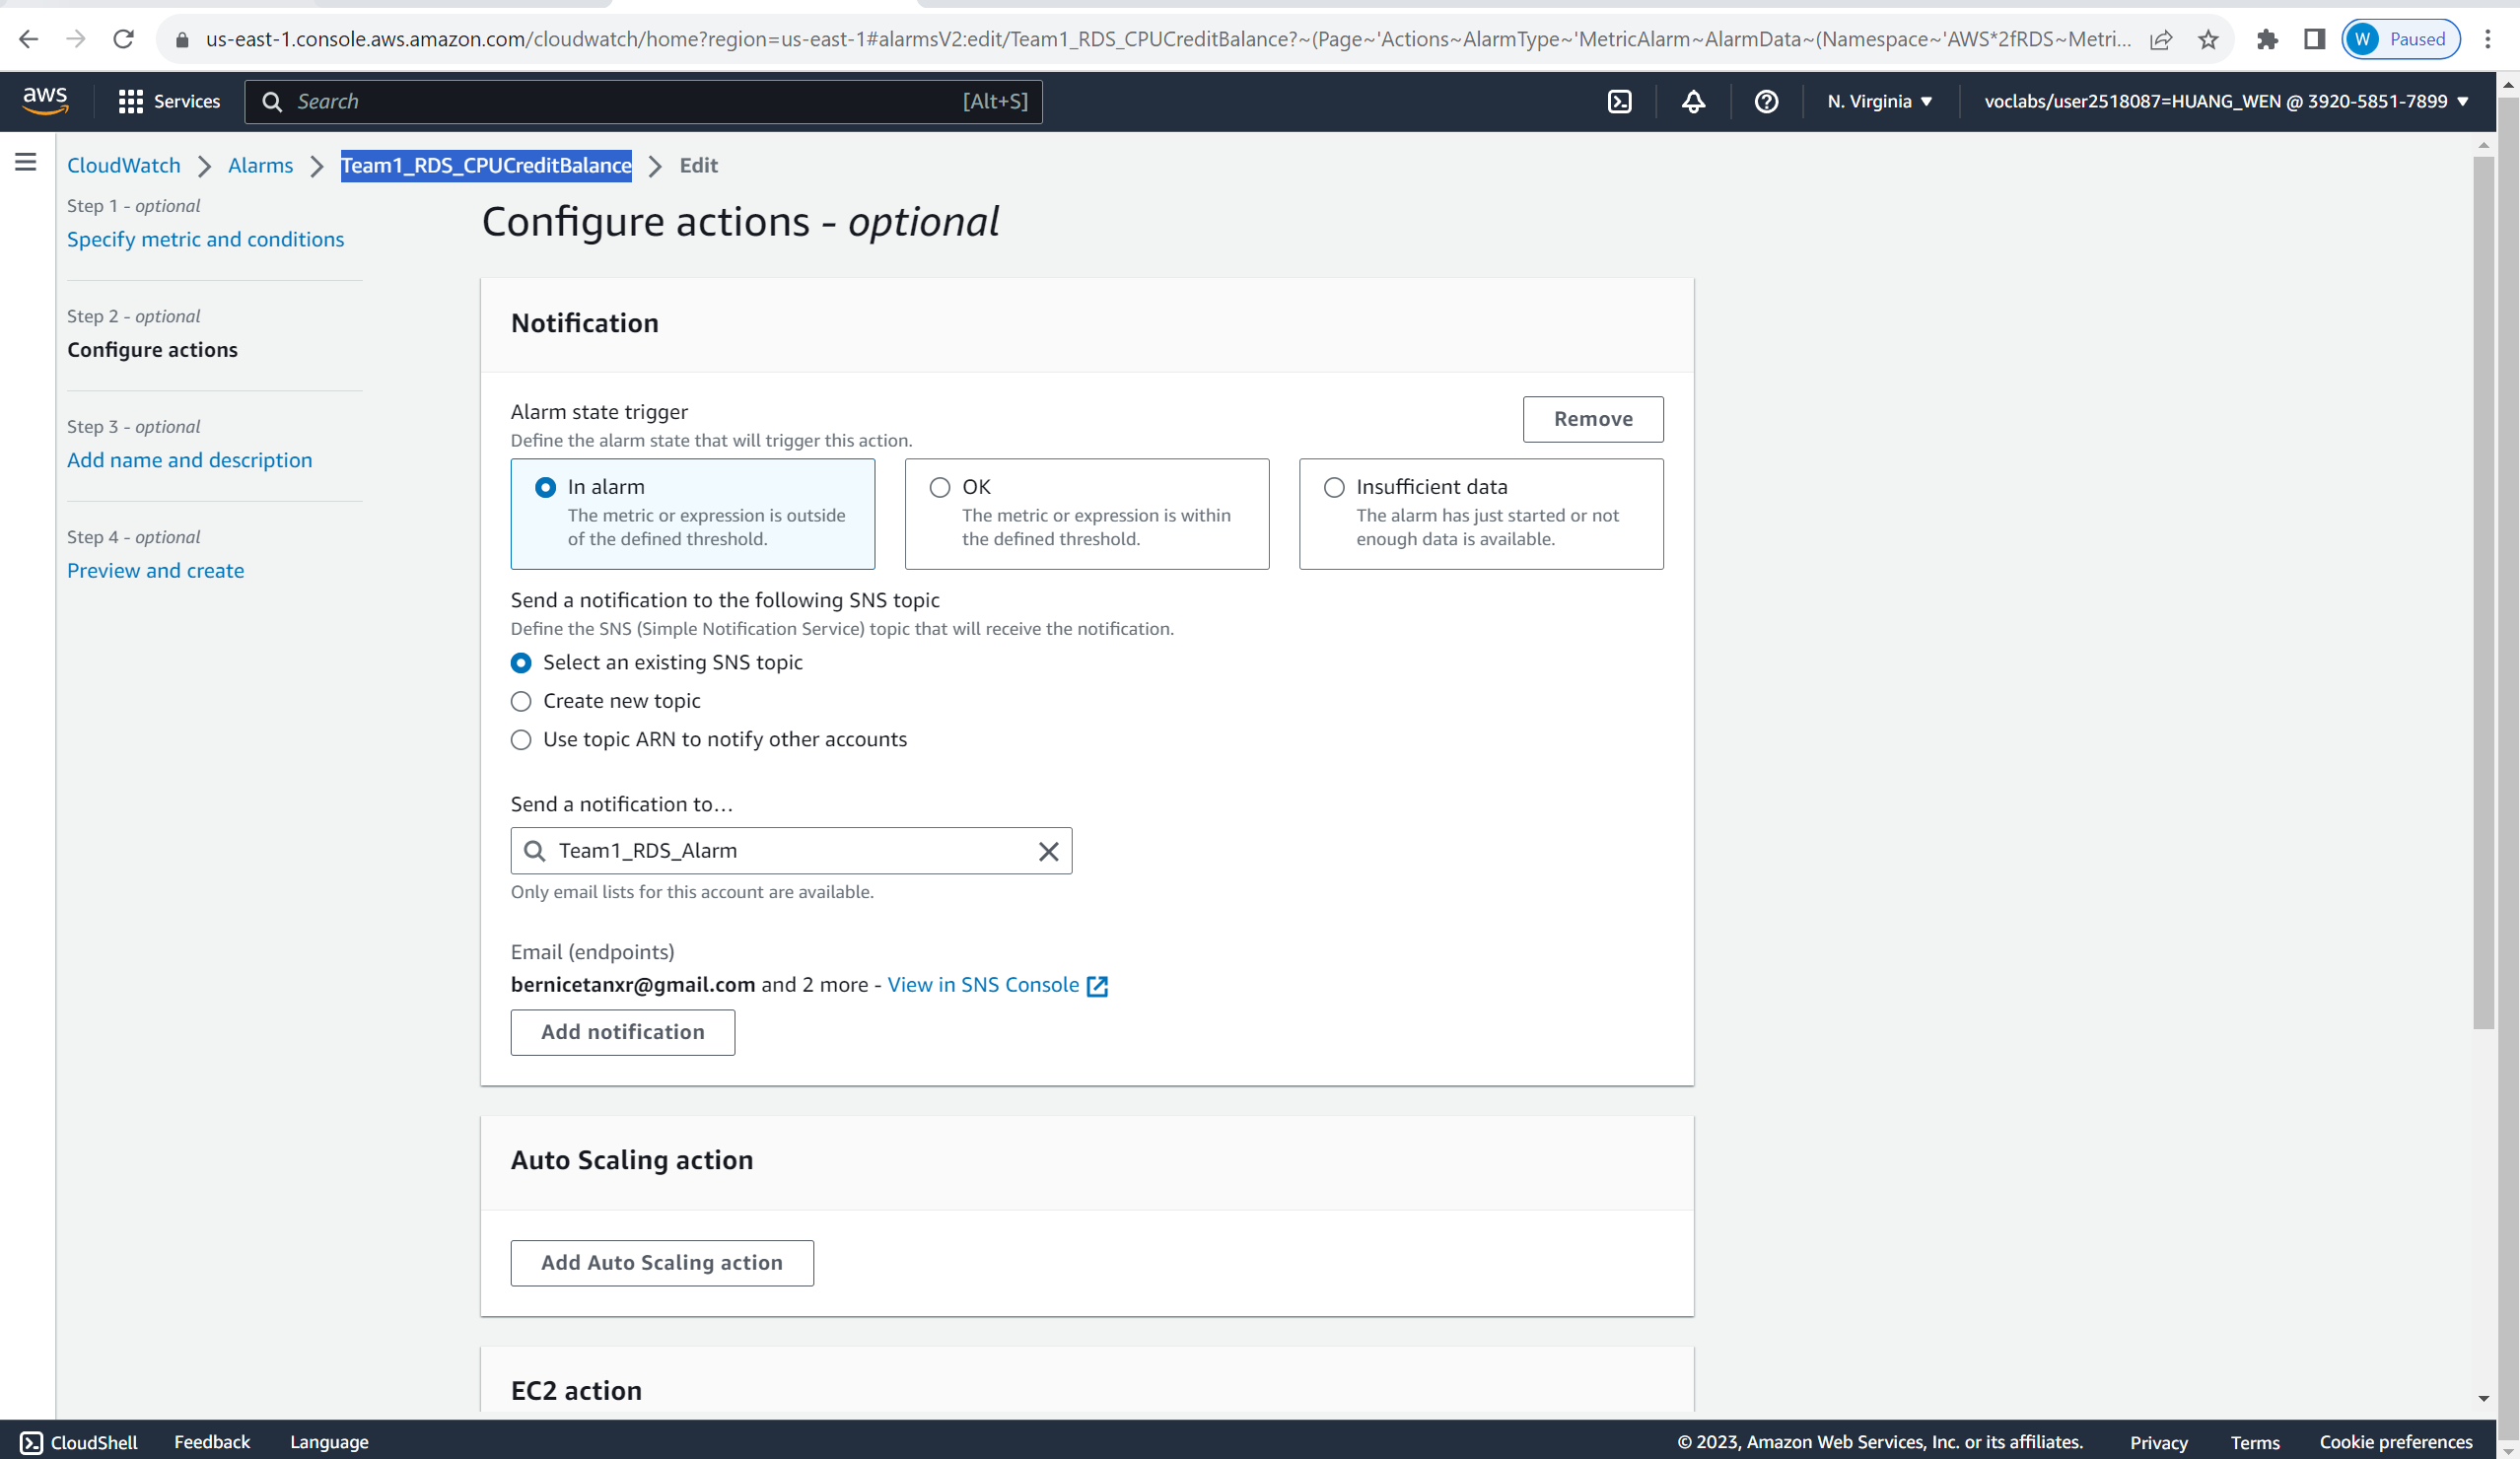

The alarm is set to monitor the CPU Credit Balance for our RDS. When the credit balance is lower/equal to 30, it will send a notification to the Team1_RDS_Alarm topic.

The next alarm is called RDS_Alarm_CPU_Ultilization.

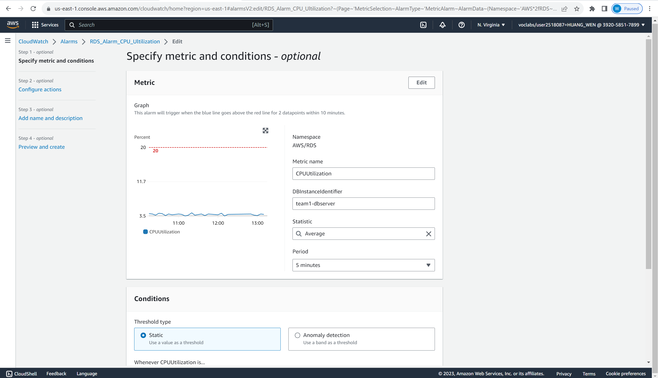

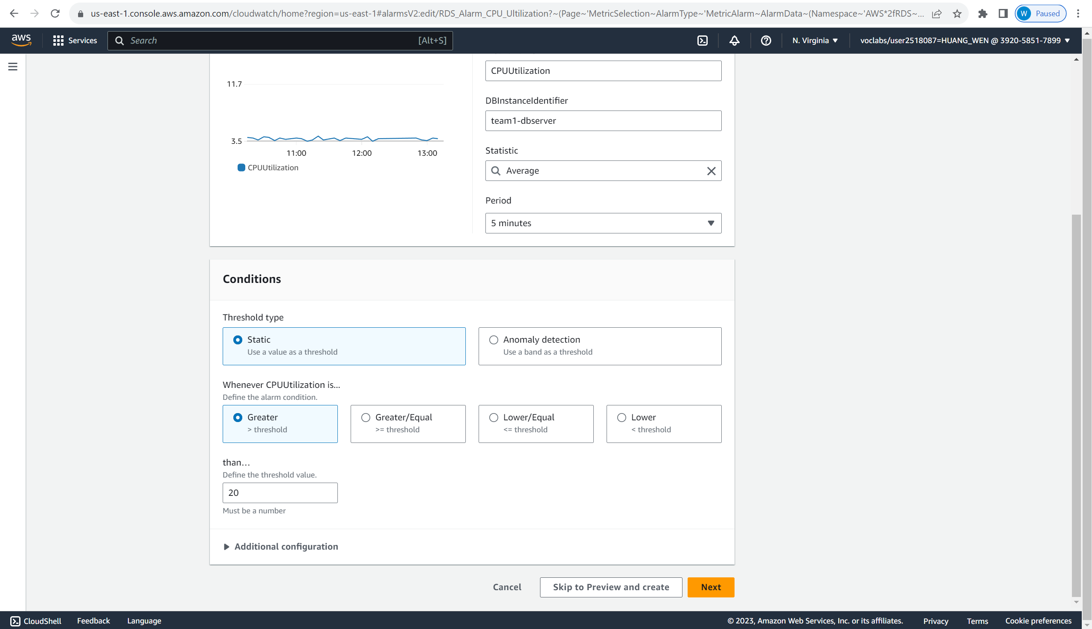

The alarm is set to monitor the CPU Utilization for our RDS. When the Utilization is greater than 20%, it will send a notification to the Team1_RDS_Alarm topic.

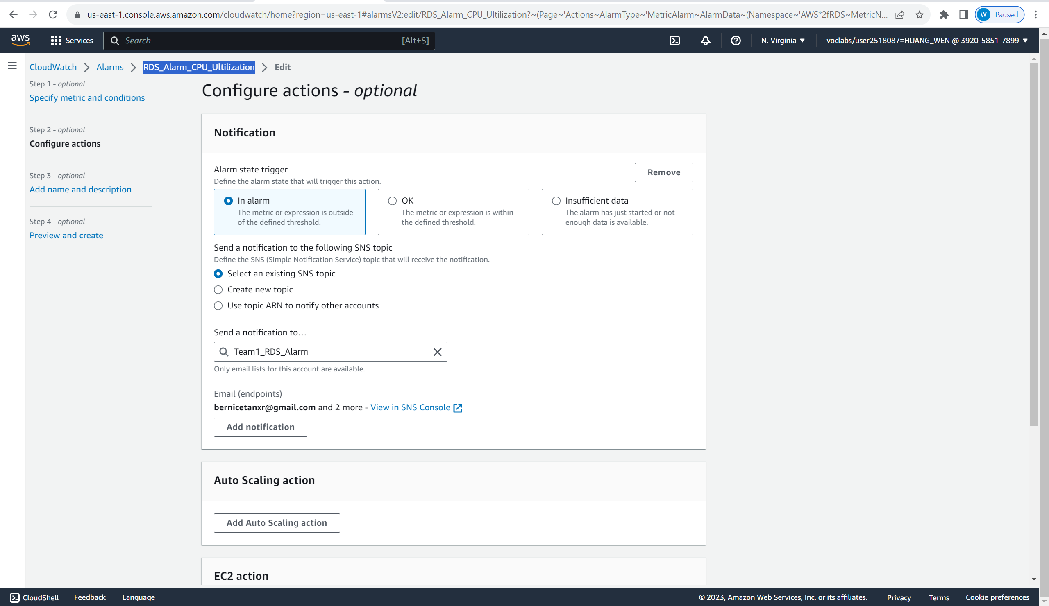

Next alarm is called TargetTracking-Team1-AutoScalingGroup-AlarmHigh-630dc7a4-e3d8-44c2-af9f-2894d31af7ed

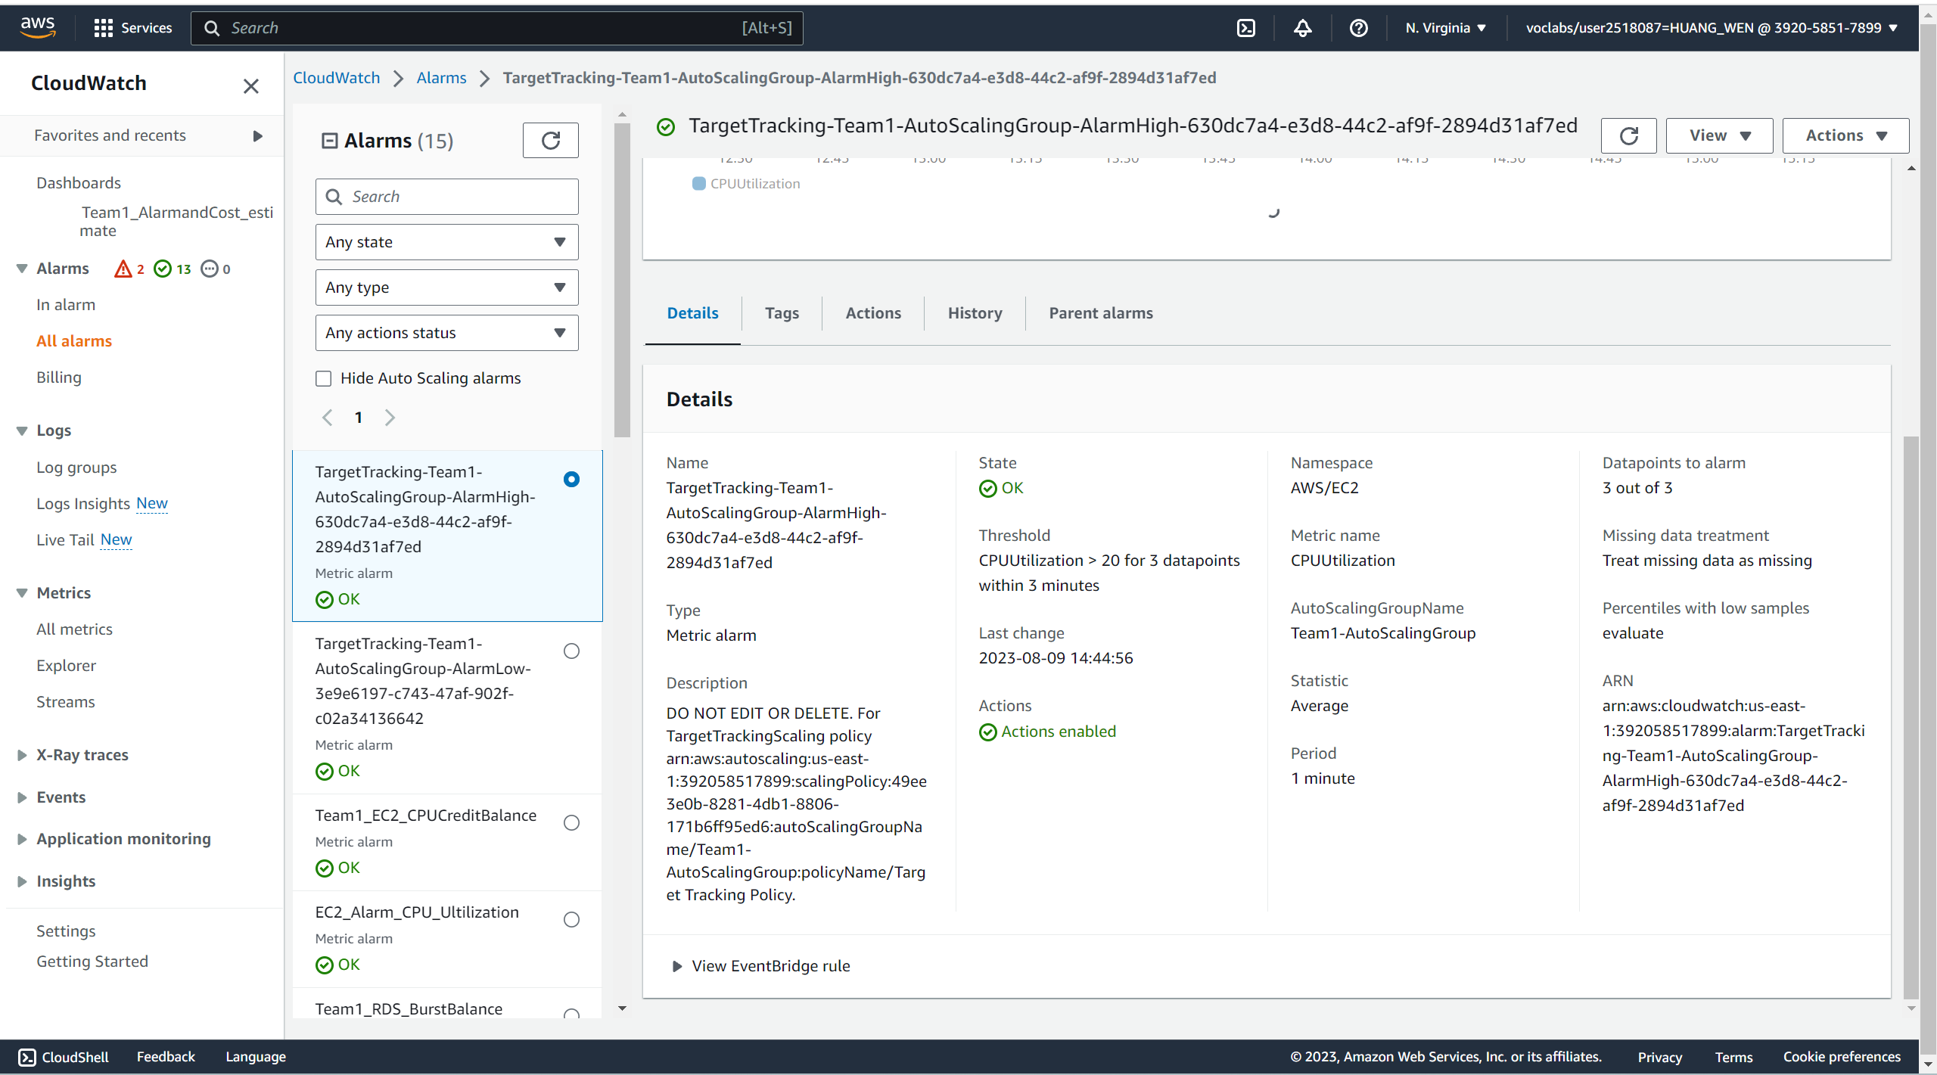

It will send notification to user when the EC2 CPU utilization is above the 20% threshold.

The last alarm is called TargetTracking-Team1-AutoScalingGroup-AlarmLow-3e9e6197-c743-47af-902f-c02a34136642

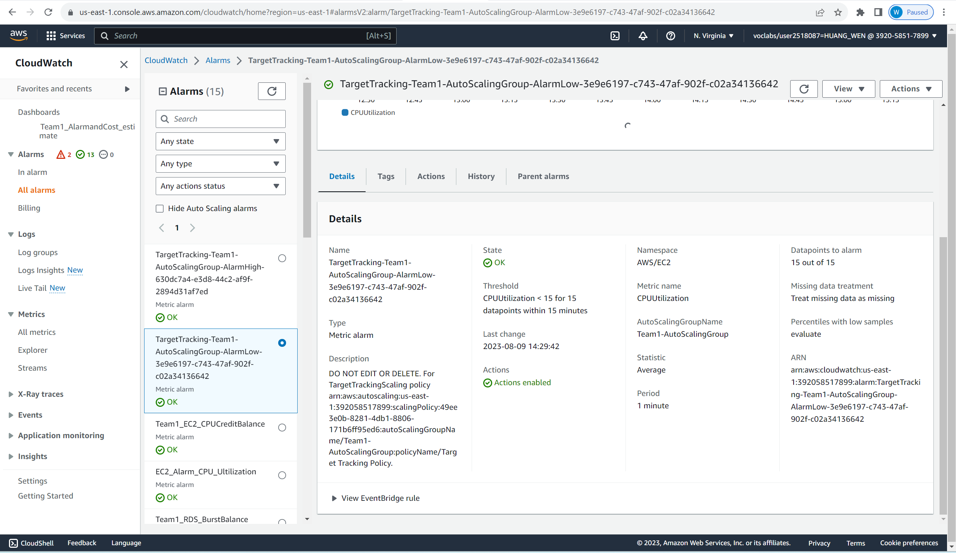

It will send notification to user when the EC2 CPU utilization is below 15% threshold.

Next, we will move on to SNS topic. The following are the two topics created for notification for RDS and EC2 separately. When the alarm attached to the topic is in alarm state, it will send an email notification to the topic’s subscriber.

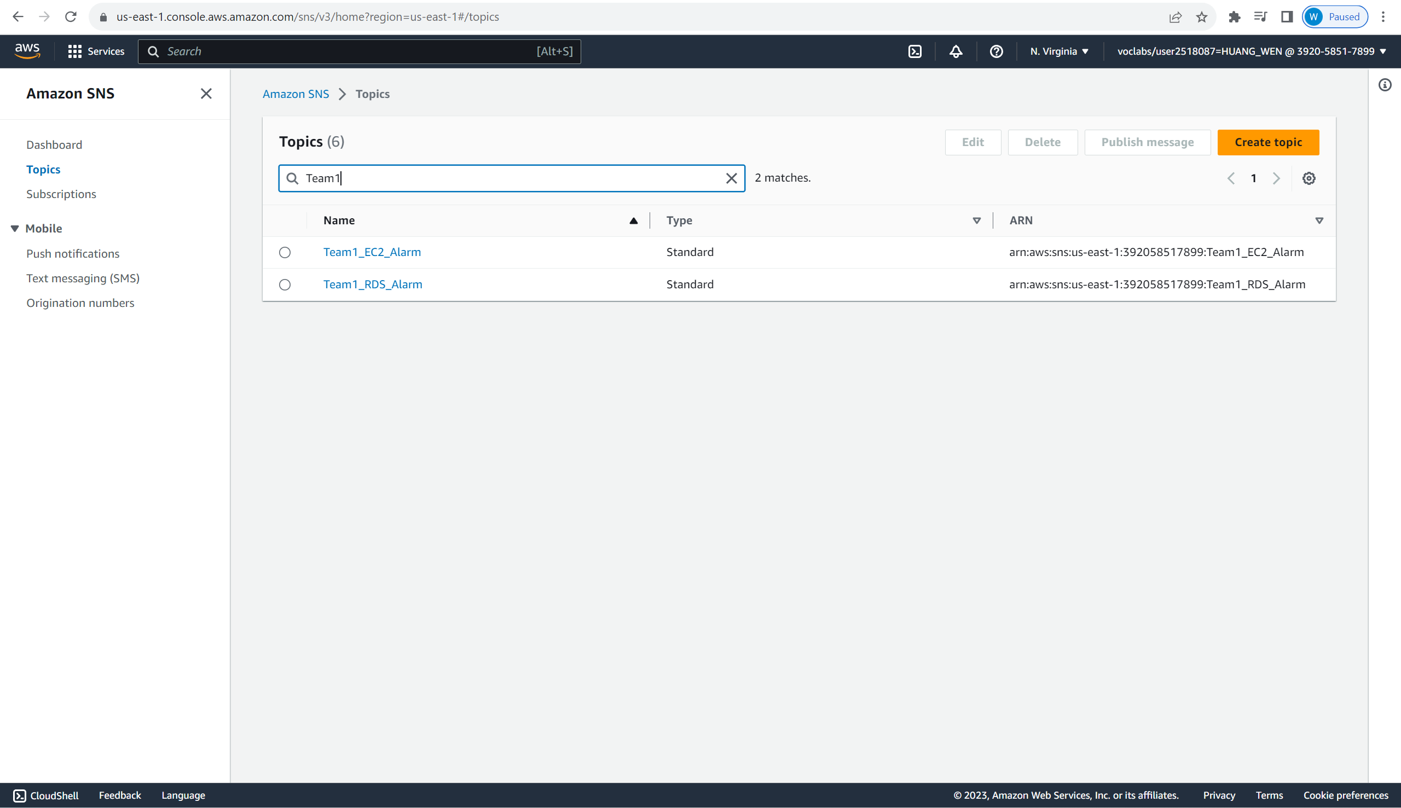

This is the EC2 topic and the subscriber to it.

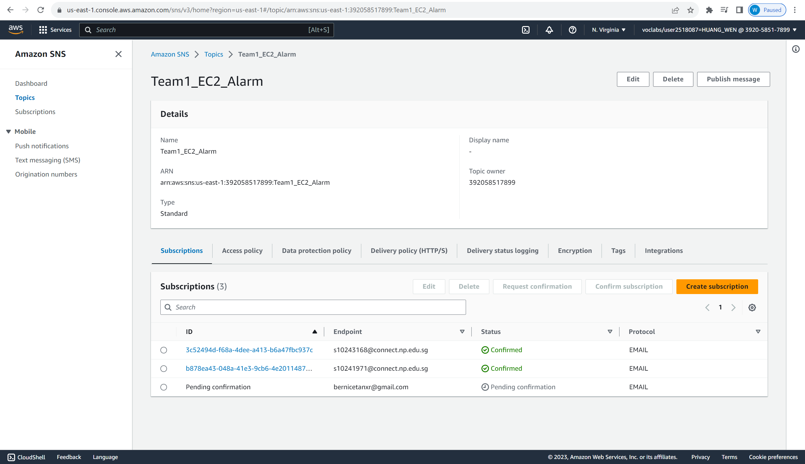

This is the RDS topic and the subscriber to it.

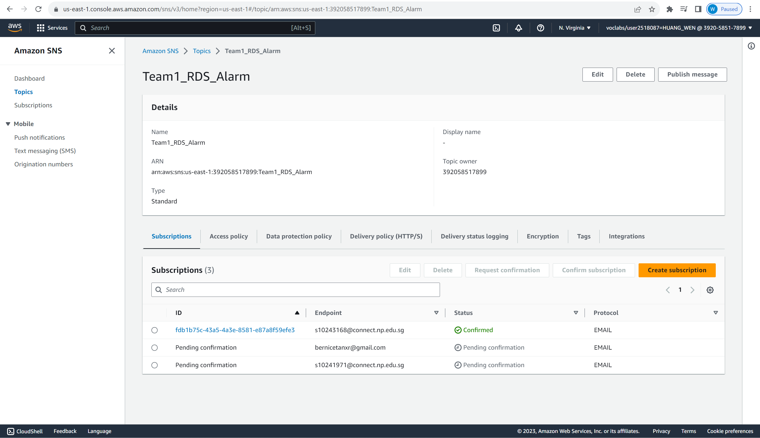

There is another SNS topic for Auto-Scaling Group.

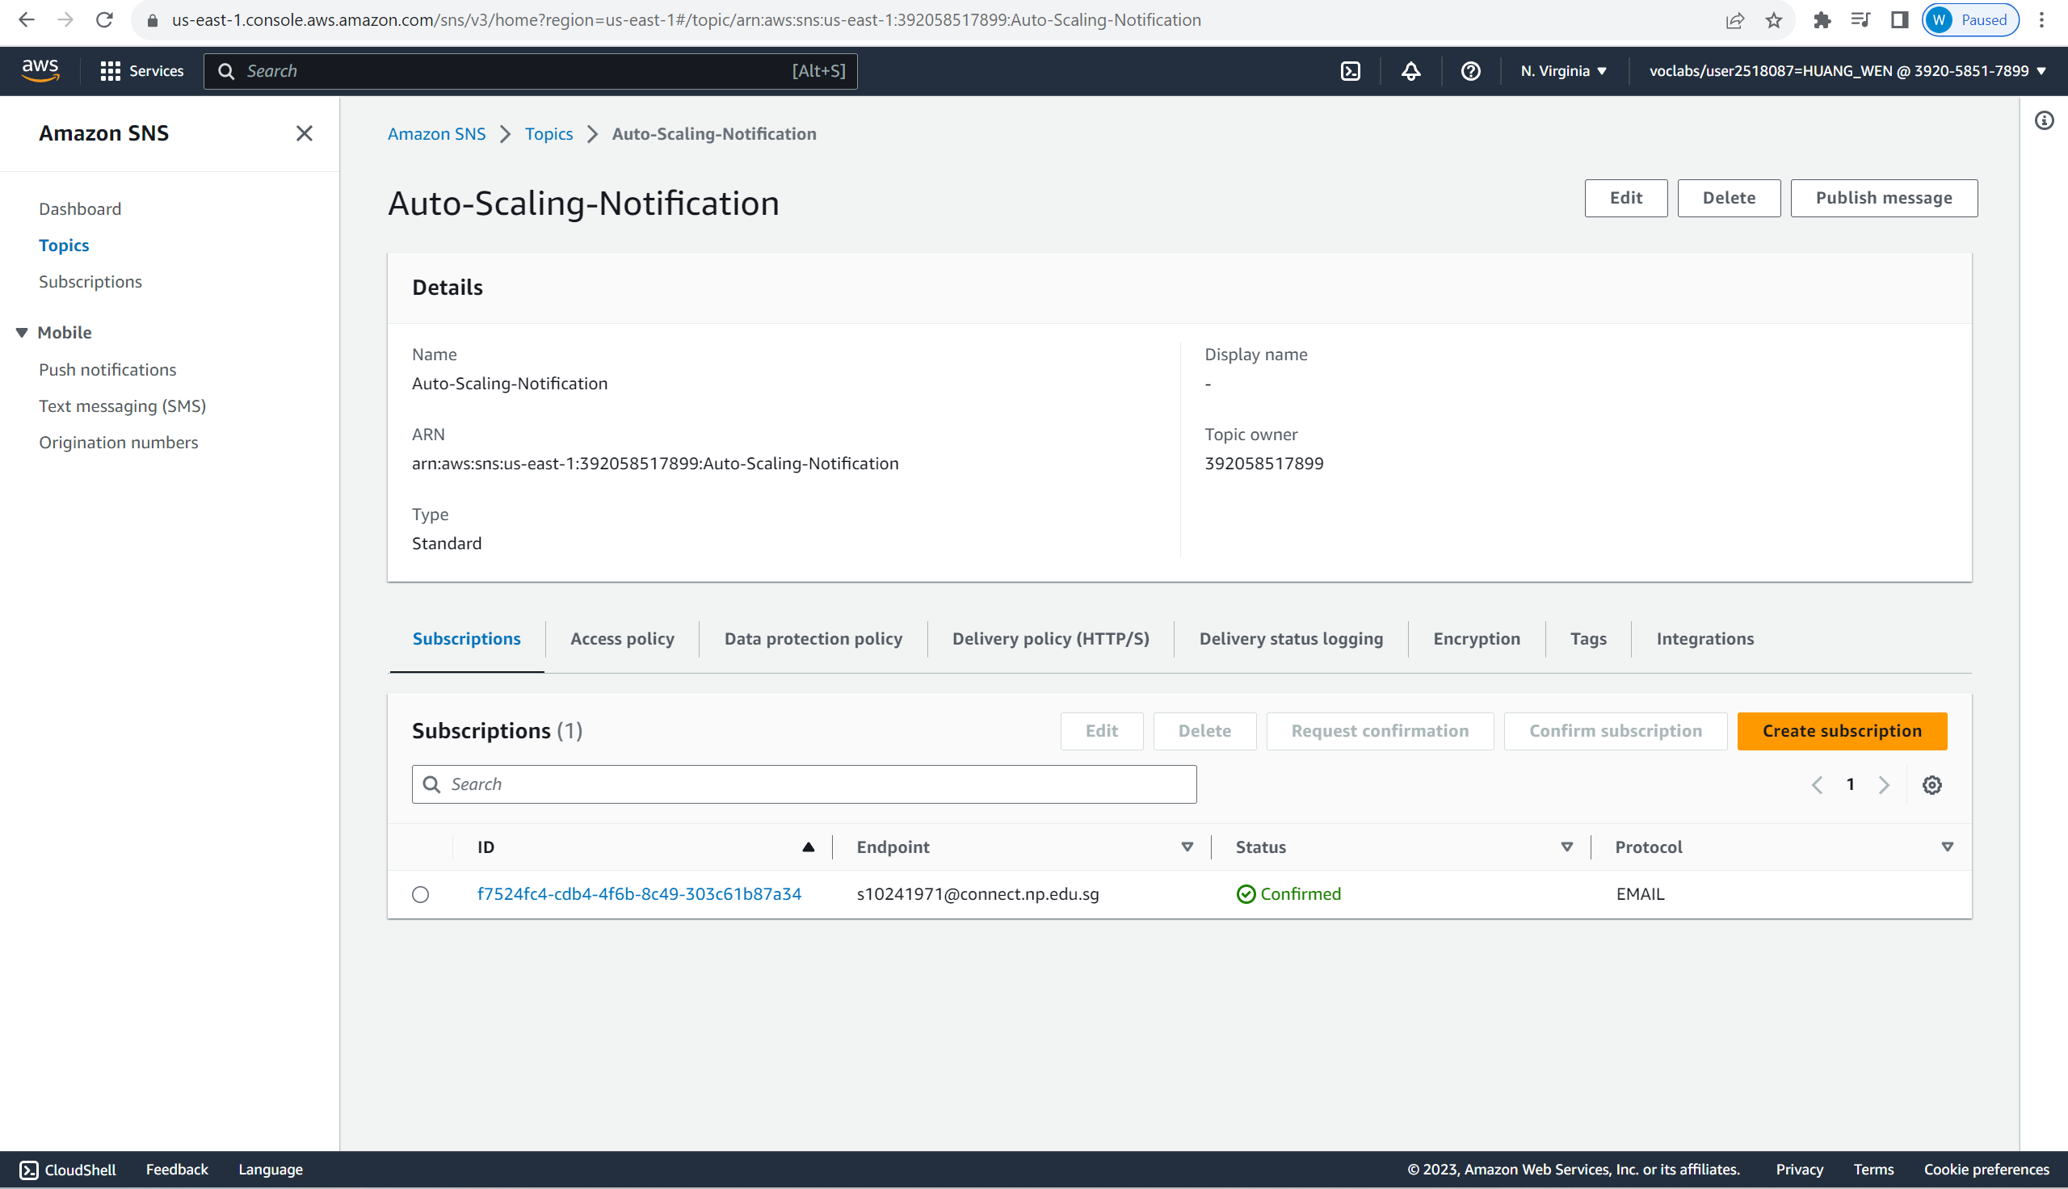

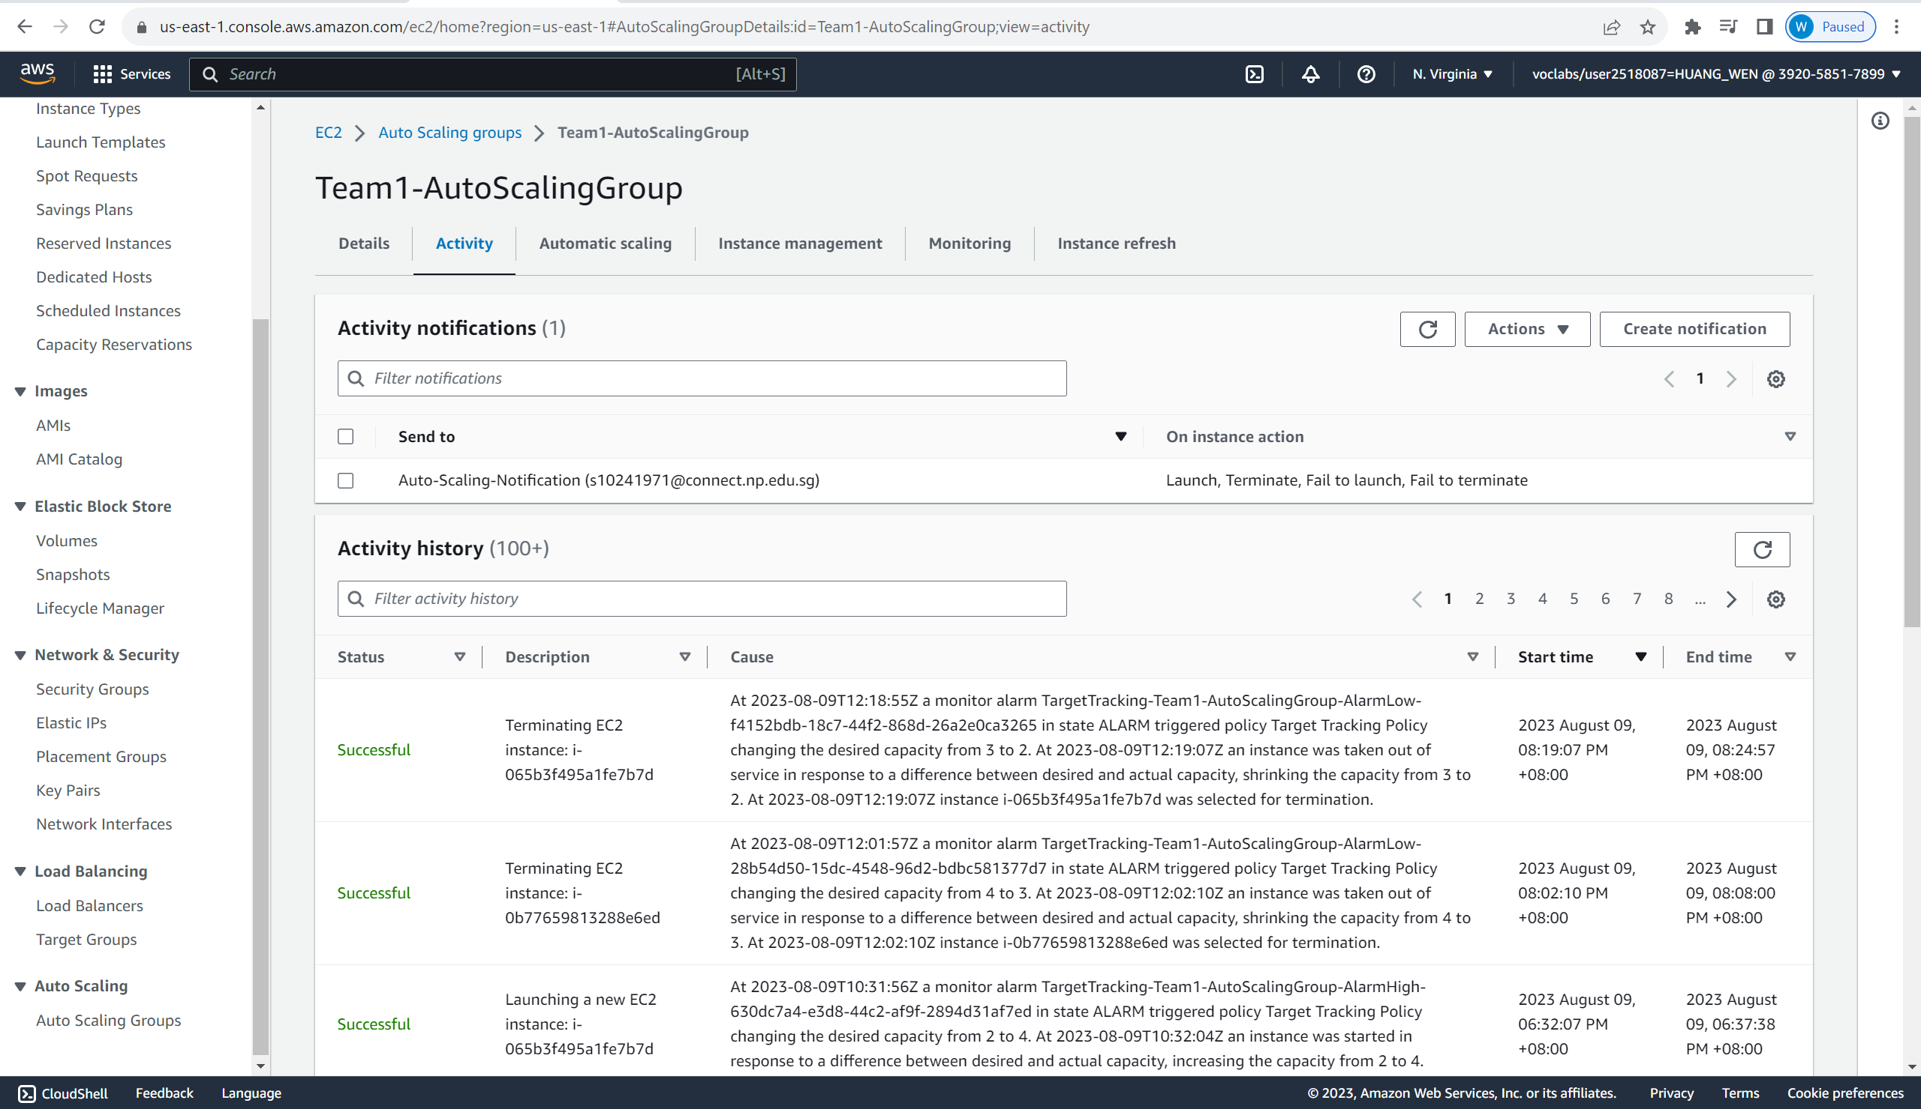

It will send an email to the subscriber of the topic, notifying him when the Auto-Scaling Group Launch, Terminate, Fail to Launch and Fail to Terminate an instance.

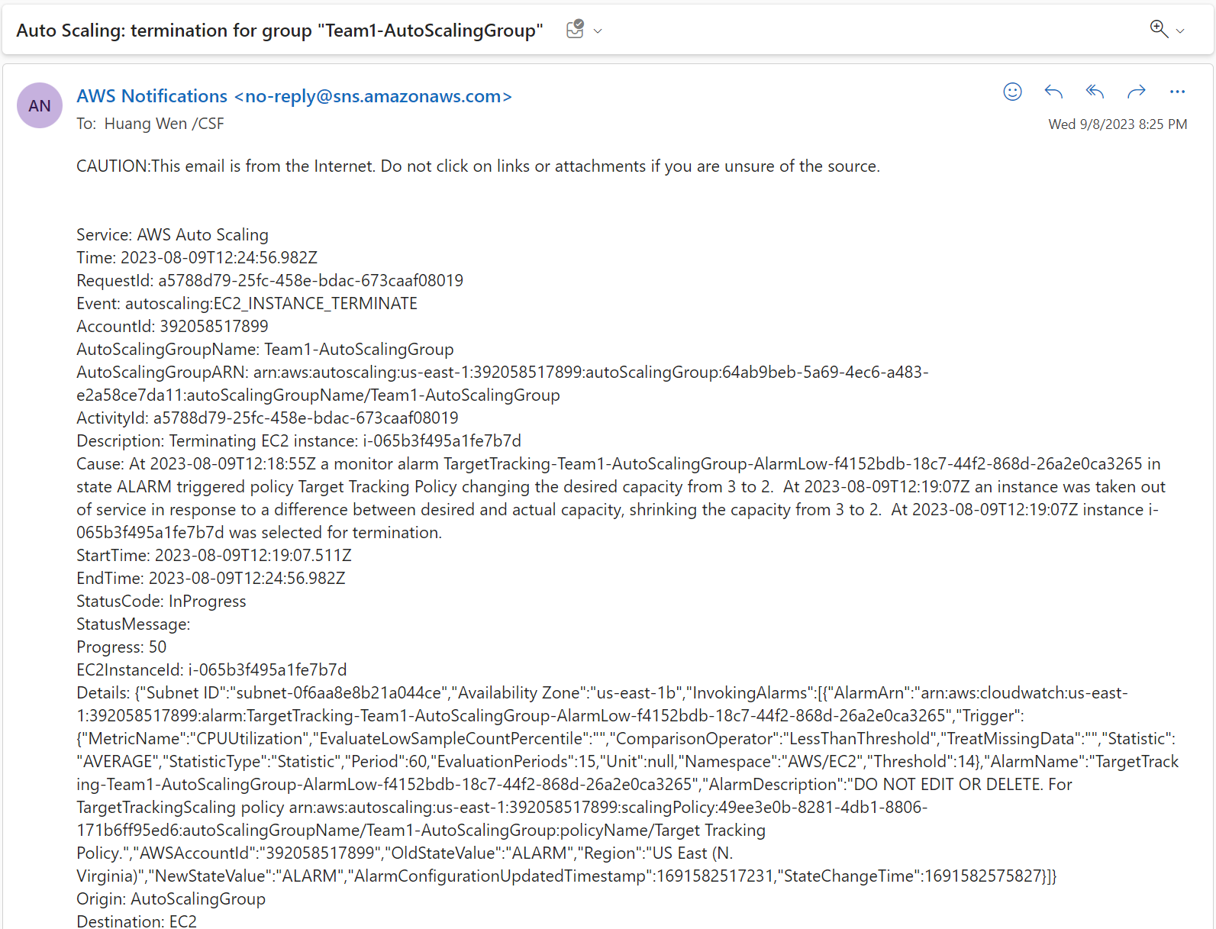

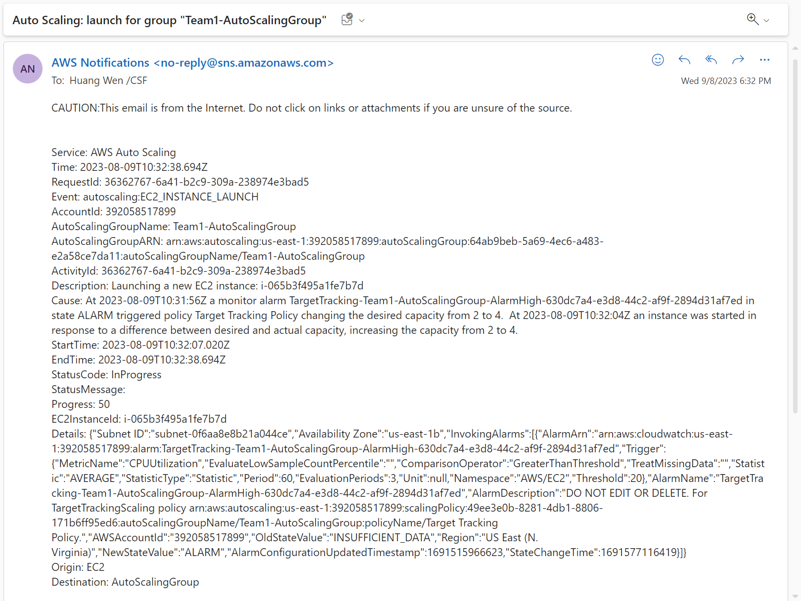

## Description of cloud solution (Requirement 2)

### 4.2.1 NoSQL Database for Customer Data

To store customer data from the website, my team has set up a NoSQL database using **Amazon DynamoDB** named **“CustomerData”**. This database is designed to capture customer information, including their first name, last name, and email address.



In the database schema, we have set the **"emailAddress"** as the **partition key.** Also the **attributes** for Customer’s **"lastName"** and **"firstName"** have been added to the database schema. This allows for a more comprehensive customer record, enabling the application to capture and store all relevant details about each customer.

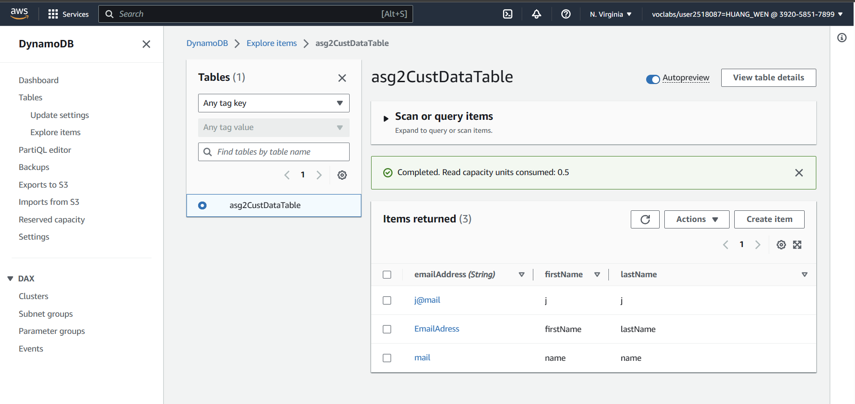

### 4.2.2 HTML Forms Page and API Gateway Integration

To capture the customer data, we have created a HTML forms page named **“Index.html”**, which serves as an intuitive interface where customer fills in their details.

Index.html:

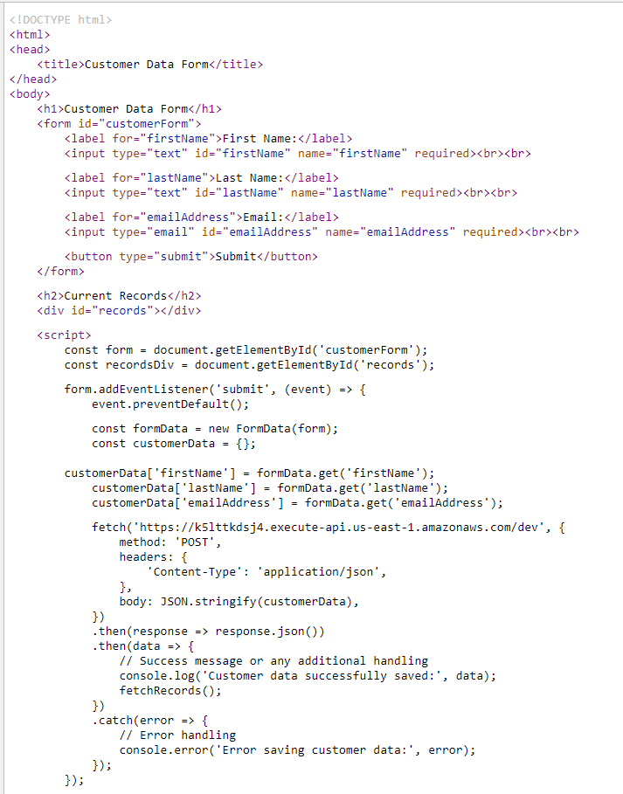

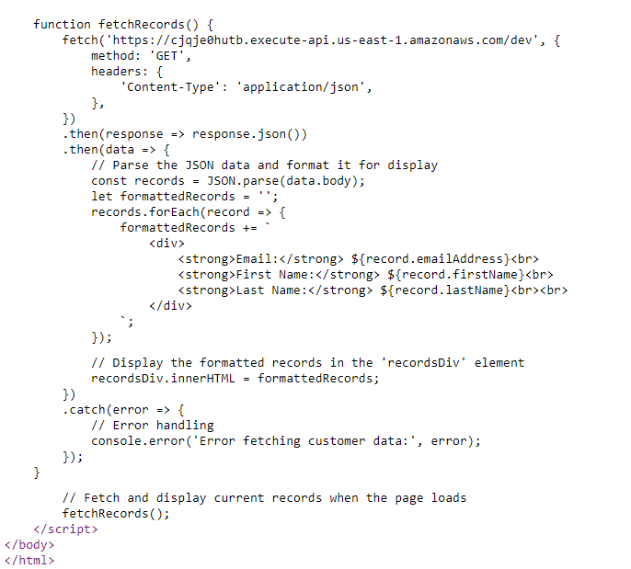

The page is hosted in an **S3 bucket** named **“static-web-host-bucket-asg2”**, making it easily accessible to users. When a user submits the form, it triggers an **HTTP POST request** to the **API Gateway endpoint** associated with the **"ASG2POSTCustDataAPI**."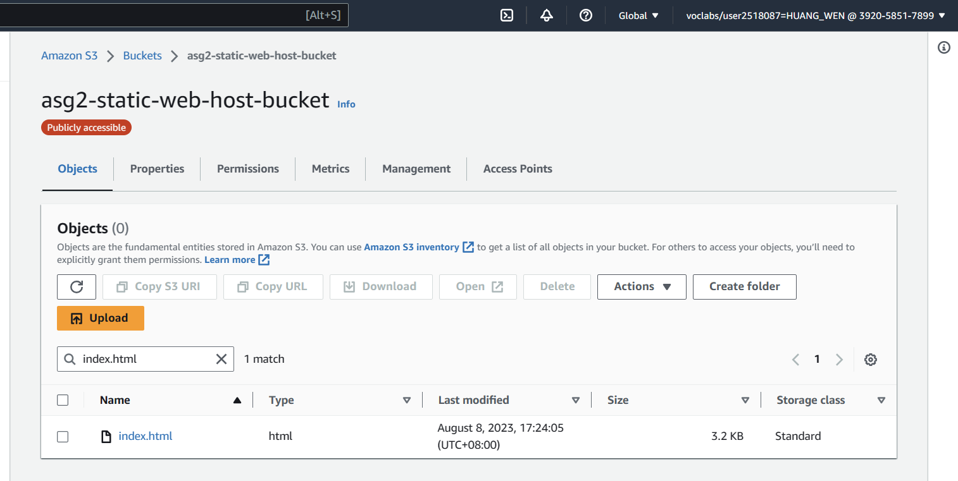

### 4.2.3 Lambda Functions for Data Processing:

Upon receiving the HTTP POST request from the API Gateway, the **"****ASG2POSTCustomerDataFunction****" Lambda function** is activated. This function is responsible for processing the customer data and **creating a new record in the DynamoDB table "CustomerData."** The serverless architecture allows the application to scale automatically, ensuring that it can handle a large number of simultaneous requests without manual intervention.

### 4.2.4 Retrieving and Displaying Customer Data:

To retrieve and display the customer data from the DynamoDB table, the HTML forms page initiates a **HTTP GET request** to the **API Gateway endpoint** associated with the **"ASG2GETCustomerDataAPI."** This triggers the **"****ASG2GETCustDataFunction****" Lambda function**, which fetches the relevant records from the DynamoDB table and sends the data back to the form to be displayed. Again, the serverless approach is to ensure that the system can handle concurrent requests efficiently.

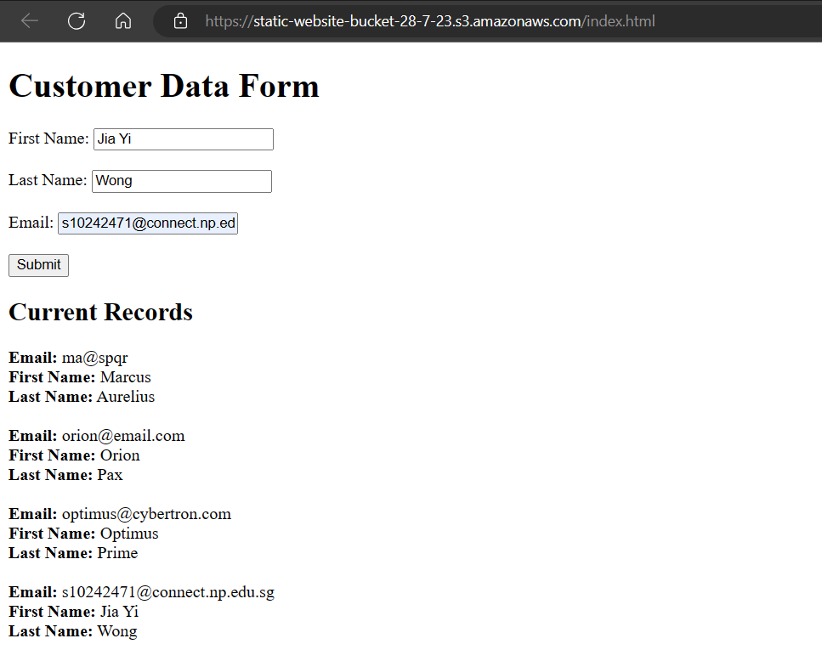

### 4.2.5 Notification System Requirements

##### 4.2.5.1 New Customer Data Notification

The serverless architecture meets the requirement for a notification system that alerts the administrator whenever new customer data is added to the DynamoDB table. This is achieved through the **"****ASG2NotifyDynamoDBFunction****" Lambda function**, which is triggered automatically when a new record is created in the "CustomerData" DynamoDB table. The Lambda function sends an **email notification** to the administrator using the **"ASG2UpdatedDynamoDBTopic"** Simple Notification Service (SNS) topic. This allows the administrator to stay informed about any new customer submissions.

##### 4.2.5.2 File Upload Notification

Additionally, the serverless application fulfils the requirement for notifying the administrator when a file is uploaded to the S3 bucket. The **"****ASG2NotifyS3Function****" Lambda function** is invoked upon detecting a new file upload event in the designated S3 bucket. The function sends an email notification to the administrator's email account and phone number using the **"ASG2UpdatedS3Topic" SNS** topic.



# Lambda Functions Code

## 5.1 Post Customer Data To DynamoDB Function

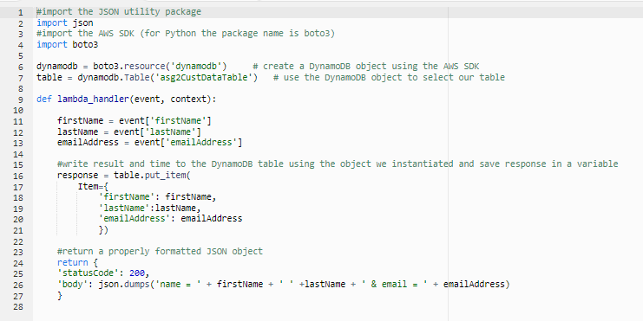

## 5.2 Get Customer Data From DynamoDB Function

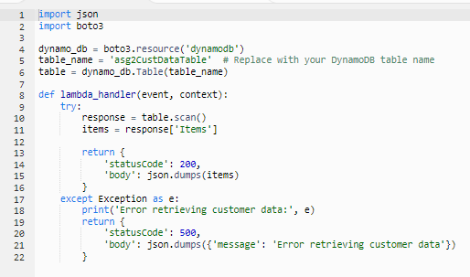

## 5.3 Notify New DynamoDB Record Function

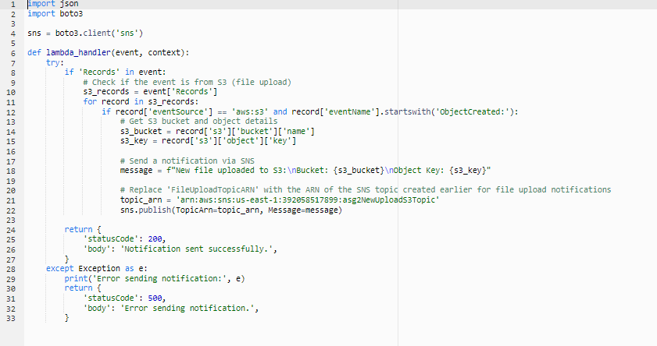

## 5.4 Notify S3 File Upload Function



# Testing methods

# Requirement 1

For requirement 1, comprehensive testing and validation were conducted to ensure that the implemented cloud solution was designed to meet KVM Pte Ltd’s requirements, ensuring scalability, availability and security. The testing approach comprises of the following:

1. Functional Testing
   1. High Availability and Resilience

The aim of this test is to verify whether instances are resilient. We tested this out by terminating the instances to see if other instances will be hosted on other availability zones and if the traffic to the unhealthy instances will be rerouted.

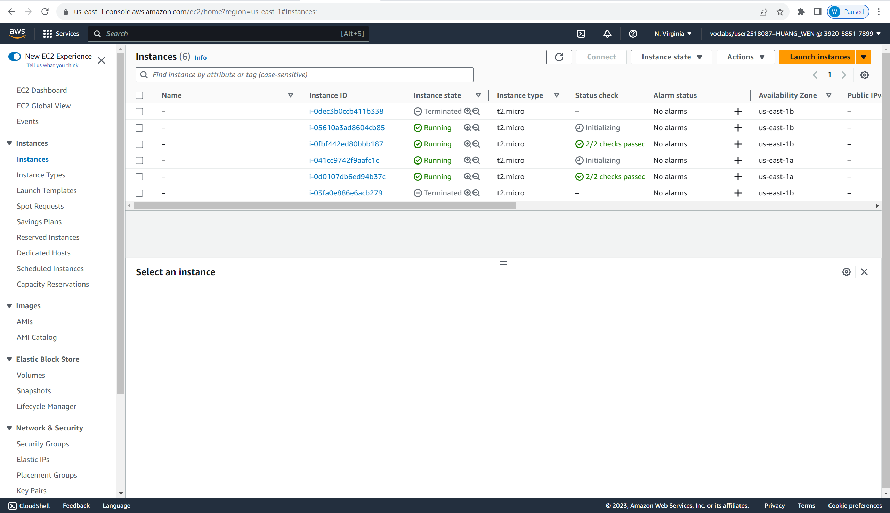

When the demand of the web app increases, auto scaling group will launch new instances (until the total instances number reach 4).

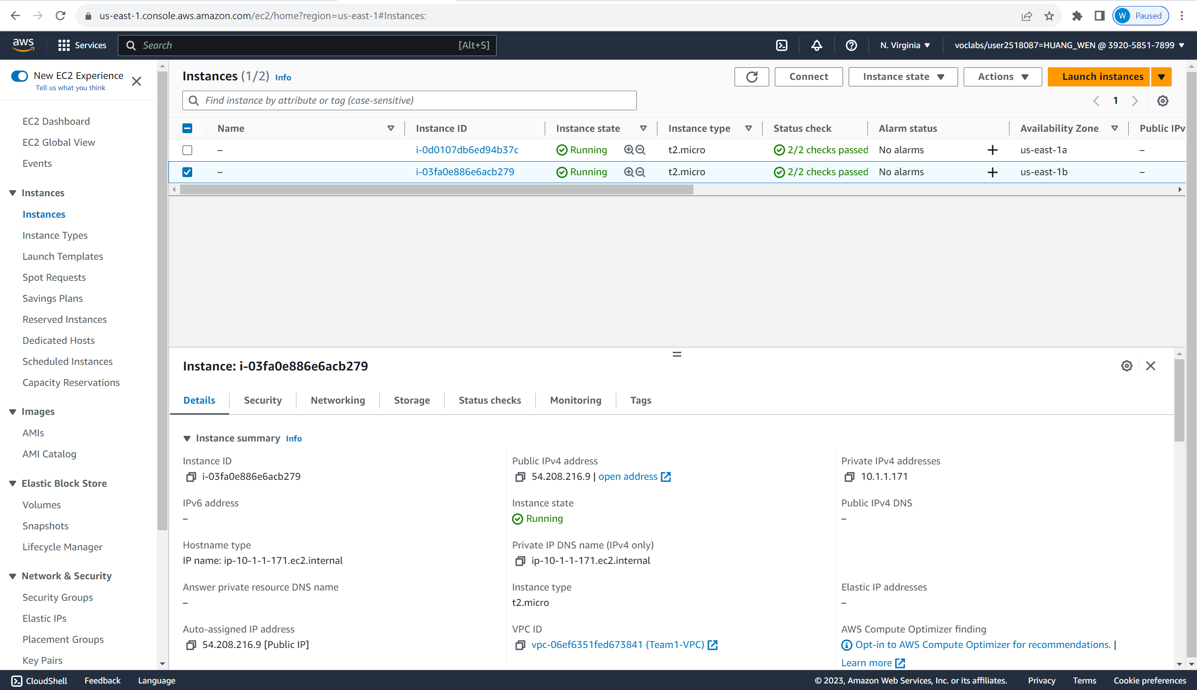

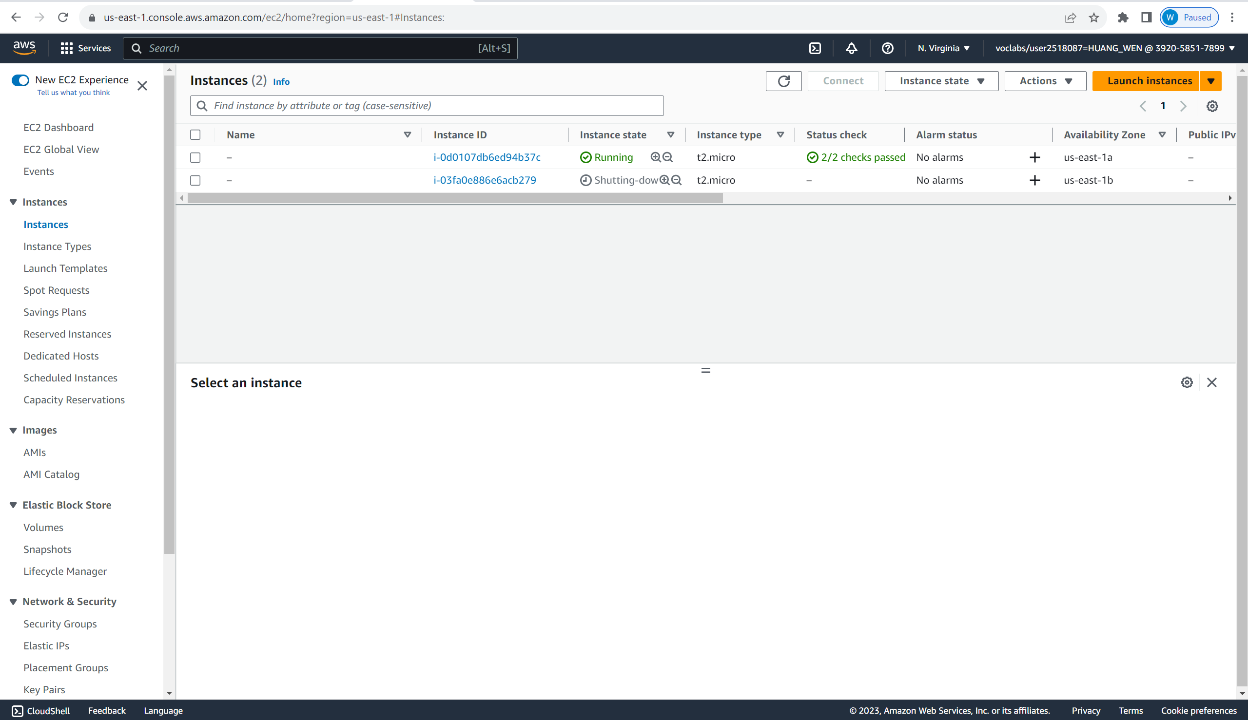

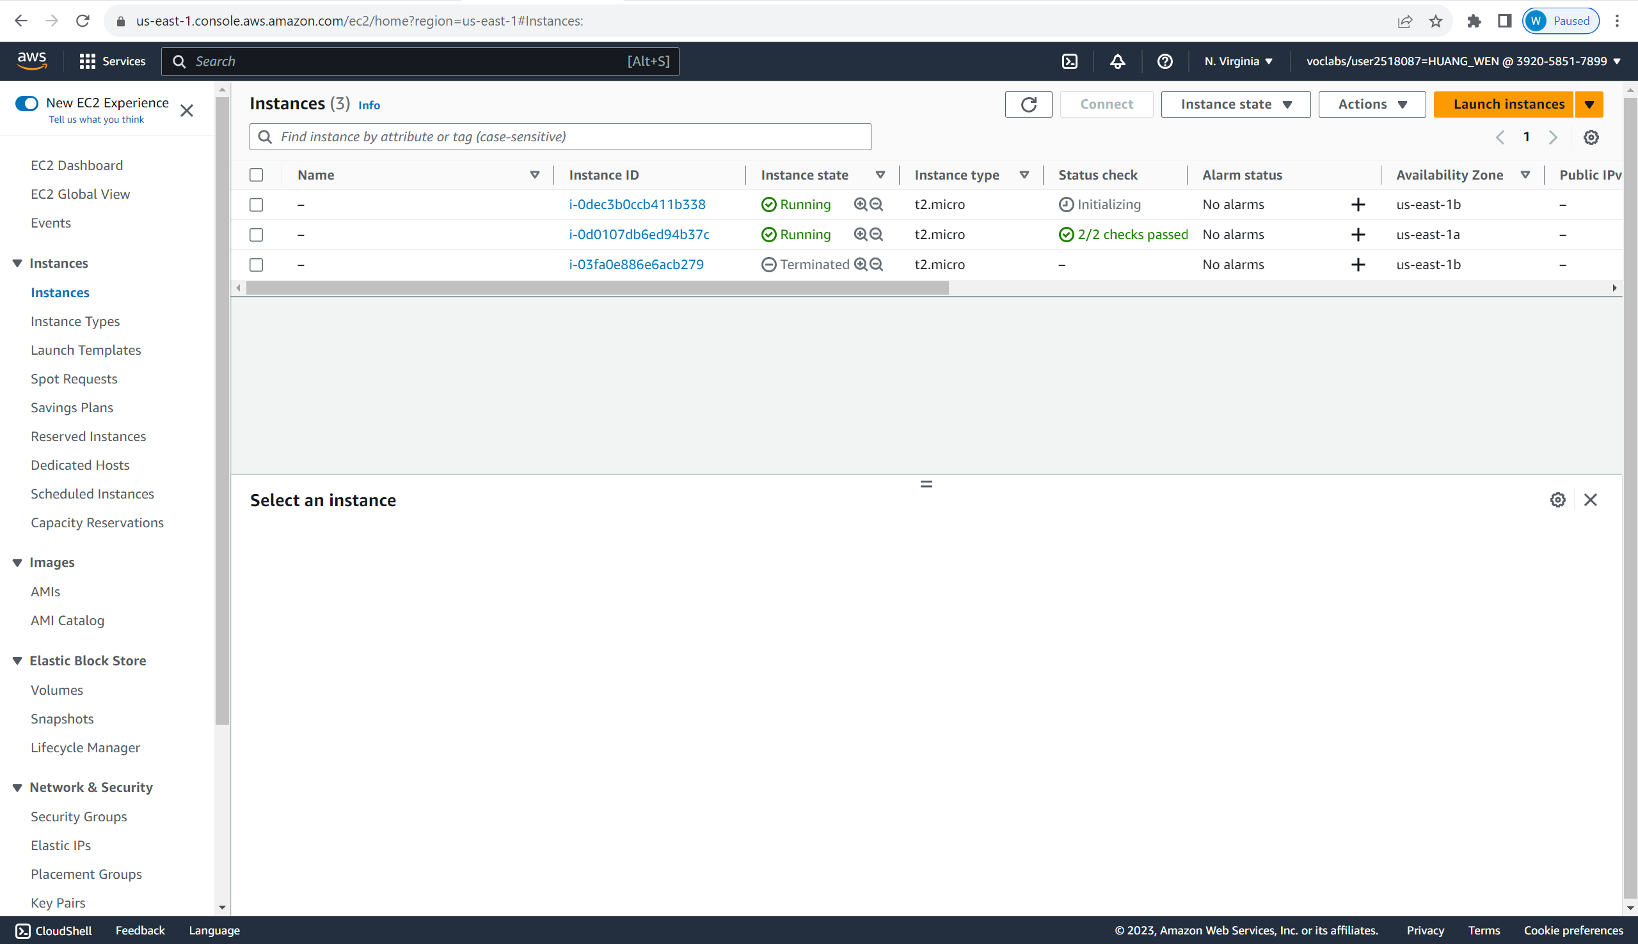

* 1. Auto Scaling

The aim of this test is to ensure that instances are dynamically added

and removed according to the target tracking policy. We tested this out

by overloading the instances, increasing the CPU utilization. If it is over 20 % CPU utilization the policy will add a new instance.

1. Monitoring and Alerting Testing

We have configured alarms using CloudWatch and SNS to inform us when certain thresholds have exceeded. Admins will subscribe to the Topic and receive a Simple Notification Service to subscribe where they will receive emails on the issues encountered. Below are examples of the issues that admins will receive:

We have configured the alarms for:

1. EC2 CPU Credit Balance: where admins will be notified when the credit balance is lower or equals to 15, where the EC2 will reach baseline performance where it may not be able to support the web application.

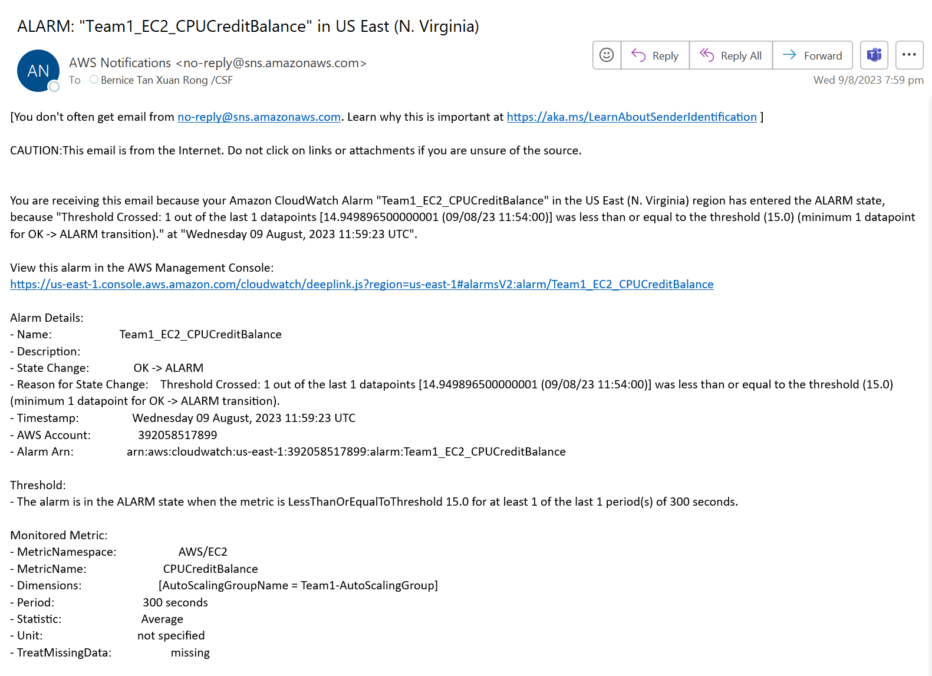

1. EC2 CPU Utilization: If the CPU Utilization exceeds 20%, instances will be added

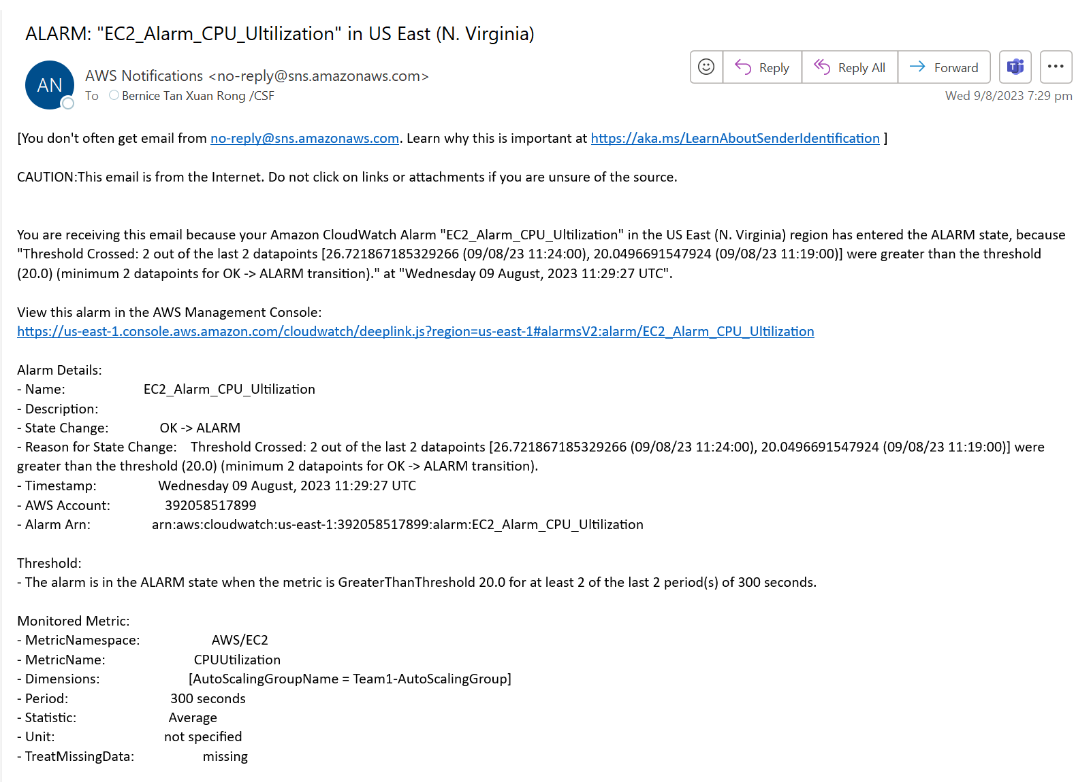

1. EC2 Auto Scaling: Admins will be informed whenever EC2 instance launches, launch failures, termination and termination failures are detected.

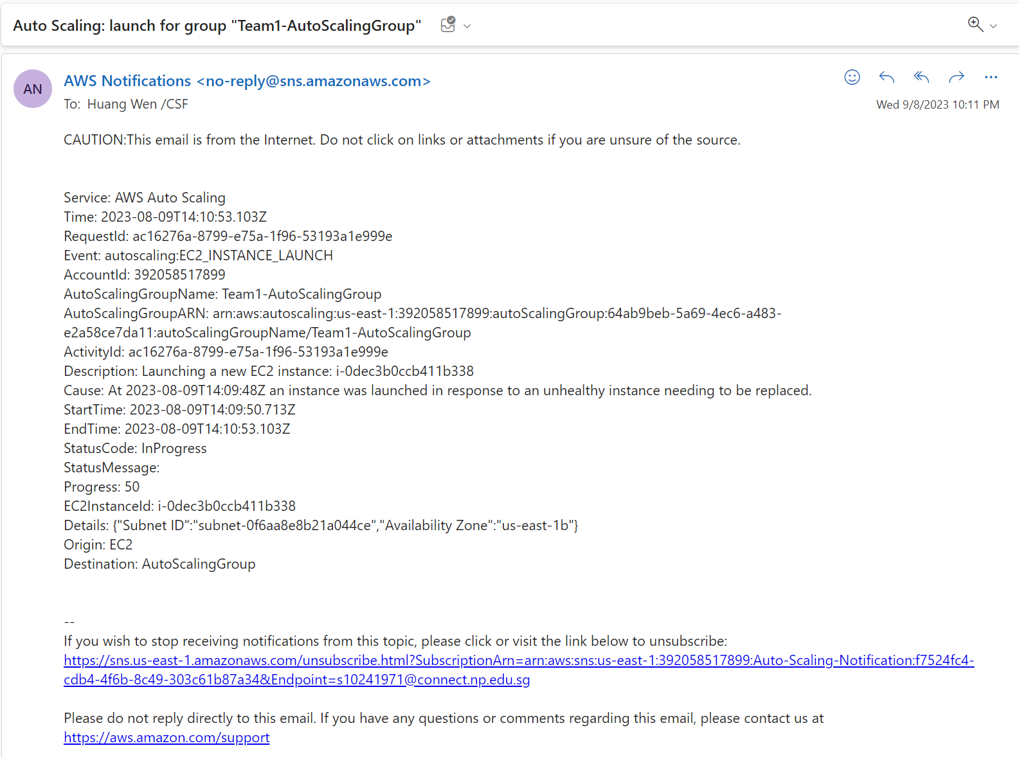

1. Backup and Recovery Testing

We tested this by checking for the next maintenance window and checking if we configured automatic backups. There are also automatic snapshots of the database created.

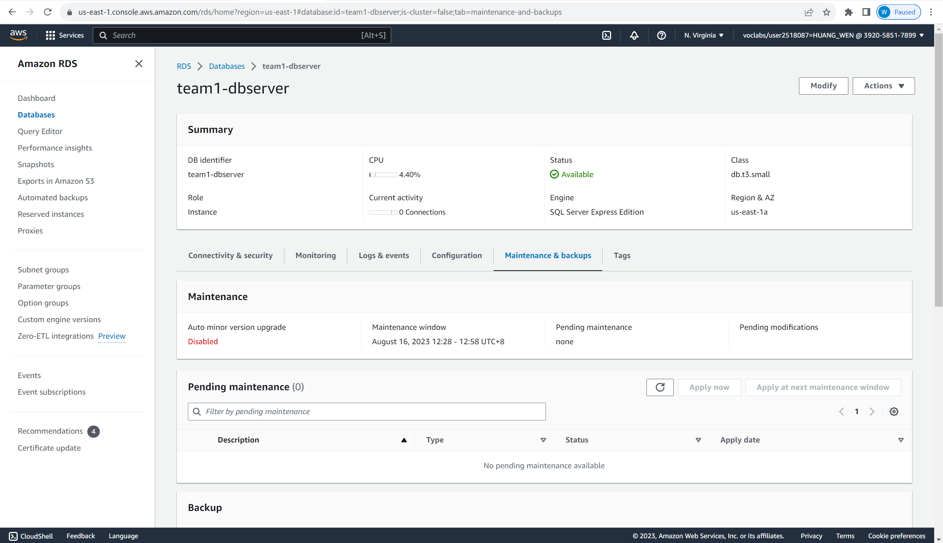

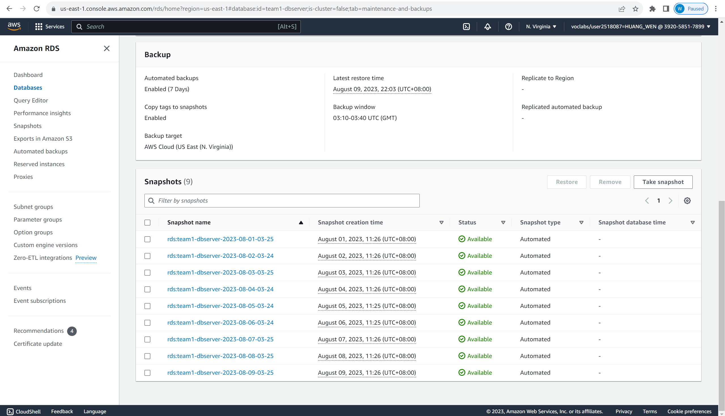

1. Network and Connectivity Testing
   1. VPC and RDS Connectivity

The aim of this test is to see if instances within the same VPC are able to communicate with each other. To test this, changes from one instance, should update in the other instances as well.

We also tested the connectivity between the instances and the RDS. To check the RDS and Instance connectivity, we can see if the application is able to launch and function.

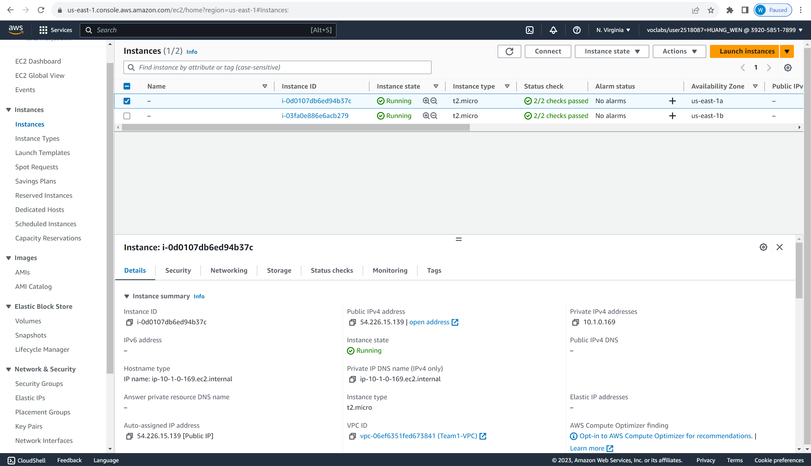

Now we will open the web app using one of the instances Public IP addresses. IP address is 54.226.15.139.

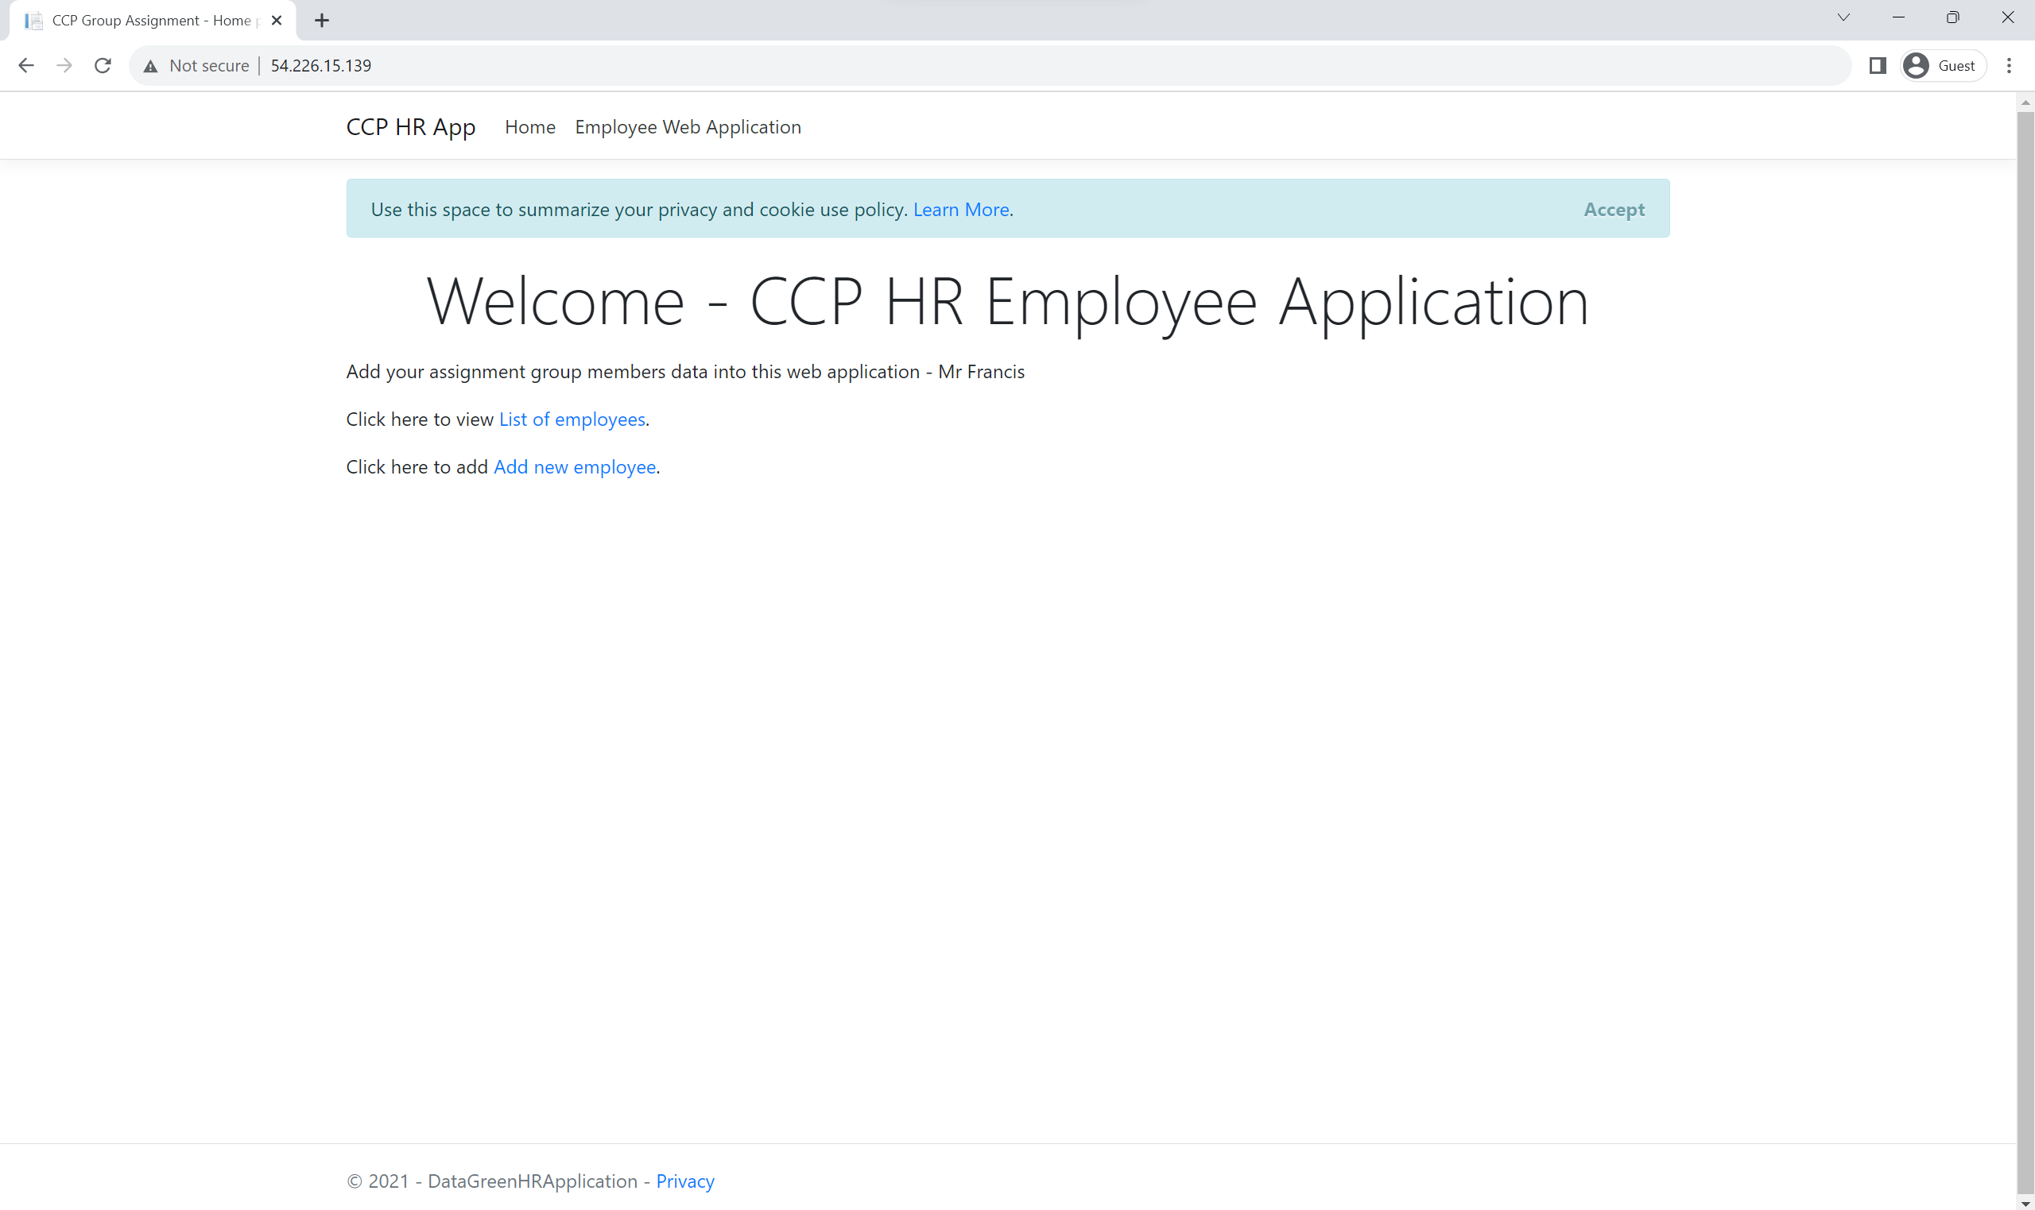

Now we will create a new employee, John.

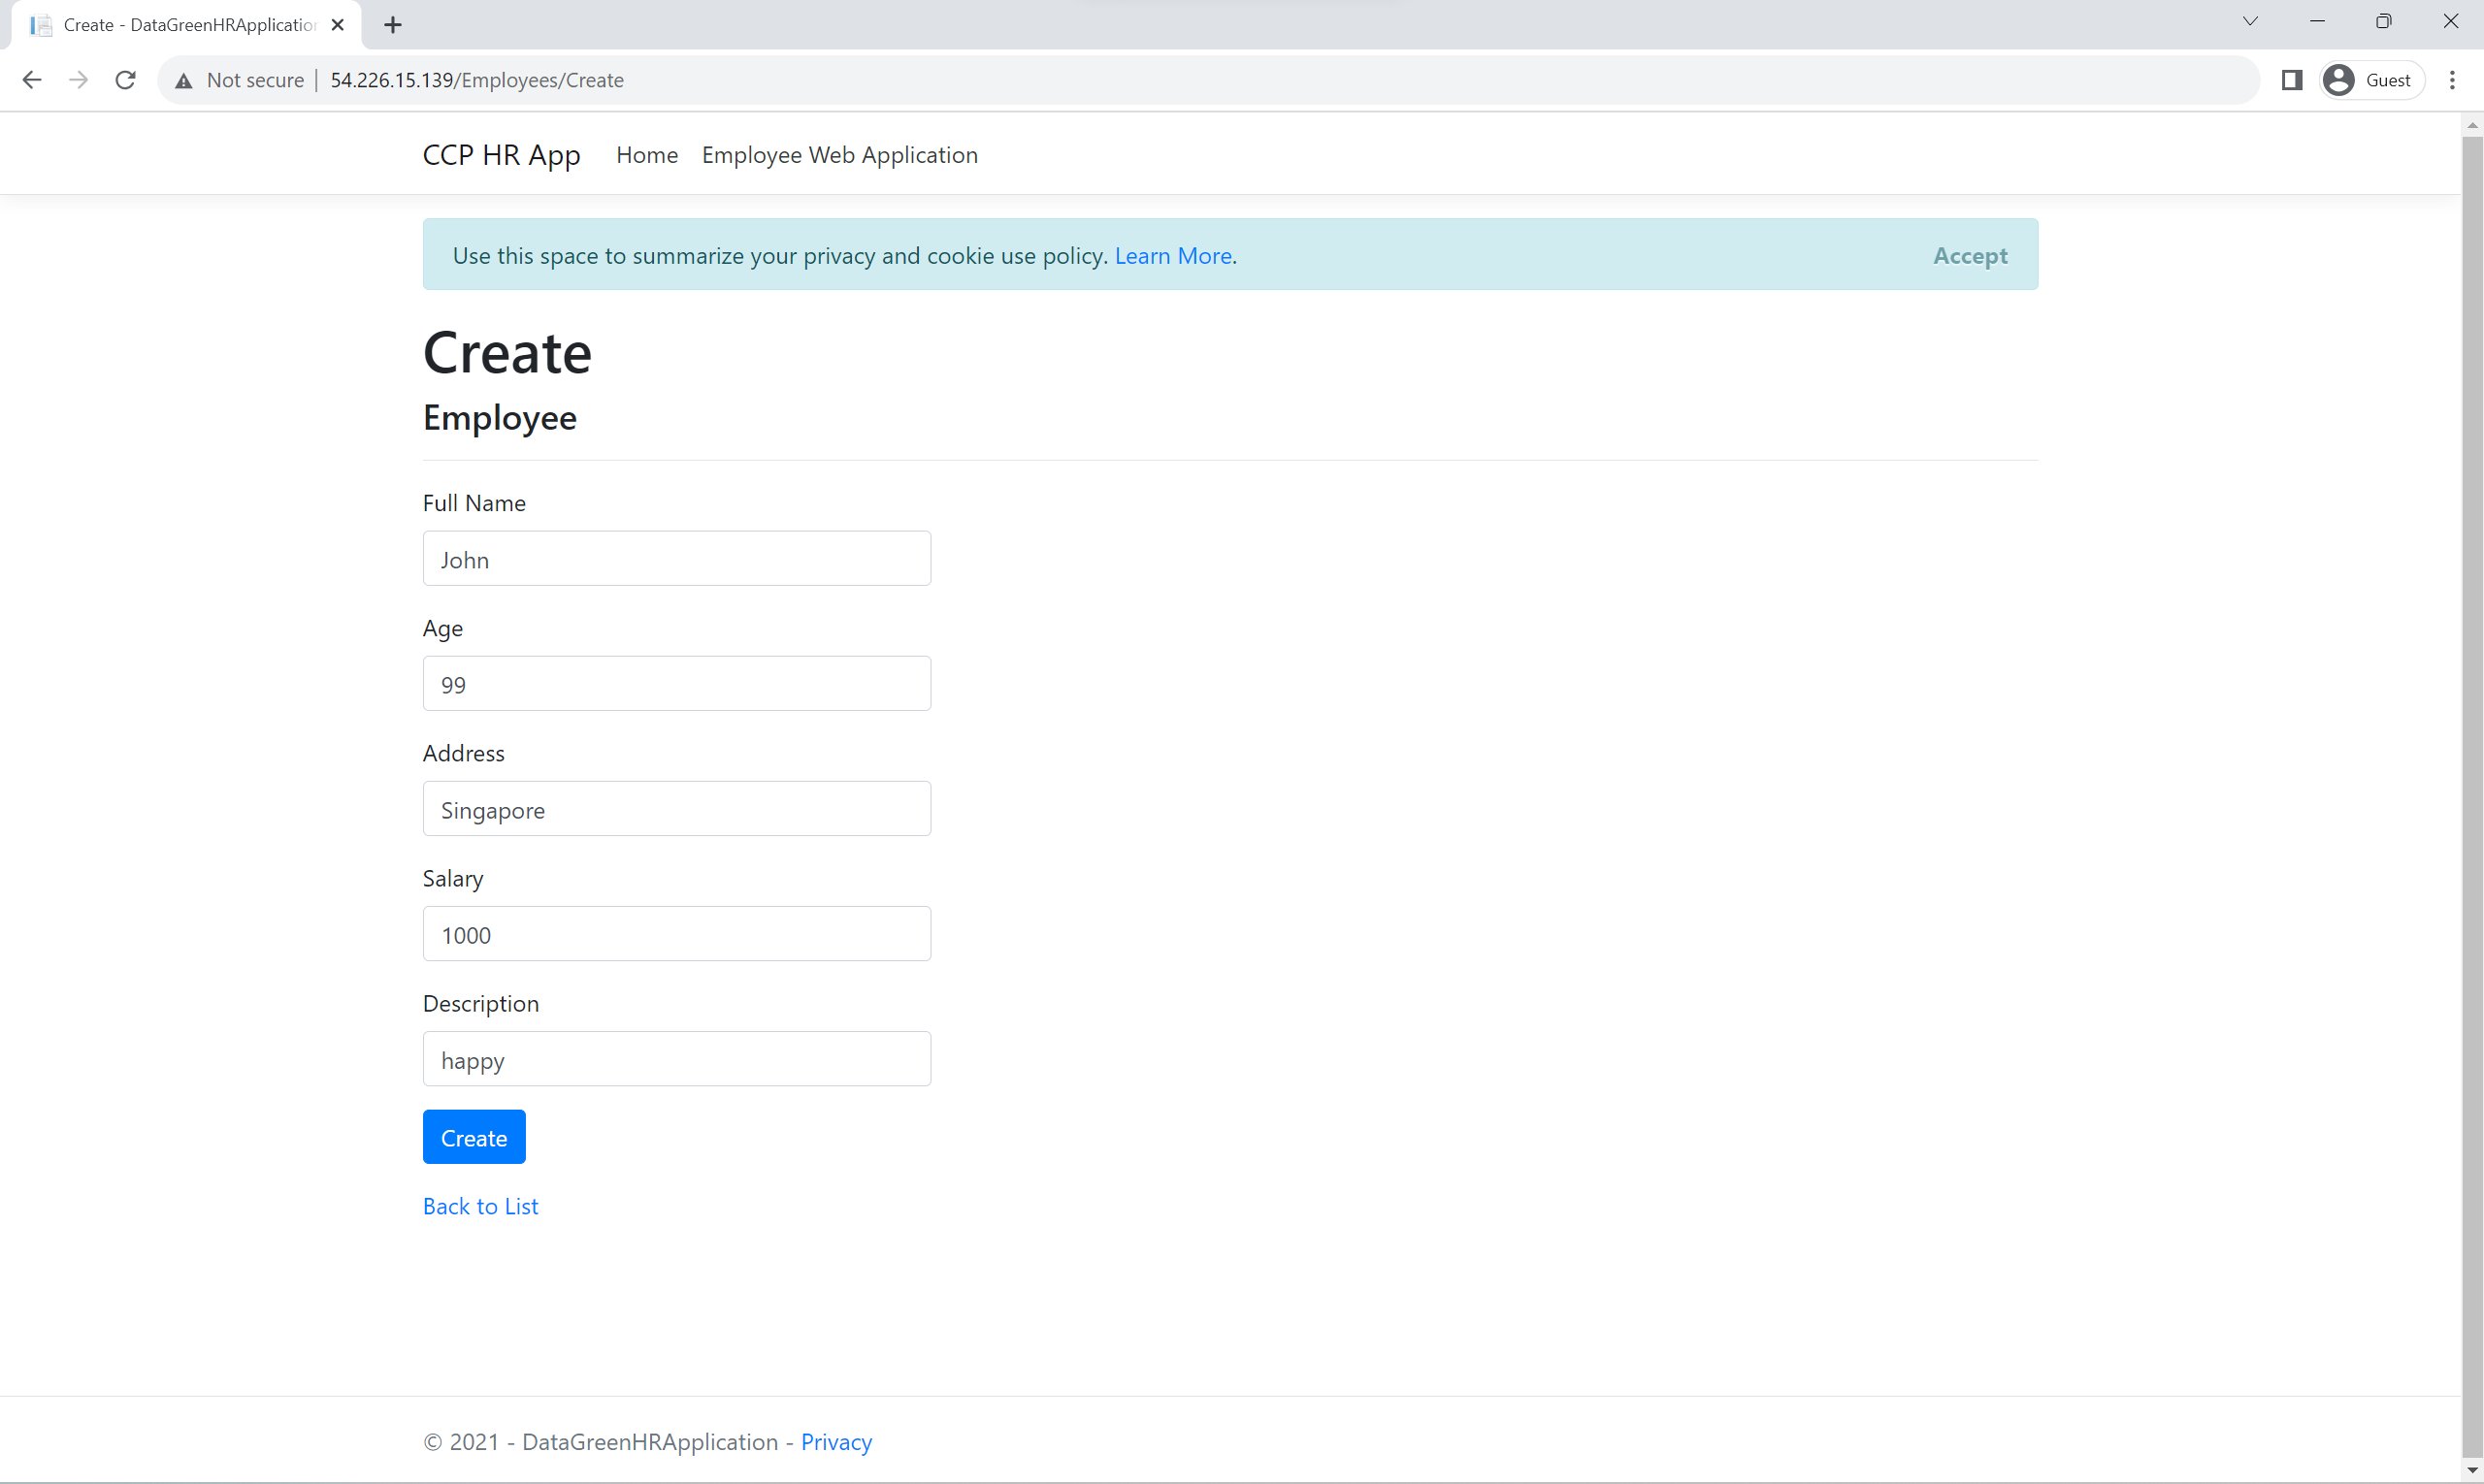

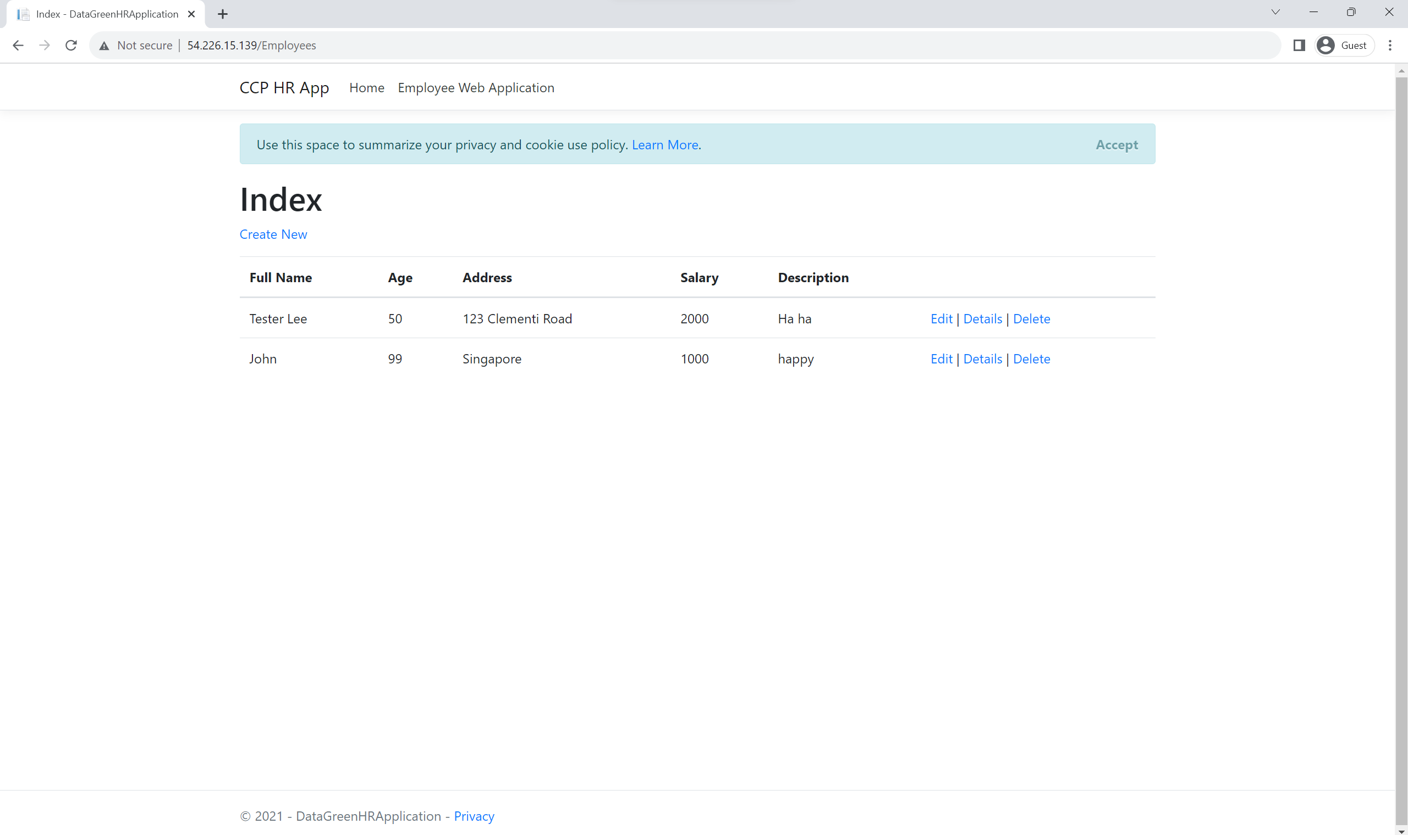

Then, we will access the web page using another instance’s Public IP address and see if the new employee is updated in the RDS database. The IP address is 54.208.216.9.

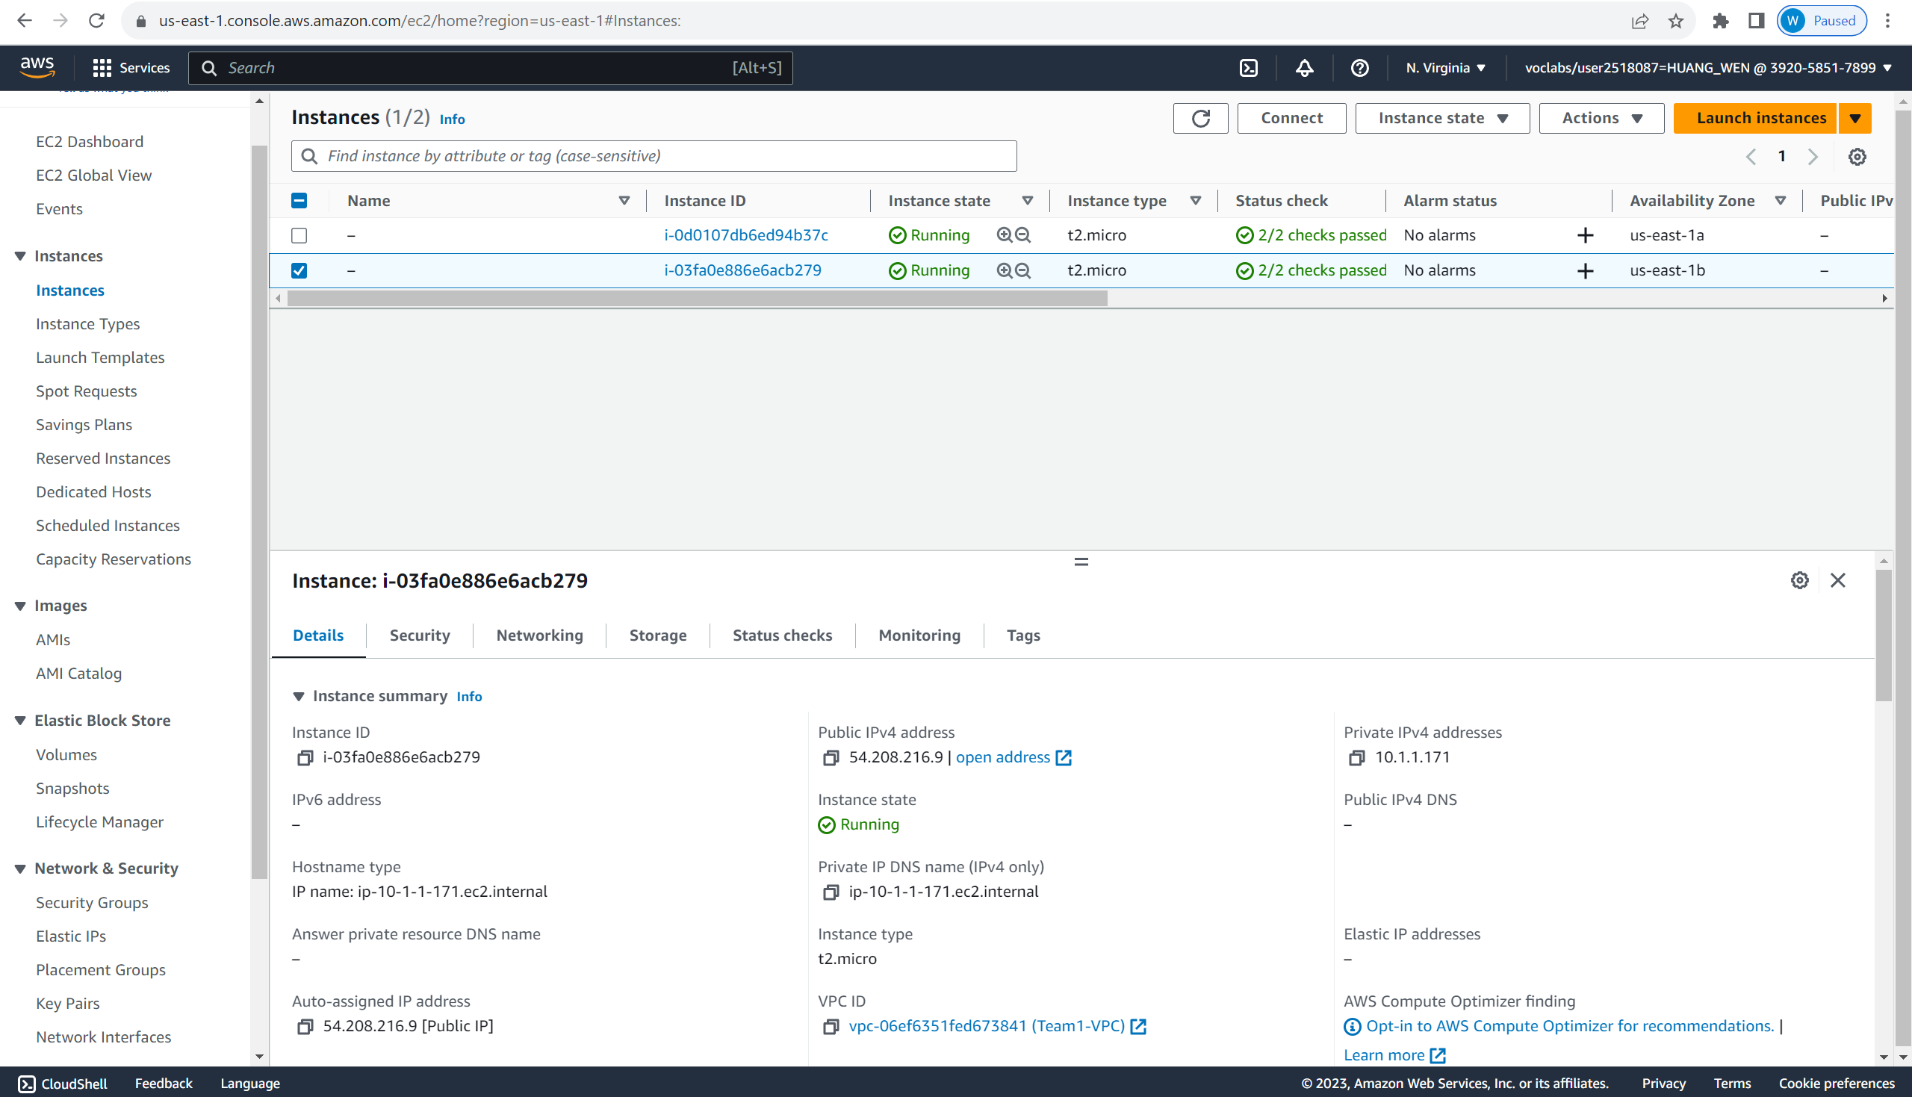

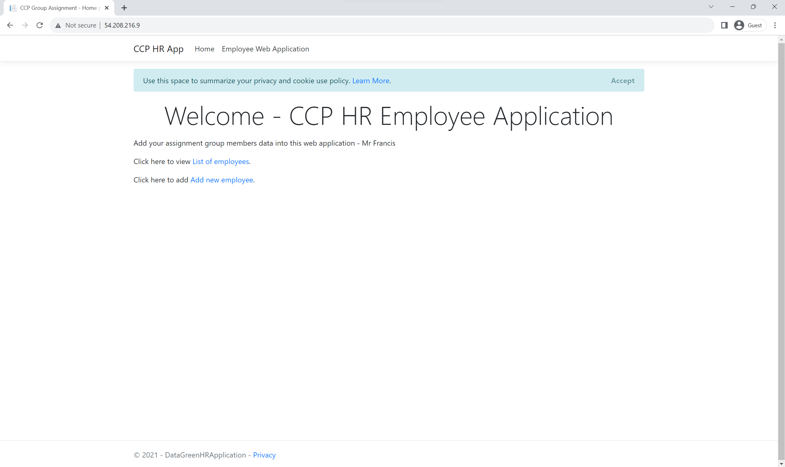

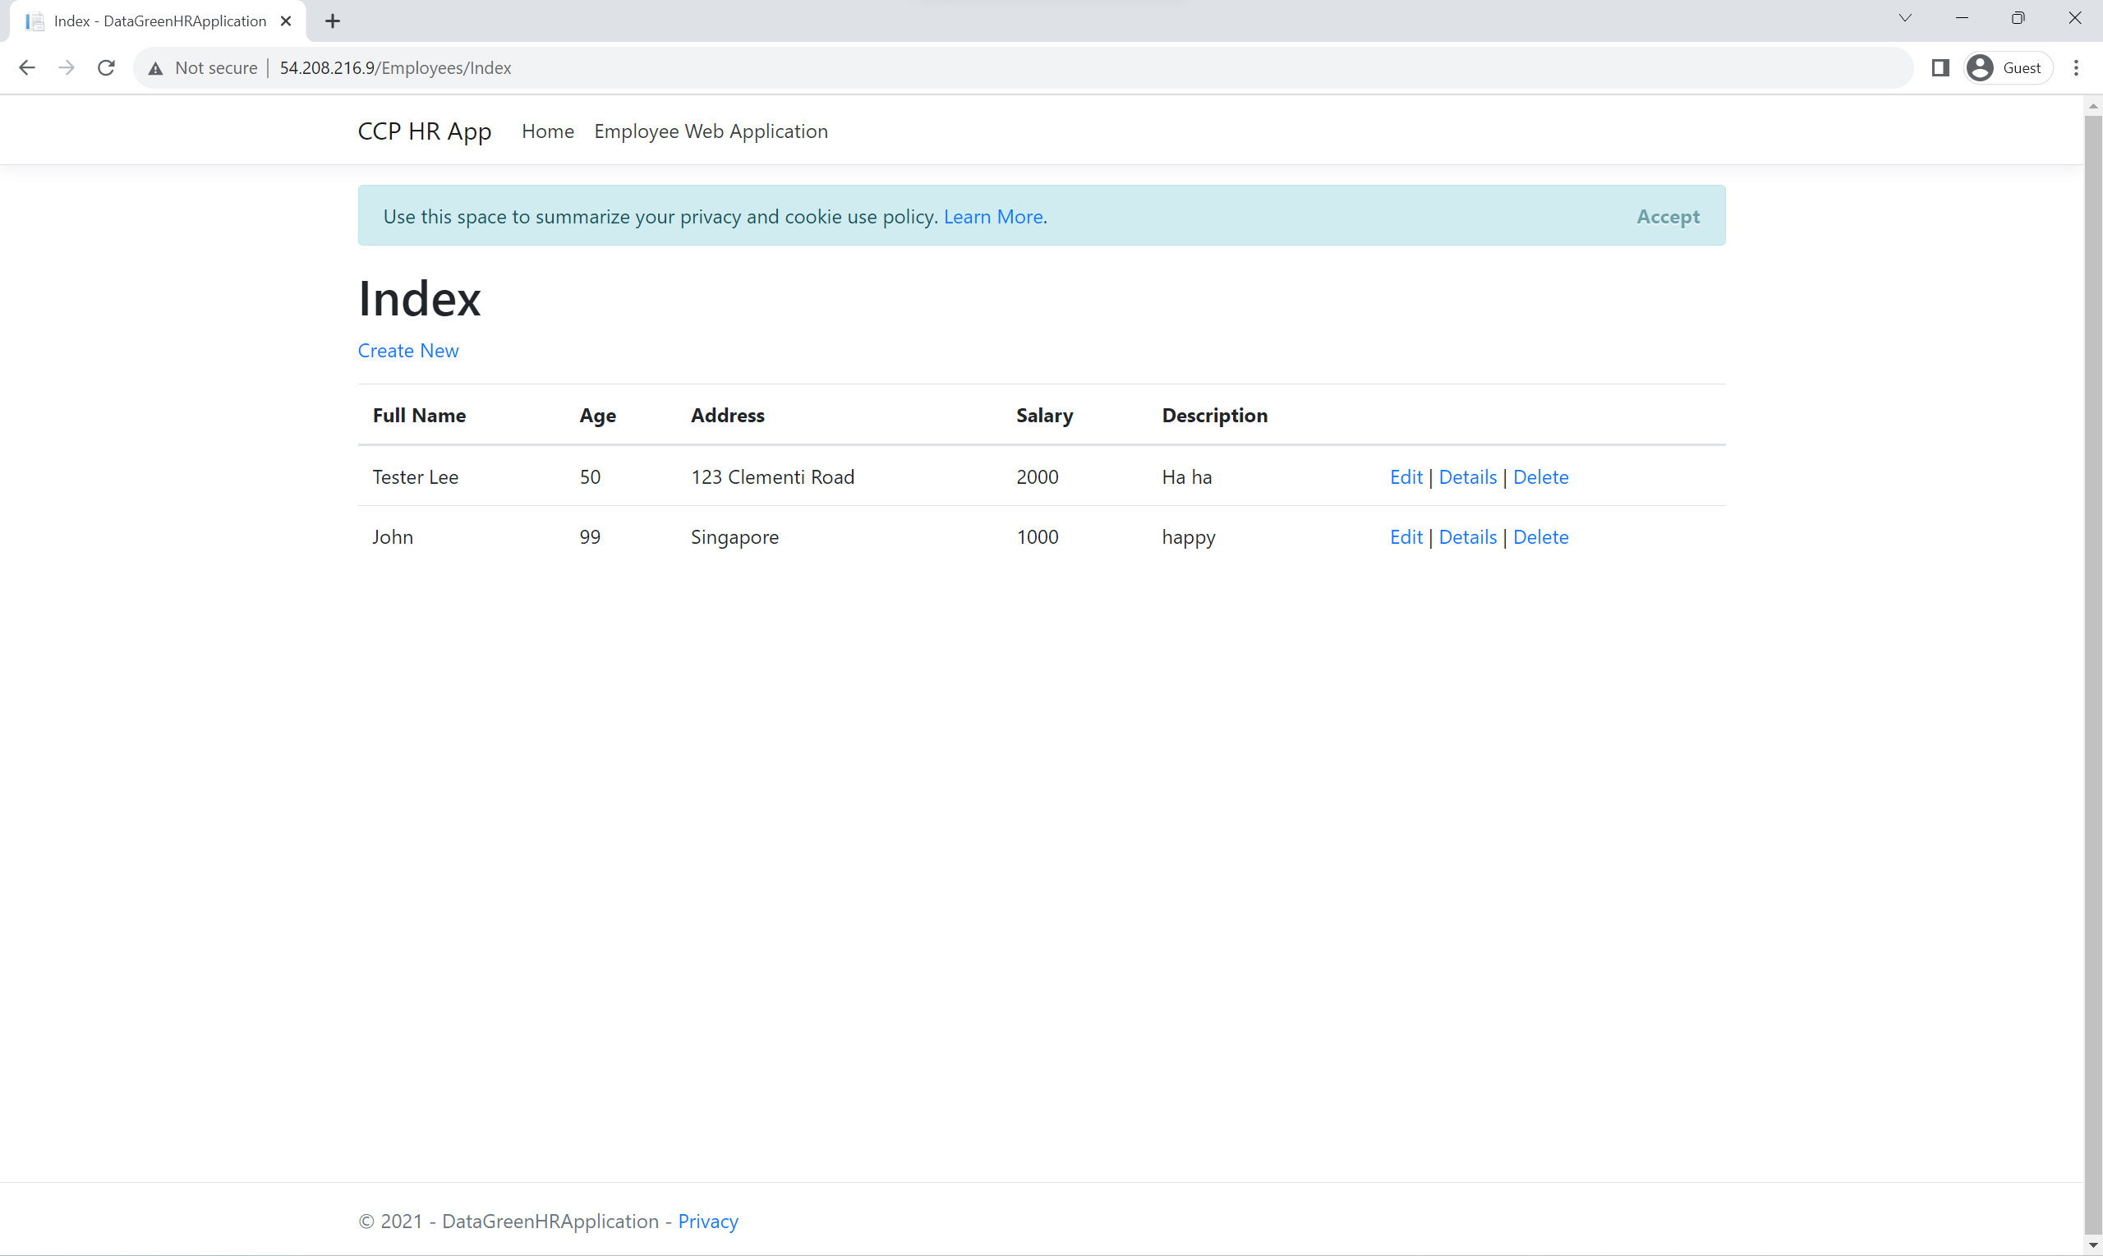

As we can see the new employee, this shows that the RDS connection is working.

# Requirement 2

To test the application architecture for requirement 2, we ran the application to see if it worked. We first accessed the webpage, then filled in the values and submitted the form. The application should work successfully if it meets all these requirements:

1. Webpage accessible to public
2. New record created in DynamoDB when form submitted
3. Webpage displays new records with the other records
4. Notification received when new record created in DynamoDB
5. Notification received when new file uploaded to S3 bucket

# Testing steps:

* + - 1. **Access the form page using incognito mode**

link: <https://asg2-static-web-host-bucket.s3.amazonaws.com/index.html>

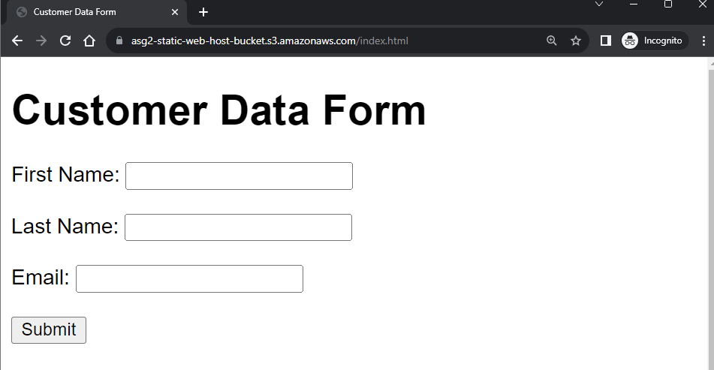

Figure 7.2.1.1– access webpage using incognito mode

* + - 1. **Fill in & Submit Customer Data Form**

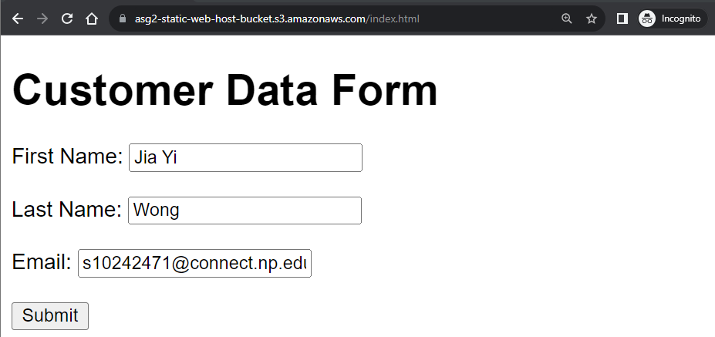

Figure 7.2.1.2 – fill in and submit form

* + - 1. **Check DynamoDB table “asg2CustdataTable”**

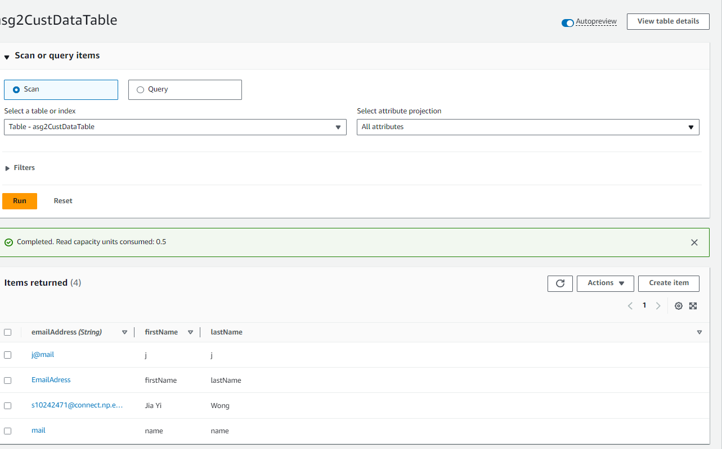

Figure 7.2.1.3 – Table with new record

* + - 1. **Check webpage for displayed new record**

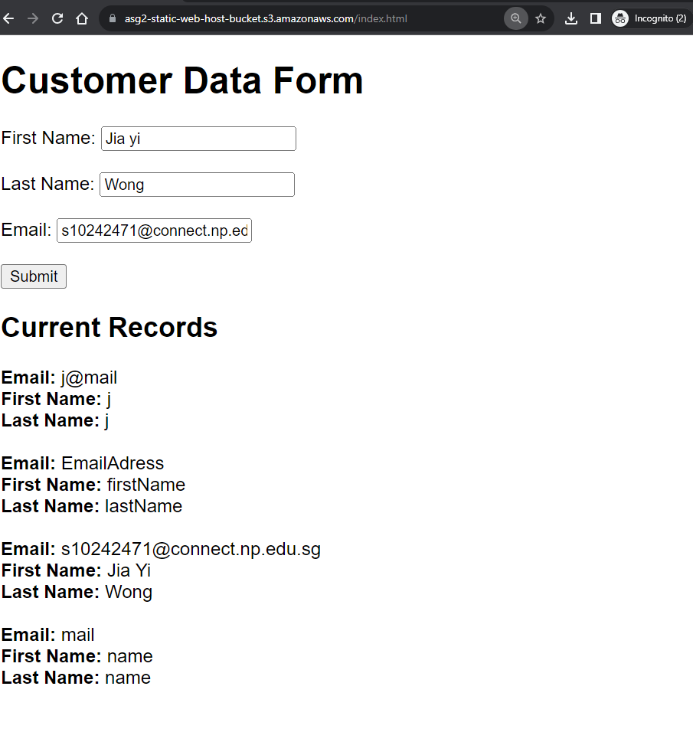

Figure 7.2.1.4 –Web page with displayed new record

* + - 1. **Check Email for new DynamoDB record notification**

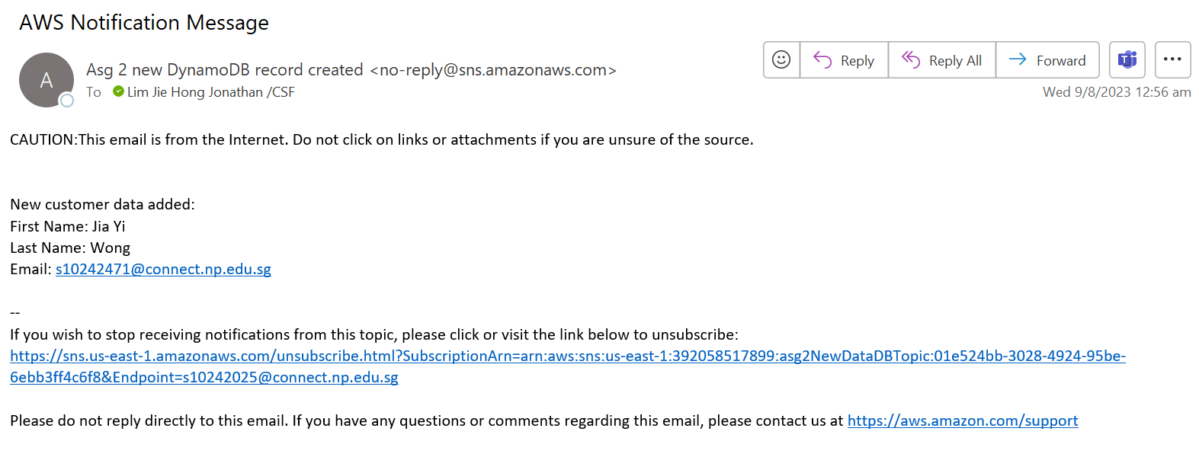

Figure 7.2.1.5 – DynamoDB email notification

* + - 1. **Upload new file to S3 bucket “asg2-static-web-host-bucket-s3”**

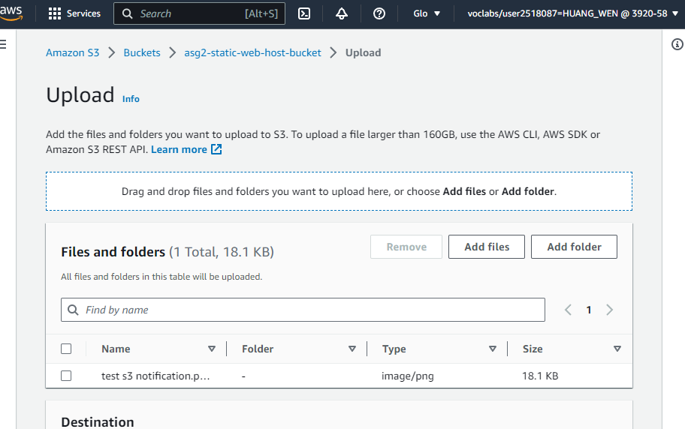

Figure 7.2.1.6 – S3 test upload

* + - 1. **Check Email for new S3 upload notification**

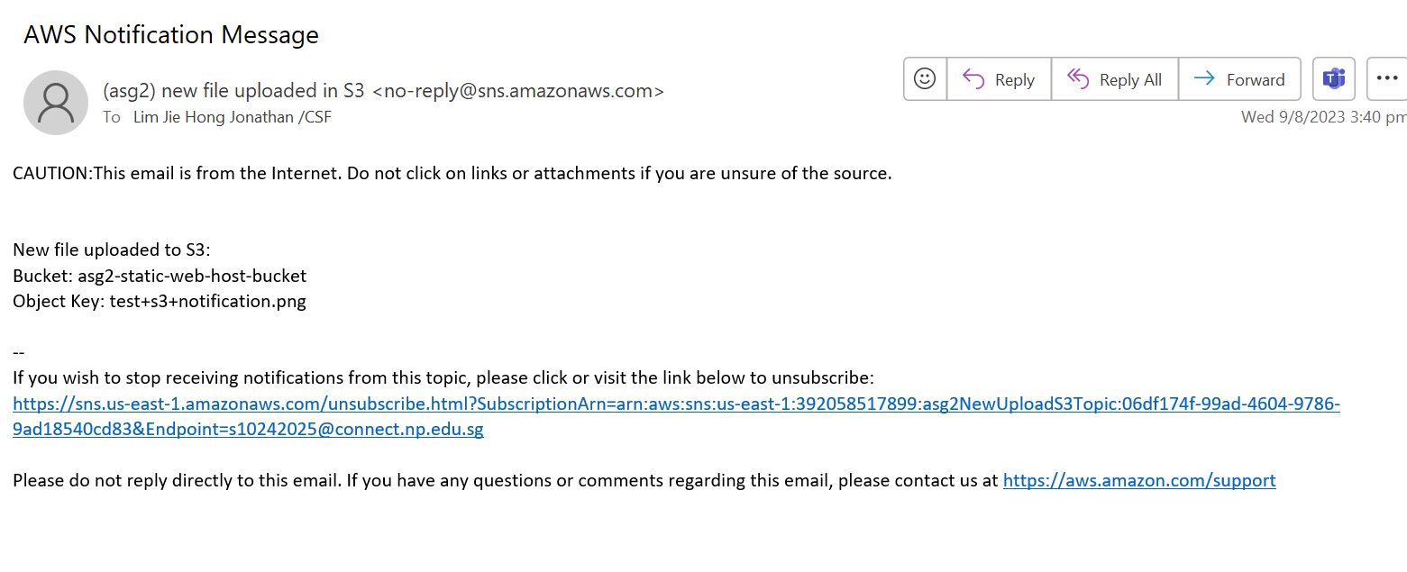

Figure 7.2.1.7 – S3 upload notification

In conclusion, the application managed to achieve all requirements, and hence works properly as expected.

# Our Cloud Solution Design Principles:

## Security:

The security pillar ensures that the cloud infrastructure we build it able to protect data, systems, and assets in the cloud. Security is a top priority in our cloud solution. Below are the security principles of the AWS well-architected design principles for security in cloud that we follow to protect data and resources.

8.1.1 Enable traceability  
Being able to audit and trace changes in the cloud infrastructure will help us take note of accountability with the changes made. Regular security audits and compliance checks will be performed to maintain a secure environment with the help of AWS CloudTrail. This also includes a notification system to alert developers if there are major changes or problems to the cloud infrastructure. This would then allow the developers to be able to identify the problem and find a solution for it as soon as possible.

### Apply security at all layers

It is important to apply as much security to each layer of the cloud infrastructure as it supports the security principle, defense in depth. Being able to apply security at all layers ensures a holistic security cloud infrastructure and hence, for our cloud infrastructure, we have implemented security in different layers of the services and resources used. In both the cloud infrastructure for requirement 1 and 2, it includes the use of Amazon VPC, which allows us to enable multiple layers of security. Firstly, with the public and private subnets, there is implemented Access Control List (ACL) that will specifically control every inbound and outbound traffic. Secondly, we have also applied security at an EC2 instance level with security groups, where it controls all inbound traffic only.

### 8.1.3 Automate security best practices

Being able to implement automated security mechanisms would help with both cost optimization and scaling of our cloud infrastructure. In our cloud infrastructure, we have implemented features such as an auto-scaling group to auto scale the number of EC2 servers depending on the traffic demands as well as Lambda function to help provision and manage servers without someone having to manage it. Additionally, in requirement 2, we made use of AWS API Gateway which is a fully managed service that makes it easy for developers to create, publish, maintain, monitor, and secure APIs at any scale. It is a helps developer to create APIs without having to worry about the underlying infrastructure.  
  
Being able to utilize such managed services helps to reduce human errors that could be made by the staff and gives them more time to work on higher-priority work that need more attention. It also ensures that security policies are constantly enforced to the services.

8.1.4 Protect data in transit and at rest (storage)  
It is important that we protect data in transit at rest as these data could be personal information of customers. Without properly protecting the data, it may violate confidentiality and integrity. One example is that attackers could carry out Man-In-The-Middle (MITM) attacks as the data is in transit to read or alter the data. Even if the data is at rest, which means that the data is stored in the storage, attackers could launch attacks like insider threats, SQL injection to gain access to the data stored. Hence, it is very important that we protect data both in transit and at rest.   
  
To protect the data of the customers, we have ensured that the RDS is in a private subnet with a configured ACL where users from the internet are unable to gain access to it. RDS also encrypts the databases with the key pairs managed by AWS Key Management Service (KMS). RDS also creates read replica and snapshots in different availability zones for availability of the data. The S3 buckets and DynamoDB also provides encryption at rest with AWS KMS by default.

8.1.5 Keep people away from data  
Being able to limit the number of people to have access or unauthorized people to the data helps to reduce the potential human error and risk of the sensitive data being mishandled or changed. To do so, it is recommended that we use AWS resources and services. One way we did it was to implement this design principle by using public and private subnets. With the help of AWS Internet Gateway (IGW), it routes traffic to specific subnets or security groups. In this case, the internet gateway would route internet traffic to the EC2 instances in the public subnets but not the RDS in the private subnets.

8.1.6 Prepare for security events   
Even with so many security features implemented for our AWS services, it is also important that we also test them out to see how effective they are. Hence we did it in section Testing Methods of our report. By doing so, it helps us to prepare for future incidents that may cause a breach in security as well as how effective are our implementation of AWS services.

(AWS, n.d.)

## Reliability

The reliability of the cloud infrastructure refers to the ability of a workload to perform its intended function correctly and consistently when it's expected to. Its focus is to prevent failures from happening by ensuring availability to the cloud infrastructure by using strategies shown below. This means that a reliable workload will not fail often, and if it does fail, it will recover quickly.

### Automatically recover from failure

Within any cloud infrastructure, it would be expected that there will be some fault or failure within it. Hence it is important that we design our infrastructure to be able to withstand failures as well as repair issues automatically. Fault tolerance refers to the ability to always ensure availability by withstanding system failure. This would mean that instead of building a monolithic application, we should be designing a microservice infrastructure. This helps to maintain availability even when a single component fails, and the applications components are loosely coupled. In the scenario that a single component fails, other components fail and possibly the entire application fails.

We have implemented this by utilizing the following AWS resources and services. This would then help to increase the availability, reduce down time and improve performance.

* **CloudWatch & AWS Simple Notification Services**

Before having AWS resources and services to automatically recover from failure, it is also good to have a triggered alarm and notification system to the developers to notify them that a failure or fault occurred. With CloudWatch, it helps to monitor what is happening in the cloud and if any fault or failure were to occur, it would trigger AWS SNS to send out a notification to the developer.

* **2 Availability Zones**

Having 2 availability zones helps with reliability as it ensures availability at all times. If a fault occurred in an availability zone (e.g., the availability zone fails), there will always be another availability zone available.

* **Auto-Scaling Group**

In the case that a possible fault occurs to one of the EC2 instances, the auto-scaling group would create another instance for the demand in traffic and to replace the failed EC2 instance.

* **Storage Services**

We have also implemented reliable storage services which means that we have multiple copies of your data and applications so that you can still access them if one copy fails. For example, we used Amazon S3 for object storage and Amazon Relational Database Service (RDS) for relational database storage that supports having multiple copies in different availability zones.

### Test recovery procedures

Before deploying the cloud infrastructure, it would always be good to test out the recovery plans and procedures designed by stimulating different scenarios of failures. This would allow us to take note of all possible fault and failure pathways and gives us stimulation of how the recovery procedures do work. A better understanding of how the recovery procedures would effectively recover from failure would help to reduce the risks of possible failure in the future. In our testing, we checked if the autoscaling can increase horizontally when there is high demand.

### Scale horizontally to increase aggregate workload availability

As mentioned earlier, we would like to build a infrastructure that is loosely coupled so that if one resource fails, it would not affect the rest. Therefore, it is important that instead of using one large resource scaled vertically, we use multiple resources scaled horizontally.

In our cloud infrastructure, we made sure to use multiple EC2 instances in an autoscaling group across 2 availability zones with an elastic load balancer. The load balancer helps to distribute internet requests from users across the multiple smaller EC2 instance resources which always ensures availability. With such implementation, it ensures that in the case of a failure, it would not be a common point of failure and the cloud infrastructure would still be able to go on.

### Stop guessing capacity

With the help of the AWS cloud, we would not have to worry and think in advance if the resources deployed would be able to hit demand or if the demand will be so little that the resources deployed are useless. Without this major problem, we would have lower failures of being over demanded as the AWS auto scaling group helps to increase and decrease the number of EC2 instances based on this demand. When there is high in demand, the auto-scaling group would automatically scale the number of EC2 instances from 2 to 4. And if the demand is low, it would then be scaled back to 2. This would ensure help maintain that the EC2 instances are always of an optimal level to satisfy the request demands.

### Manage change in automation

This refers to the process of ensuring that changes to the workloads are made in a controlled and repeatable manner. This can help to prevent unexpected problems and to improve the reliability of your workloads. To apply this design principle of reliability, we have made use of CloudWatch as a monitoring tool as an early detection of problems to be fixed early and auto-scaling group as an automation tool to reduce accidental human errors.

## Performance Efficiency

This pillar of the AWS Well-Architected Framework refers to being able to efficiently meet system requirements and maintain efficiency as demand fluctuates. To achieve optimal performance efficiency, we have carefully chosen the appropriate combination of AWS services.

### Democratize advanced technologies

This design principle refers to being able to make advanced technologies available to a wider range of users, regardless of their technical expertise. For requirement 1, instead of rebuilding their infrastructure, we only improved it by introducing a few new services that are self-explanatory such as CloudWatch, AWS SNS and CoudTrail. However, the rest of the cloud design is an improved version of their cloud architecture design where we only increase the resources used by reorganizing the design. In this way, when the KVM staffs take over, they would not need to relearn the resources and services used, as it is just an improved and expanded version of their original cloud design.

### User serverless architectures

In our requirement 2, we have leverage on AWS Lambda to run serverless functions, enabling event-driven operations for improved application responsiveness. Leveraging on serverless functions helps to remove the need for the KVM staff to manage and maintain the underlying infrastructure. We have also utilized the below serverless resources.

* + Amazon Simple Storage Service (Amazon S3)
  + AWS Lambda
  + Amazon DynamoDB
  + API Gateway

### Consider mechanical sympathy

Based on the requirements that KVM has given us, we have designed the cloud infrastructure to maximum efficiency. All AWS resources and services chosen are based on the conditions and requirements of KVM and how to better enhance their cloud infrastructure. For example, in requirement 2, we used DynamoDB to ensure fast and reliable data storage and retrieval and it also fulfil the requirements by KVM

## 8.4 Cost Optimization

We adopted a cost-conscious approach in our cloud solution design. By using general-purpose EC2 instances and optimizing resource utilization through AWS Auto Scaling, we can ensure cost efficiency while meeting performance requirements.

# Cloud Monitoring Plan for Web Application and AWS Resources/Services

## Techniques Used:

## Principles Used:

# Problems and Resolutions

1. CIDR Blocks for the respective Subnets:

* Public Subnet 1 (us-east-1a): 10.1.0.0/24
* Public Subnet 2 (us-east-1b): 10.1.1.0/24
* Private Subnet 1 (us-east-1a): 10.1.2.0/24
* Private Subnet 2 (us-east-1b): 10.1.3.0/24

1. Selection of API Gateway

Choosing of API Gateway

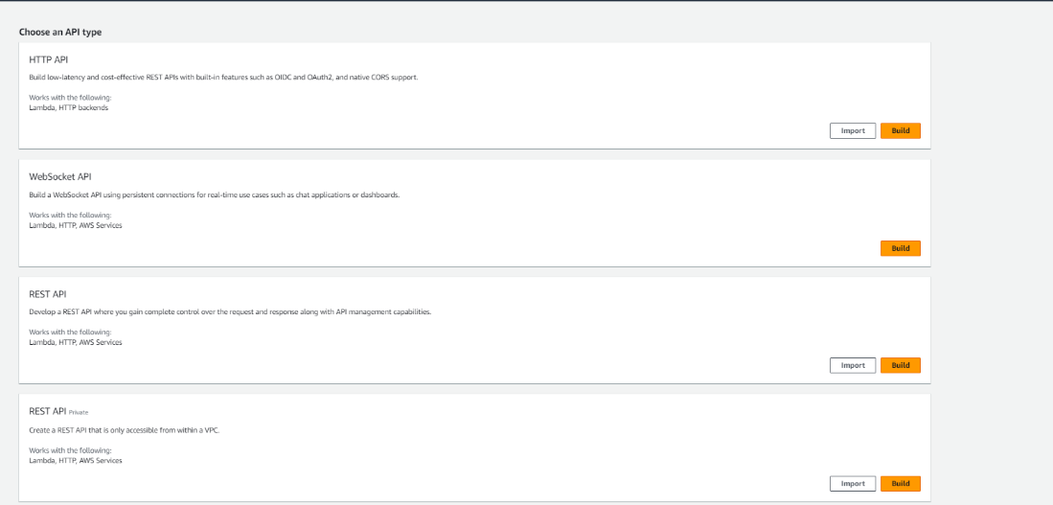

As it is our first time using API Gateway, we had some difficulties understanding how to utilize API gateway, what APIs does, and which API Gateway was the best fit. After some extensive research, there are mainly 3 different APIs: REST API, HTTP API, and WebSocket API. REST APIs are a more specific type of HTTP API that adheres to the REST architectural principles. HTTP APIs are a broader category that includes any API accessed over the HTTP protocol, including both RESTful (using HTTP requests to access and use data) and non-RESTful APIs. WebSocket APIs, on the other hand, enable real-time bidirectional communication between a client and server over a persistent WebSocket connection. WebSocket APIs are usually used more for real-time chatting websites. In the end we chose to use REST APIs because it was commonly used and the application did not require real-time communication.

1. Selection of the Execution Roles in Permissions Tab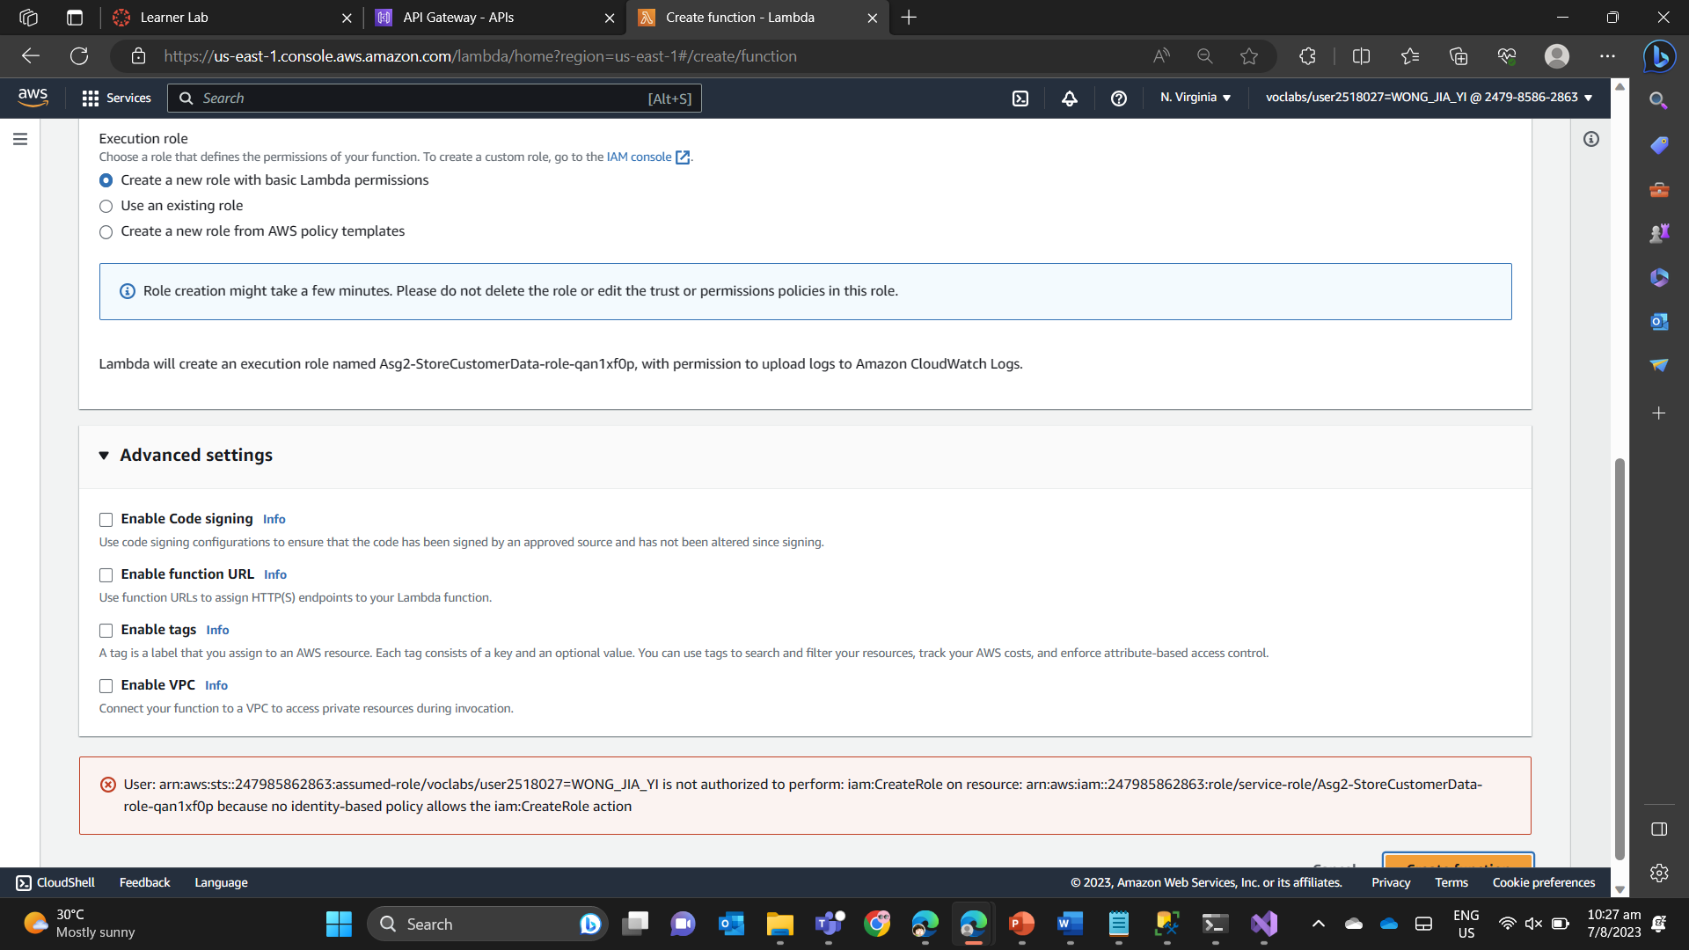

In the process of creating a Lambda role, we encountered an error message, stating that we lacked the necessary authorization to create the role. We managed to resolve this problem by selecting the existing role "LabRole", which already had the necessary permissions to create and execute Lambda functions. To prevent this problem from happening again, we will make sure to check the permissions of existing roles before creating new ones. This also makes it easier for us to set up the services in a more efficient way.

1. Did not enable CORS (cross origin resource sharing)

For the serverless application, the two APIs endpoints are used in the webpage to make HTML GET and POST requests. Therefore, the application did not work as the HTML requests as the browser blocked the requests due to the requests coming from different domains. We solved this by enabling CORS which allowed the requests to be made.

# References

Cloud computing services—Amazon web services(Aws). (n.d.). Amazon Web Services, Inc. Retrieved August 9, 2023, from <https://aws.amazon.com/>

Belgium, O. (n.d.). Create a serverless application with aws lambda and dynamodb—Nick van hoof. Retrieved August 9, 2023, from <http://ordina-jworks.github.io/cloud/2018/10/01/How-to-build-a-Serverless-Application-with-AWS-Lambda-and-DynamoDB.html>

Sarthak. (2018, August 22). How create a serverless website using aws lambda, aws s3, aws api gateway and aws dynamodb with node. Js? Full tutorial! The Web Spark. <https://thewebspark.com/2018/08/22/how-create-a-serverless-website-using-aws-lambda-aws-s3-aws-api-gateway-and-aws-dynamodb-with-node-js-full-tutorial/>

Building your first aws serverless application? Here’s everything you need to know. (n.d.). Retrieved August 9, 2023, from <https://velotio.com/engineering-blog/aws-serverless-application>

# References

AWS. (2023). *Amazon RDS.* Retrieved from AWS: https://aws.amazon.com/free/database/?trk=fc551e06-56b0-418c-9ddd-5c9dba18569b&sc_channel=ps&ef_id=EAIaIQobChMIq5Gv3Zm4gAMVT5hmAh0FeggPEAAYASAAEgKhfPD_BwE:G:s&s_kwcid=AL!4422!3!548908918497!e!!g!!amazon%20relational%20database!11543056228!112002957989

AWS. (2023). *Control traffic to subnets using network ACLs.* Retrieved from AWS: https://docs.aws.amazon.com/vpc/latest/userguide/vpc-network-acls.html

AWS. (2023). *What is Amazon VPC?* Retrieved from AWS: https://docs.aws.amazon.com/vpc/latest/userguide/what-is-amazon-vpc.html

AWS. (2023). *What is AWS CloudTrail.* Retrieved from AWS: https://docs.aws.amazon.com/awscloudtrail/latest/userguide/cloudtrail-user-guide.html

AWS. (n.d.). *Reliability - AWS AWS Well-Architected Framework*. Retrieved from AWS: https://wa.aws.amazon.com/wellarchitected/2020-07-02T19-33-23/wat.pillar.reliability.en.html

AWS. (n.d.). *Security - AWS Well-Architected Framework*. Retrieved from AWS: https://wa.aws.amazon.com/wellarchitected/2020-07-02T19-33-23/wat.pillar.security.en.html

N, V. P. (2023). *Creation of Public Subnet and Private Subnet in VPC and Test Connectivity*. Retrieved from 1CloudHub: https://www.1cloudhub.com/aws-vpc-101-creation-of-public-subnet-and-private-subnet-in-vpc-and-test-connectivity/#:~:text=A%20public%20subnet%20is%20a,route%20to%20an%20internet%20gateway.